## Appendix G - Technical details on jammer equipment

The nomenclature for naming of the jammer equipment is as follows:

|  |  |  |  |
| --- | --- | --- | --- |
| **1st Letter (Norwegian / English)** | **1St digit** | **2nd digit** | |
| **S** = Sigarett / Cigarette | **Number of antennas** | **# jammer within same category** |
| **H** = Håndholdt / Handheld |
| **U** = USB / USB stick |
| **F** = Fastmontert / Permanently installed (Fixed) |

Exempli gratia:

S1.2, is a cigarette type jammer, that has 1 antenna, and is unit nr.2 in this category.

Additional information:

* Each chapter gives an overview of each jammer brought to Jammertest. As far as possible, it gives information on
  + Centre frequency [MHz]
  + Bandwidth [MHz]
  + Power Spectral Density (PSD) [dBm/MHz] for the entire bandwidth
  + Total output power (TX total) [dBm] for the entire bandwidth
  + CF max [dBm] (maxhold power at the centre frequency)
  + Sweep rate [µs] (if applicable)
  + Modulation
* Indicators such as “L1, L2, L5” etc. are used to indicate main bands of attack, used for convenience to distinguish between jammers’ modus operandi
* 2023 measurements
  + Technical details on low power jammers given in this appendix are from uncalibrated measurements. They are rough estimates given for both the frequency and time domain. Power levels are not correctly displayed on the chart, because of external attenuators used during measurements with a signal analyser. There may also have been some constraints in the measurement device, causing fast frequency components to not be correctly displayed.
* 2024 measurements
  + Measurements done with a R&S FSW. All measurements were performed connected directly to the jammers’ antenna port, with the other antennas disconnected and (if applicable) DIP switches for the other antenna ports disabled. Powe levels etc. should be as close to reality as possible for output power at the antenna port.
  + Throughout the measurements, bandwidth is defined as 3 dB from local (identifiable) maxima along the maxhold’s descent.
  + TX power is measured within said bandwidth. Note that TX total is measured over the entire bandwidth, so that peak output power is not equal to TX total.

### Et bilde som inneholder kobling, kabel Automatisk generert beskrivelseTechnical details on low-power jammer “S1.1”

The jammer S1.1 belongs to the ‘Cigarette jammer’ category of jammers. Such jammers are often installed in the cigarette lighter outlet in cars. They are intended to cover the car, and a given radius around the car.

S1.1 is an one-antenna, so-called “L1-only”, jammer, disrupting only the upper L-band.

Technical characteristics of S1.1 (2024 measurements)

|  |  |  |  |  |  |  |
| --- | --- | --- | --- | --- | --- | --- |
| Centre frequency [MHz] | Bandwidth [MHz] | PSD [dBm/MHz] | TX total [dBm] | CF max [dBm] | Sweep rate [µs] | Modulation |
| 1577,40 | 29,96 | 7,58 | 22,34 | 7,89 | 37,1 | Sawtooth |

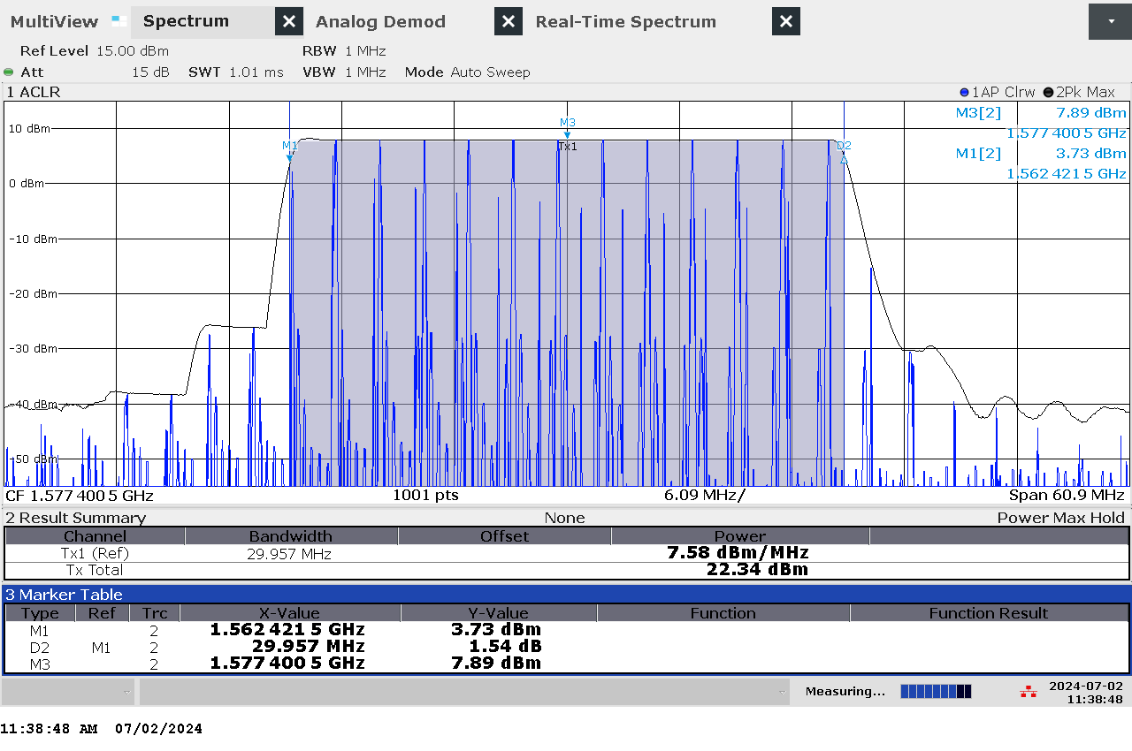

G 1: Frequency and power measurement of jammer S1.1

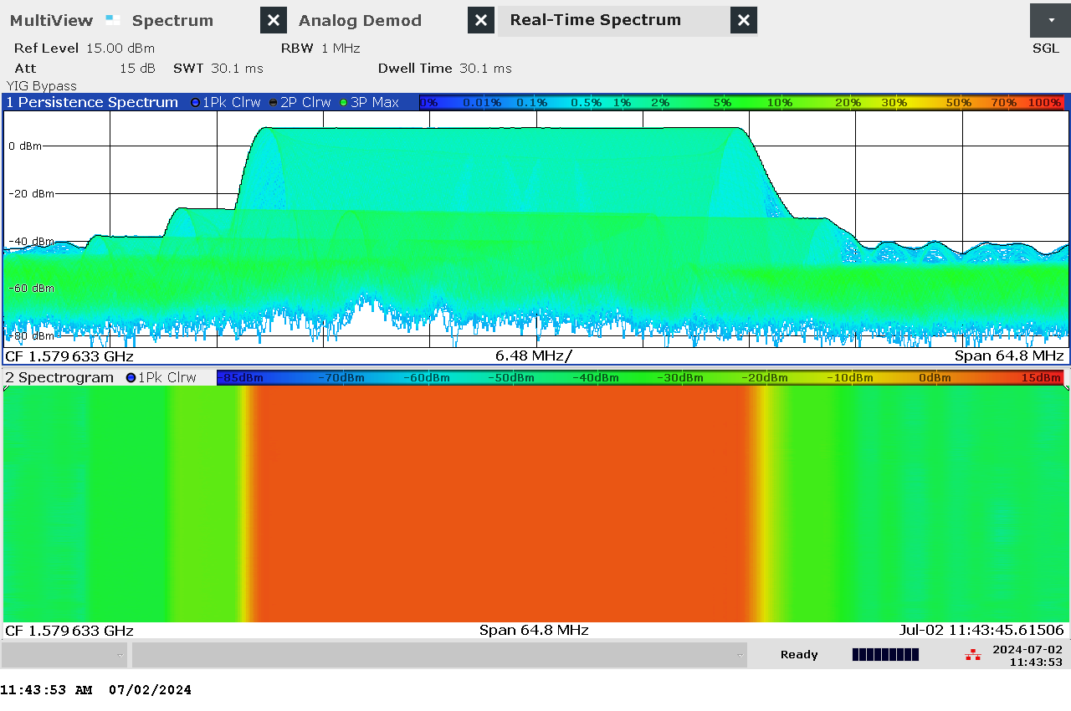

G 2: Real-time persistence and spectrogram measurement of jammer S1.1

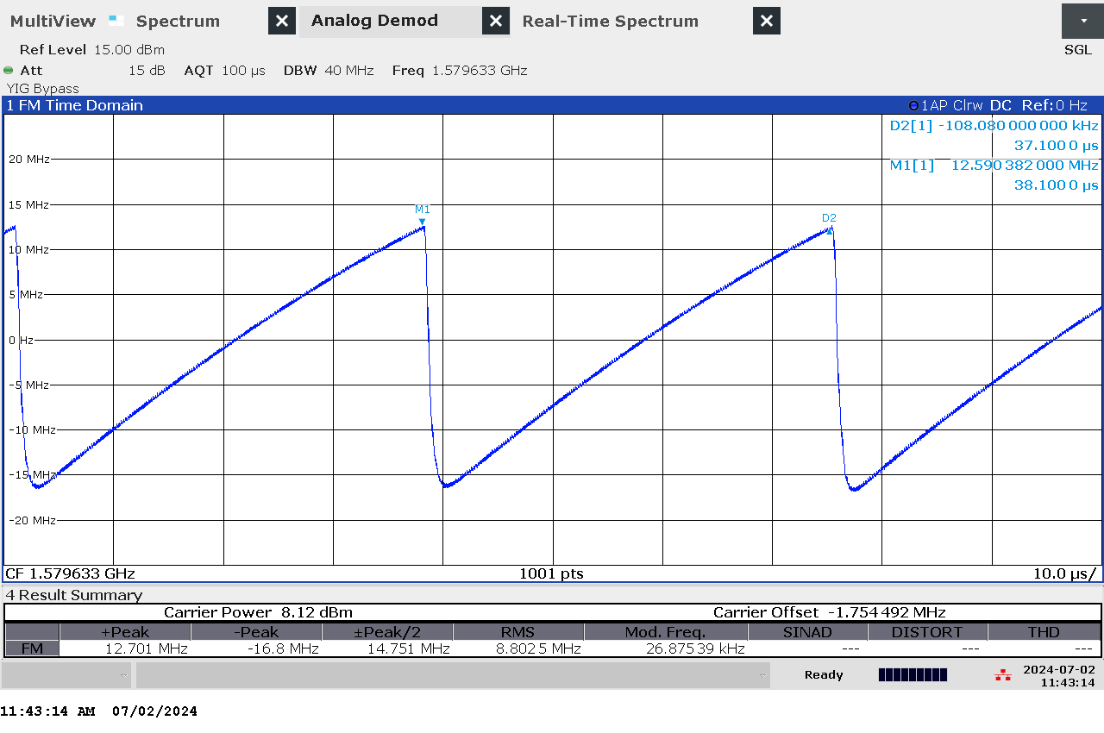

G 3: Time domain (analog demod) measurement of jammer S1.1

### Et bilde som inneholder kobling, kabel Automatisk generert beskrivelseTechnical details on low-power jammer “S1.2”

The jammer S1.2 belongs to the ‘Cigarette jammer’ category of jammers. Such jammers are often installed in the cigarette lighter outlet in cars. They are intended to cover the car, and a given radius around the car.

S1.2 is an one-antenna, so-called “L1-only”, jammer, disrupting only the upper L-band.

Technical characteristics of S1.2 (2024 measurements)

|  |  |  |  |  |  |  |
| --- | --- | --- | --- | --- | --- | --- |
| Centre frequency [MHz] | Bandwidth [MHz] | PSD [dBm/MHz] | TX total [dBm] | CF max [dBm] | Sweep rate [µs] | Modulation |
| 1582,56 | 40,03 | 12,38 | 29,01 | 12,61 | 21,56 | Sawtooth |

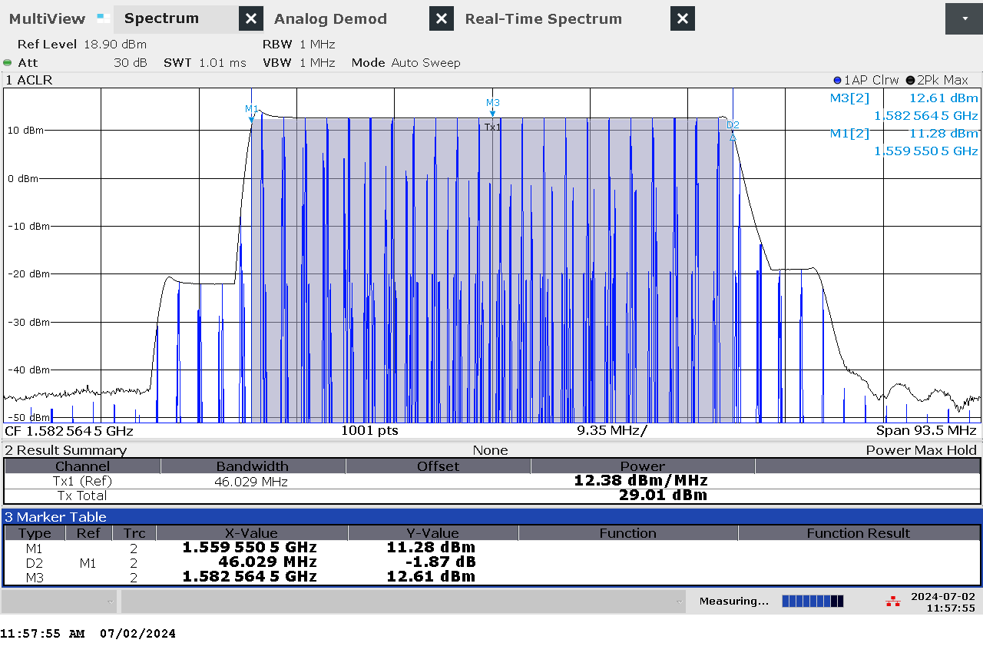

G 4: Frequency and power measurement of jammer S1.2

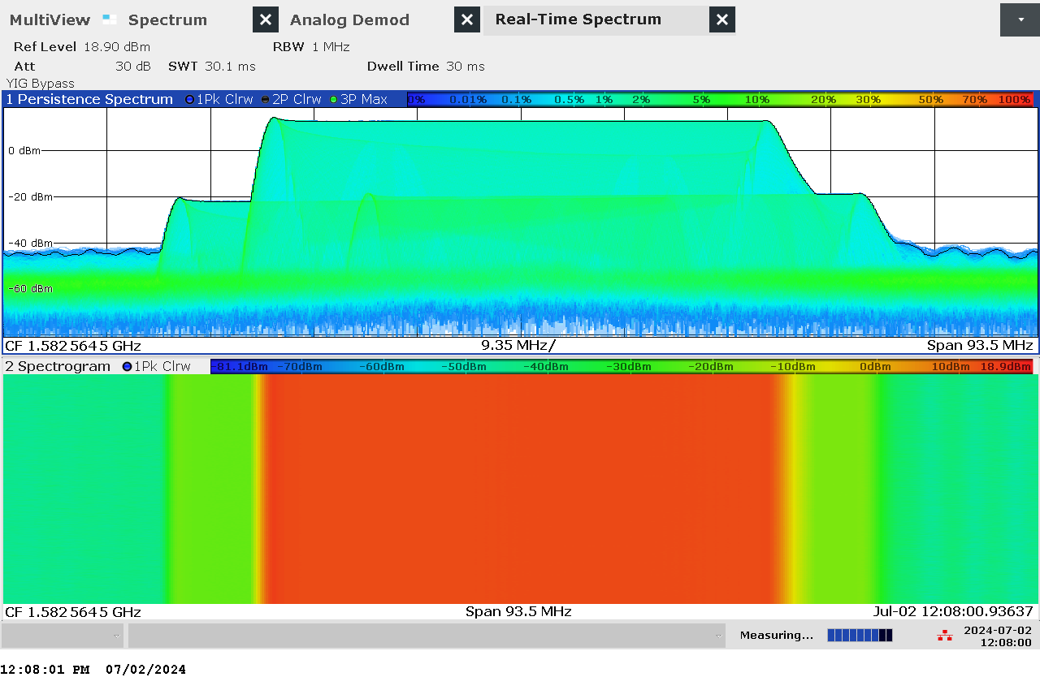

G 5: Real-time persistence and spectrogram measurement of jammer S1.2

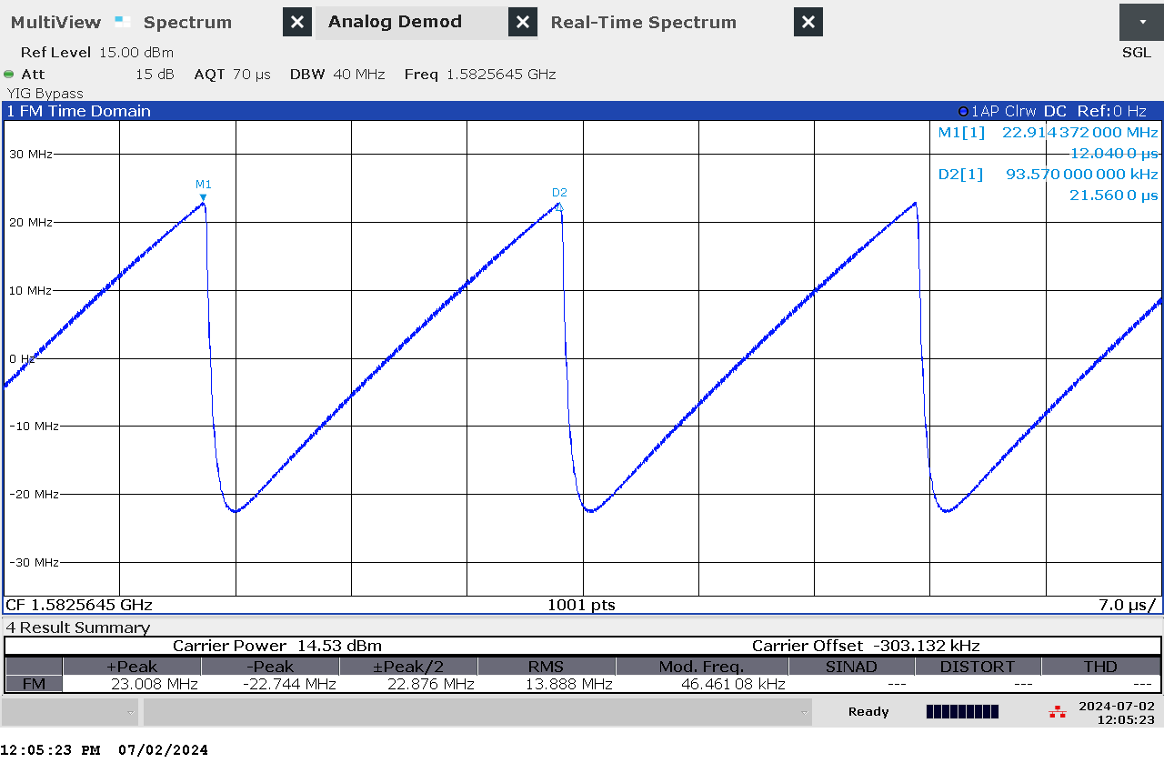

G 6: Time domain (analog demod) measurement of jammer S1.2

### Et bilde som inneholder kobling, kabel Automatisk generert beskrivelseTechnical details on low-power jammer “S1.3”

The jammer S1.3 belongs to the ‘Cigarette jammer’ category of jammers. Such jammers are often installed in the cigarette lighter outlet in cars. They are intended to cover the car, and a given radius around the car.

S1.3 is an one-antenna, so-called “L1-only”, jammer, disrupting only the upper L-band.

Technical characteristics of S1.3 (2024 measurements)

|  |  |  |  |  |  |  |
| --- | --- | --- | --- | --- | --- | --- |
| Centre frequency [MHz] | Bandwidth [MHz] | PSD [dBm/MHz] | TX total [dBm] | CF max [dBm] | Sweep rate [µs] | Modulation |
| 1579,63 | 31,88 | 7,56 | 22,60 | 7,93 | 37,5 | Sawtooth |

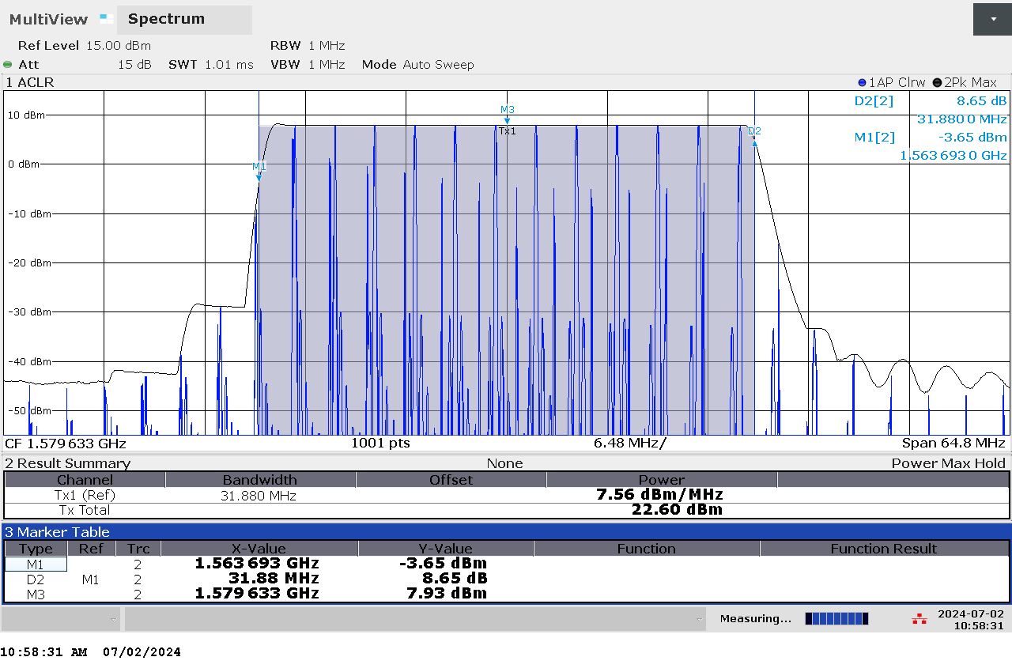

G 7: Frequency and power measurement of jammer S1.3

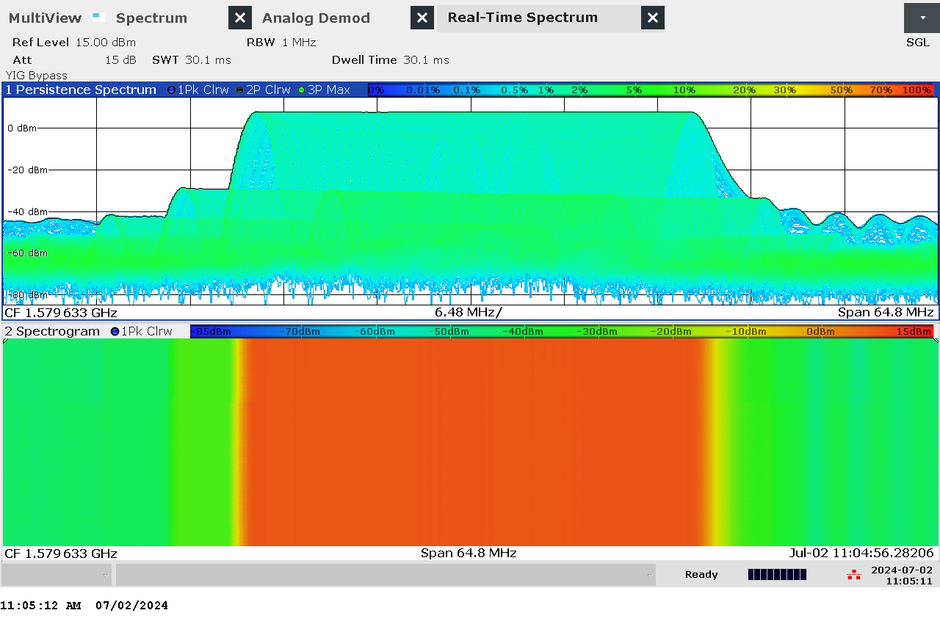

G 8: Real-time persistence and spectrogram measurement of jammer S1.3

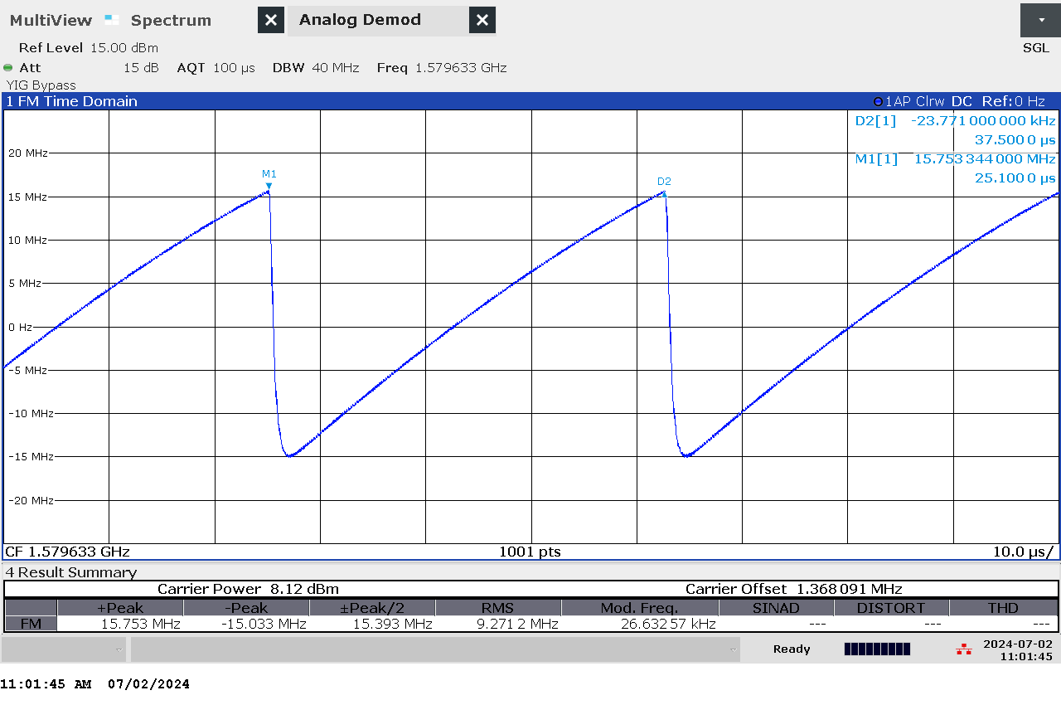

G 9: Time domain (analog demod) measurement of jammer S1.3

### Et bilde som inneholder verktøy, innendørs Automatisk generert beskrivelseTechnical details on low-power jammer “S2.1”

The jammer S2.1 belongs to the ‘Cigarette jammer’ category of jammers. Such jammers are often installed in the cigarette lighter outlet in cars. They are intended to cover the car, and a given radius around the car.

S2.1 is a two-antenna, so-called “L1+L2”, jammer, disrupting both the upper and lower L-band.

Technical characteristics of S2.1 (2024 measurements)

|  |  |  |  |  |  |  |  |
| --- | --- | --- | --- | --- | --- | --- | --- |
| Antenna | Centre frequency [MHz] | Bandwidth [MHz] | PSD [dBm/MHz] | TX total [dBm] | CF max [dBm] | Sweep rate [µs] | Modulation |
| “L1” | 1581,59 | 85,41 | 13,36 | 32,68 | 16,64 | 40,63 | Sawtooth+burst |
| “L2” | 1198,05 | 96,58 | 13,92 | 33,75 | 17,30 | 42,1 | Sawtooth+burst |

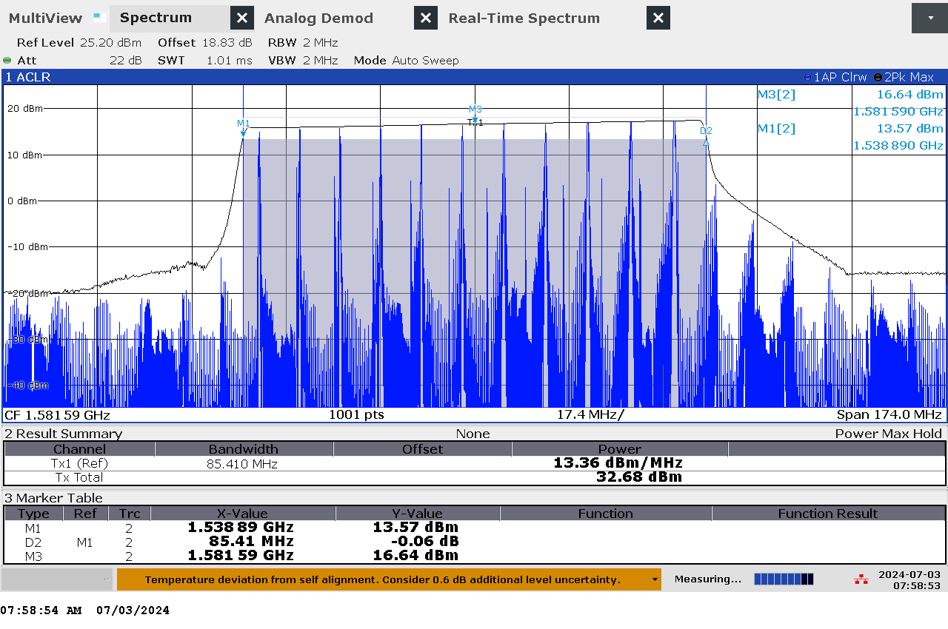

G 10: Frequency and power measurement of jammer S2.1 on antenna “L1”

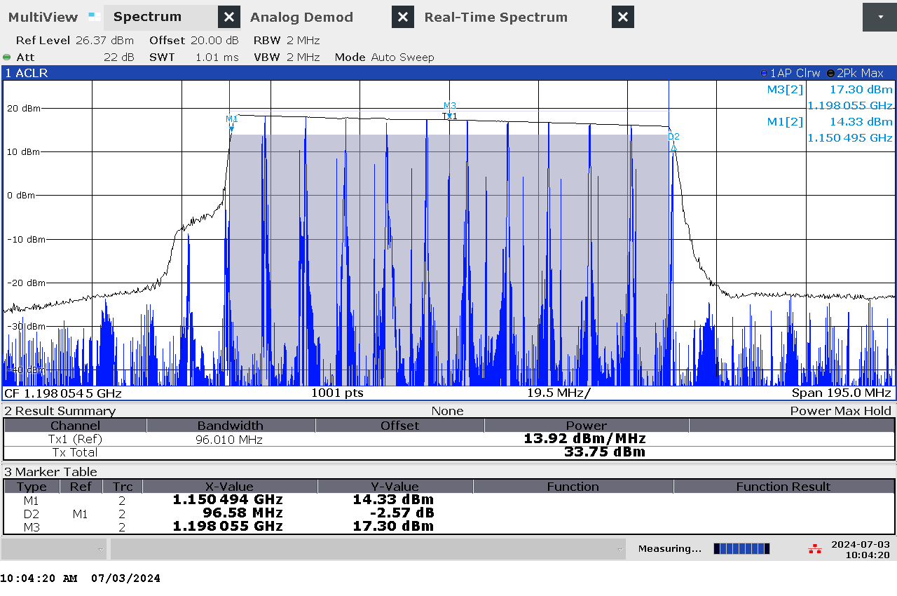

G 11: Frequency and power measurement of jammer S2.1 on antenna “L2"

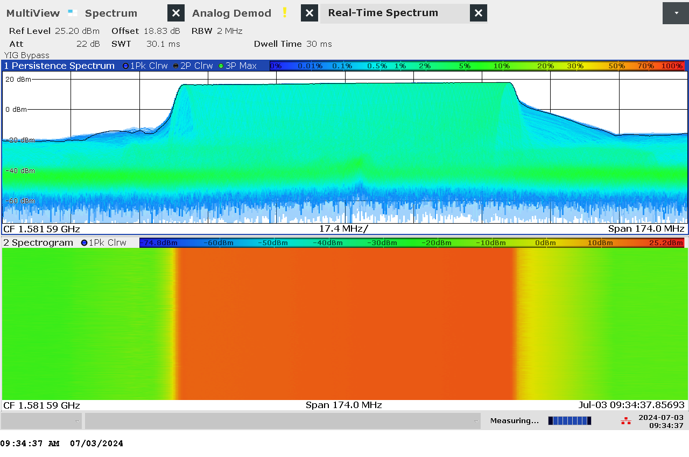

G 12: Real-time persistence and spectrogram measurement of jammer S2.1 on antenna "L1"

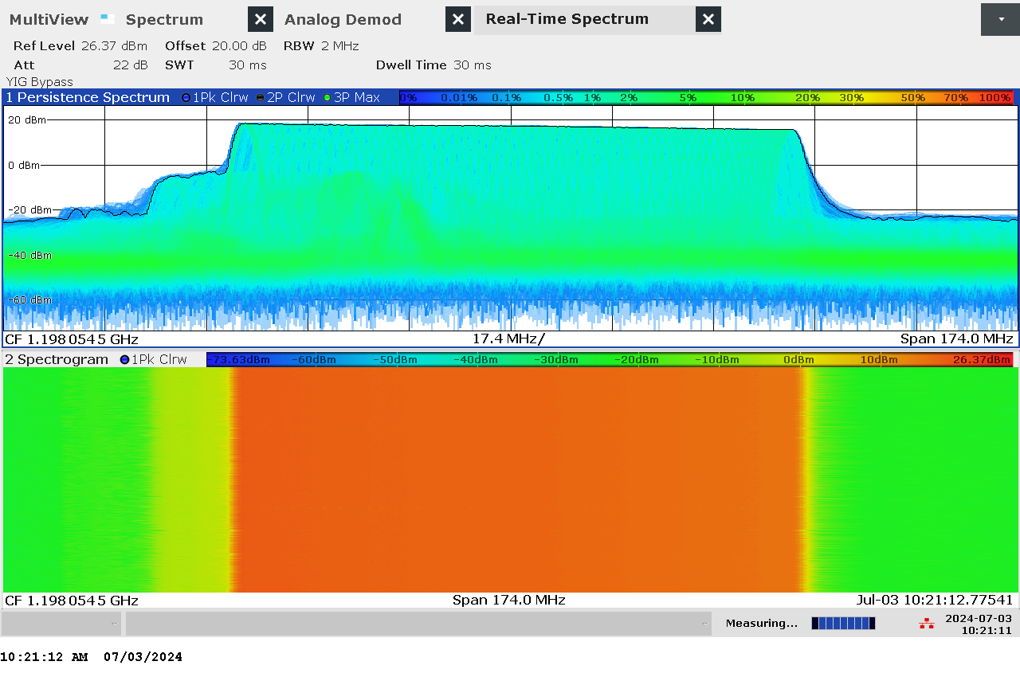

G 13: Real-time persistence and spectrogram measurement of jammer S2.1 on antenna "L2"

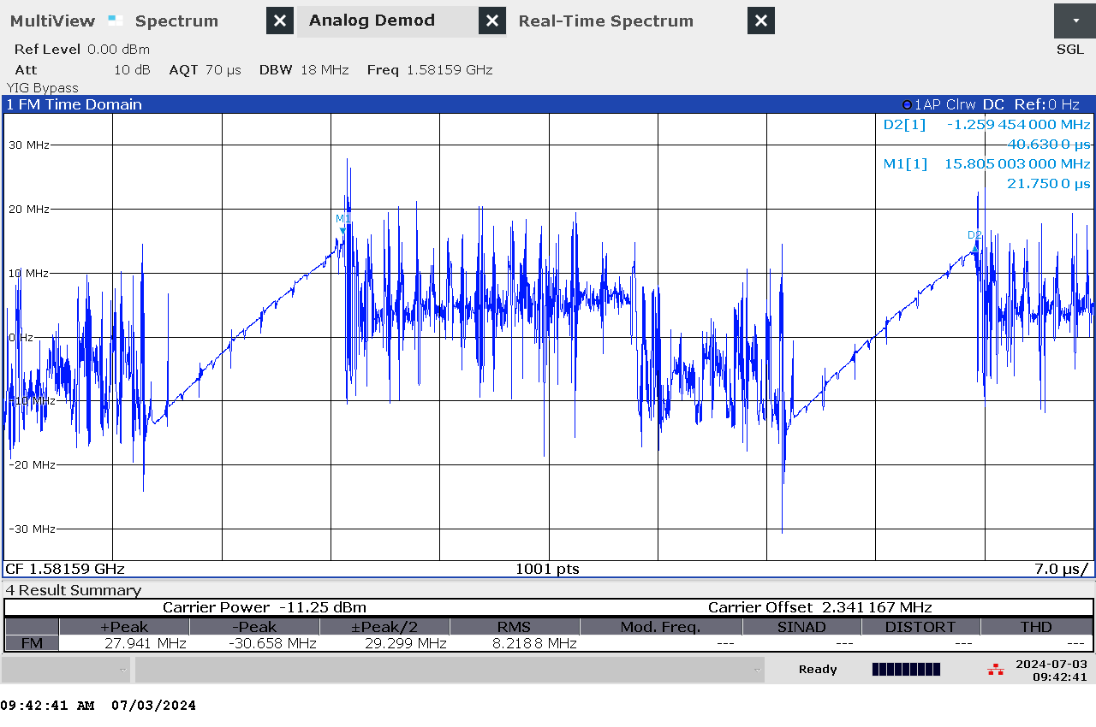

G 14: Time domain (analog demod) measurement of jammer S2.1 on antenna “L1”

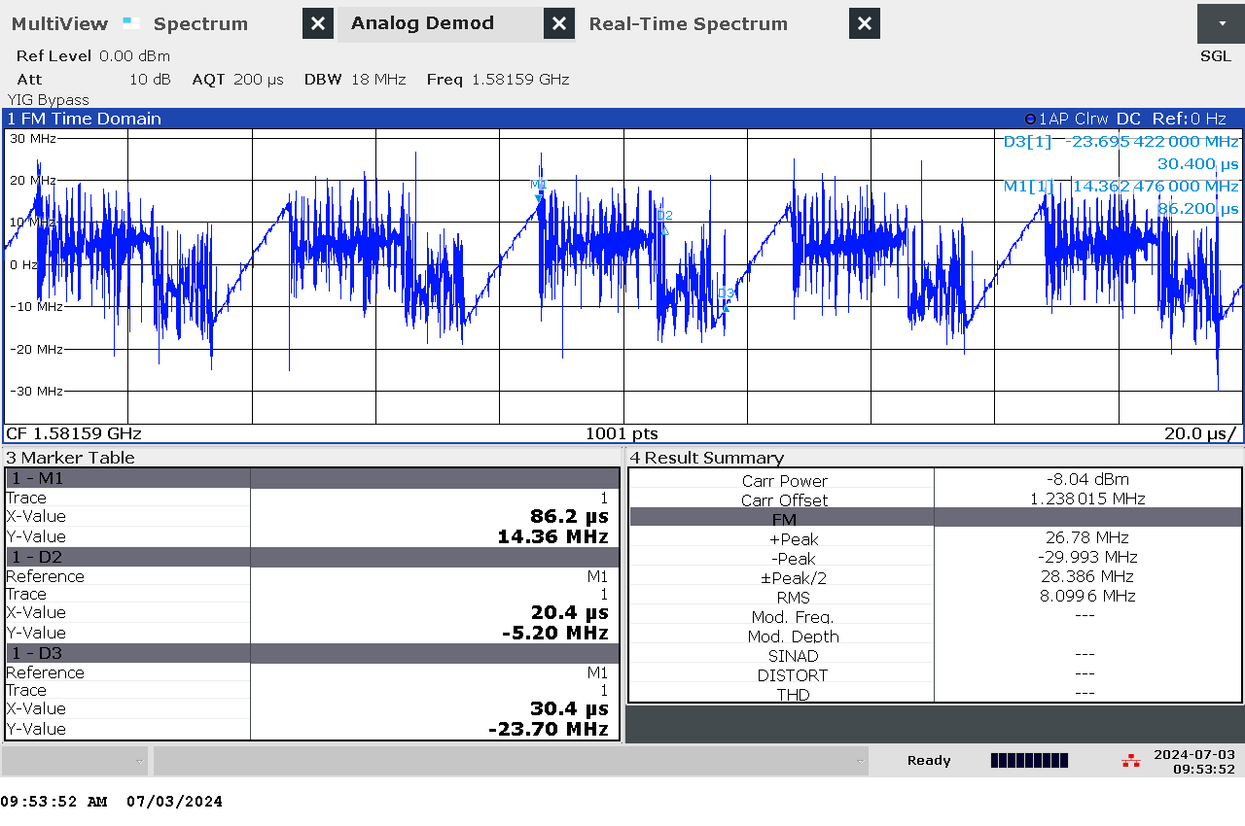

G 15: Time domain (analog demod) measurement with wider span of jammer S2.1 on antenna “L1”

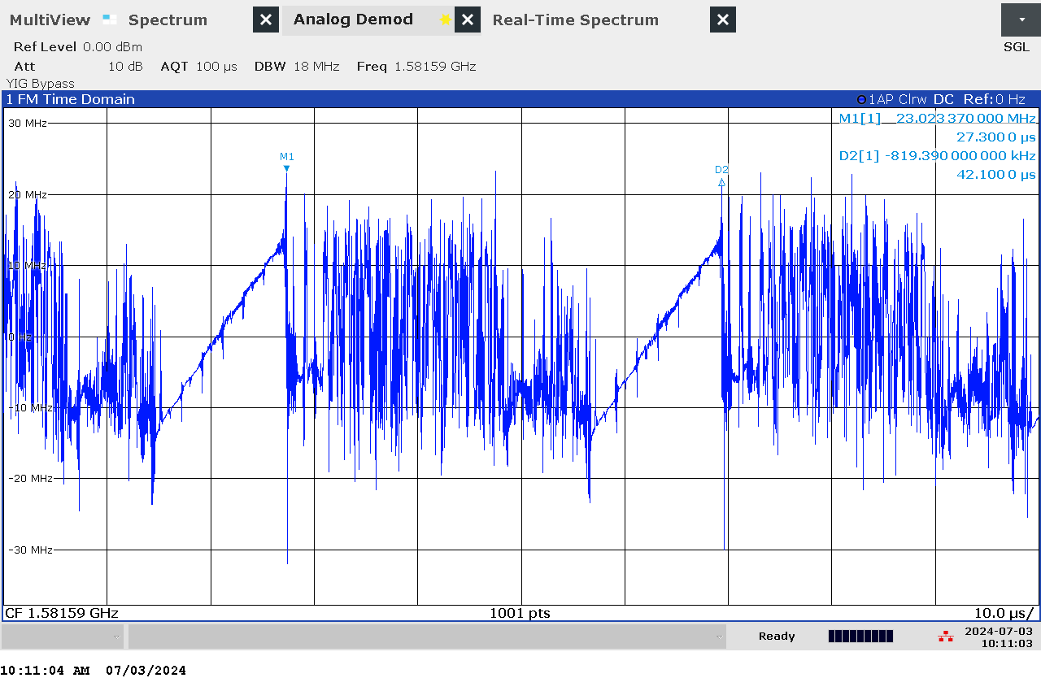

G 16: Time domain (analog demod) measurement of jammer S2.1 on antenna “L2”

### Et bilde som inneholder verktøy, innendørs Automatisk generert beskrivelseTechnical details on low-power jammer “S2.2”

The jammer S2.2 belongs to the ‘Cigarette jammer’ category of jammers. Such jammers are often installed in the cigarette lighter outlet in cars. They are intended to cover the car, and a given radius around the car.

S2.2 is a two-antenna, so-called “L1+L2”, jammer, disrupting both the upper and lower L-band.

Technical characteristics of S2.2 (2024 measurements)

|  |  |  |  |  |  |  |  |
| --- | --- | --- | --- | --- | --- | --- | --- |
| Antenna | Centre frequency [MHz] | Bandwidth [MHz] | PSD [dBm/MHz] | TX total [dBm] | CF max [dBm] | Sweep rate [µs] | Modulation |
| “L1” | 1580,86 | 87,69 | 12,82 | 32,25 | 16,17 | 40,7 | Sawtooth+burst |
| “L2” | 1207,55 | 102,04 | 11,95 | 32,04 | 17,02 | 41,0 | Sawtooth+burst |

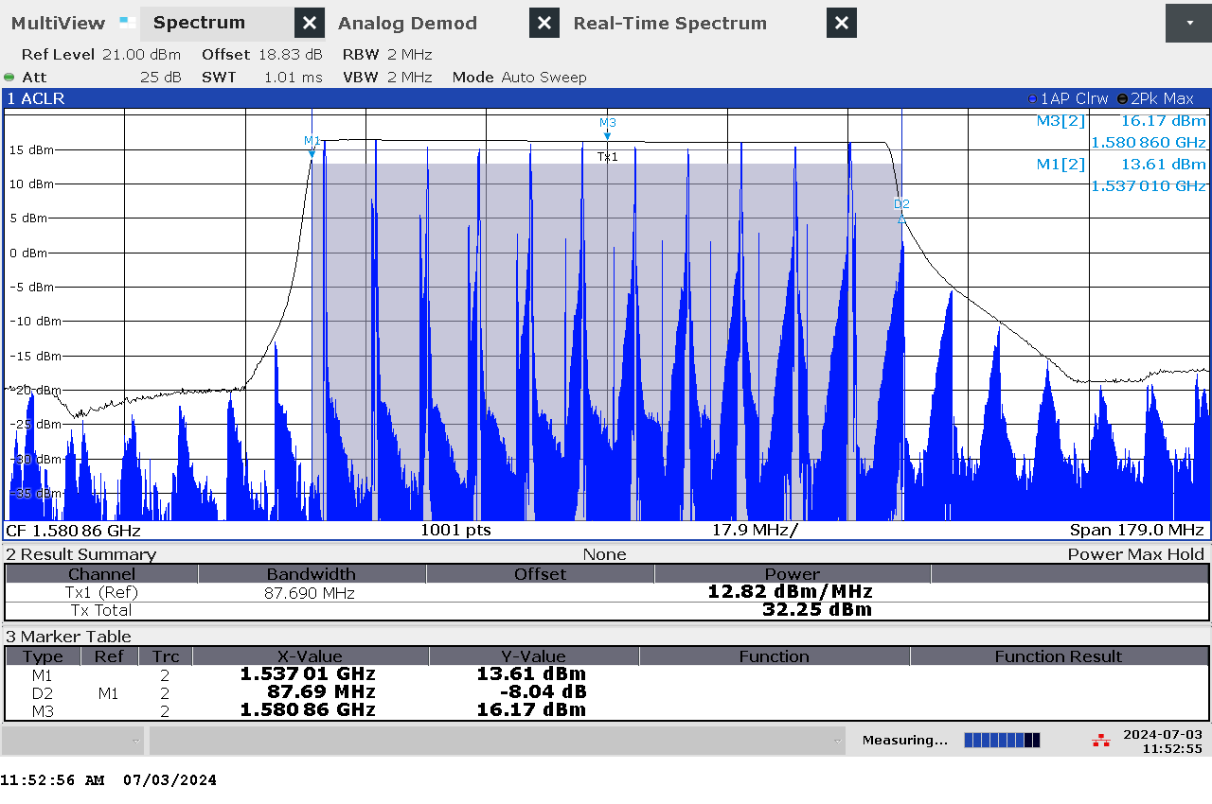

G 17: Frequency and power measurement of jammer S2.2 on antenna “L1”

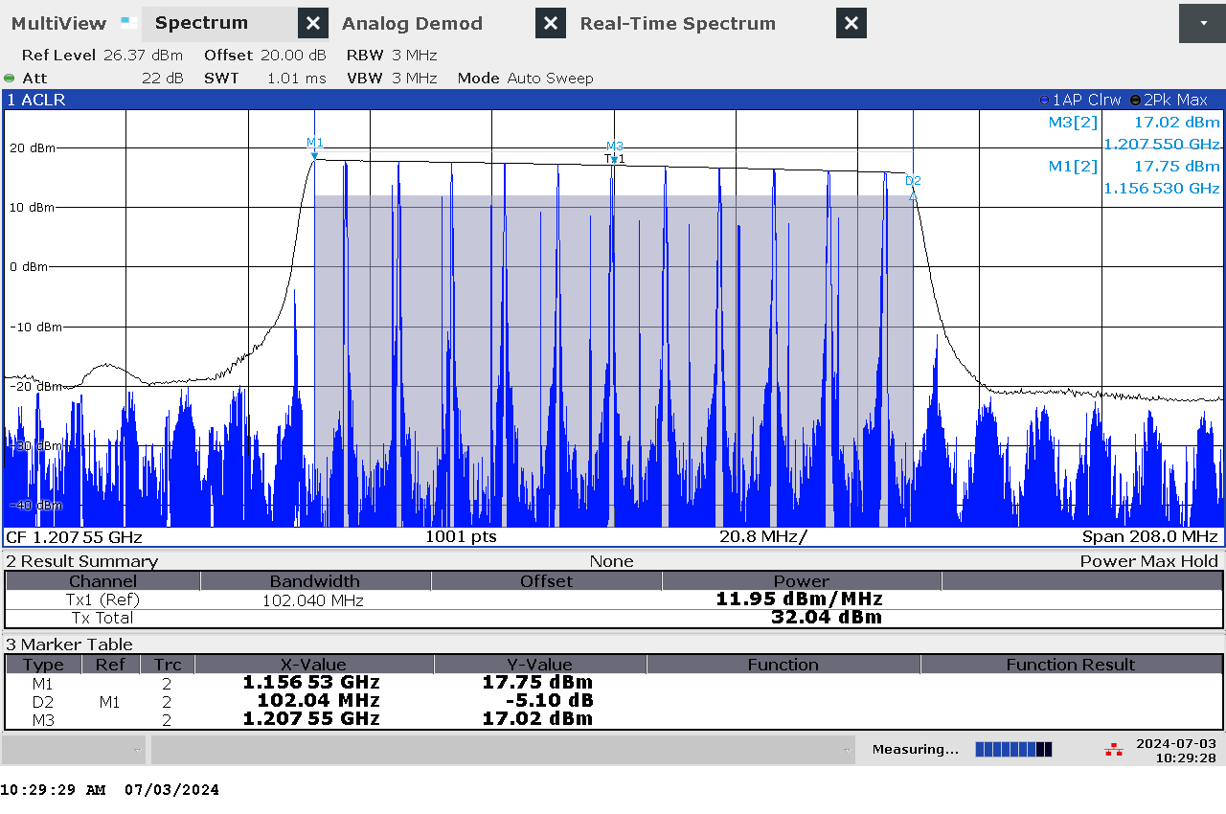

G 18: Frequency and power measurement of jammer S2.2 on antenna “L2"

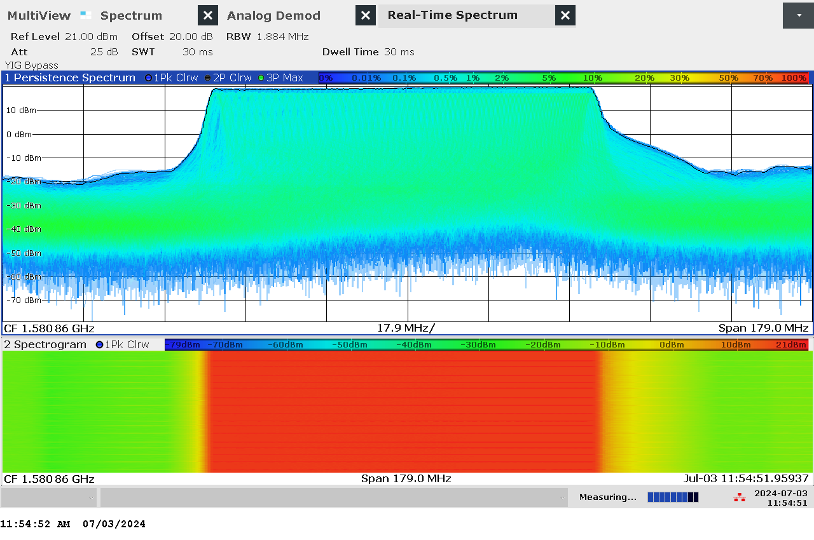

G 19: Real-time persistence and spectrogram measurement of jammer S2.2 on antenna "L1"

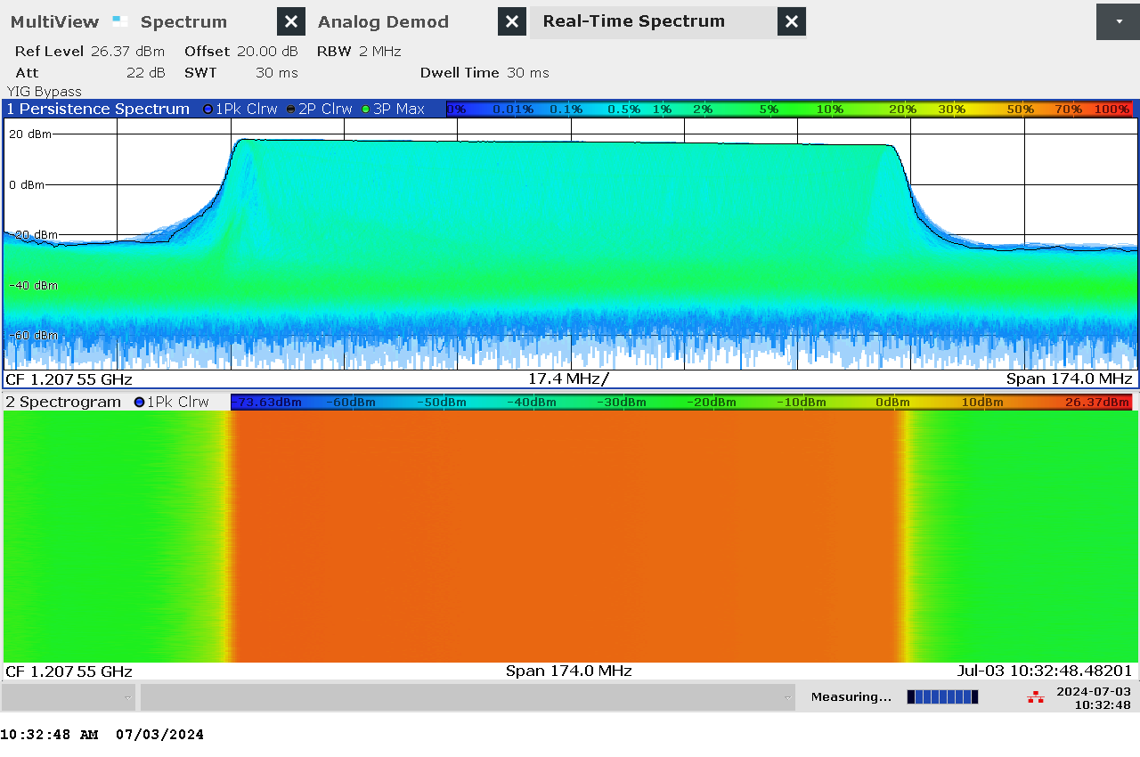

G 20: Real-time persistence and spectrogram measurement of jammer S2.2 on antenna "L2"

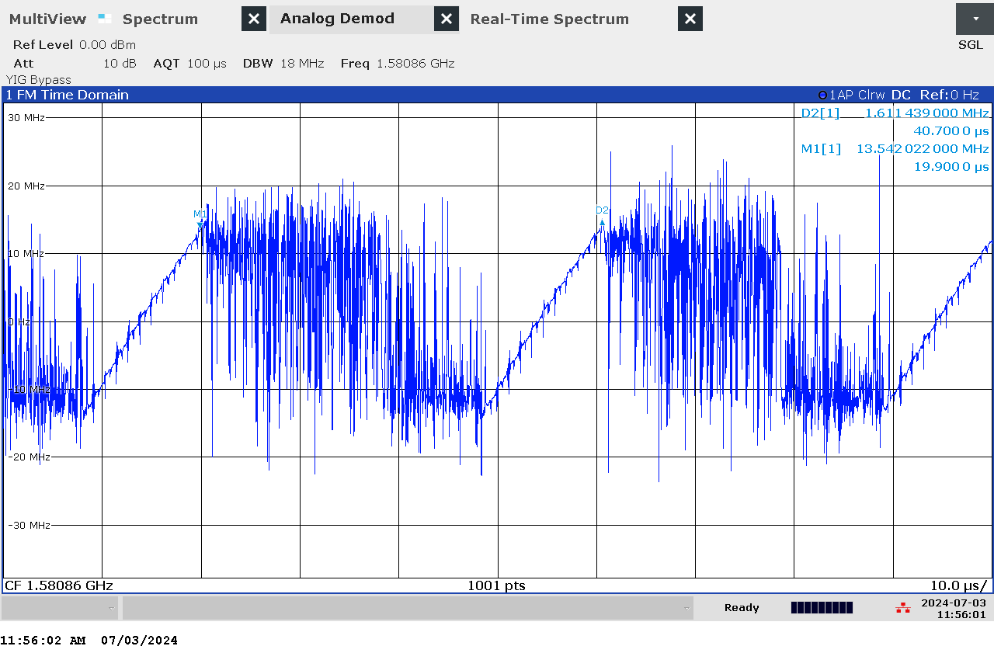

G 21: Time domain (analog demod) measurement of jammer S2.2 on antenna “L1”

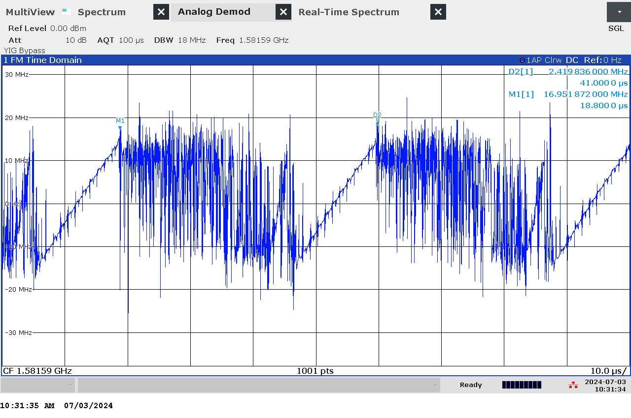

G 22: Time domain (analog demod) measurement of jammer S2.2 on antenna “L2”

### Et bilde som inneholder verktøy, innendørs Automatisk generert beskrivelseTechnical details on low-power jammer “S2.3”

The jammer S2.3 belongs to the ‘Cigarette jammer’ category of jammers. Such jammers are often installed in the cigarette lighter outlet in cars. They are intended to cover the car, and a given radius around the car.

S2.3 is a two-antenna, so-called “L1+L2”, jammer, disrupting both the upper and lower L-band.

Technical characteristics of S2.3 (2024 measurements)

|  |  |  |  |  |  |  |  |
| --- | --- | --- | --- | --- | --- | --- | --- |
| Antenna | Centre frequency [MHz] | Bandwidth [MHz] | PSD [dBm/MHz] | TX total [dBm] | CF max [dBm] | Sweep rate [µs] | Modulation |
| “L1” | 1586,65 | 93,19 | 14,30 | 34,0 | 17,40 | 46,7 | Sawtooth+burst |
| “L2” | 1204,33 | 102,05 | 12,01 | 32,1 | 17,06 | 50,5 | Sawtooth+burst |

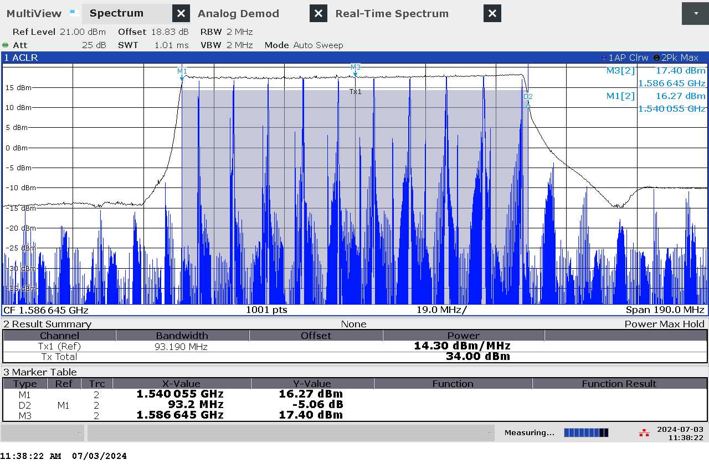

G 23: Frequency and power measurement of jammer S2.3 on antenna “L1”

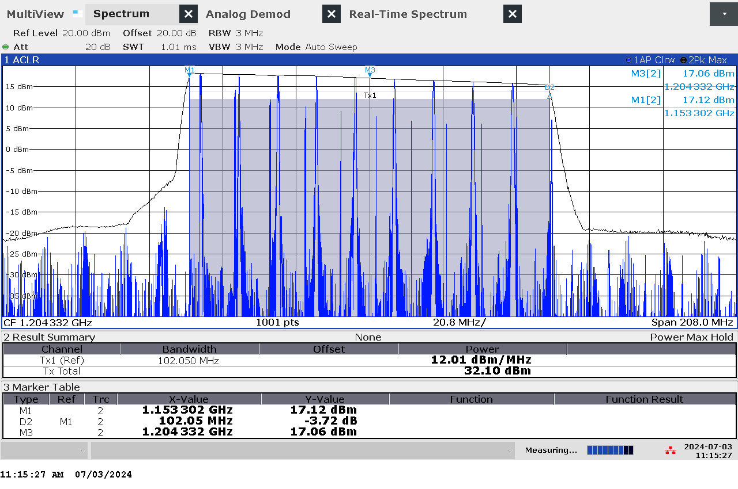

G 24: Frequency and power measurement of jammer S2.3 on antenna “L2"

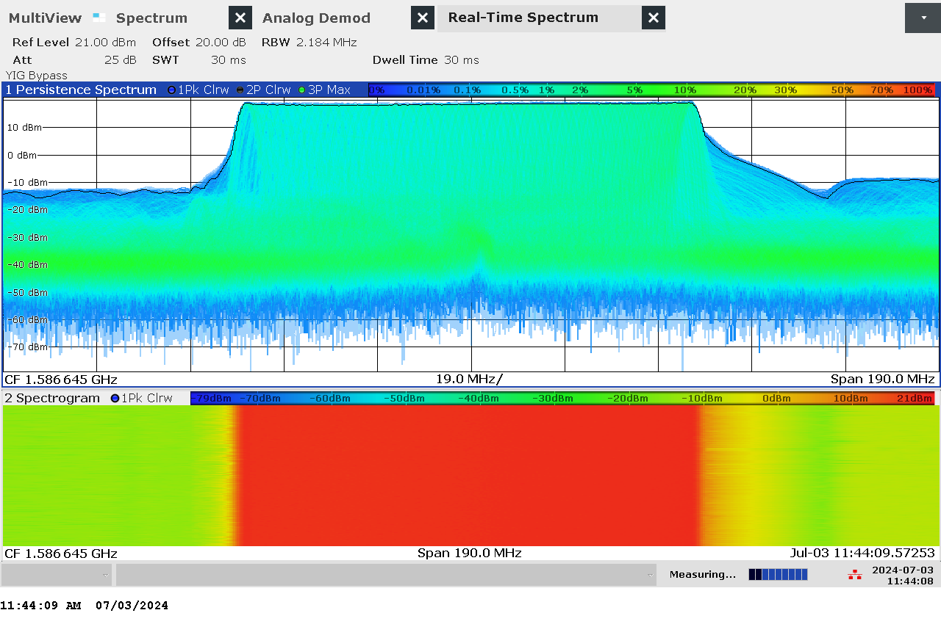

G 25: Real-time persistence and spectrogram measurement of jammer S2.3 on antenna "L1"

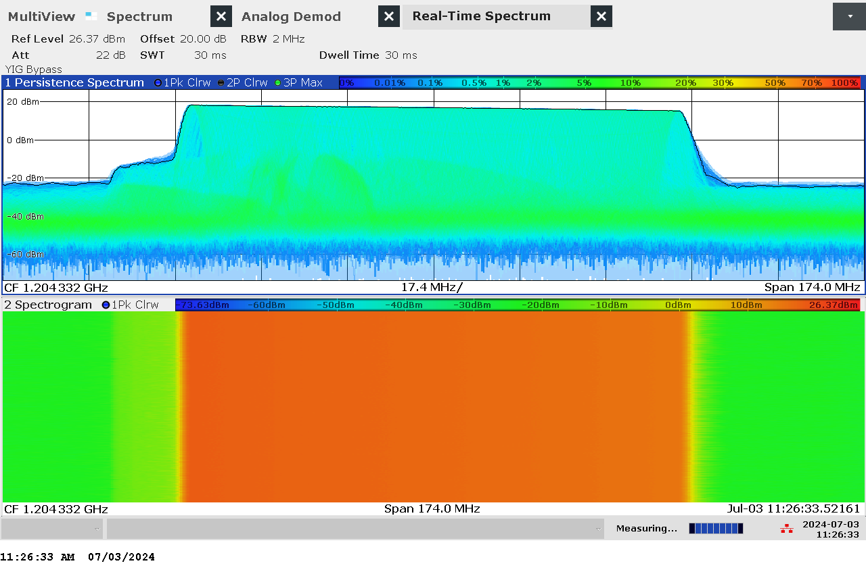

G 26: Real-time persistence and spectrogram measurement of jammer S2.3 on antenna "L2"

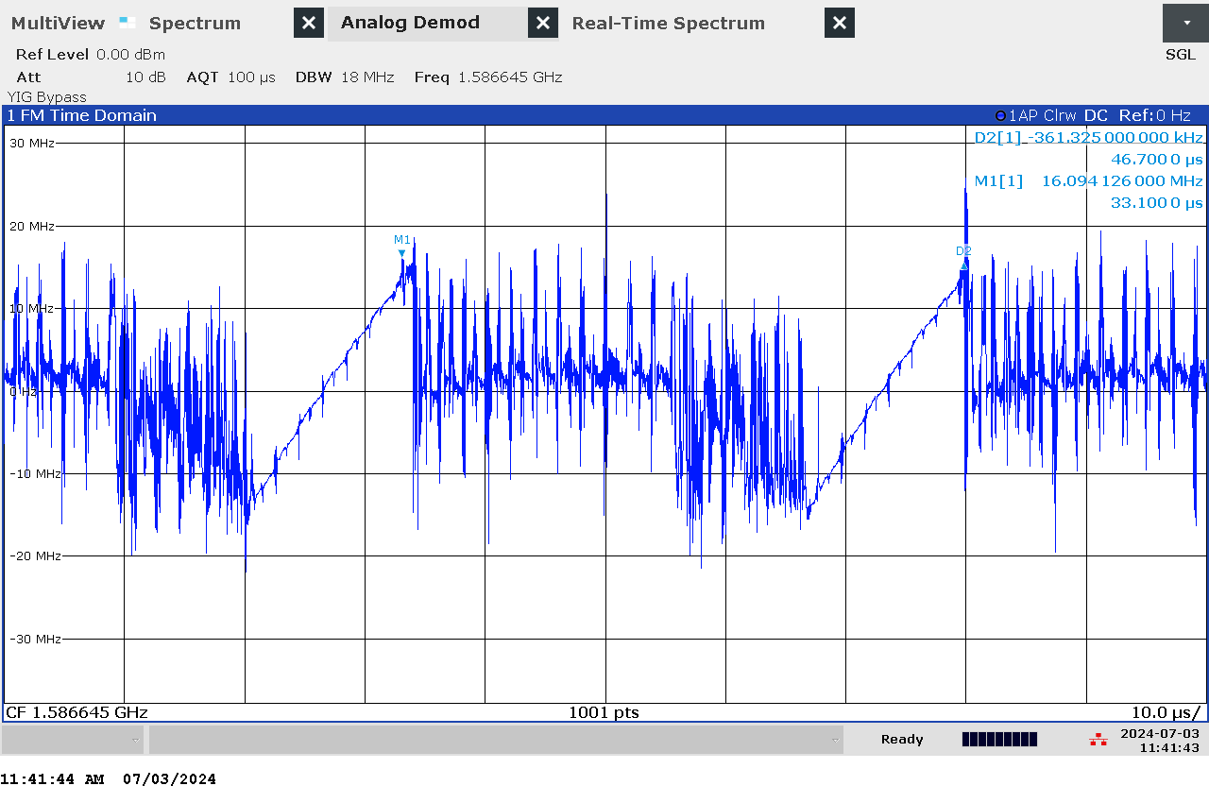

G 27: Time domain (analog demod) measurement of jammer S2.3 on antenna “L1”

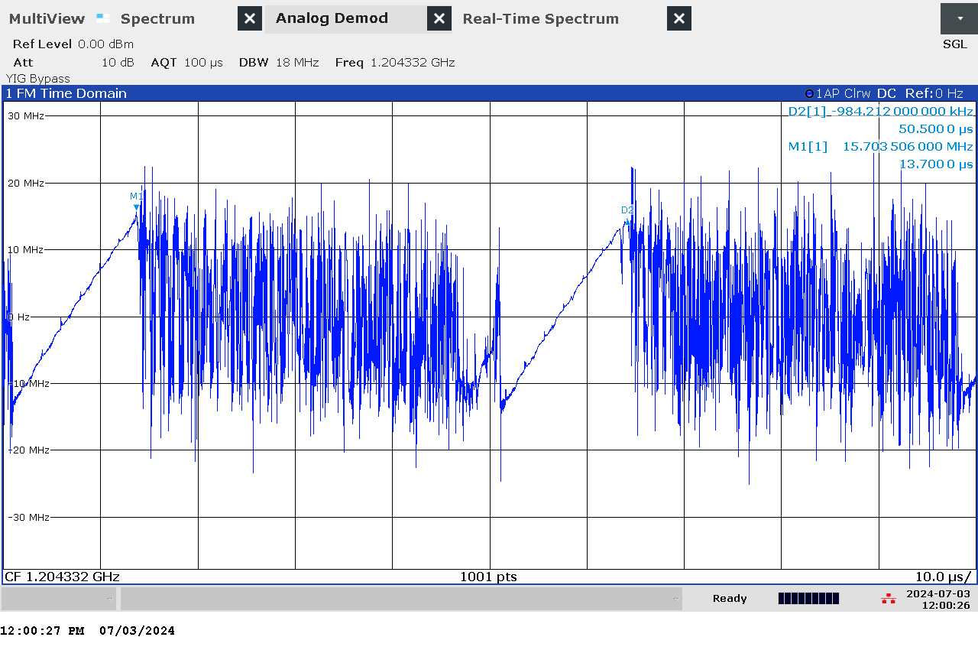

G 28: Time domain (analog demod) measurement of jammer S2.3 on antenna “L2”

### Et bilde som inneholder verktøy, innendørs Automatisk generert beskrivelseTechnical details on low-power jammer “S2.4”

The jammer S2.4 belongs to the ‘Cigarette jammer’ category of jammers. Such jammers are often installed in the cigarette lighter outlet in cars. They are intended to cover the car, and a given radius around the car.

S2.4 is a two-antenna, so-called “L1+L2”, jammer, disrupting both the upper and lower L-band.

Technical characteristics of S2.4 (2024 measurements)

|  |  |  |  |  |  |  |  |
| --- | --- | --- | --- | --- | --- | --- | --- |
| Antenna | Centre frequency [MHz] | Bandwidth [MHz] | PSD [dBm/MHz] | TX total [dBm] | CF max [dBm] | Sweep rate [µs] | Modulation |
| “L1” | 1582,09 | 86,35 | 12,42 | 31,78 | 15,91 | 43,5 | Sawtooth+burst |
| “L2” | 1202,90 | 96,56 | 13,63 | 33,48 | 17,03 | 47,3 | Sawtooth+burst |

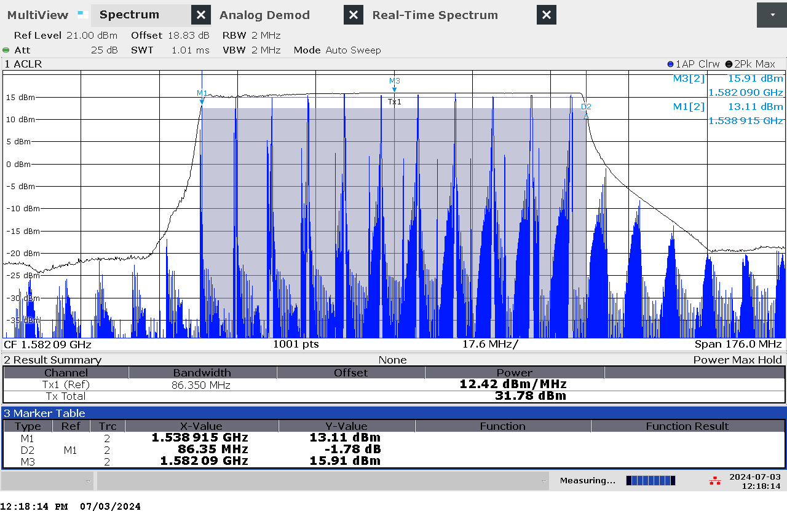

G 29: Frequency and power measurement of jammer S2.4 on antenna “L1”

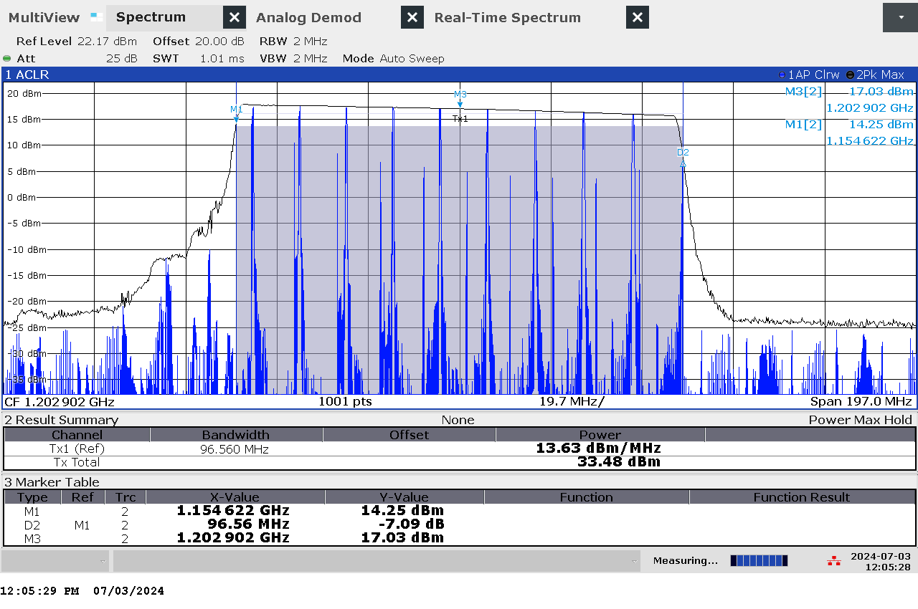

G 30: Frequency and power measurement of jammer S2.4 on antenna “L2"

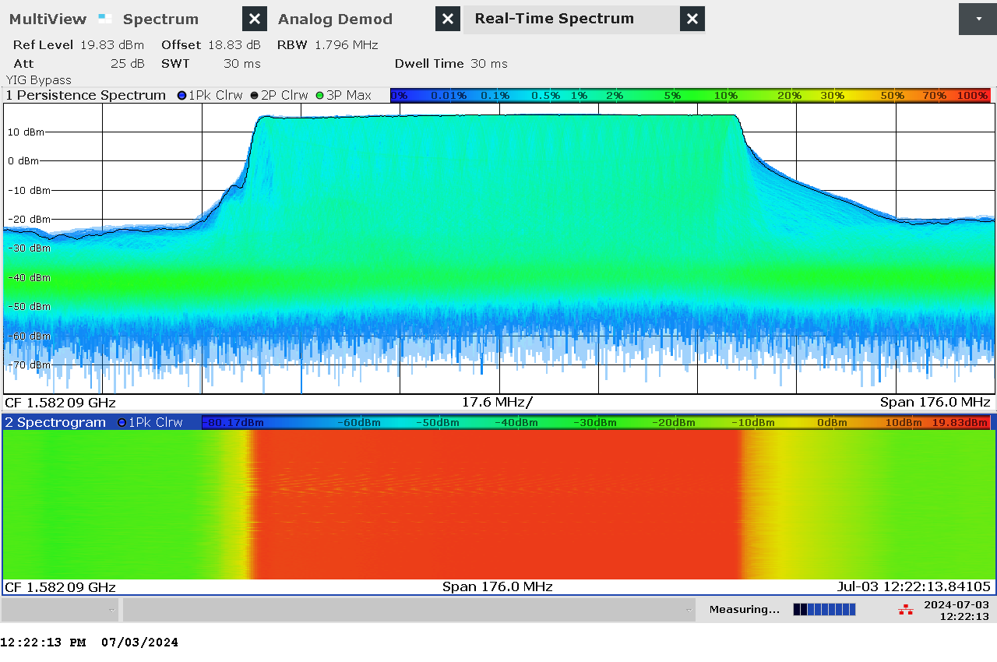

G 31: Real-time persistence and spectrogram measurement of jammer S2.4 on antenna "L1"

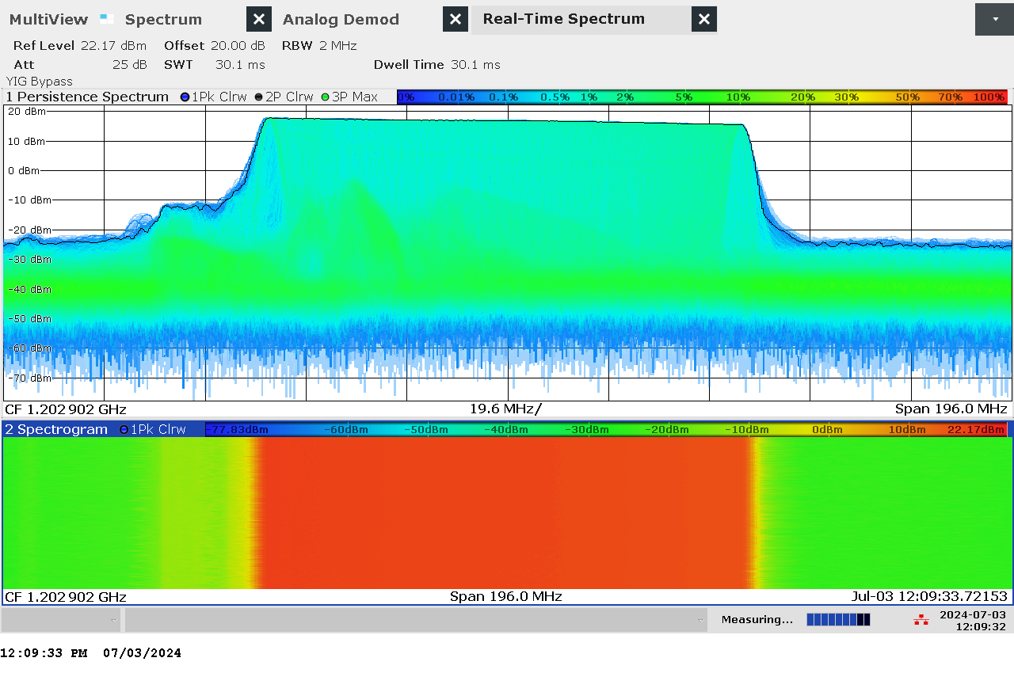

G 32: Real-time persistence and spectrogram measurement of jammer S2.4 on antenna "L2"

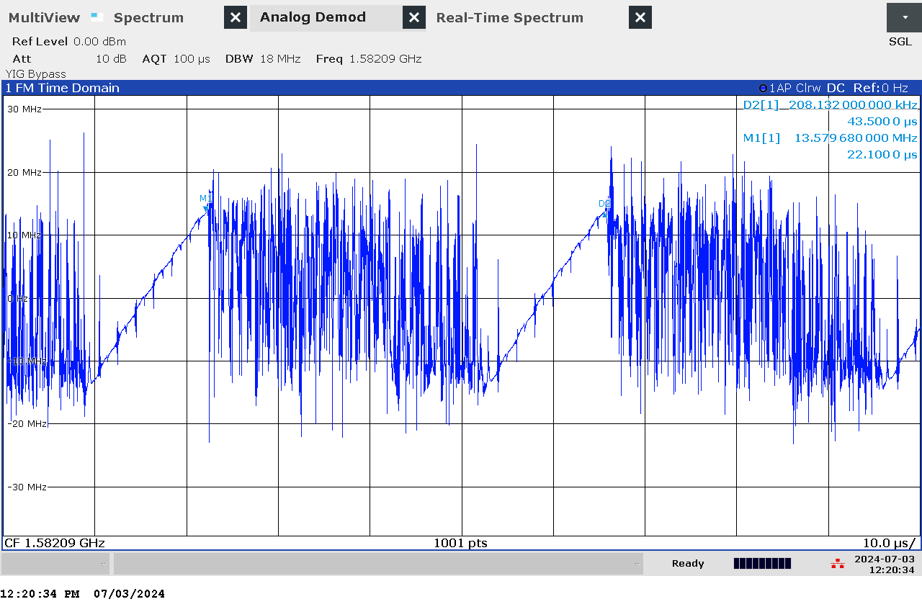

G 33: Time domain (analog demod) measurement of jammer S2.4 on antenna “L1”

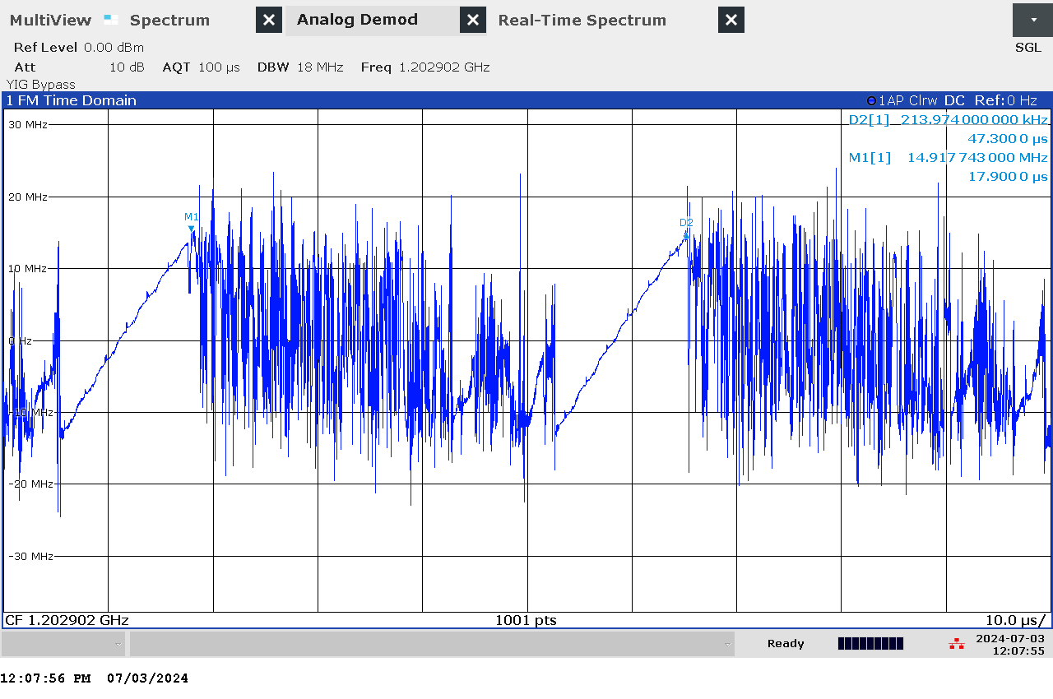

G 34: Time domain (analog demod) measurement of jammer S2.4 on antenna “L2”

### Et bilde som inneholder innendørs Automatisk generert beskrivelseTechnical details on low-power jammer “U1.1 to U1.4”

USB jammers is category of jammers that is often installed in the USB outlet. The are intended to cover a small radius. These particular jammers suggest in the LED screen that they jam two bands, although this is not the case (see below).

Technical characteristics of U1.1 to U1.4 (2023 measurements)

|  |  |  |  |  |  |  |
| --- | --- | --- | --- | --- | --- | --- |
| Centre frequency [MHz] | Bandwidth [MHz] | PSD [dBm/MHz] | TX total [dBm] | CF max [dBm] | Sweep rate [µs] | Modulation |
| 1590 - 1600 | 70 - 80 | N/A | N/A | N/A | 5 - 8 | Sawtooth |

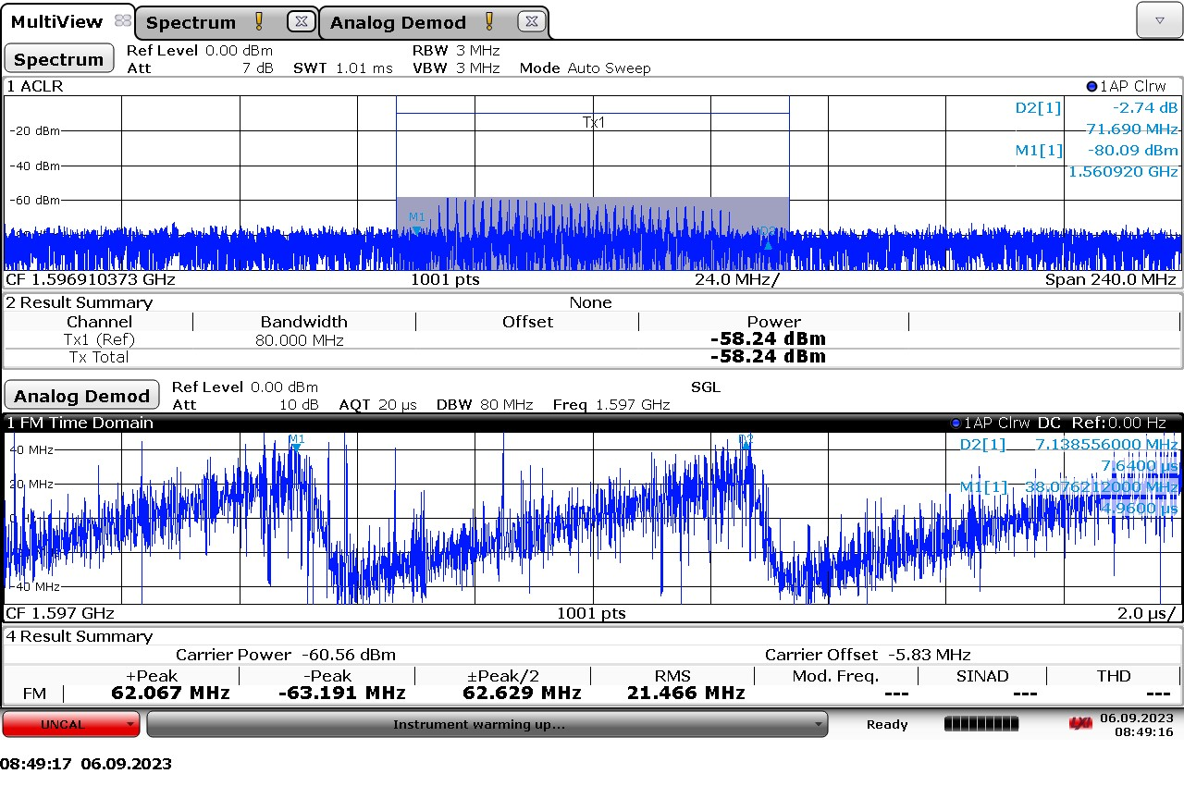

G 35: Example measurement of a U1.1 – U1.4 jammer

### Technical details on low-power jammer “H1.1”

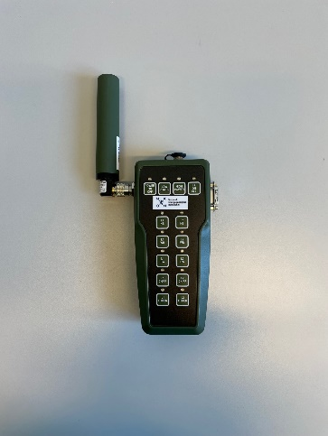The jammer H1.1 belongs to the ‘Handheld category’ of jammers. It is a medium weight battery driven jammer with a configuration panel for operation: multi-frequency and multi-modulation for both low and high output power. Its commercially available for military training purposes as Novatel’s NEAT-jammer. Antenna has TNC-connector.

H1.1 is an one-antenna, yet multi-frequency, jammer, therefore a so-called “L1+L2”, disrupting parts of both the upper and lower L-band.

Configuration choices are (as provided by the producer):

* Centre frequency: 1575.42 MHz and 1227.6 MHz
* Estimated output power: low power -5 dBm, high power 20 dBm
* Type of modulation: narrow band (NB), wide band (WB), continuous wave (CW), chirp/sweep and other (optional to program)

In the 2024 measurements below, bandwidth is defined as

* main lobe in PRN signal
* 3 dB from local (identifiable) maxima

Technical characteristics of H1.1 (2024 measurements)

|  |  |  |  |  |  |  |  |
| --- | --- | --- | --- | --- | --- | --- | --- |
| Antenna configuration | Centre frequency [MHz] | Bandwidth [MHz] | PSD [dBm/MHz] | TX total [dBm] | CF max [dBm] | Sweep rate [µs] | Modulation |
| L1, NB, HIGH PWR | 1575,42 | 2,05 | 17,52 | 20,63 | 11,07 | N/A | PRN (spreading code of 1 MHz) |
| L1, WB, HIGH PWR | 1575,40 | 20,03 | 8,20 | 21,25 | 11,43 | N/A | PRN (spreading code of 10 MHz) |
| L1, CW, HIGH PWR | 1575,42 | 0,103 | 22,50 | 12,62 | 13,67 | N/A | CW |
| L1, CHIRP, HIGH PWR | 1575,60 | 18,75 | 3,10 | 15,83 | -5,73 | 10,42 | Sawtooth |
| L1, NB, LOW PWR | 1575,42 | 2,05 | -12,84 | -9,73 | -19,35 | N/A | PRN (spreading code of 1 MHz) |
| L1, WB, LOW PWR | 1575,40 | 19,93 | -21,66 | -8,66 | -17,91 | N/A | PRN (spreading code of 10 MHz) |
| L1, CW, LOW PWR | 1575,42 | 0,10 | -7,55 | -17,46 | -16,37 | N/A | CW |
| L1, CHIRP, LOW PWR | 1575,60 | 18,75 | -27,03 | -14,31 | -35,65 | 10,46 | Sawtooth |
| L2, NB, HIGH PWR | 1227,42 | 2,049 | 18,73 | 21,84 | 12,17 | N/A | PRN (spreading code of 1 MHz) |
| L2, WB, HIGH PWR | 1227,36 | 20,30 | 9,27 | 22,34 | 12,09 | N/A | PRN (spreading code of 10 MHz) |
| L2, CW, HIGH PWR | 1227,42 | 0,10 | 23,96 | 14,13 | 15,17 | N/A | CW |
| L2, CHIRP, HIGH PWR | 1227,22 | 18,79 | 4,98 | 17,72 | -4,11 | 10,4 | Sawtooth |
| L2, NB, LOW PWR | 1227,42 | 2,05 | -11,20 | -8,09 | -17,79 | N/A | PRN (spreading code of 1 MHz) |
| L2, WB, LOW PWR | 1227,36 | 20,30 | -20,39 | -7,32 | -17,41 | N/A | PRN (spreading code of 10 MHz) |
| L2, CW, LOW PWR | 1227,42 | 0,10 | -5,98 | -15,81 | -14,77 | N/A | CW |
| L2, CHIRP, LOW PWR | 1227,22 | 18,76 | -24,97 | -12,23 | -33,98 | 10,4 | Sawtooth |

Measurements given below are for ‘High power’ configurations only.

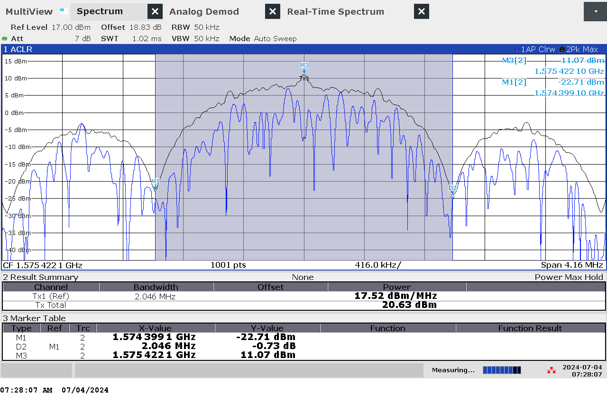

G 36: Frequency and power measurement of jammer H1.1 with antenna configuration L1 Narrow band High Power (NB HIGH PWR)

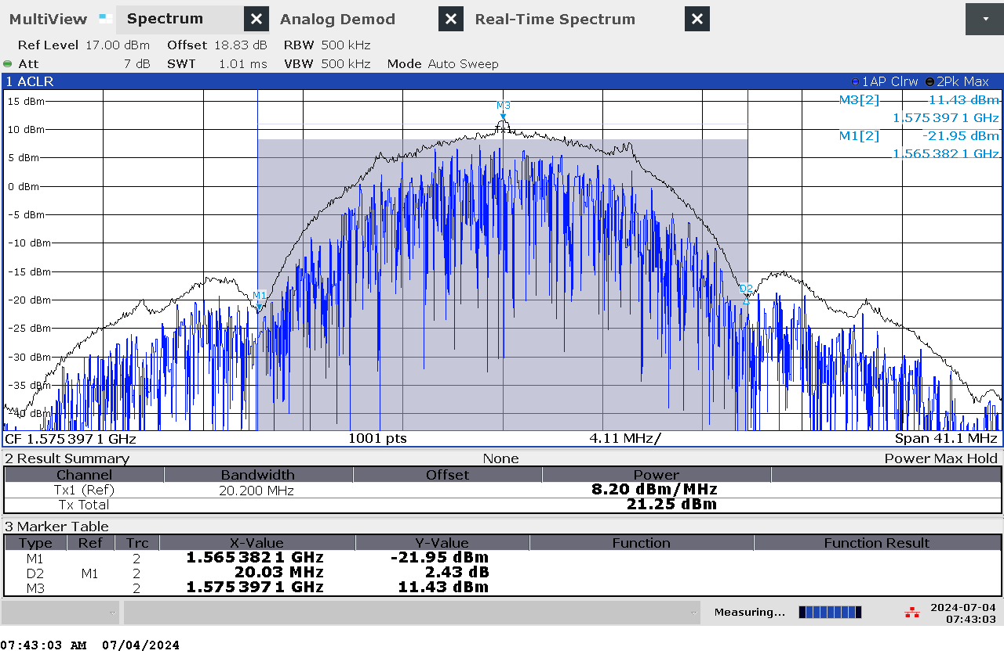

G 37: Frequency and power measurement of jammer H1.1 with antenna configuration L1 Wide band High Power (WB HIGH PWR)

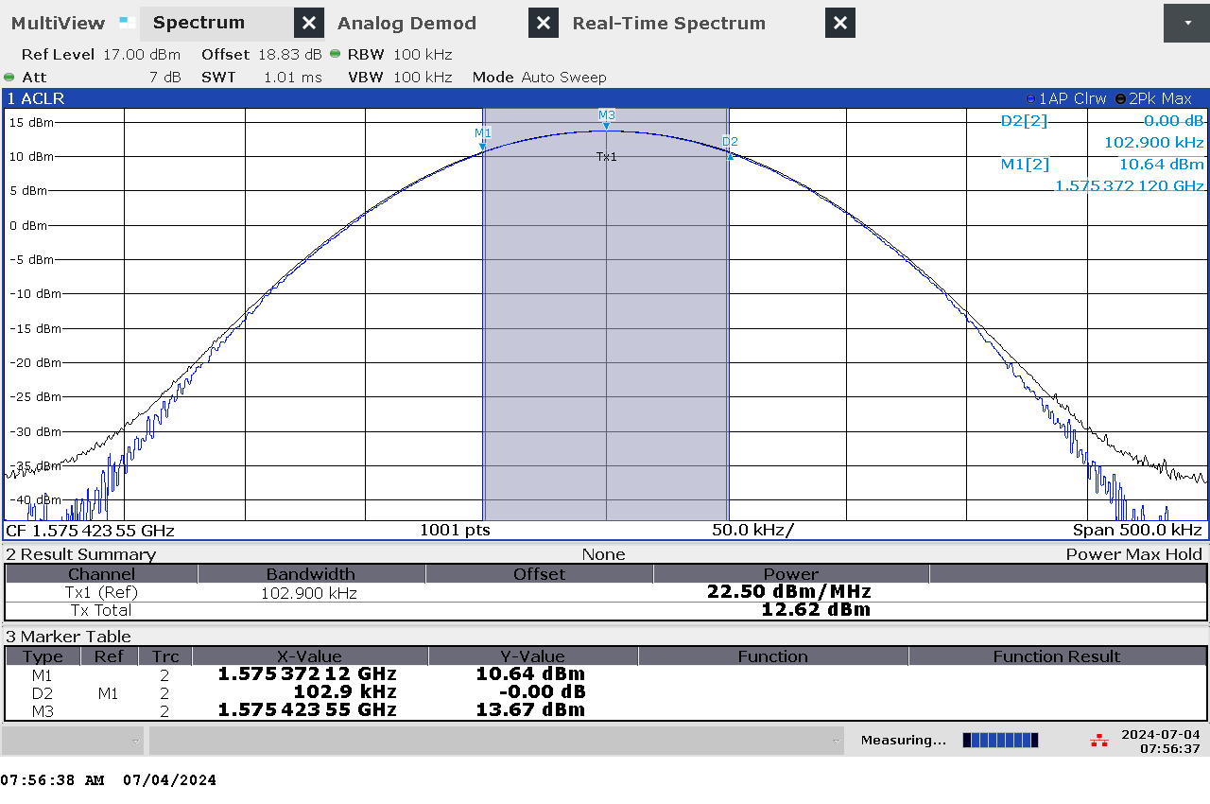

G 38: Frequency and power measurement of jammer H1.1 with antenna configuration L1 Continuous Wave band High Power (CW HIGH PWR)

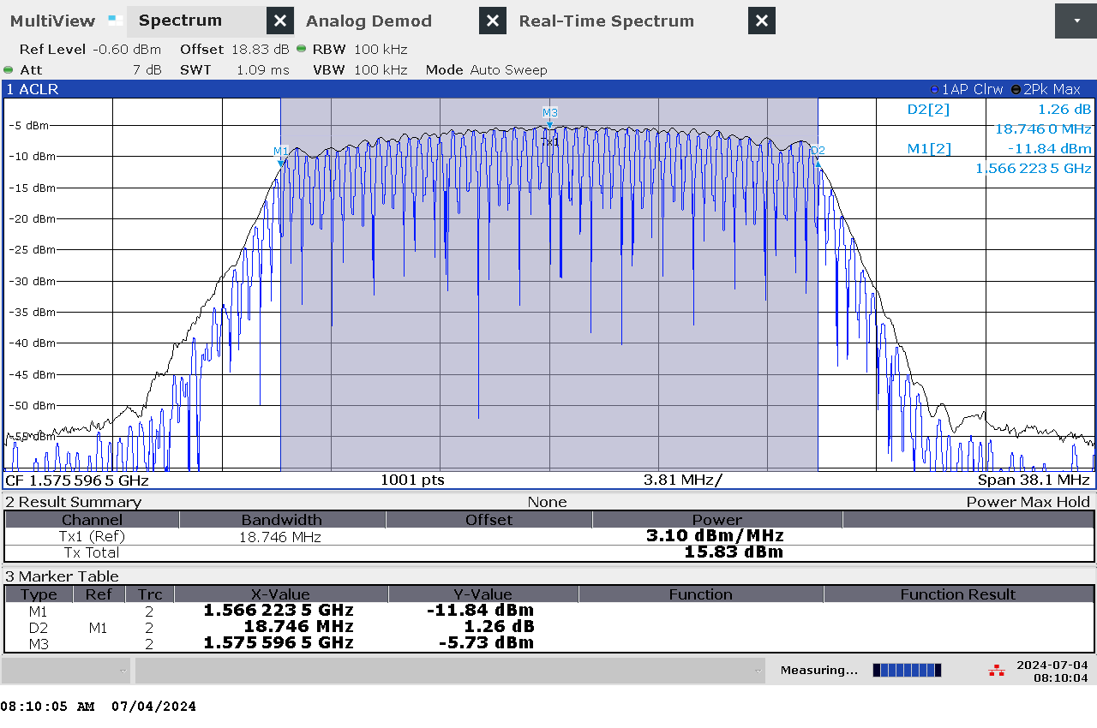

G 39: Frequency and power measurement of jammer H1.1 with antenna configuration L1 Chirp High Power (CHIRP HIGH PWR)

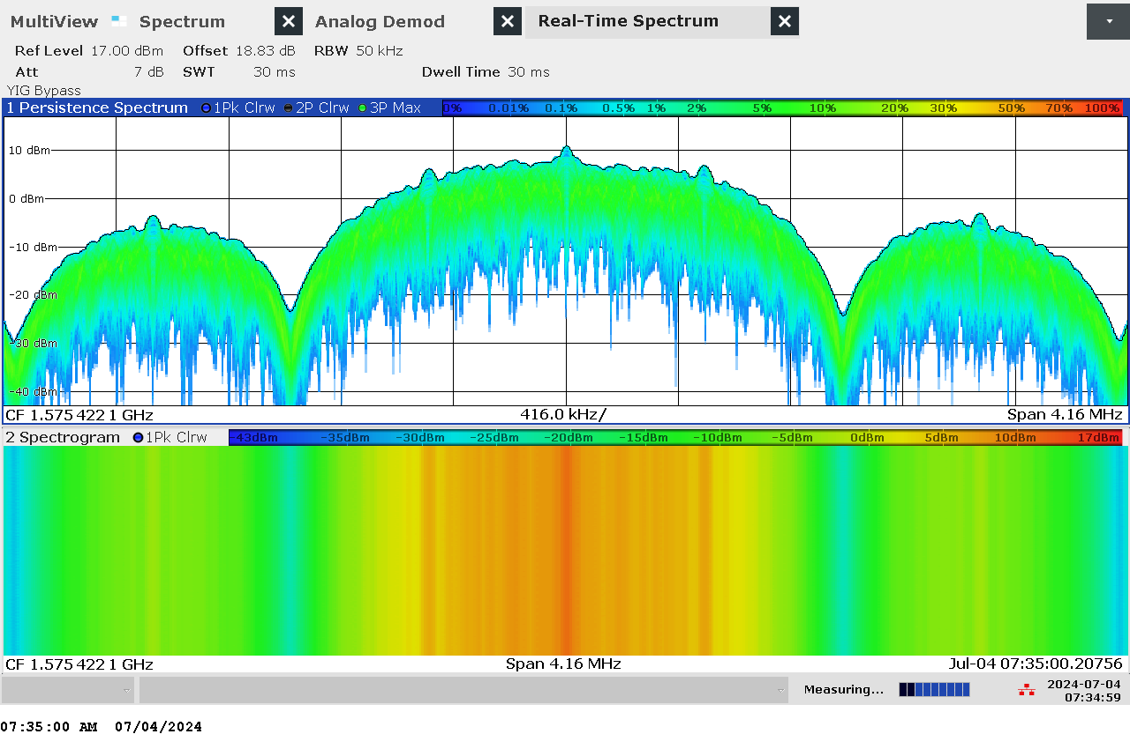

G 40: Real-time persistence and spectrogram measurement of jammer H1.1 with antenna configuration L1 Narrow band High Power (NB HIGH PWR)

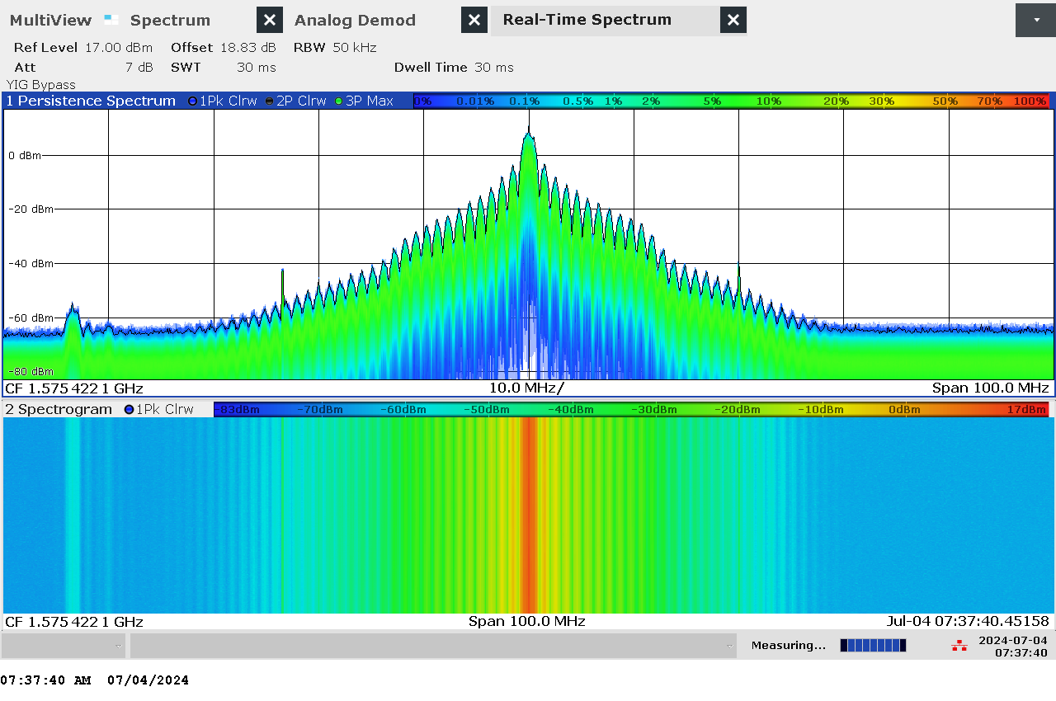

G 41: Real-time persistence and spectrogram measurement with wider span of jammer H1.1 with antenna configuration L1 Narrow band High Power (NB HIGH PWR)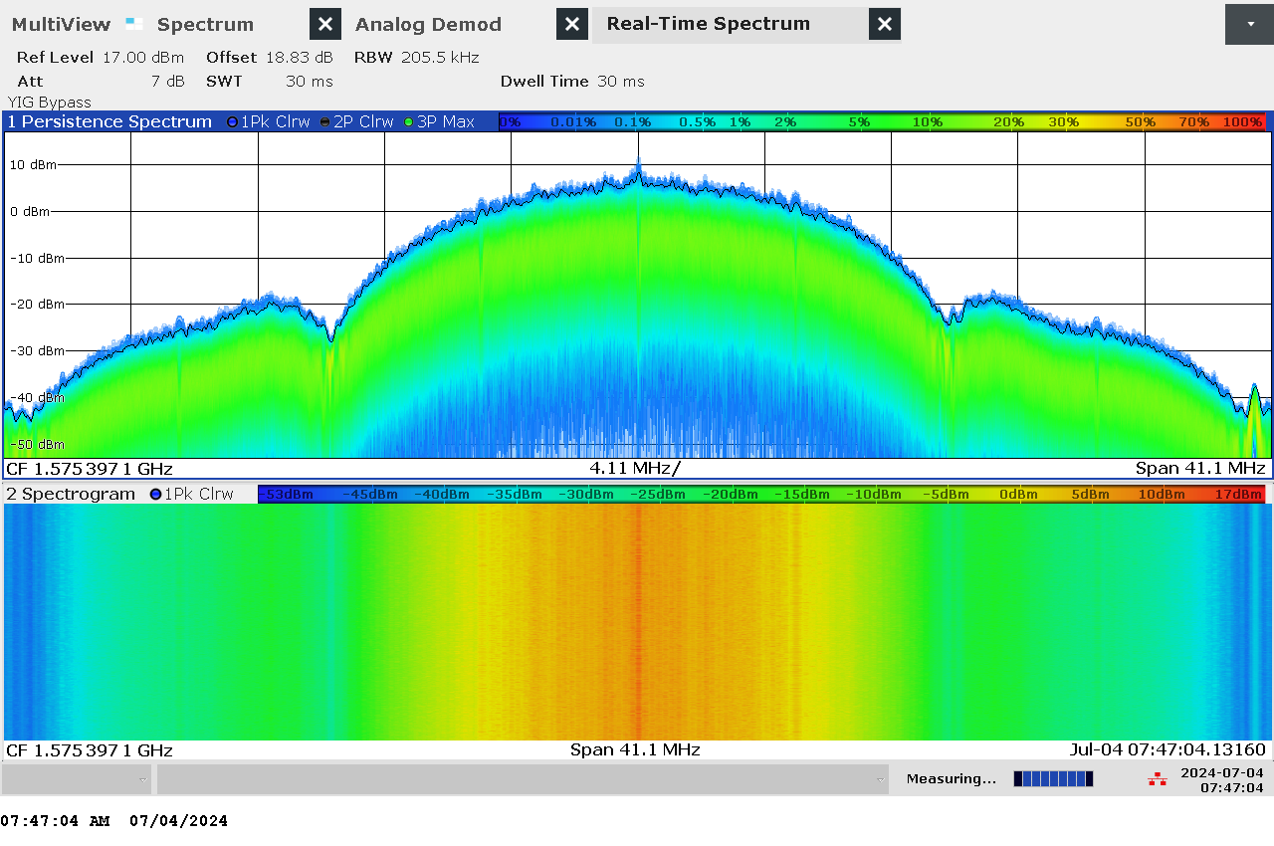

G 42: Real-time persistence and spectrogram measurement of jammer H1.1 with antenna configuration L1 Wide band High Power (WB HIGH PWR)

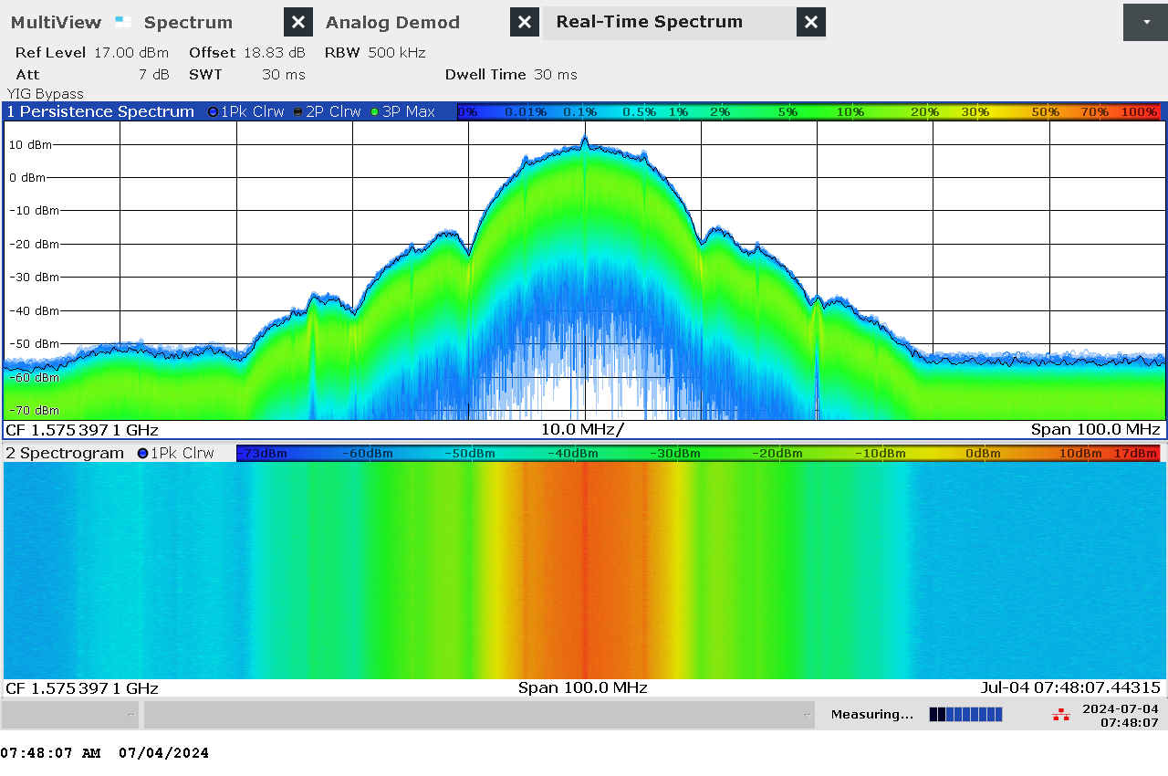

G 43: Real-time persistence and spectrogram measurement with wider span of jammer H1.1 with antenna configuration L1 Wide band High Power (WB HIGH PWR)

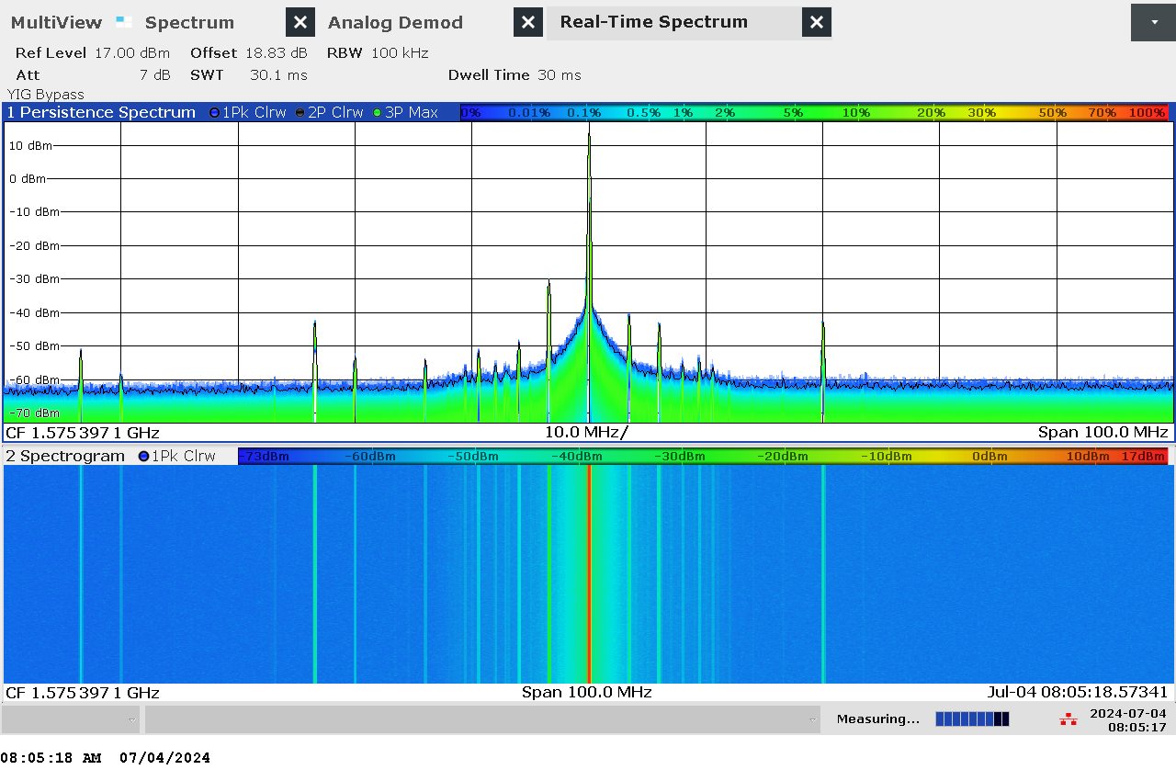

G 44: Real-time persistence and spectrogram measurement with wider span of jammer H1.1 with antenna configuration L1 Continuous Wave band High Power (CW HIGH PWR)

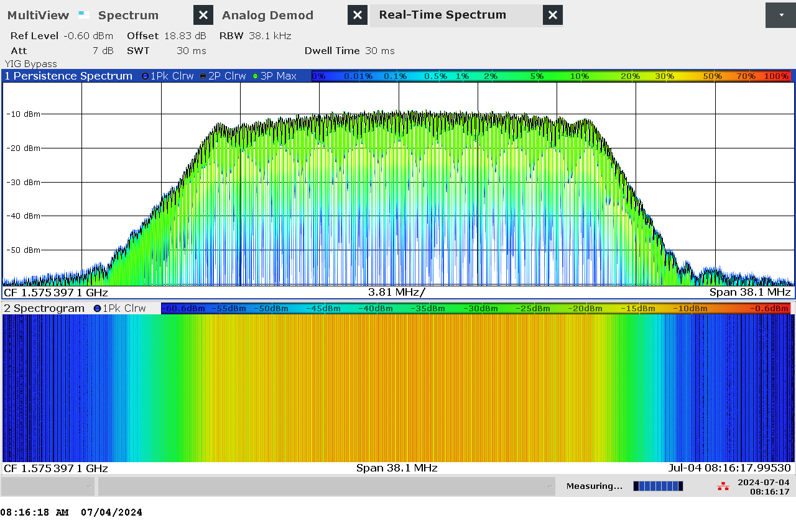

G 45: Real-time persistence and spectrogram measurement of jammer H1.1 with antenna configuration L1 Chirp High Power (CHIRP HIGH PWR)

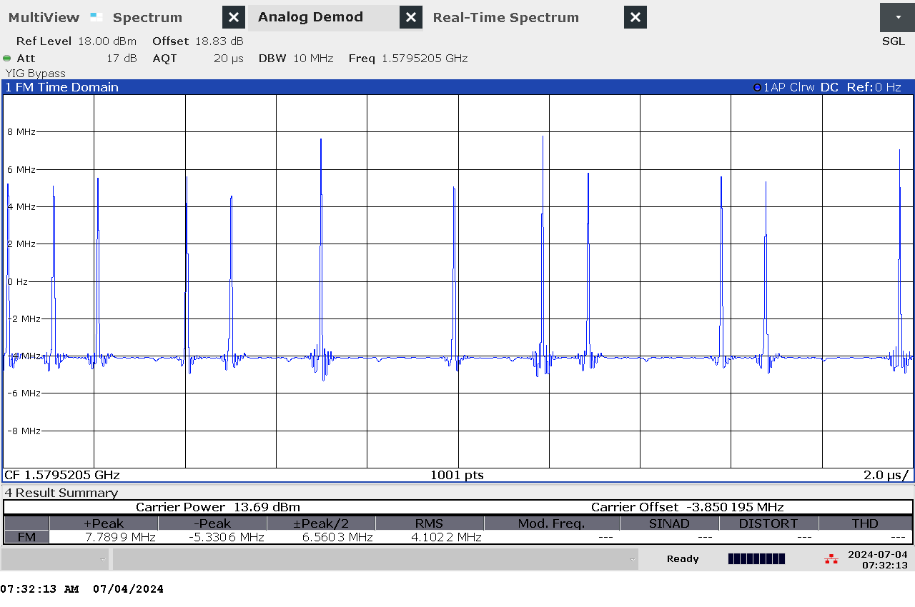

G 46: Time domain (analog demod) measurement of jammer H1.1 with antenna configuration L1 Narrow band High Power (NB HIGH PWR)

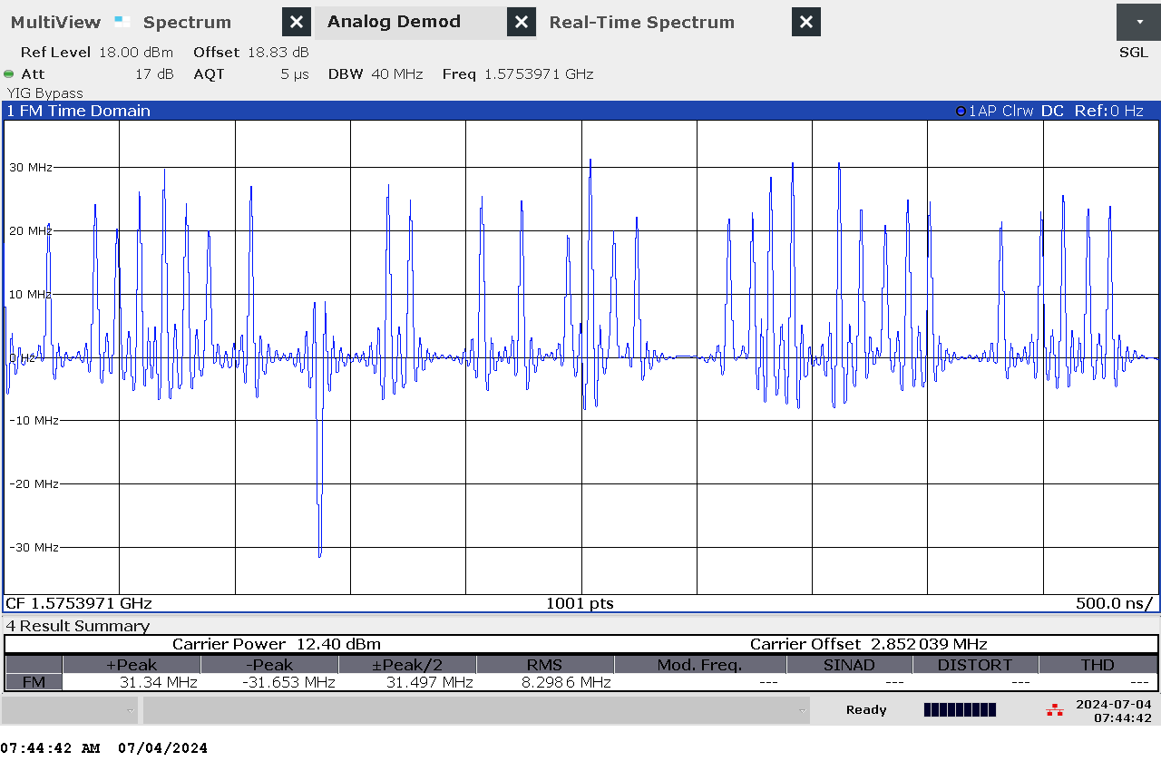

G 47: Time domain (analog demod) measurement of jammer H1.1 with antenna configuration L1 Wide band High Power (WB HIGH PWR)

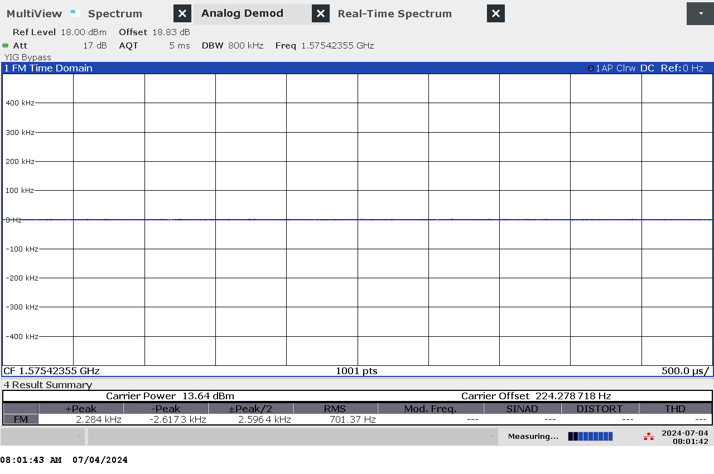

G 48: Time domain (analog demod) measurement of jammer H1.1 with antenna configuration L1 Continuous Wave band High Power (CW HIGH PWR)

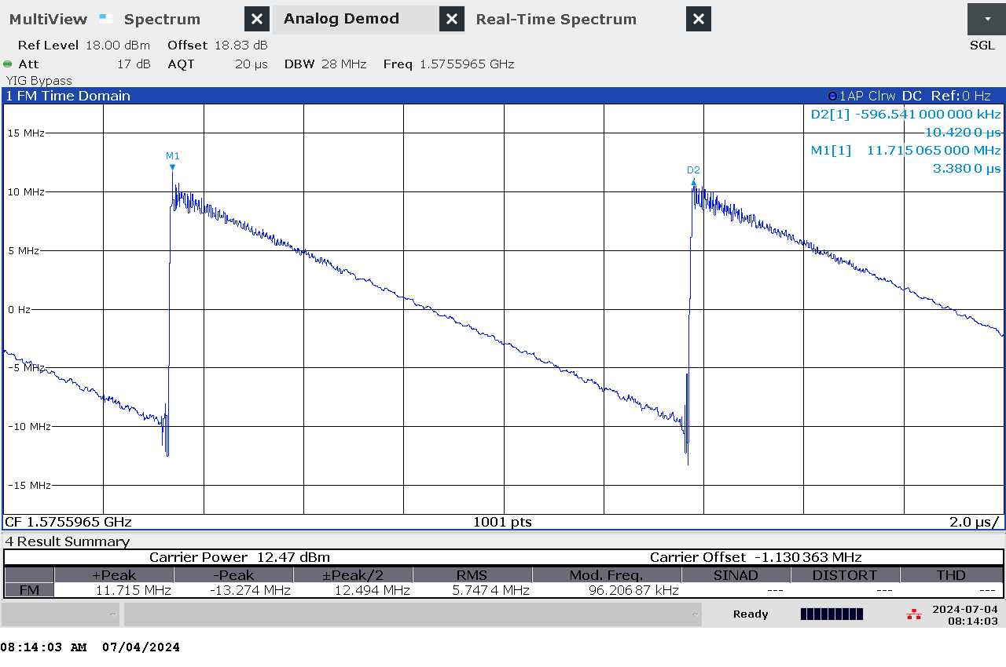

G 49: Time domain (analog demod) measurement of jammer H1.1 with antenna configuration L1 Chirp High Power (CHIRP HIGH PWR)

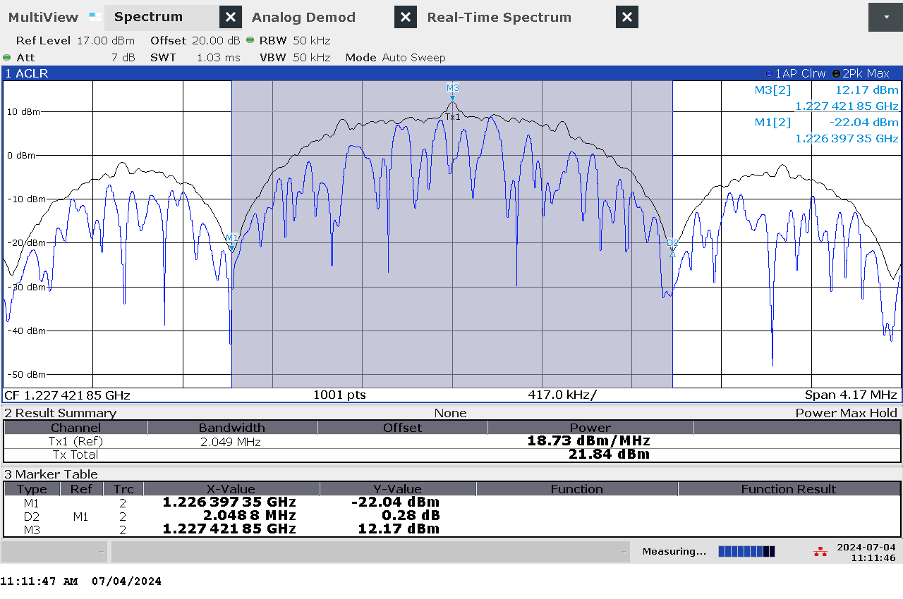

G 50: Frequency and power measurement of jammer H1.1 with antenna configuration L2 Narrow band High Power (NB HIGH PWR)

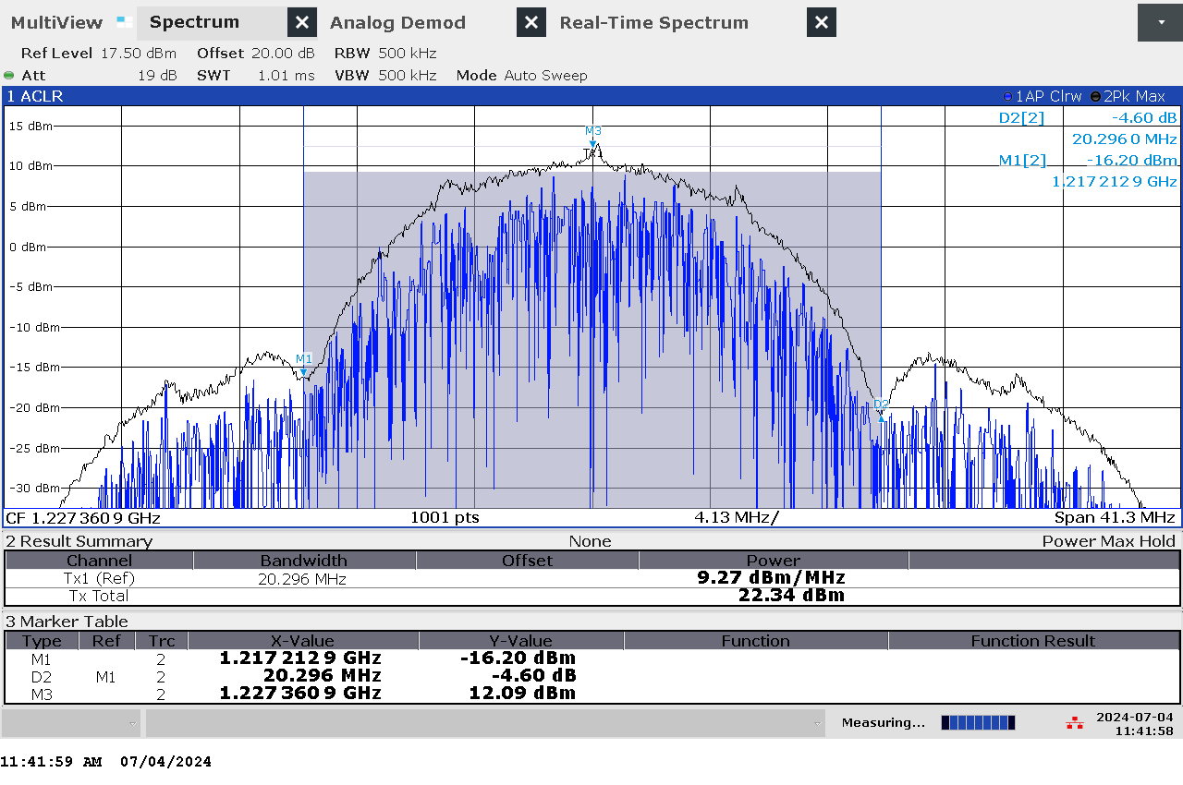

G 51: Frequency and power measurement of jammer H1.1 with antenna configuration L2 Wide band High Power (WB HIGH PWR)

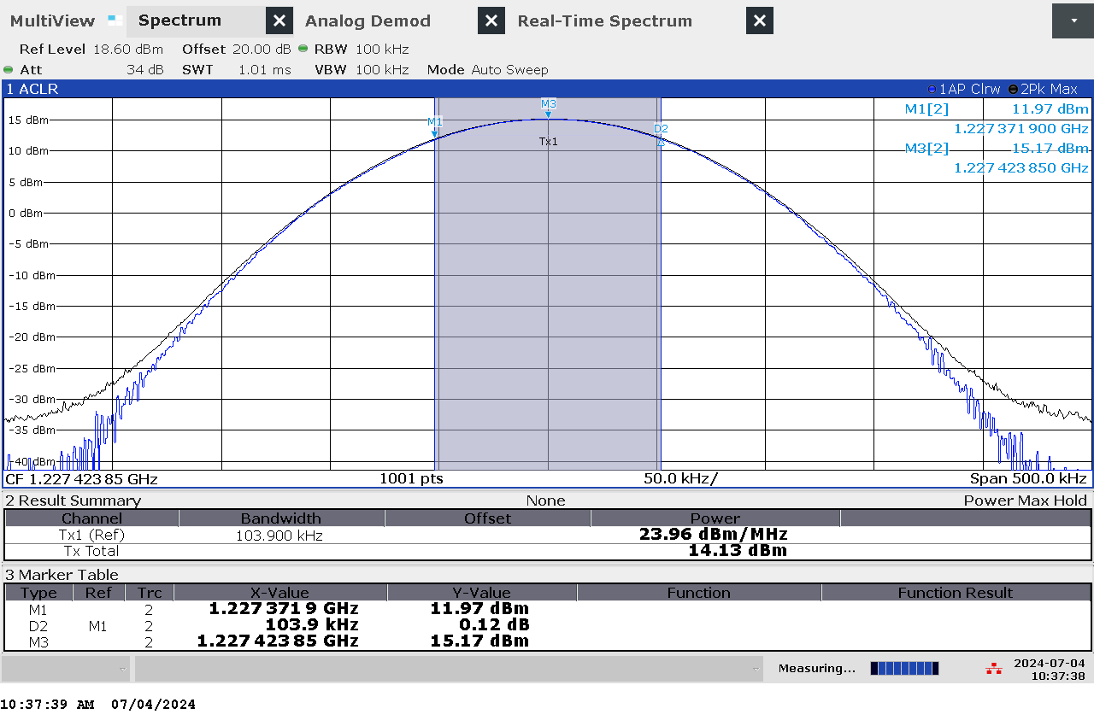

G 52: Frequency and power measurement of jammer H1.1 with antenna configuration L2 Continuous Wave band High Power (CW HIGH PWR)

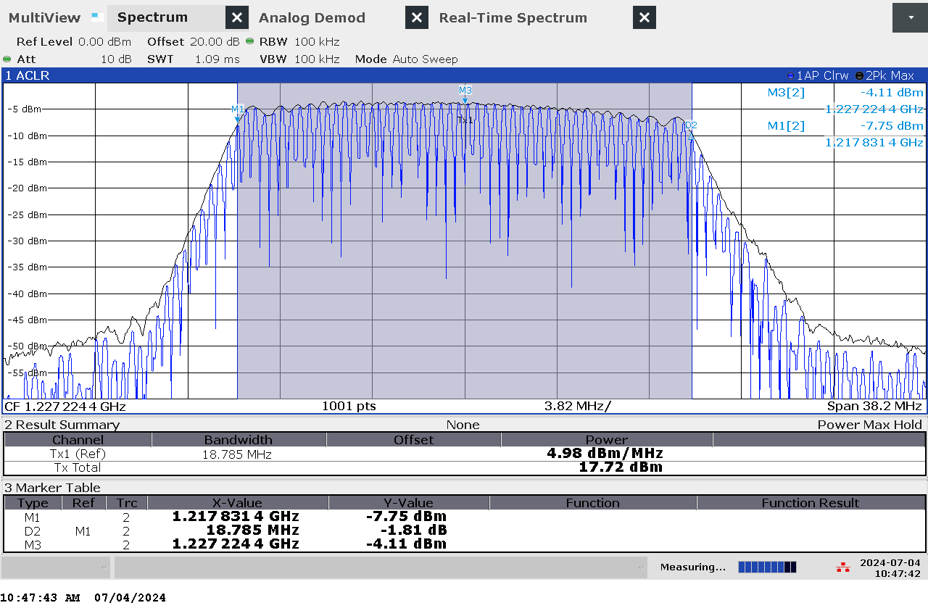

G 53: Frequency and power measurement of jammer H1.1 with antenna configuration L2 Chirp High Power (CHIRP HIGH PWR)

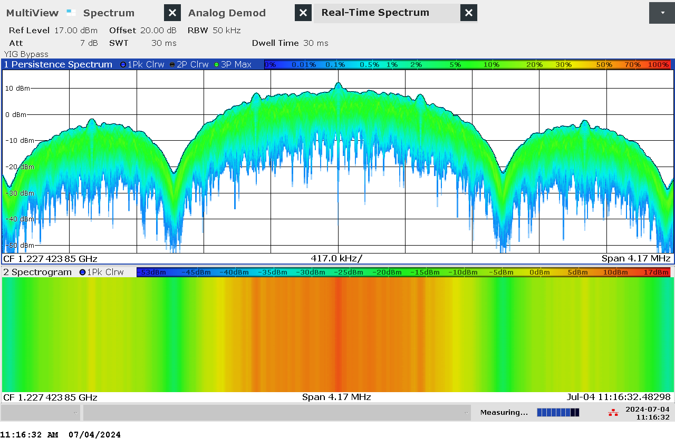

G 54: Real-time persistence and spectrogram measurement of jammer H1.1 with antenna configuration L2 Narrow band High Power (NB HIGH PWR)

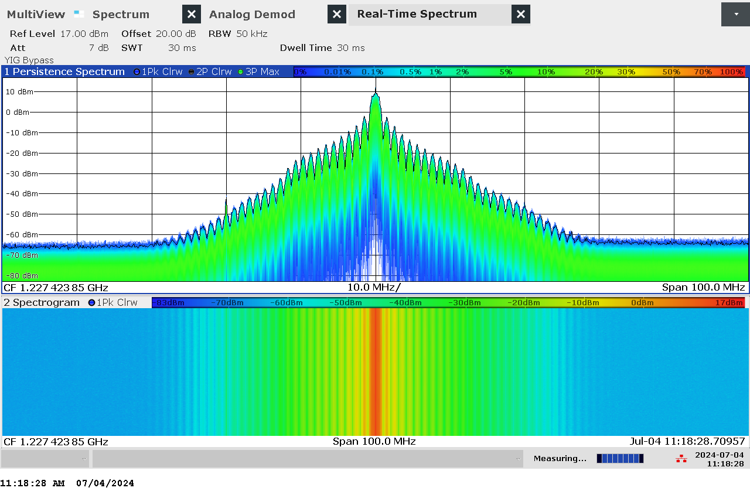

G 55: Real-time persistence and spectrogram measurement with wider span of jammer H1.1 with antenna configuration L2 Narrow band High Power (NB HIGH PWR)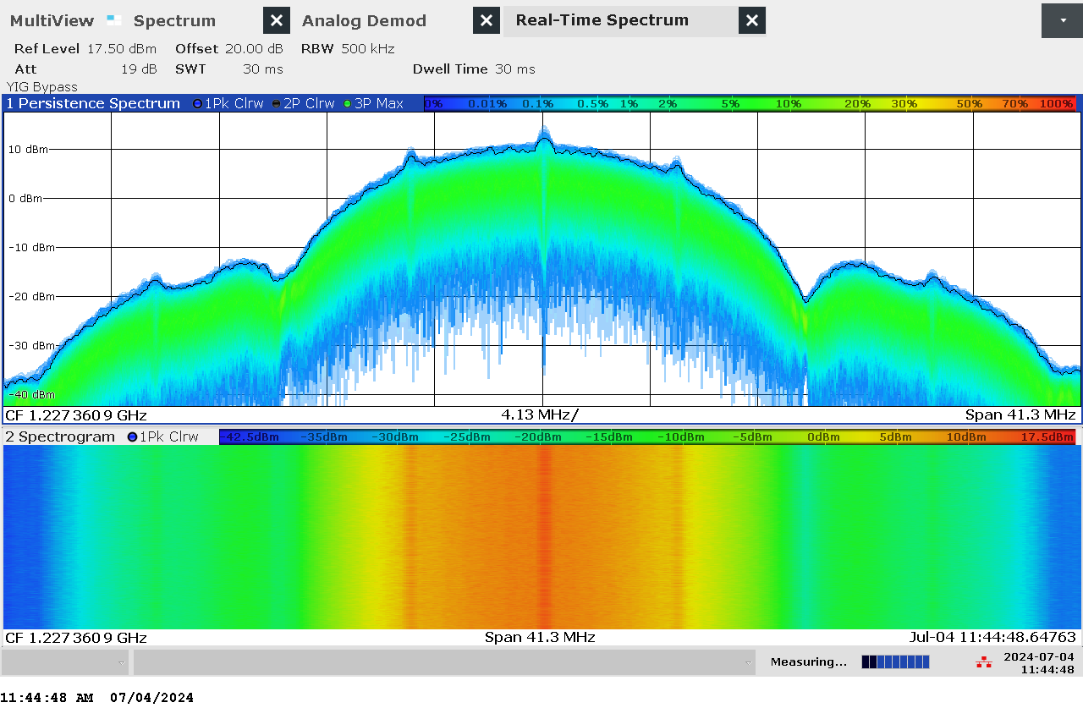

G 56: Real-time persistence and spectrogram measurement of jammer H1.1 with antenna configuration L2 Wide band High Power (WB HIGH PWR)

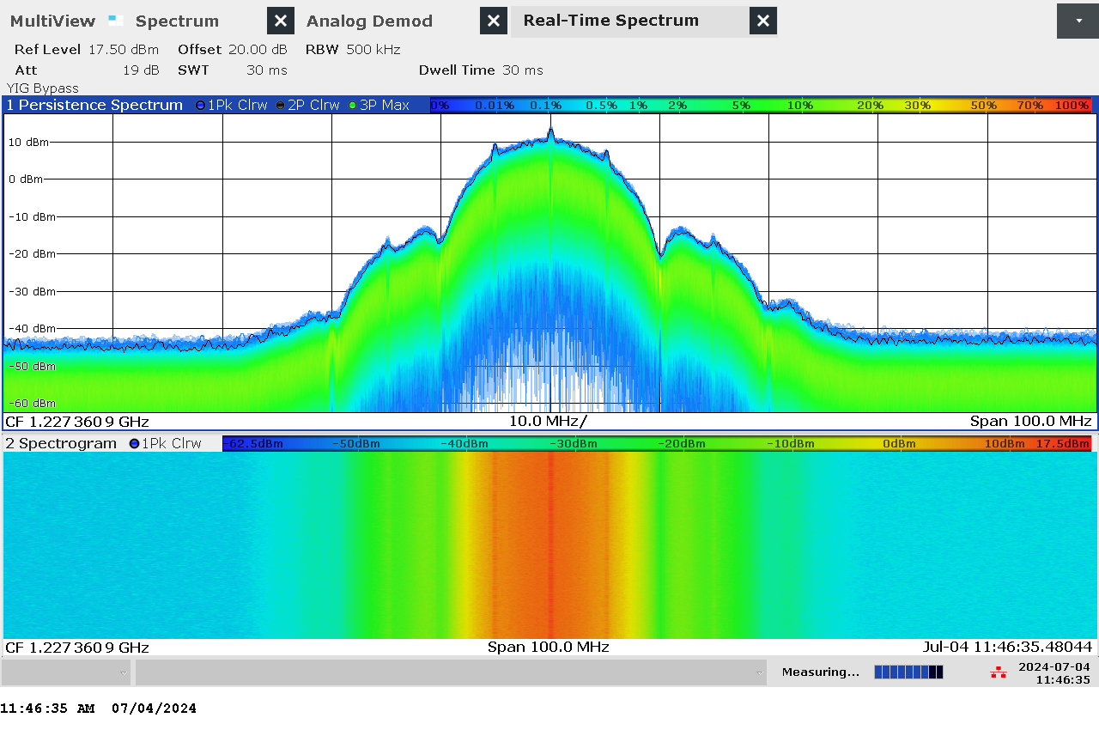

G 57: Real-time persistence and spectrogram measurement with wider span of jammer H1.1 with antenna configuration L2 Wide band High Power (WB HIGH PWR)

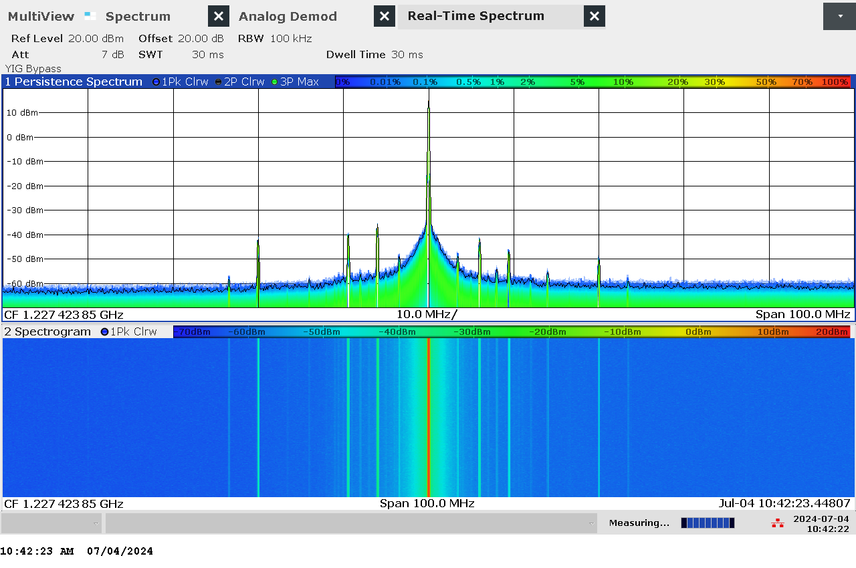

G 58: Real-time persistence and spectrogram measurement with wider span of jammer H1.1 with antenna configuration L2 Continuous Wave band High Power (CW HIGH PWR)

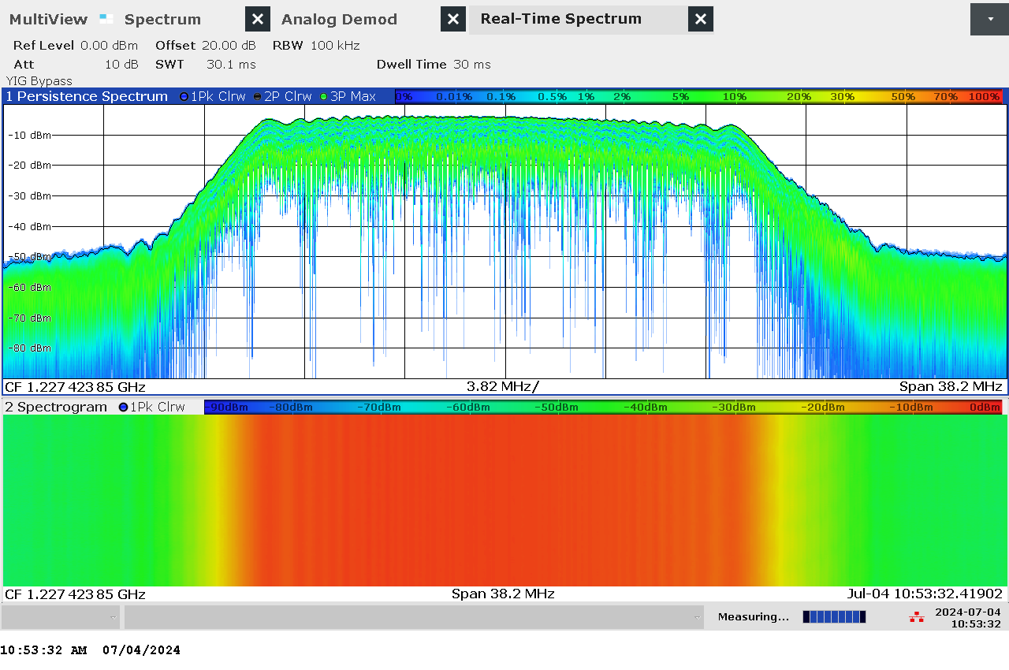

G 59: Real-time persistence and spectrogram measurement of jammer H1.1 with antenna configuration L2 Chirp High Power (CHIRP HIGH PWR)

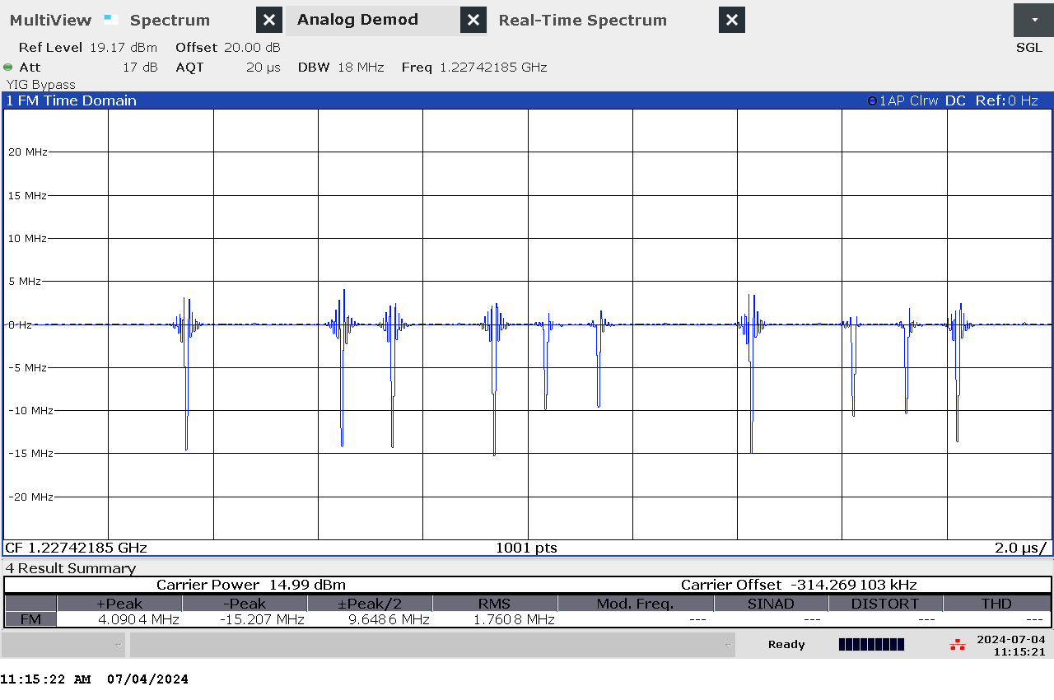

G 60: Time domain (analog demod) measurement of jammer H1.1 with antenna configuration L2 Narrow band High Power (NB HIGH PWR)

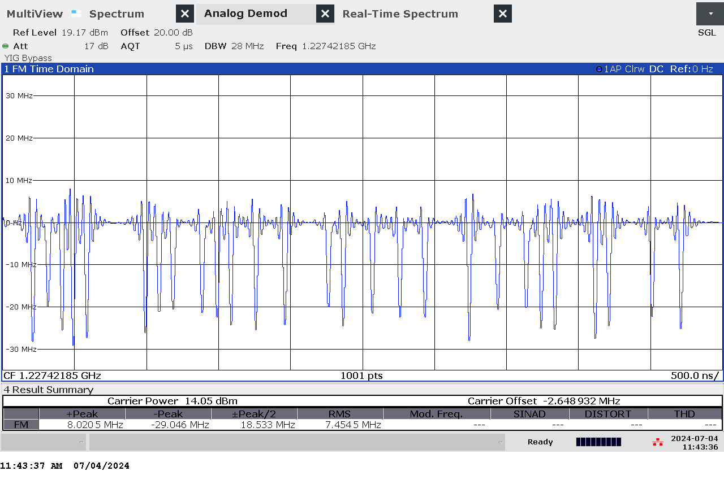

G 61: Time domain (analog demod) measurement of jammer H1.1 with antenna configuration L2 Wide band High Power (WB HIGH PWR)

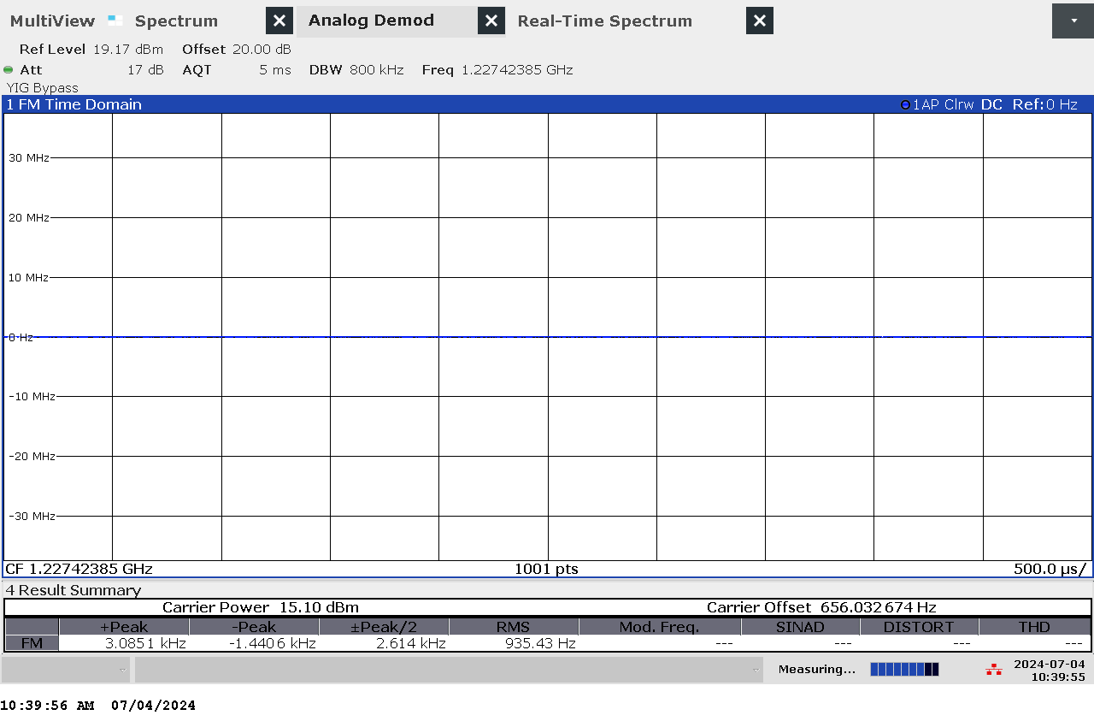

G 62: Time domain (analog demod) measurement of jammer H1.1 with antenna configuration L2 Continuous Wave band High Power (CW HIGH PWR)

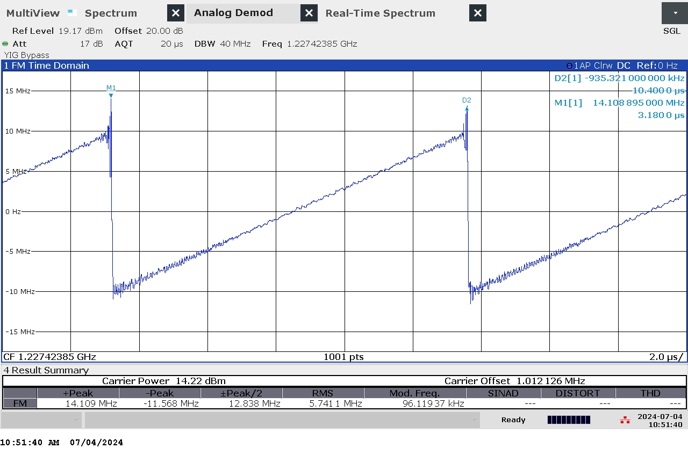

G 63: Time domain (analog demod) measurement of jammer H1.1 with antenna configuration L2 Chirp High Power (CHIRP HIGH PWR)

### ImageTechnical details on low-power jammer “H1.2”

The jammer H1.2 belongs to the ‘Handheld category’ of jammers. It is a small and light battery driven jammer with an easy operation, just an on/off-button with a LED-light to indicate activation.

H1.2 is an one-antenna, so-called “L1-only”, jammer, disrupting only the upper L-band.

Technical characteristics of H1.2 (2024 measurements)

|  |  |  |  |  |  |  |  |
| --- | --- | --- | --- | --- | --- | --- | --- |
| Antenna | Centre frequency [MHz] | Bandwidth [MHz] | PSD [dBm/MHz] | TX total [dBm] | CF max [dBm] | Sweep rate [µs] | Modulation |
| “L1” | 1575,22 | 21,99 | 14,35 | 27,78 | 9,36 | 6,08 | Sawtooth |

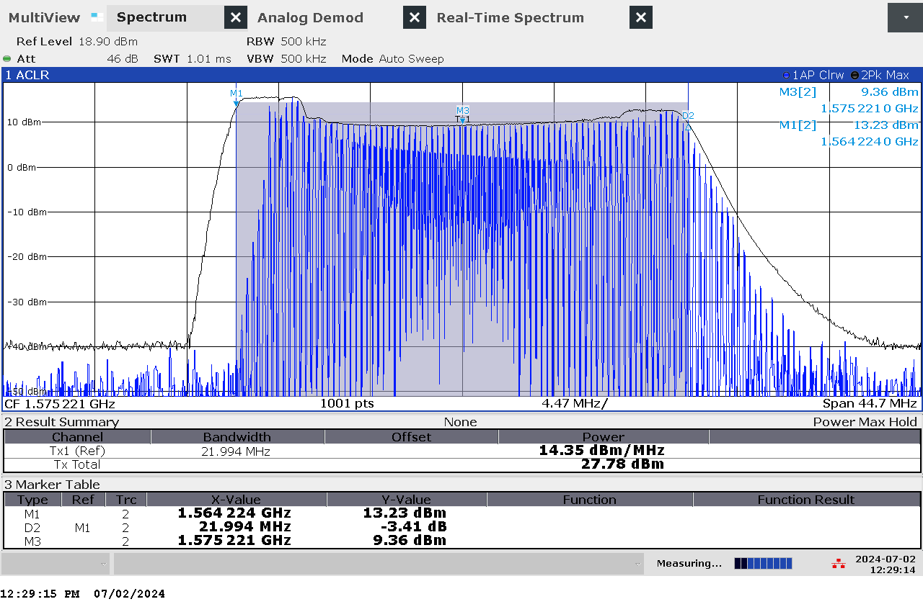

G 64: Frequency and power measurement of jammer H1.2

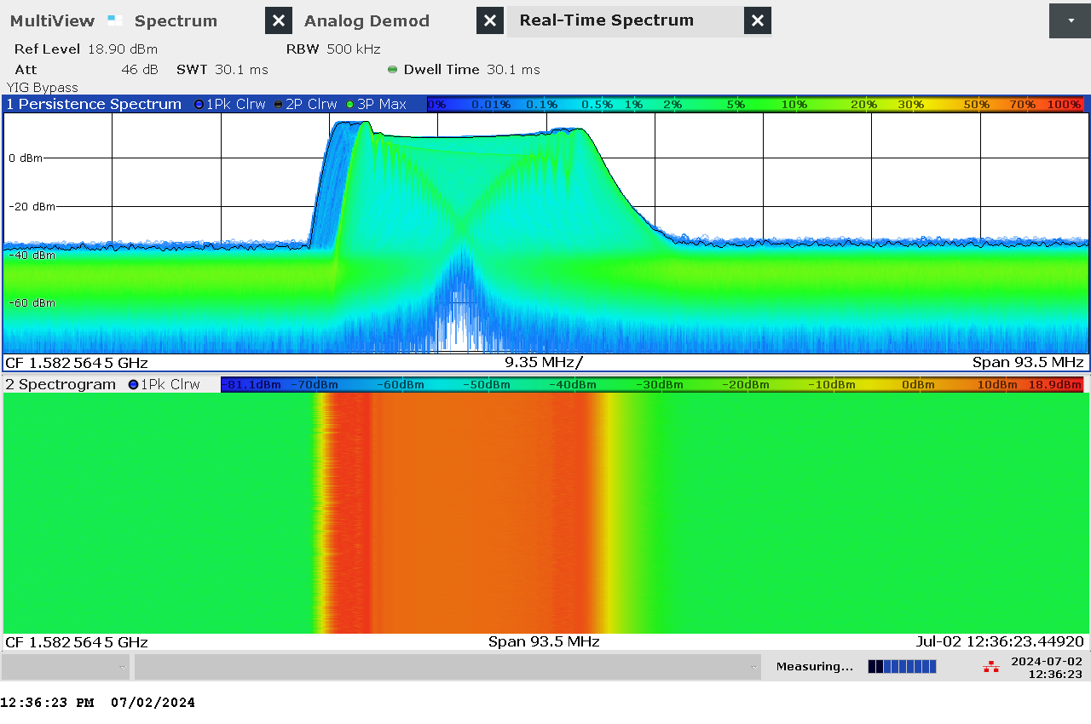

G 65: Real-time persistence and spectrogram measurement of jammer H1.2

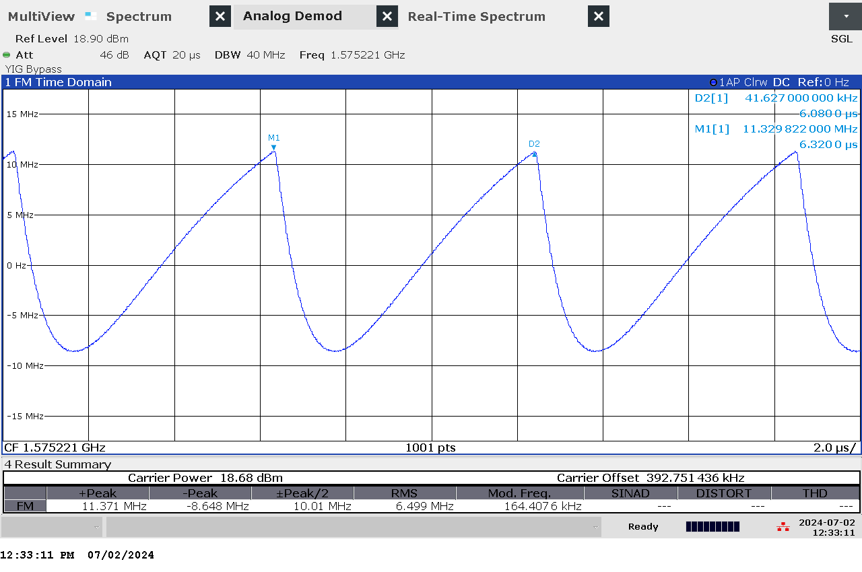

G 66: Time domain (analog demod) measurement of jammer H1.2

### Et bilde som inneholder tekst, skjermbilde, datamaskin Automatisk generert beskrivelseTechnical details on low-power jammer “H1.3”

H1.3 is a small, handheld and battery driven jammer using frequency hopping (normally commercially available jammers employ chirp signals, making this jammer an oddity).

H1.3 is an one-antenna, so-called “L1-only”, jammer, disrupting only the upper L-band.

Technical characteristics of H1.3 (2023 measurements)

|  |  |  |  |  |  |  |
| --- | --- | --- | --- | --- | --- | --- |
| Centre frequency [MHz] | Bandwidth [MHz] | PSD [dBm/MHz] | TX total [dBm] | CF max [dBm] | Sweep rate [µs] | Modulation |
| 1575 | 1 | N/A | N/A | N/A | 5 - 8 | Frequency hopping |

* Type of modulation: frequency hopping
  + Jumping between 6 separated frequencies. Every 50 ms the frequency increases 200 kHz, starting with 1574.62 MHz. After approximately 1 MHz the frequency jumps back to the start frequency at 1574.62 MHz.

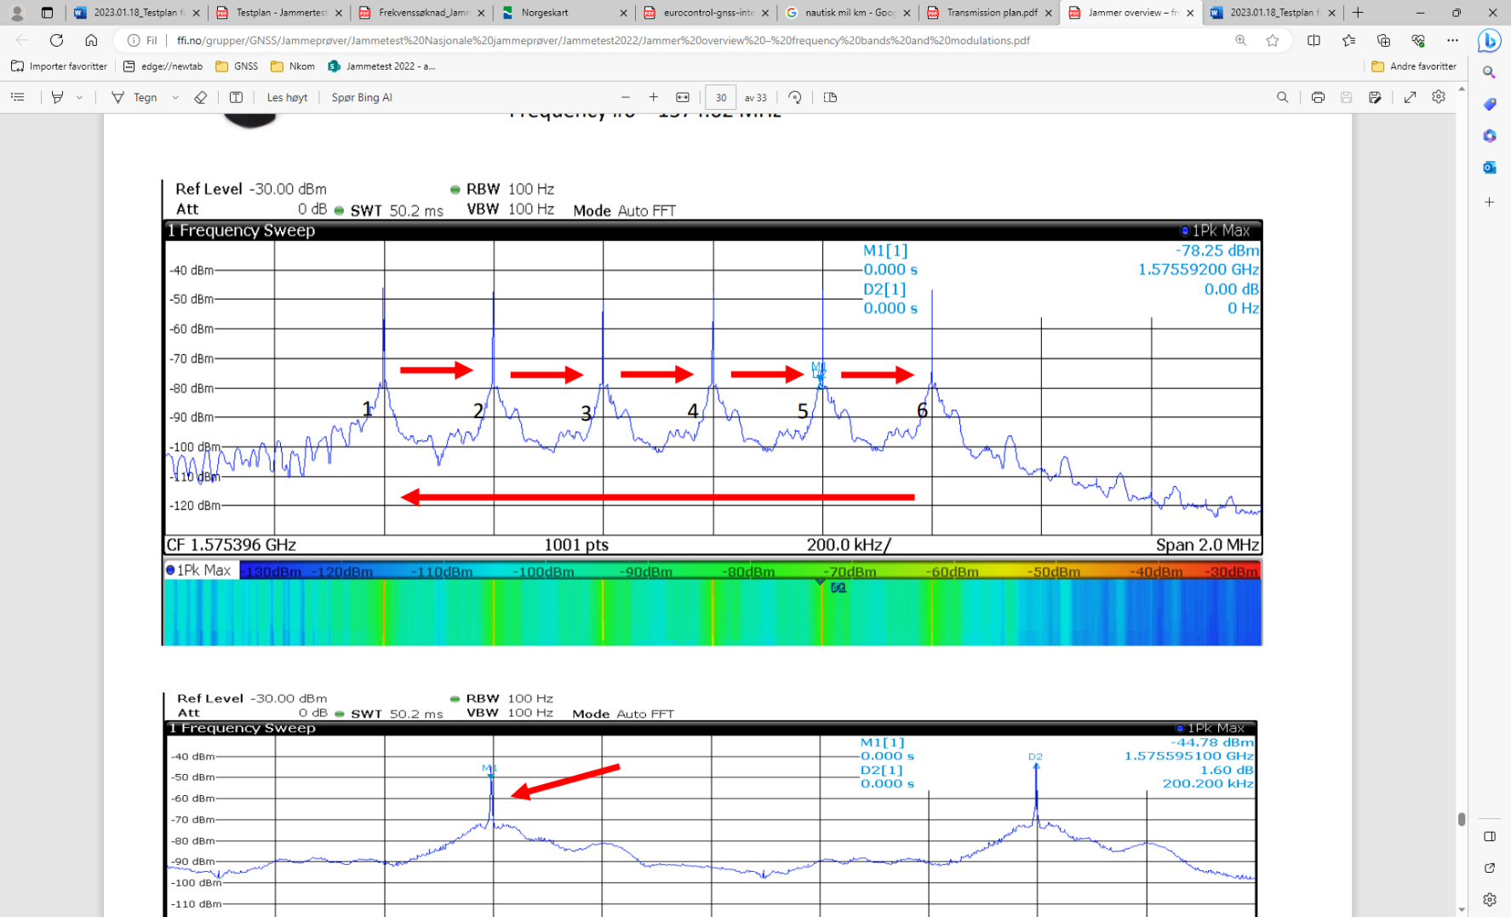

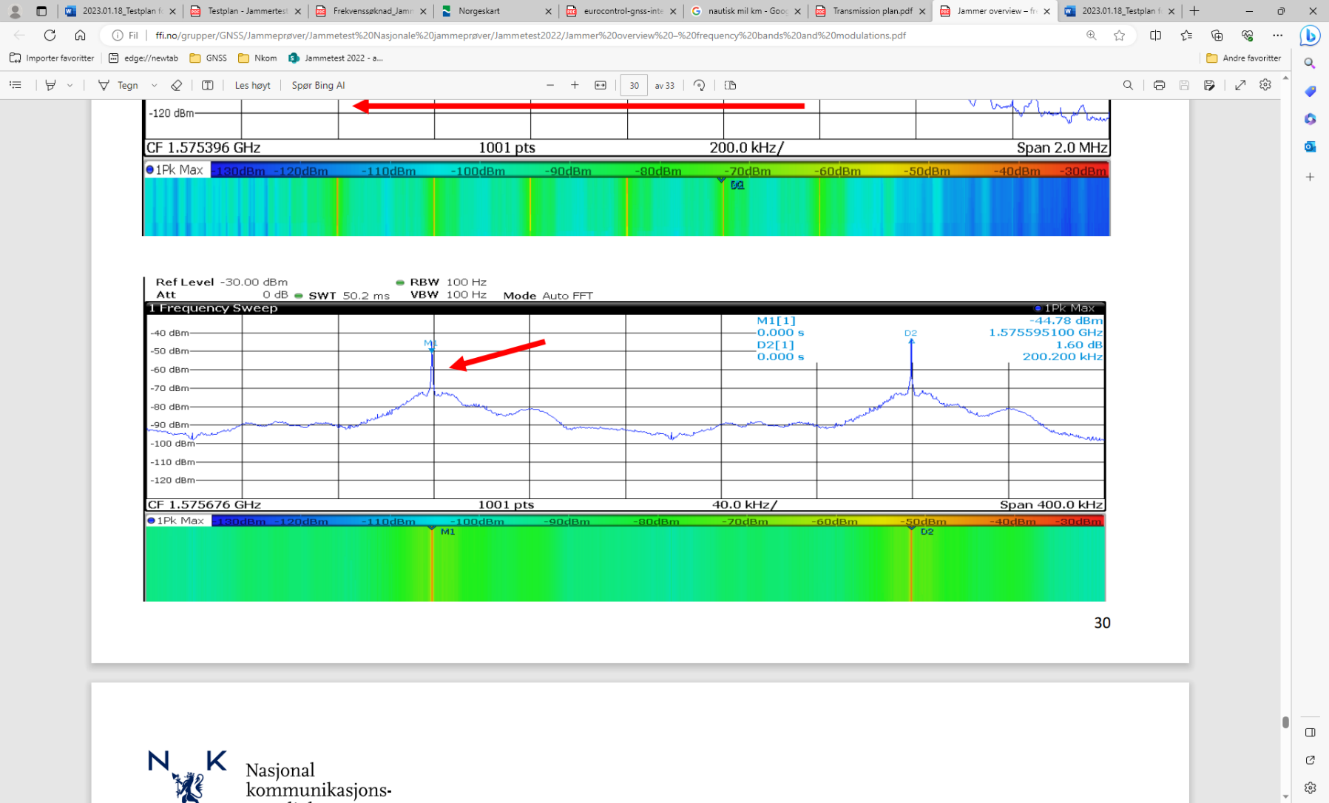

G 67: Example measurement of H1.3 jammer

### Technical details on low-power jammer “H1.4”

Jammer H1.4 is assumed more or less identical to jammer H1.1 (originating from the same source and built by the same producer).

### Technical details on low-power jammer “H1.5”

Jammer H1.5 is assumed more or less identical to jammer H1.1 (originating from the same source and built by the same producer).

### Et bilde som inneholder tekst, skjermbilde, programvare, Nettside Automatisk generert beskrivelseTechnical details on low-power jammer “H2.1 and H2.2”

H2.1 and H2.2 are small and light handheld, battery driven jammers with built-in antennas.

They are two-antenna, so-called “L1+L2”, jammers, disrupting both the upper and lower L-band.

Technical characteristics of H2.1 and H2.2 (2023 measurements)

|  |  |  |  |  |  |  |
| --- | --- | --- | --- | --- | --- | --- |
| Centre frequency [MHz] | Bandwidth [MHz] | PSD [dBm/MHz] | TX total [dBm] | CF max [dBm] | Sweep rate [µs] | Modulation |
| 1580 | 20 | N/A | N/A | N/A | 9 | Sawtooth |
| 1227 | 20 | N/A | N/A | N/A | 9 | Sawtooth |

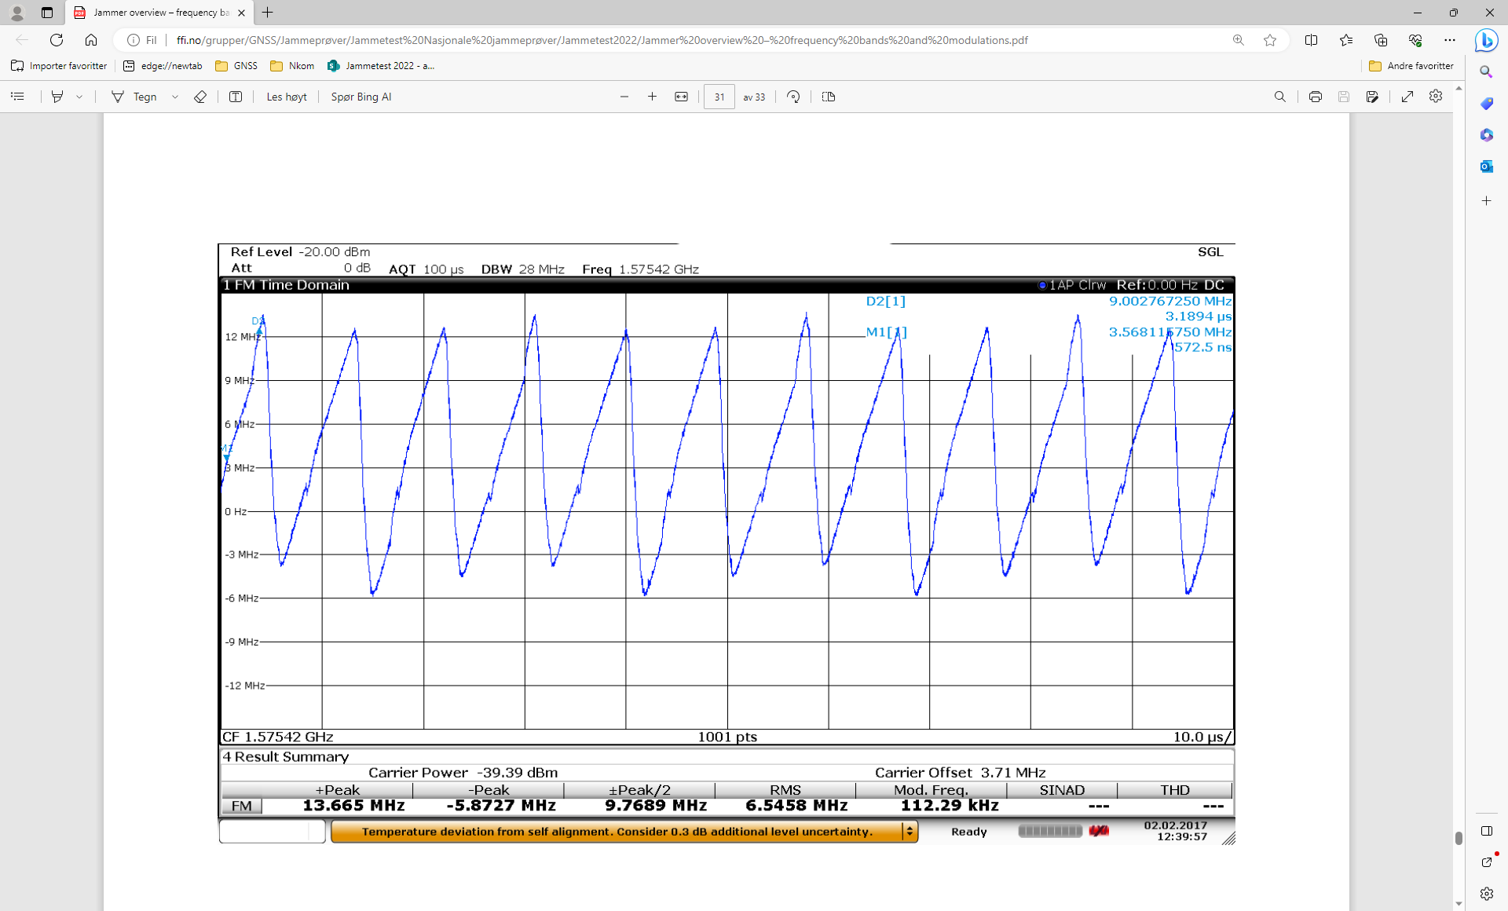

G 68: Example measurement of H2.1 and H2.2 jammer

### ImageTechnical details on low-power jammer “H3.1”

The jammer H3.1 belongs to the ‘Handheld category’ of jammers. It is a small and light battery driven jammer with an easy operation, just an on/off-button with a LED-light to indicate activation.

H3.1 is a three-antenna, so-called “multi-frequency”, jammer, but not a “multi-GNSS-jammer”. It jams three different bands, but only one channel is relevant for GNSS bands (“L1-only”), so disrupting only the upper L-band.

Relevant GNSS antenna is marked: “GPS”

Technical characteristics of H3.1 (2024 measurements)

|  |  |  |  |  |  |  |  |
| --- | --- | --- | --- | --- | --- | --- | --- |
| Antenna | Centre frequency [MHz] | Bandwidth [MHz] | PSD [dBm/MHz] | TX total [dBm] | CF max [dBm] | Sweep rate [µs] | Modulation |
| “GPS” | 1577,93 | 28,29 | 17,34 | 31,86 | 16,17 | 6,16 | Sawtooth |

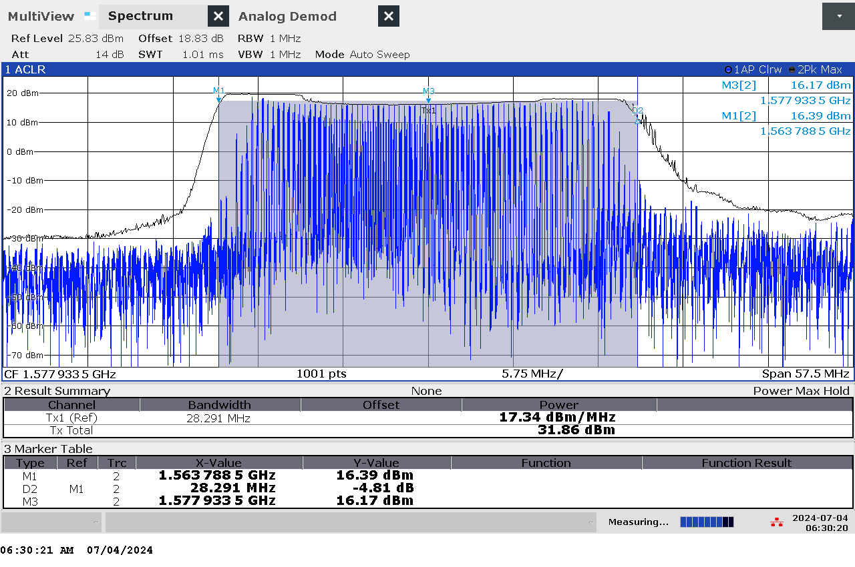

*G 69: Frequency and power measurement of jammer H3.1 on antenna “GPS”*

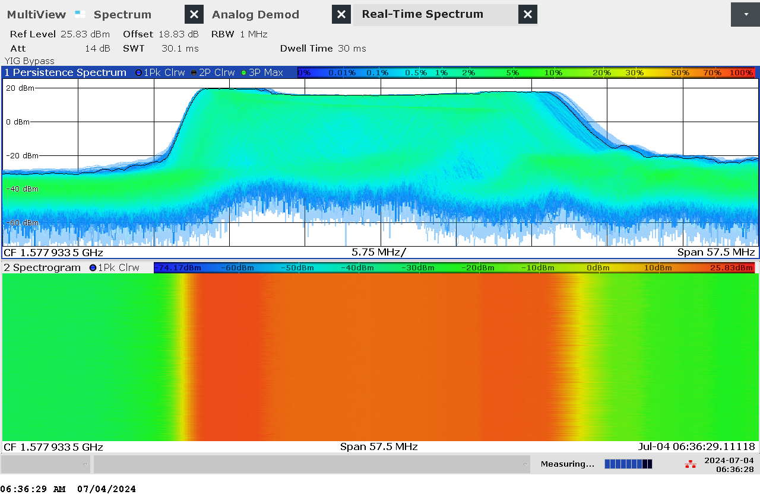

G 70: Real-time persistence and spectrogram measurement of jammer H3.1 on antenna “GPS”

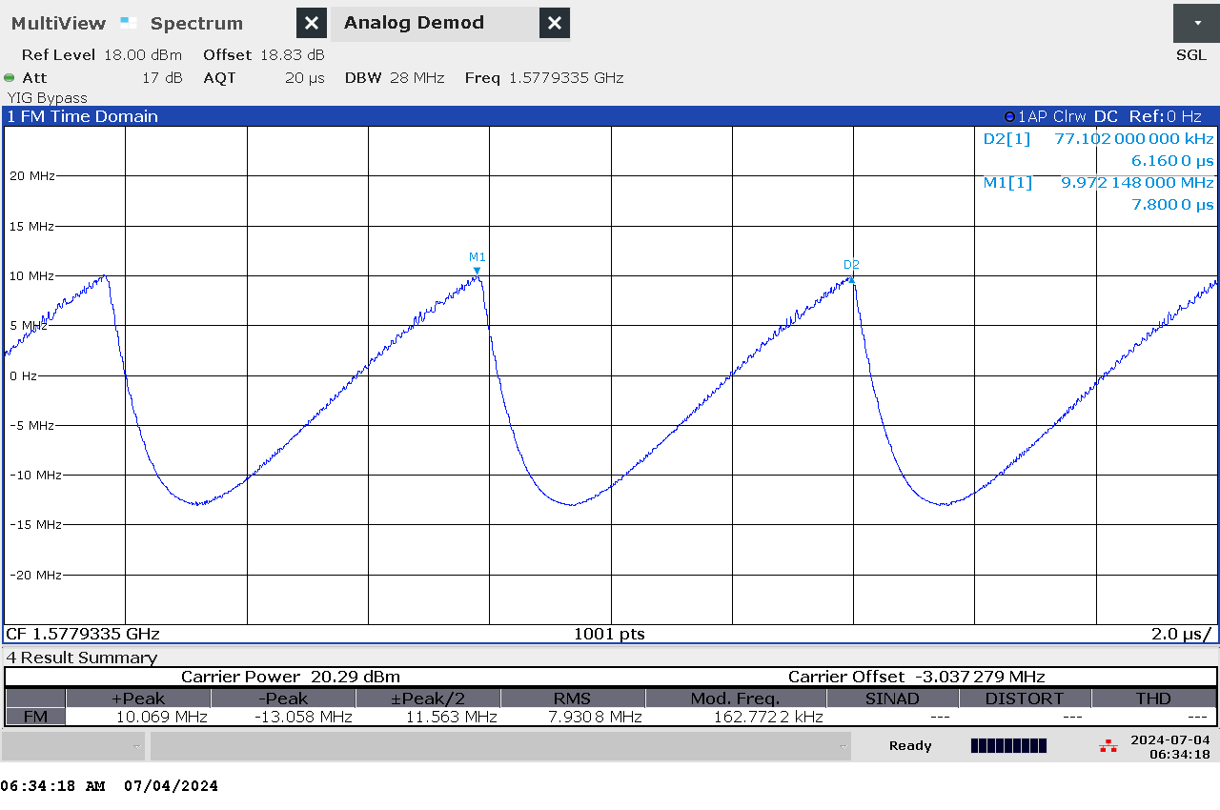

G 71: Time domain (analog demod) measurement of jammer H3.1 on antenna “GPS”

### ImageTechnical details on low-power jammer “H3.2”

The jammer H3.2 belongs to the ‘Handheld category’ of jammers. It is a small and light battery driven jammer with an easy operation, just an on/off-button with a LED-light to indicate activation.

H3.2 is a three-antenna, so-called “multi-frequency”, jammer, but not a “multi-GNSS-jammer”. It jams three different bands, but only one channel is relevant for GNSS bands (“L1-only”), so disrupting only the upper L-band.

Relevant GNSS antenna is marked: “GPS”

Technical characteristics of H3.2 (2024 measurements)

|  |  |  |  |  |  |  |  |
| --- | --- | --- | --- | --- | --- | --- | --- |
| Antenna | Centre frequency [MHz] | Bandwidth [MHz] | PSD [dBm/MHz] | TX total [dBm] | CF max [dBm] | Sweep rate [µs] | Modulation |
| “GPS” | 1579,52 | 30,81 | 17,97 | 32,86 | 16,65 | 6,44 | Sawtooth |

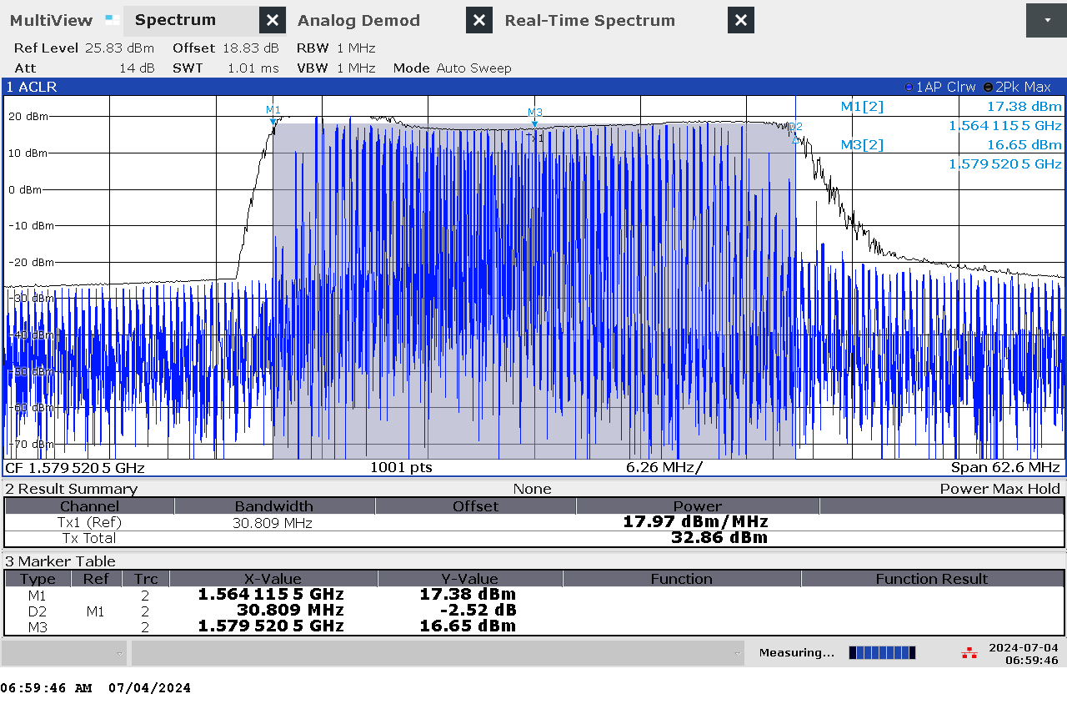

G 72: Frequency and power measurement of jammer H3.2 on antenna “GPS”

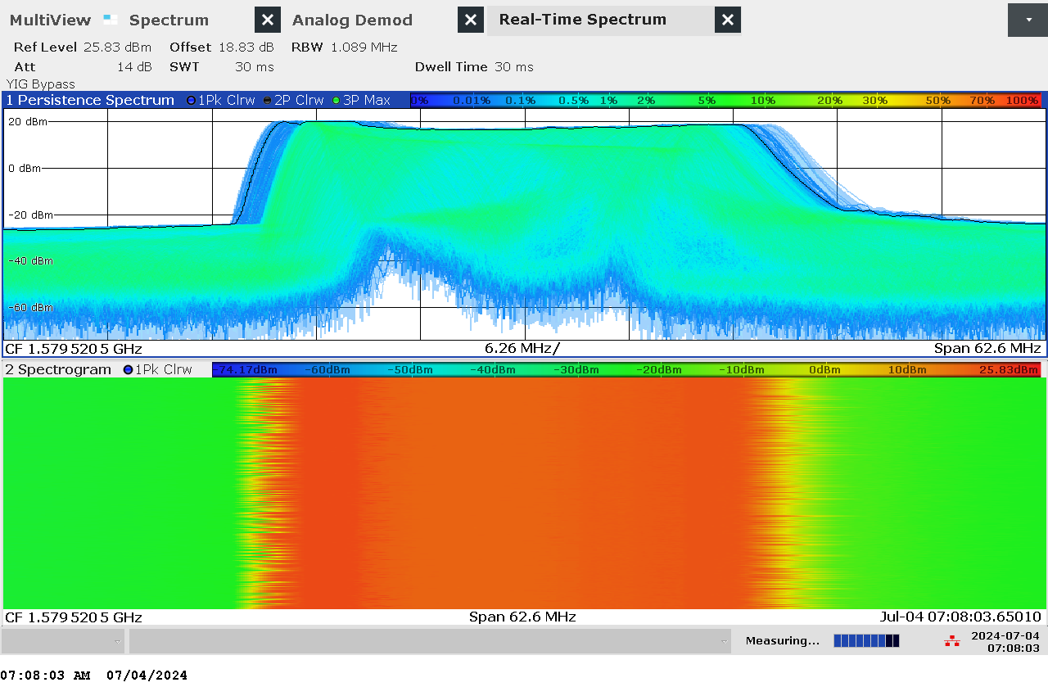

G 73: Real-time persistence and spectrogram measurement of jammer H3.2 on antenna “GPS”

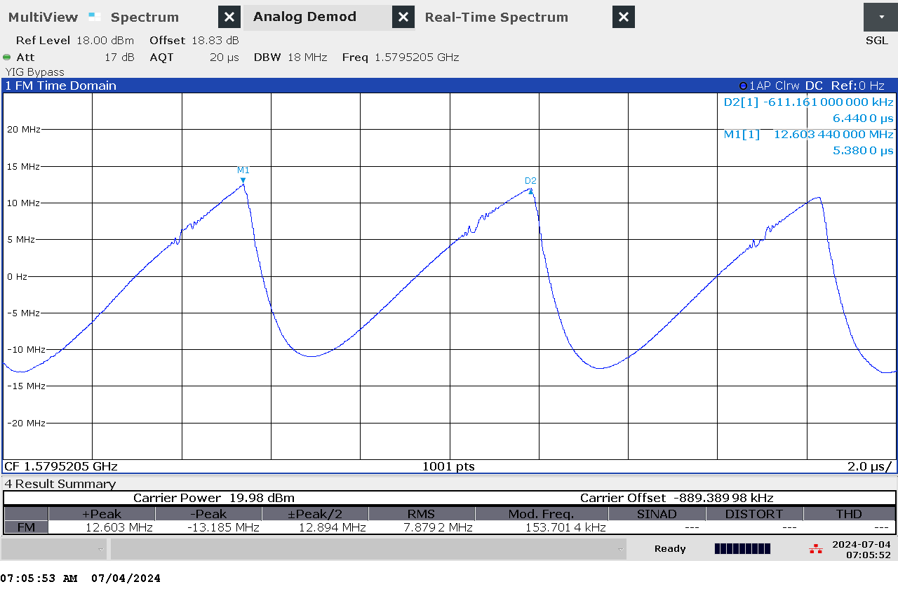

G 74: Time domain (analog demod) measurement of jammer H3.2 on antenna “GPS”

### Et bilde som inneholder tekst, skjermbilde, diagram Automatisk generert beskrivelseTechnical details on low-power jammer “H3.3”

The jammer H3.3 belongs to the ‘Handheld category’ of jammers. It is a small and relatively light battery driven jammer with an easy operation, just an on/off-button with a LED-light to indicate activation.

H3.3 is a three-antenna, so-called “L1+L2+L5”, jammer, disrupting both the upper and lower L-band.

The three antennas are marked with white lines of different length: short=L1, medium=L2, long=L5

The jammer has additional noise in several other (non GNSS) frequency bands, but with significant lower power.

Technical characteristics of H3.3 (2024 measurements)

|  |  |  |  |  |  |  |  |
| --- | --- | --- | --- | --- | --- | --- | --- |
| Antenna | Centre frequency [MHz] | Bandwidth [MHz] | PSD [dBm/MHz] | TX total [dBm] | CF max [dBm] | Sweep rate [µs] | Modulation |
| “short” (L1) | 1575,35 | 19,93 | 26,37 | 39,36 | 23,56 | 12,96 | Sawtooth |
| “medium” (L2) | 1228,06 | 14,36 | 27,38 | 38,95 | 22,44 | 12,51 | Sawtooth |
| “long” (L5) | 1176,24 | 17,45 | 28,62 | 41,04 | 25,83 | 12,51 | Sawtooth |

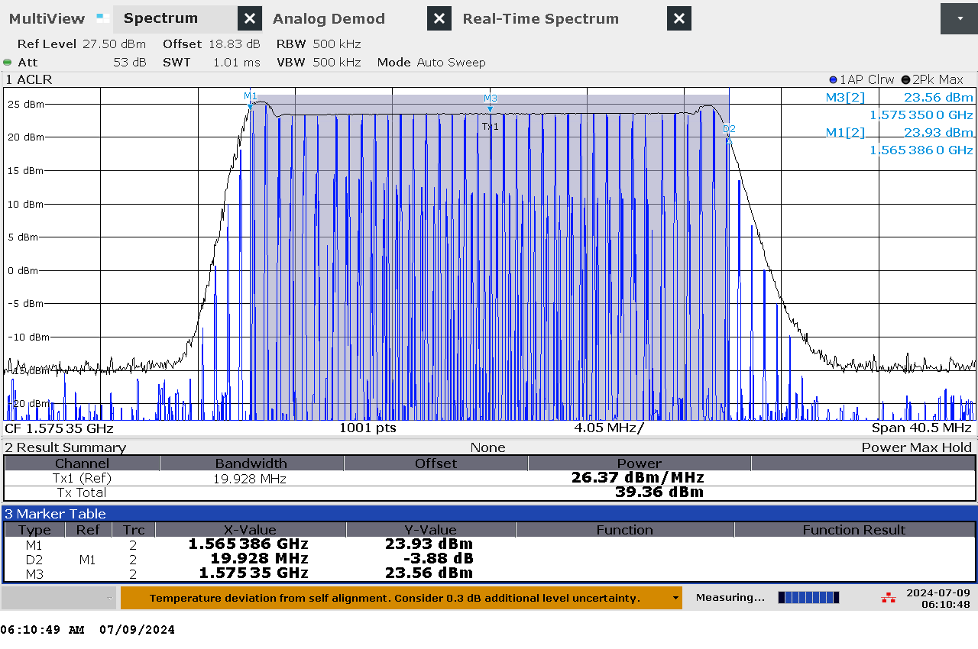

G 75: Frequency and power measurement of jammer H3.3 on antenna “short” (L1)

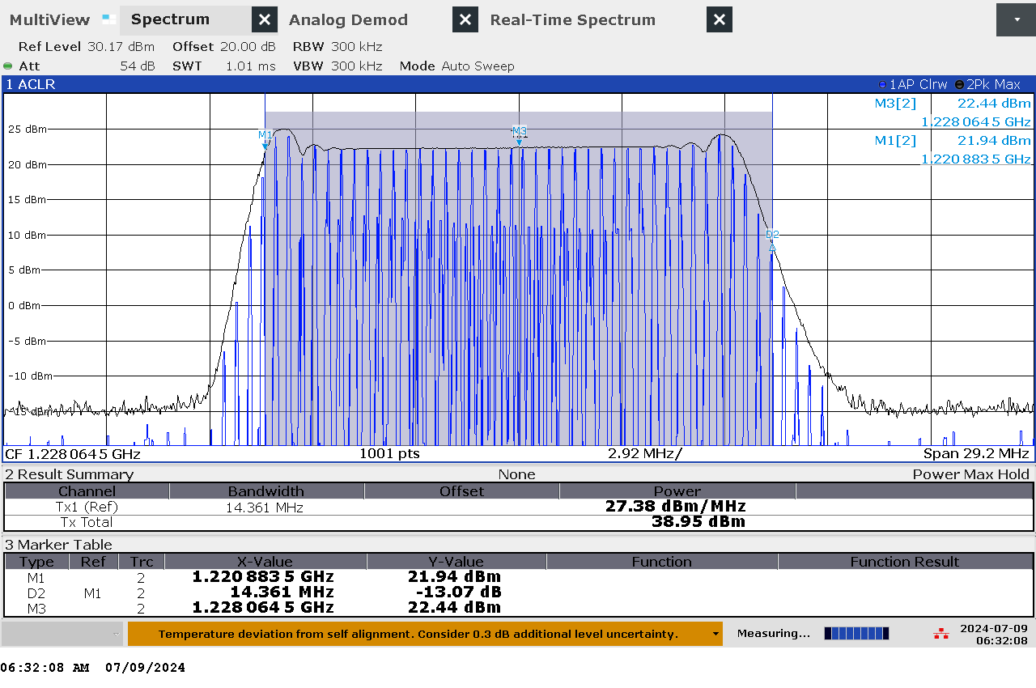

G 76: Frequency and power measurement of jammer H3.3 on antenna “medium” (L2)

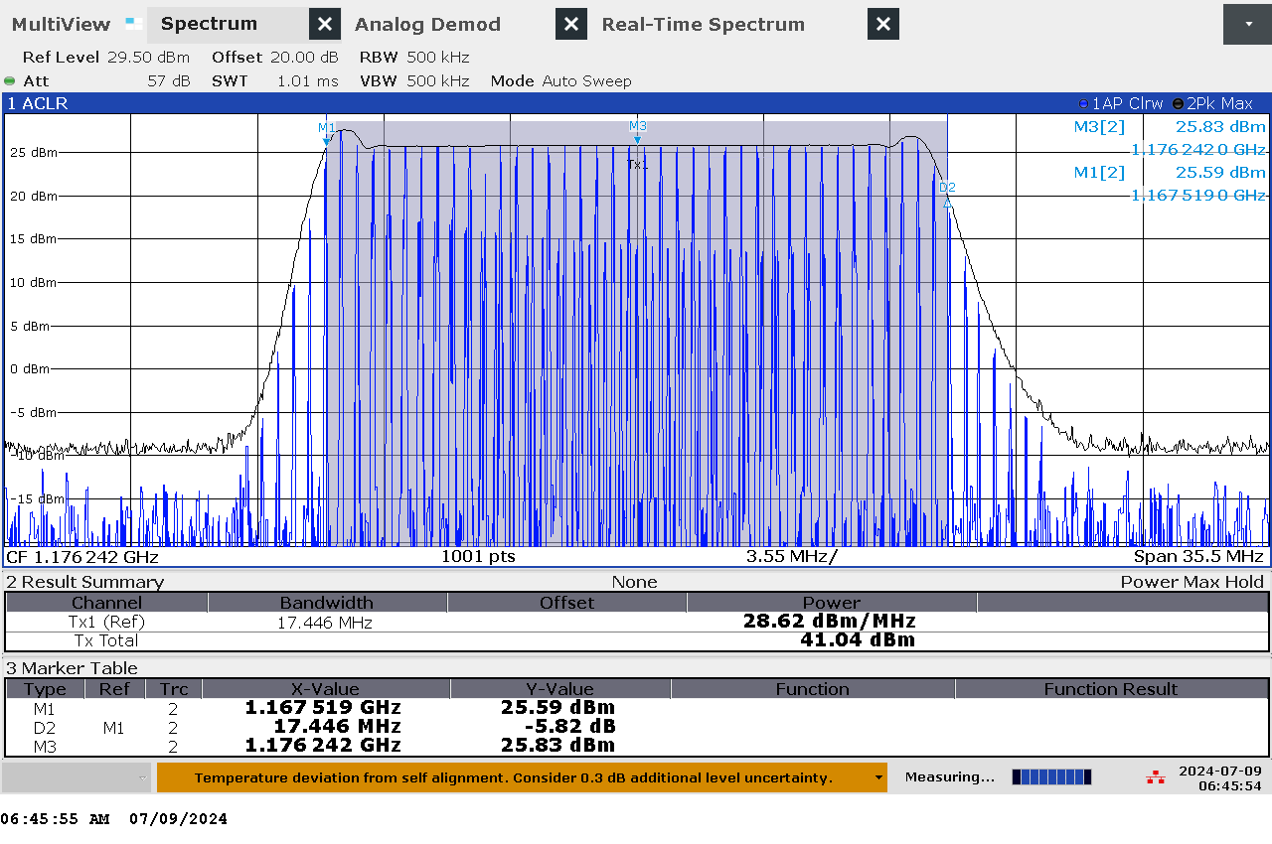

G 77: Frequency and power measurement of jammer H3.3 on antenna “long” (L5)

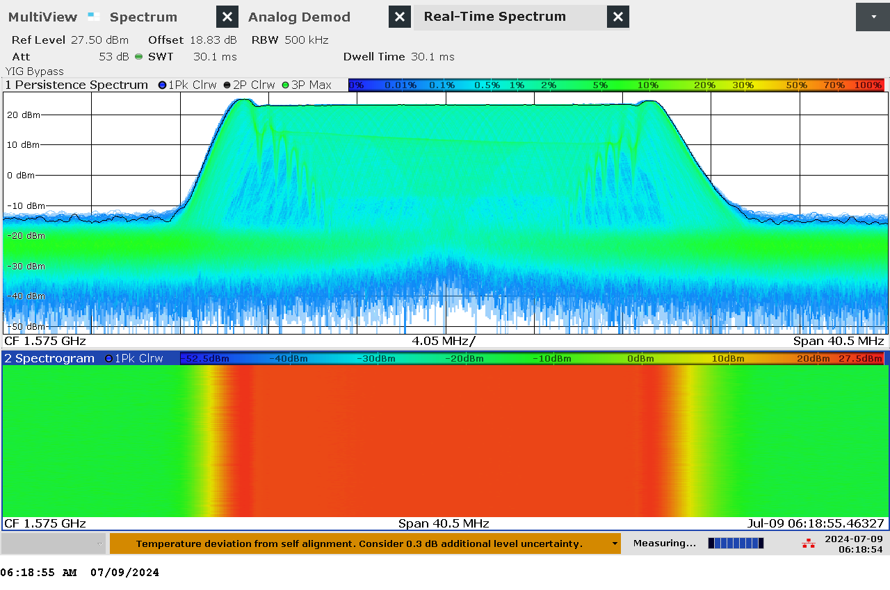

G 78: Real-time persistence and spectrogram measurement of jammer H3.3 on antenna “short” (L1)

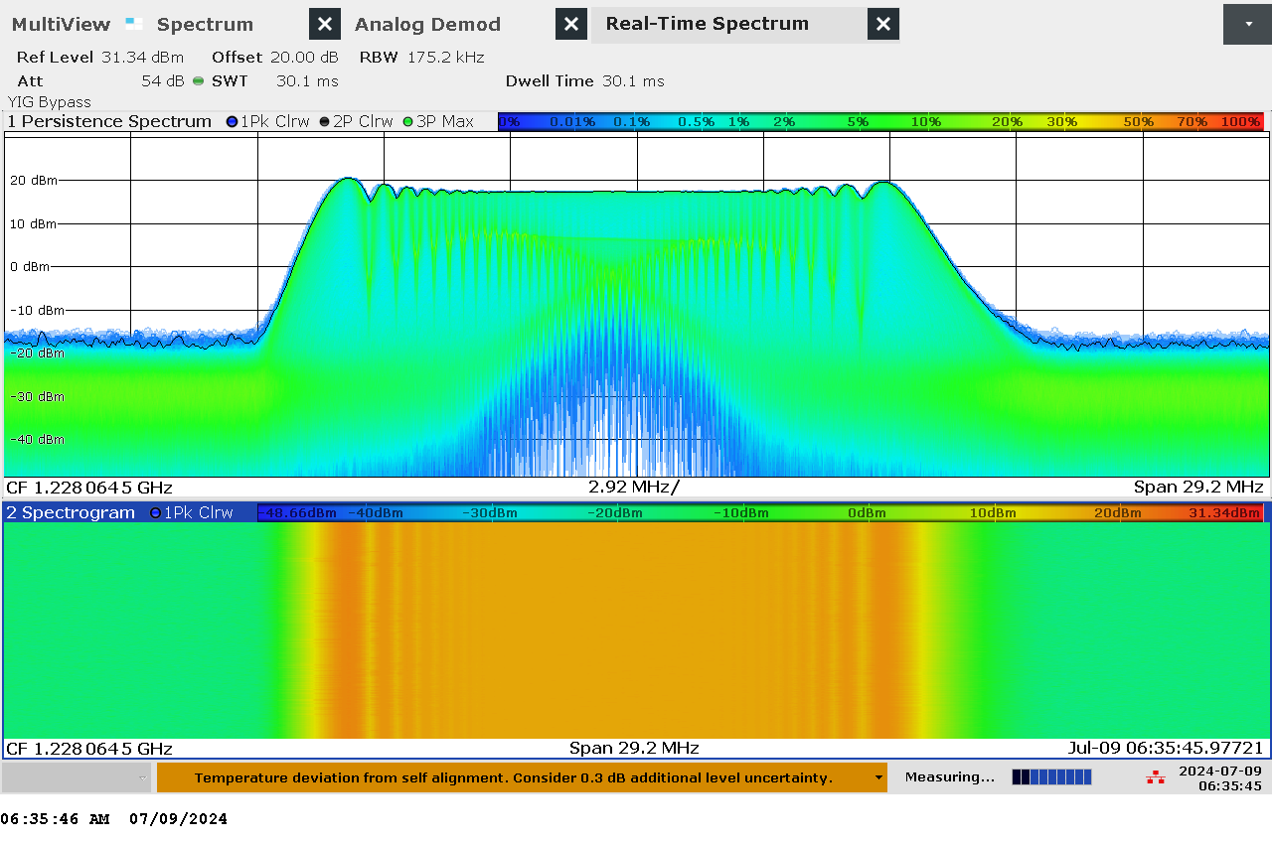

G 79: Real-time persistence and spectrogram measurement of jammer H3.3 on antenna “medium” (L2)

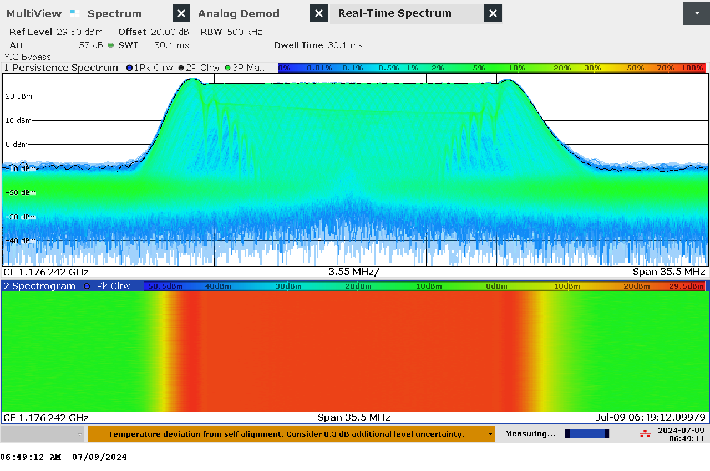

G 80: Real-time persistence and spectrogram measurement of jammer H3.3 on antenna “long” (L5)

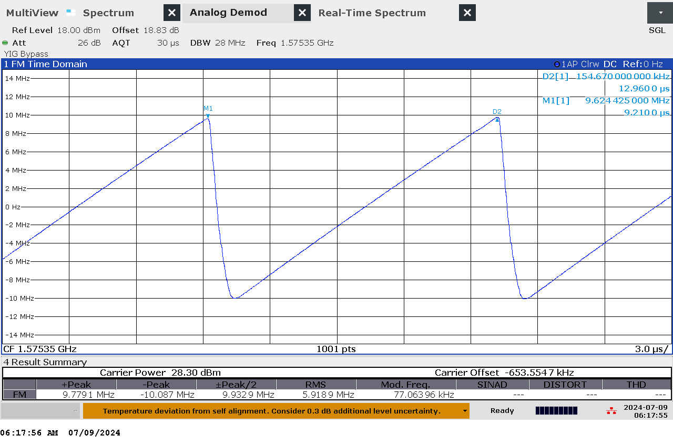

G 81: Time domain (analog demod) measurement of jammer H3.3 on antenna “short” (L1)

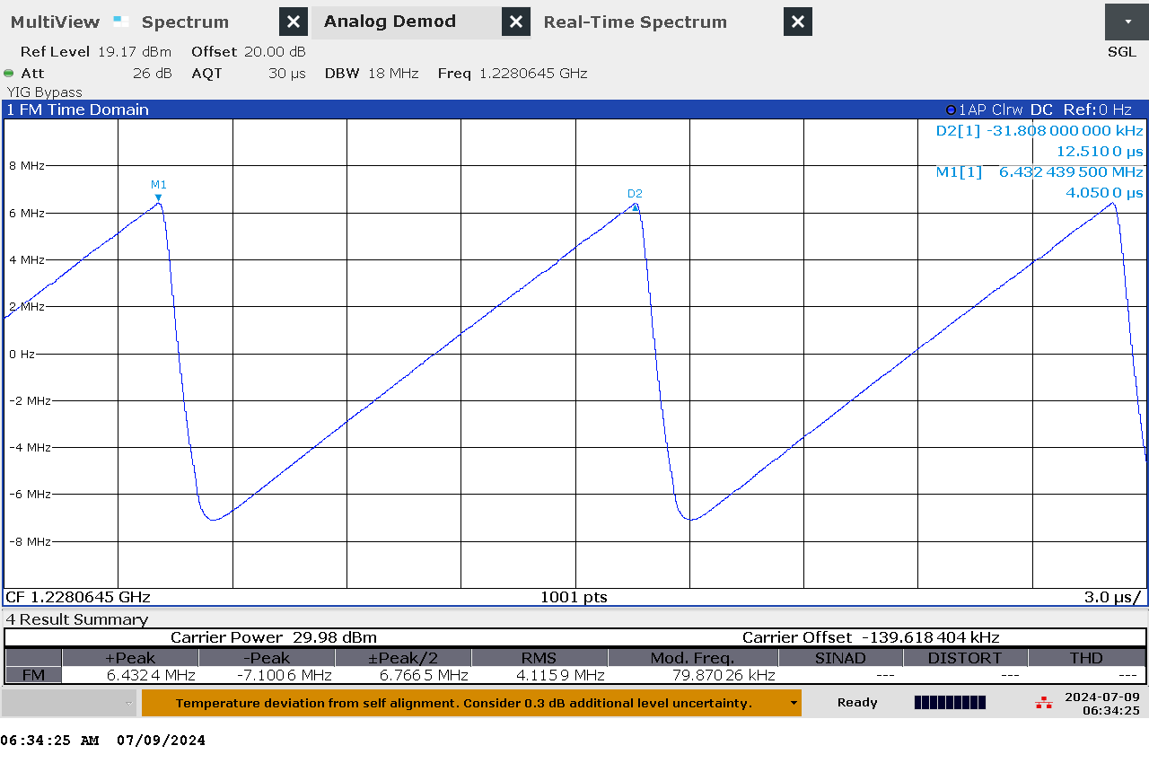

G 82: Time domain (analog demod) measurement of jammer H3.3 on antenna “medium” (L2)

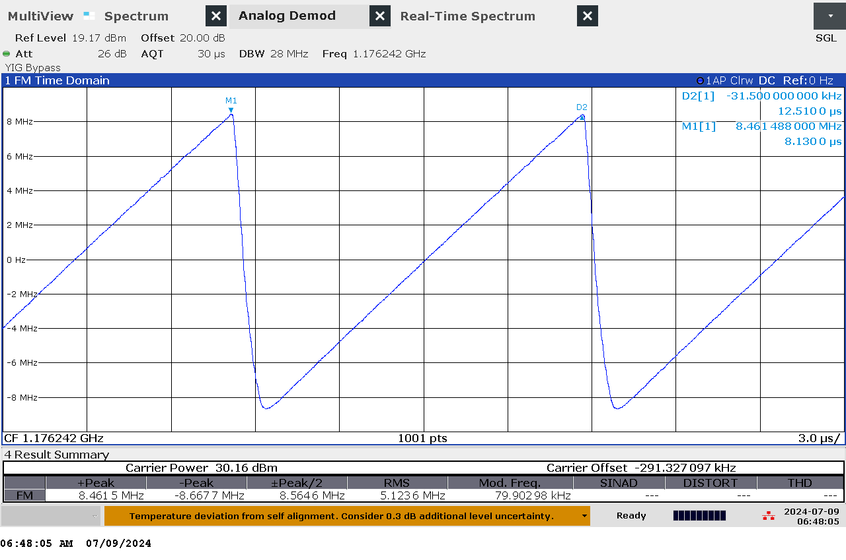

G 83: Time domain (analog demod) measurement of jammer H3.3 on antenna “long” (L5)

### Et bilde som inneholder tekst, måler Automatisk generert beskrivelseTechnical details on low-power jammer H4.1

The jammer H4.1 belongs to the ‘Handheld category’ of jammers. It is a small and relatively light battery driven jammer with a relatively easy operation, just an on/off-button with a LED-light to indicate activation and DIP switches to change between channels.

H4.1 is a four-antenna, so-called “L1+L2+L5+E6”, jammer, disrupting both the upper and lower L-band.

The four antennas are marked with numbers: “1” (L1), “2” (E6), “3” (L2) and “4” (L5)

The jammer has additional noise (harmonics) in several other (non GNSS) frequency bands.

Technical characteristics of H4.1 (2024 measurements)

|  |  |  |  |  |  |  |  |
| --- | --- | --- | --- | --- | --- | --- | --- |
| Antenna | Centre frequency [MHz] | Bandwidth [MHz] | PSD [dBm/MHz] | TX total [dBm] | CF max [dBm] | Sweep rate [µs] | Modulation |
| “1” (L1) | 1548,02 | 102,67 | 21,14 | 41,25 | 25,20 | 8,82 | Sawtooth-modulated |
| “2” (E6) | 1261,92 | 48,80 | 22,38 | 39,26 | 22,33 | 8,86 | Sawtooth |
| “3” (L2) | 1220,34 | 47,88 | 21,08 | 37,88 | 20,29 | 8,82 | Sawtooth |
| “4” (L5) | 1182,32 | 39,66 | 22,87 | 38,85 | 22,83 | 8,84 | Sawtooth |

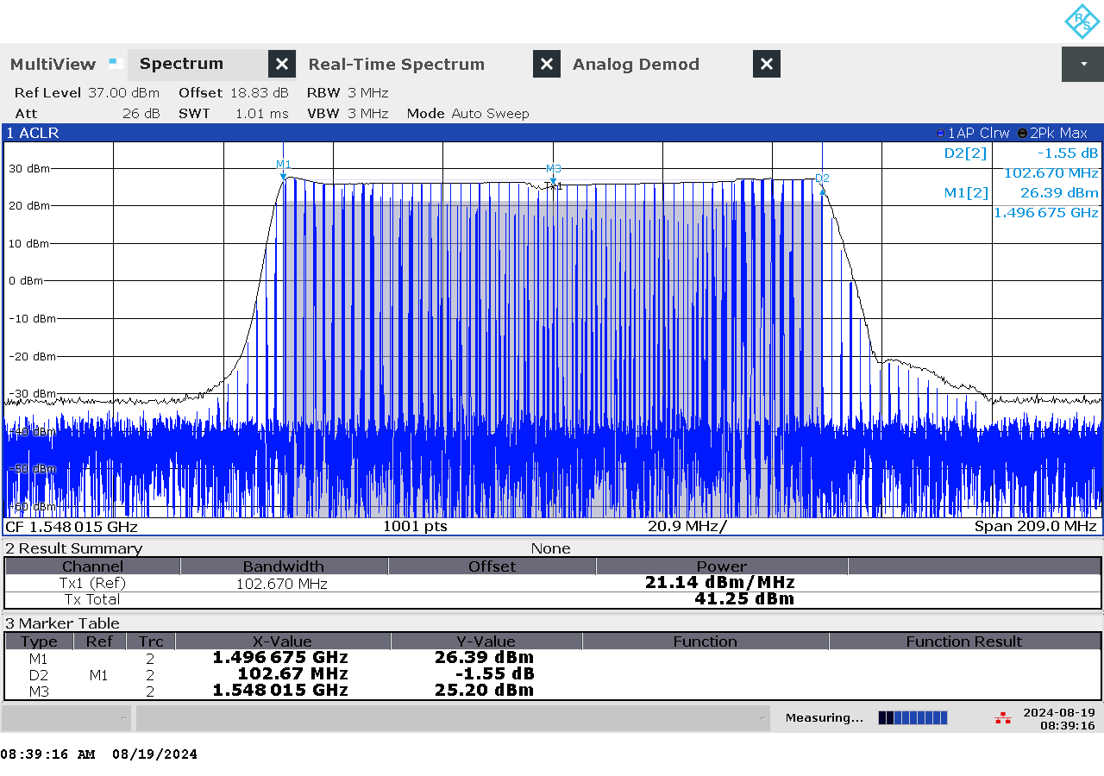

G 84: Frequency and power measurement of jammer H4.1 on antenna “1” (L1)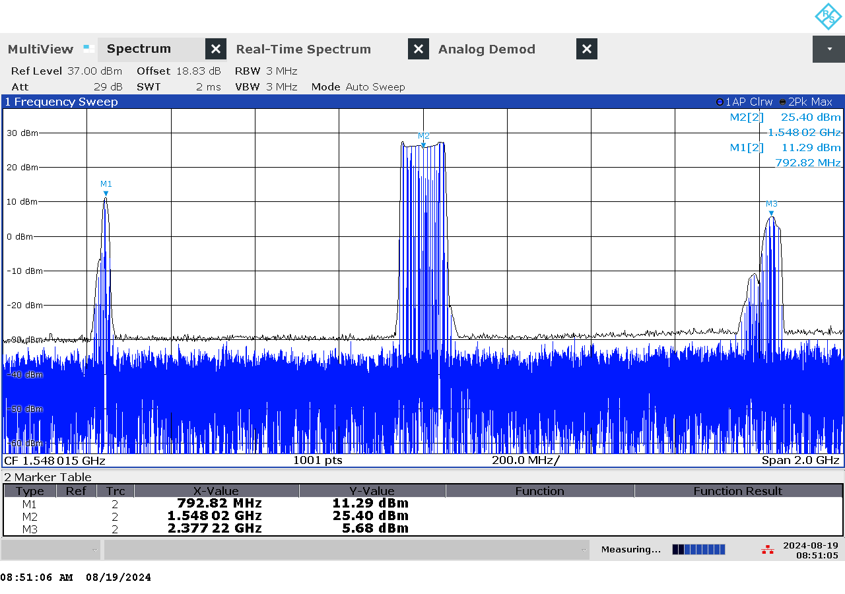

G 85: Frequency and power measurement with wider span of jammer H4.1 on antenna “1” (L1)

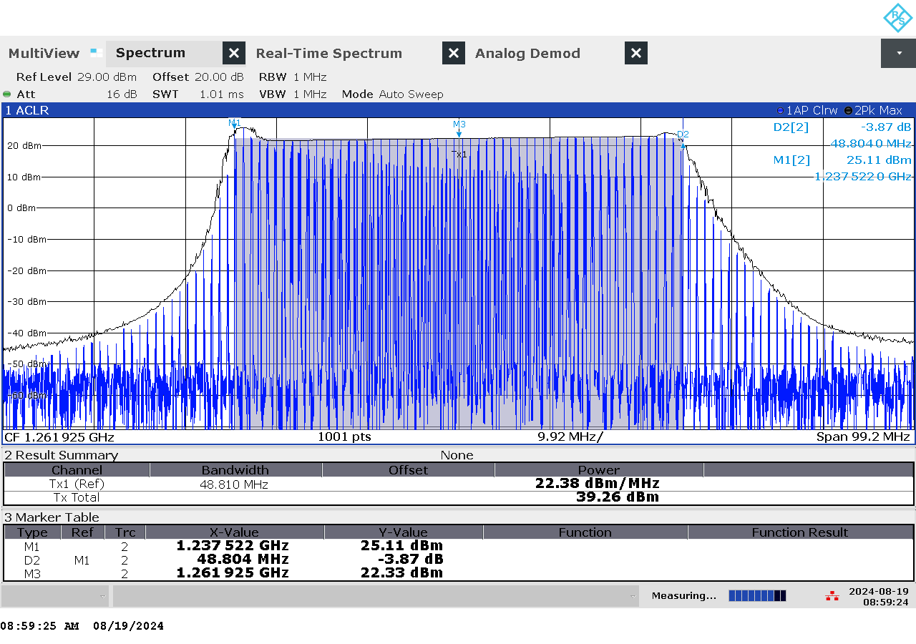

G 86: Frequency and power measurement of jammer H4.1 on antenna “2” (E6)

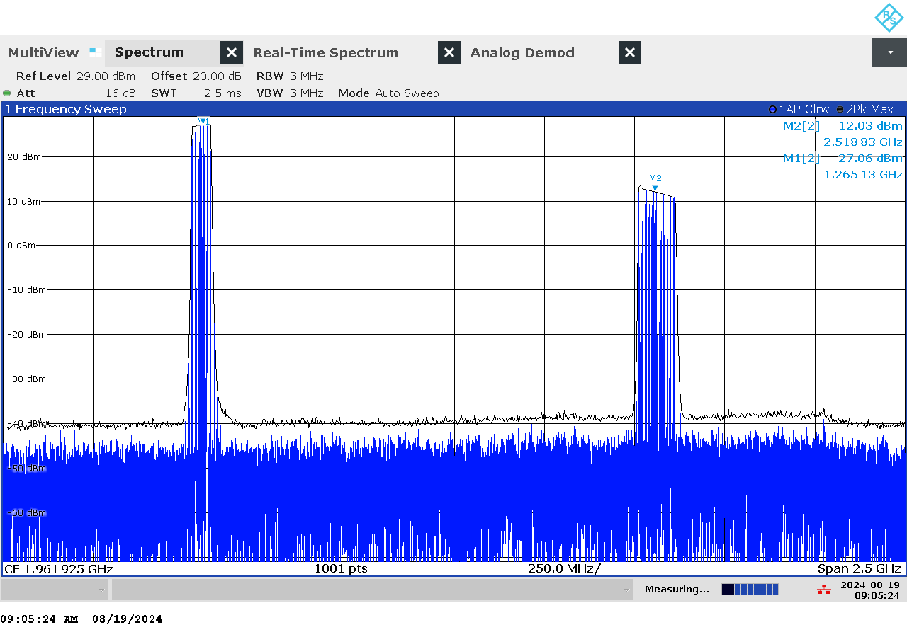

G 87: Frequency and power measurement with wider span of jammer H4.1 on antenna “2” (E6)

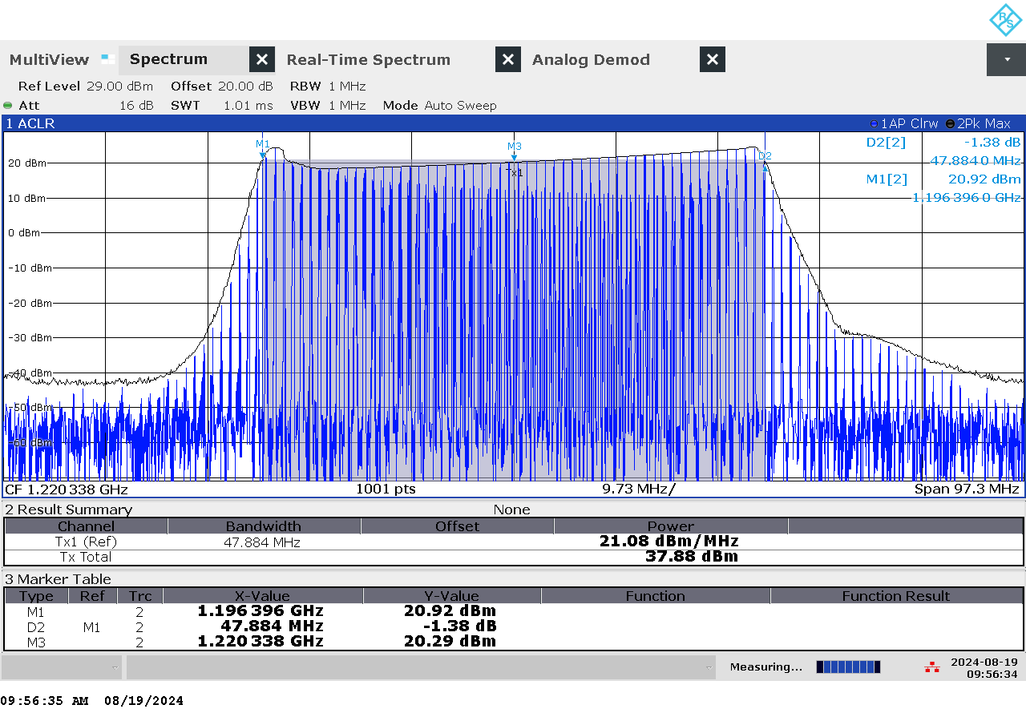

G 88: Frequency and power measurement of jammer H4.1 on antenna “3” (L2)

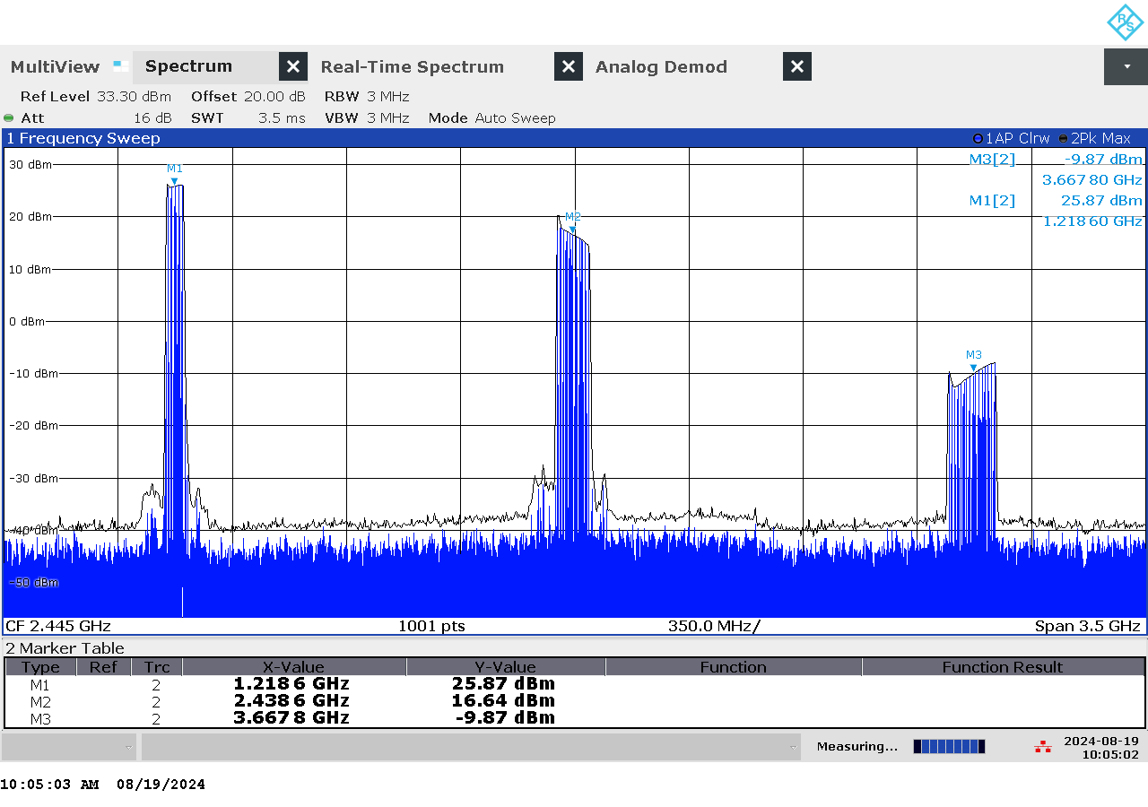

G 89: Frequency and power measurement with wider span of jammer H4.1 on antenna “3” (L2)

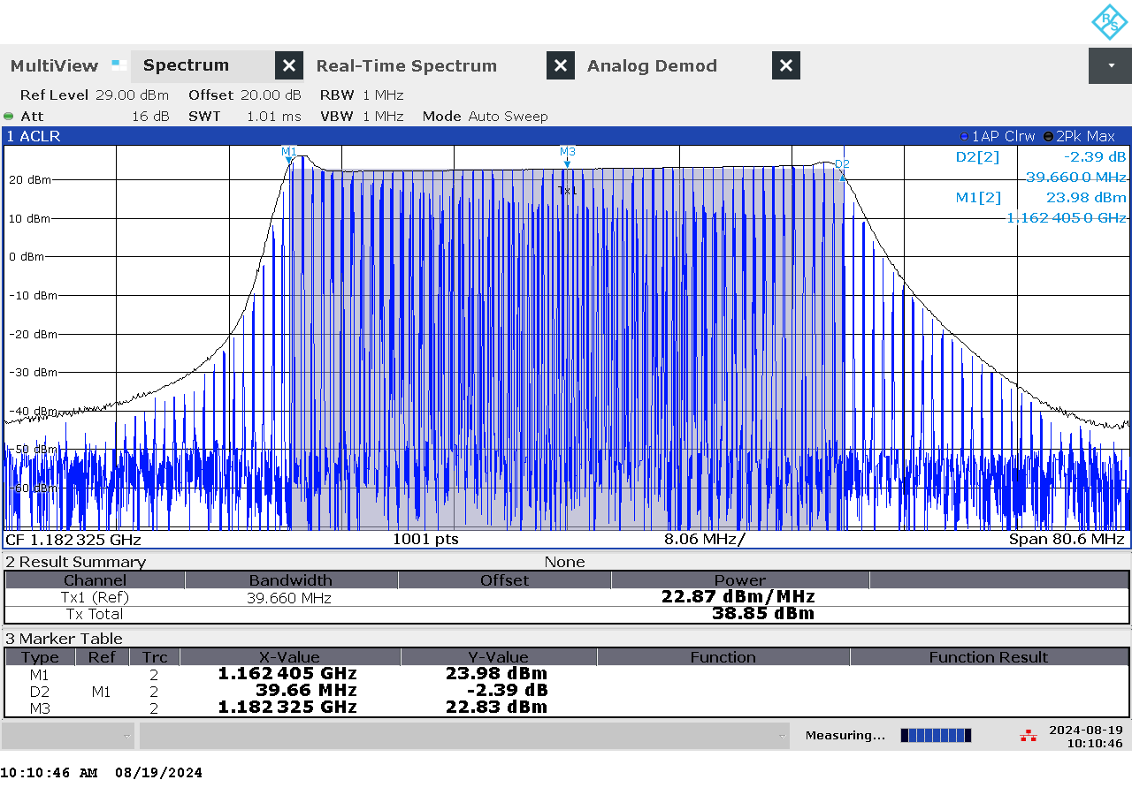

G 90: Frequency and power measurement of jammer H4.1 on antenna “4” (L5)

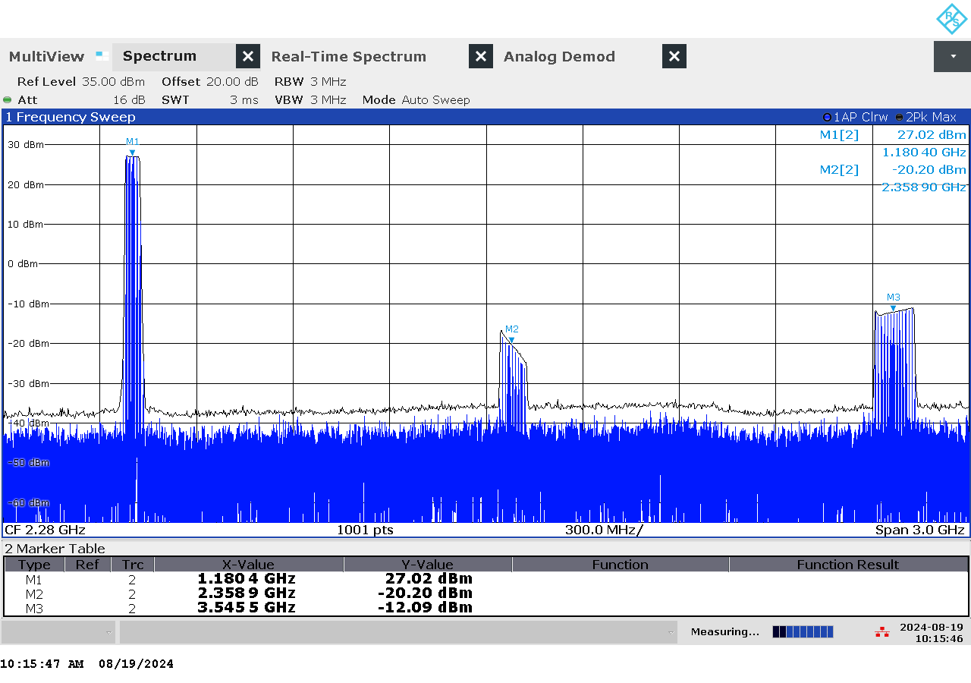

G 91: Frequency and power measurement with wider span of jammer H4.1 on antenna “4” (L5)

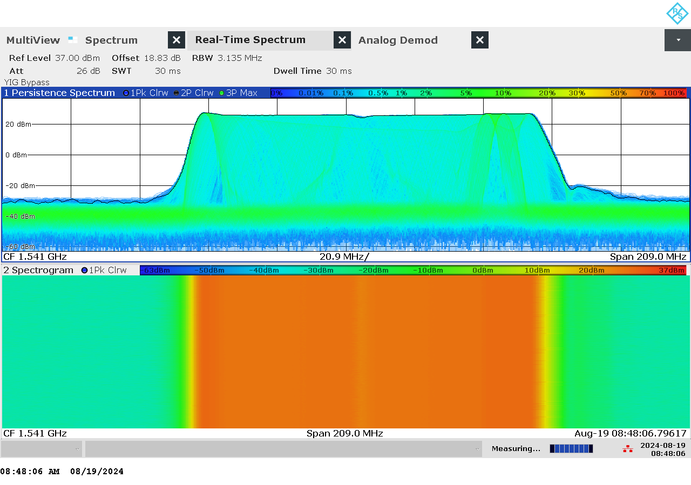

G 92: Real-time persistence and spectrogram measurement of jammer H4.1 on antenna “1” (L1)

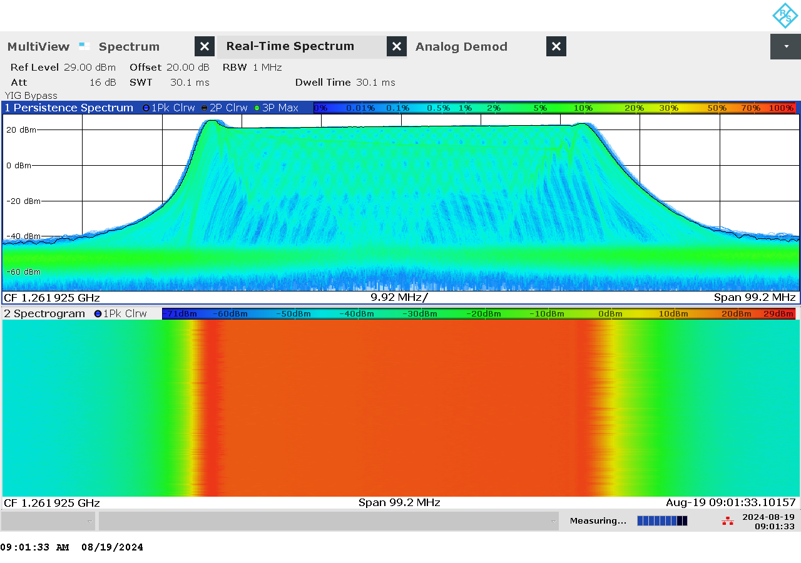

G 93: Real-time persistence and spectrogram measurement of jammer H4.1 on antenna “2” (E6)

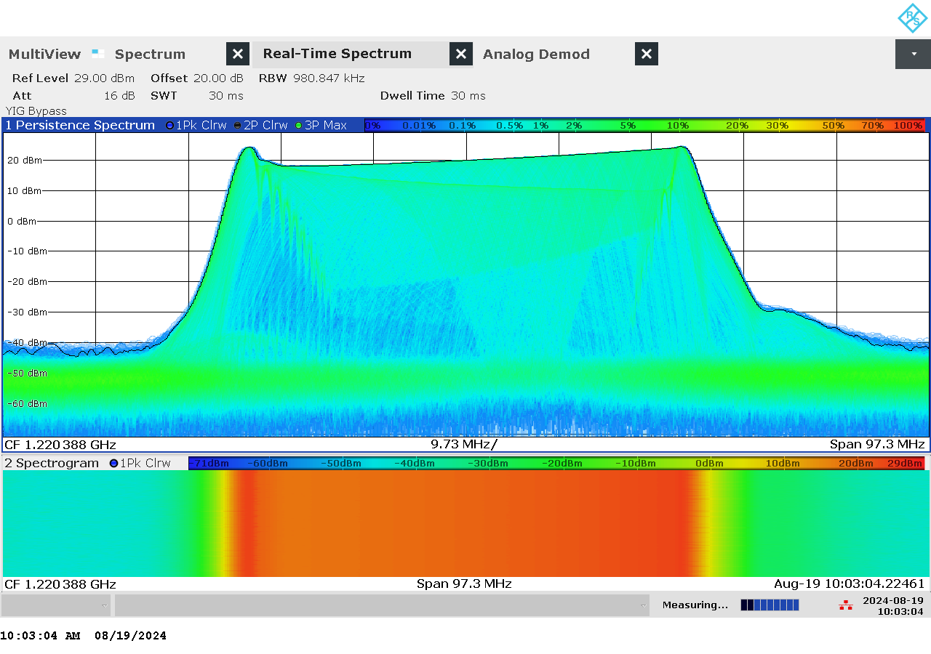

G 94: Real-time persistence and spectrogram measurement of jammer H4.1 on antenna “3” (L2)

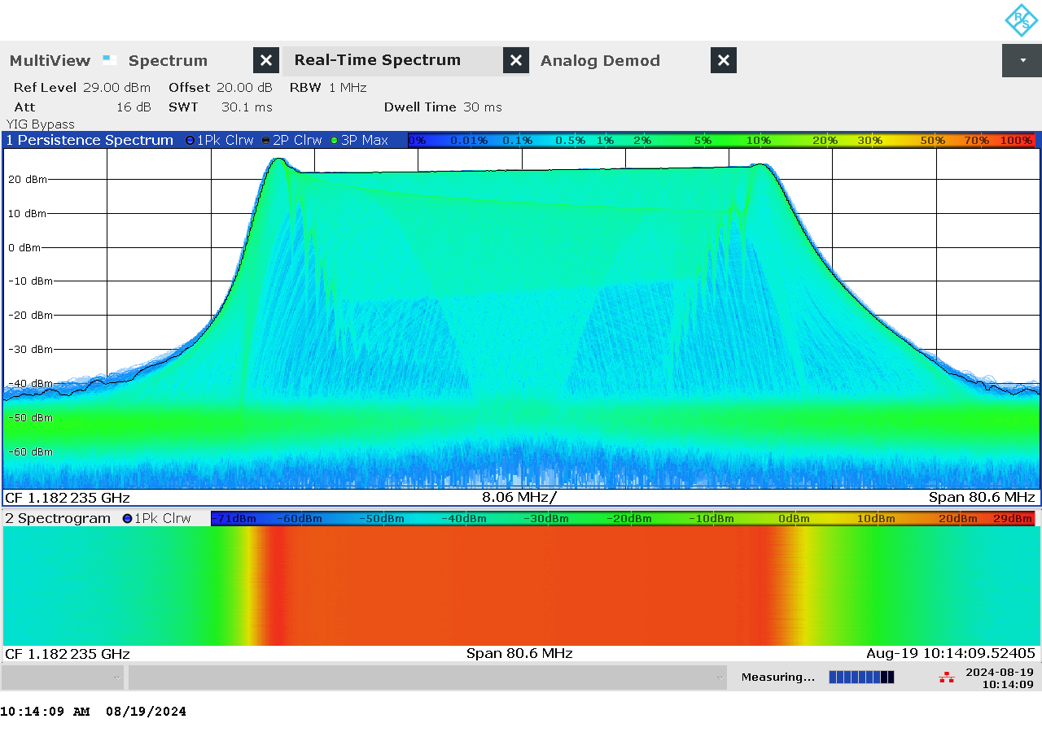

G 95: Real-time persistence and spectrogram measurement of jammer H4.1 on antenna “4” (L5)

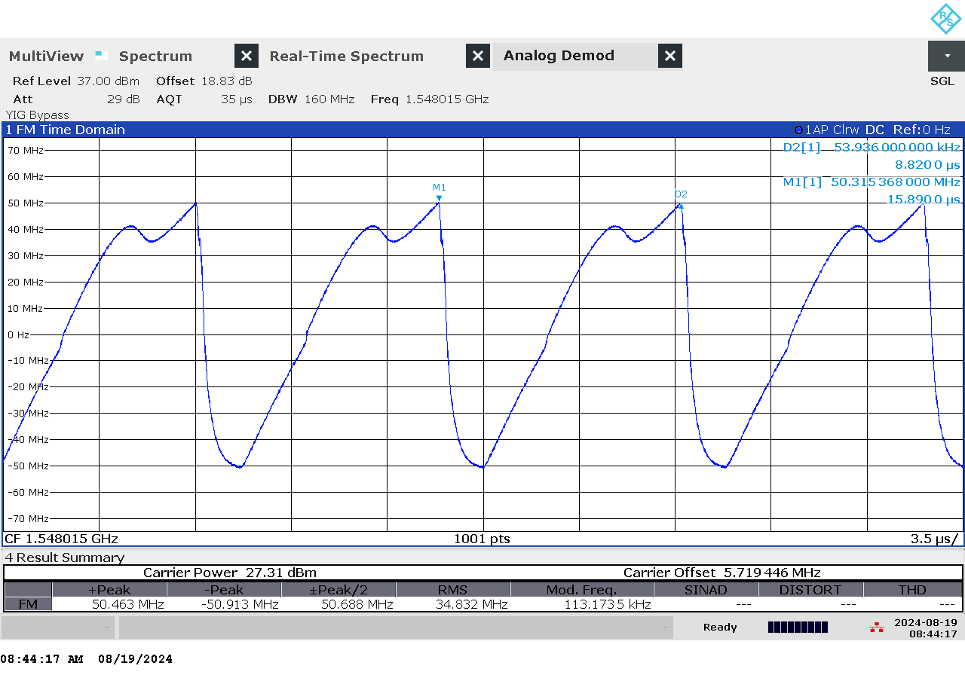

G 96: Time domain (analog demod) measurement of jammer H4.1 on antenna “1” (L1)

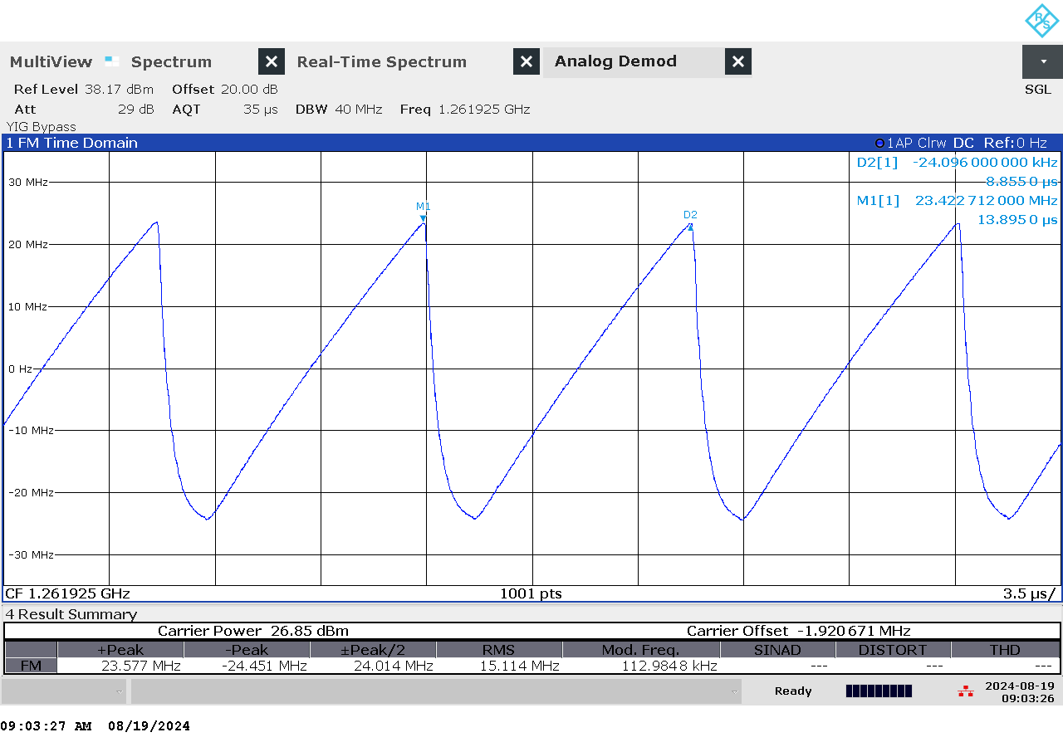

G 97: Time domain (analog demod) measurement of jammer H4.1 on antenna “2” (E6)

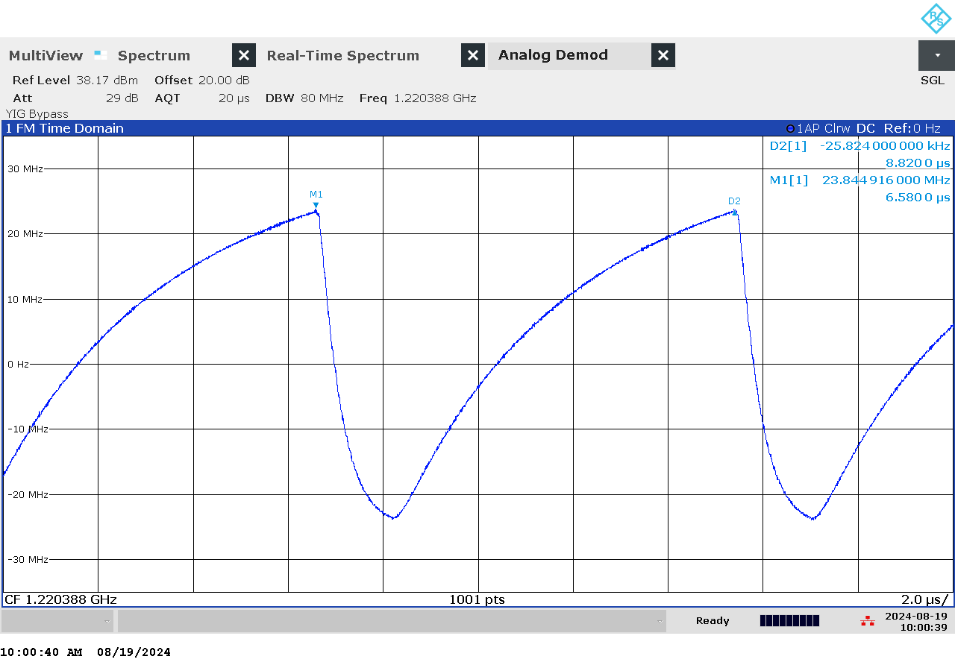

G 98: Time domain (analog demod) measurement of jammer H4.1 on antenna “3” (L2)

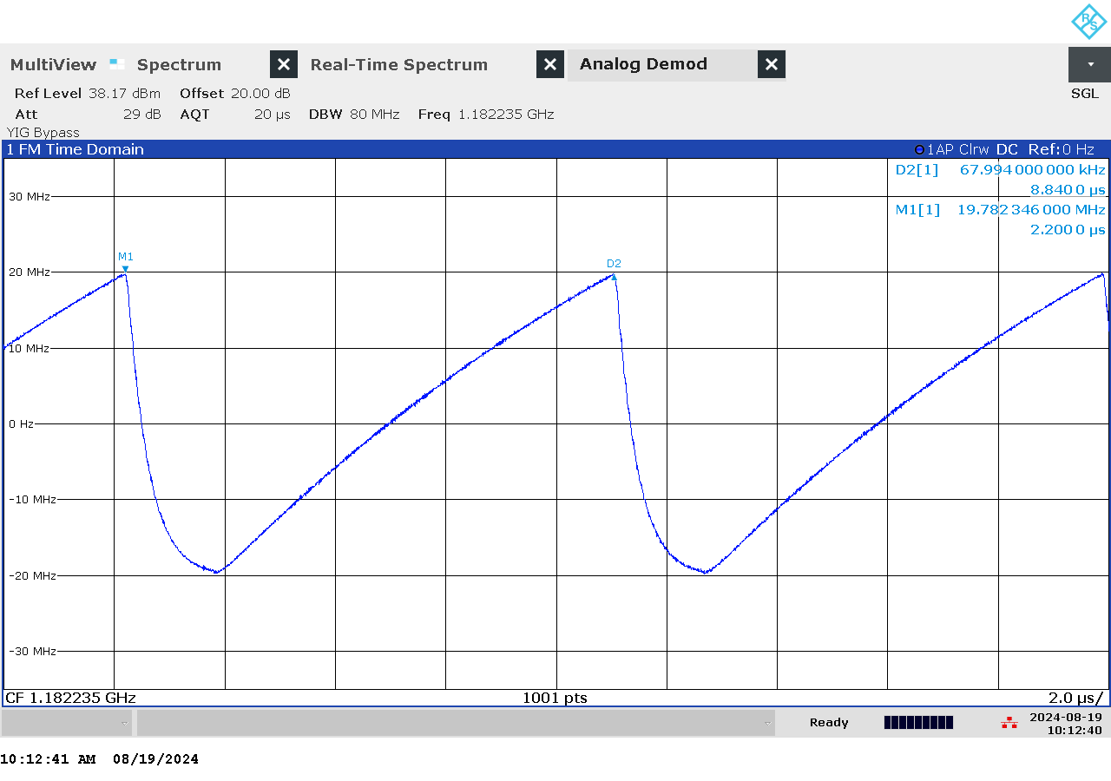

G 99: Time domain (analog demod) measurement of jammer H4.1 on antenna “4” (L5)

### Et bilde som inneholder innendørs Automatisk generert beskrivelseTechnical details on low-power jammer “H6.1”

The jammer H6.1 belongs to the ‘Handheld category’ of jammers. It is a larger but relatively light battery driven jammer with a relatively easy operation, just an on/off-button with a LED-light to indicate activation and DIP switches to change between channels.

H6.1 is a six-antenna, so-called “multi-frequency”, jammer, but technically not a “multi-GNSS-jammer”. It jams six different bands, but only two channels are relevant for GNSS bands, both in the upper L-band (so “L1-only”), thus only disrupting the upper L-band.

The most relevant GNSS antenna is marked “6”. The periphery antenna is marked “4”. To avoid disrupting non-GNSS services, use only antenna “6”.

Technical characteristics of H6.1 (2024 measurements)

|  |  |  |  |  |  |  |  |
| --- | --- | --- | --- | --- | --- | --- | --- |
| Antenna | Centre frequency [MHz] | Bandwidth [MHz] | PSD [dBm/MHz] | TX total [dBm] | CF max [dBm] | Sweep rate [µs] | Modulation |
| “4” | 1621,23 | 87,50 | 2,89 | 22,31 | 5,57 | 5,9 | Sawtooth |
| “6” (L1) | 1581,18 | 22,24 | 24,60 | 38,07 | 24,37 | 5,86 | Sawtooth |

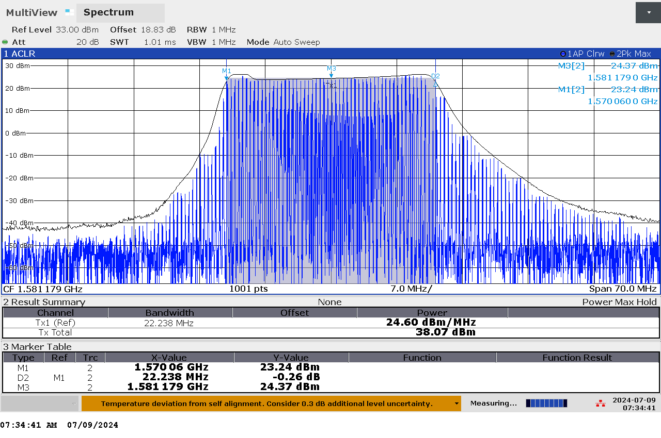

G 100: Frequency and power measurement of jammer H6.1 on antenna “6” (L1)

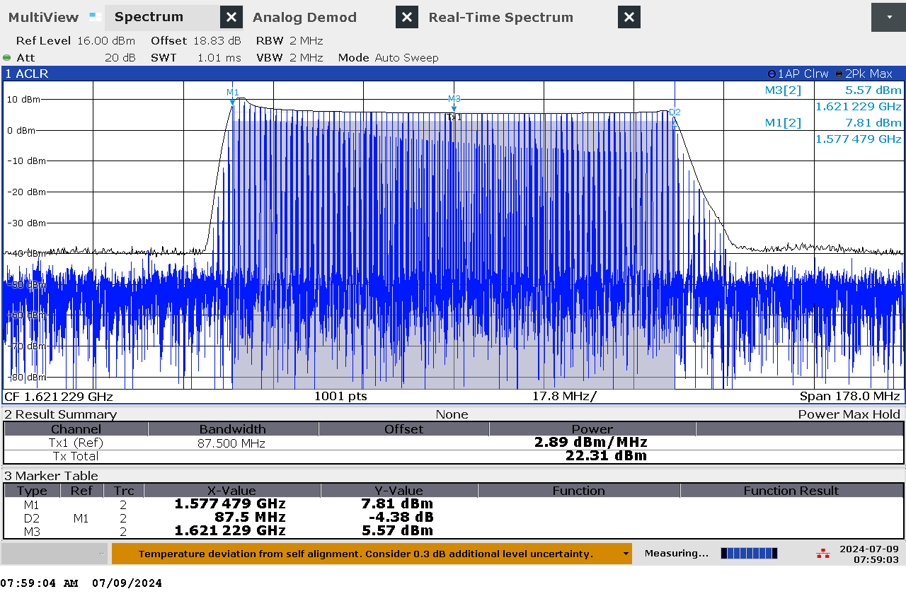

G 101: Frequency and power measurement of jammer H6.1 on antenna “4”

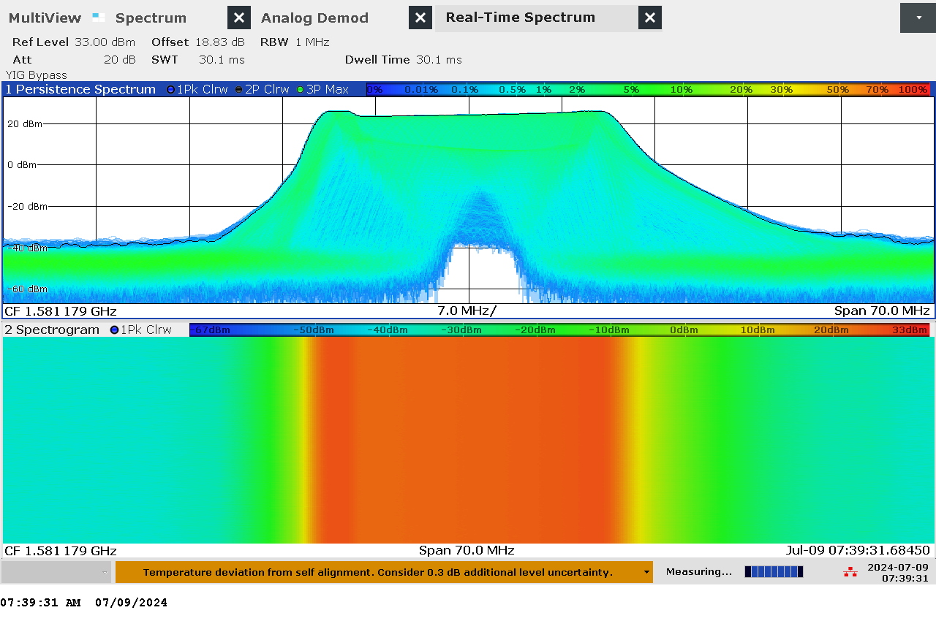

G 102: Real-time persistence and spectrogram measurement of jammer H6.1 on antenna “6” (L1)

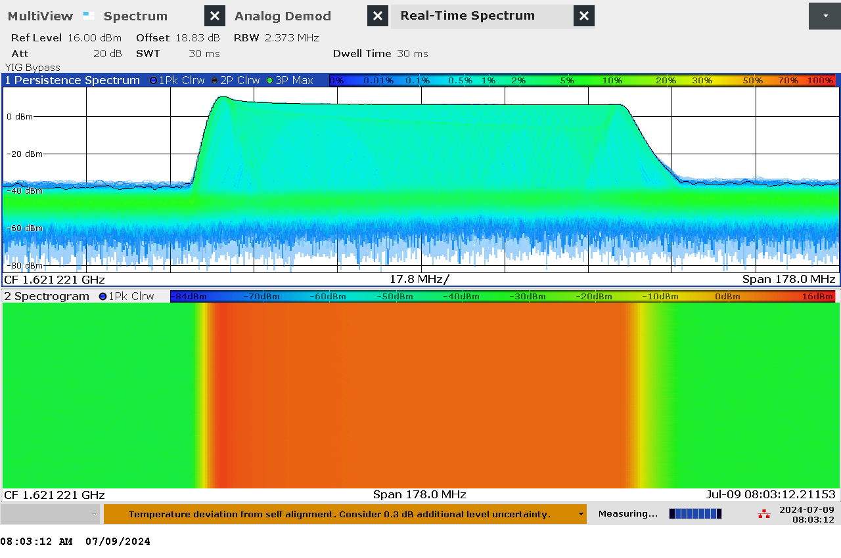

G 103: Real-time persistence and spectrogram measurement of jammer H6.1 on antenna “4”

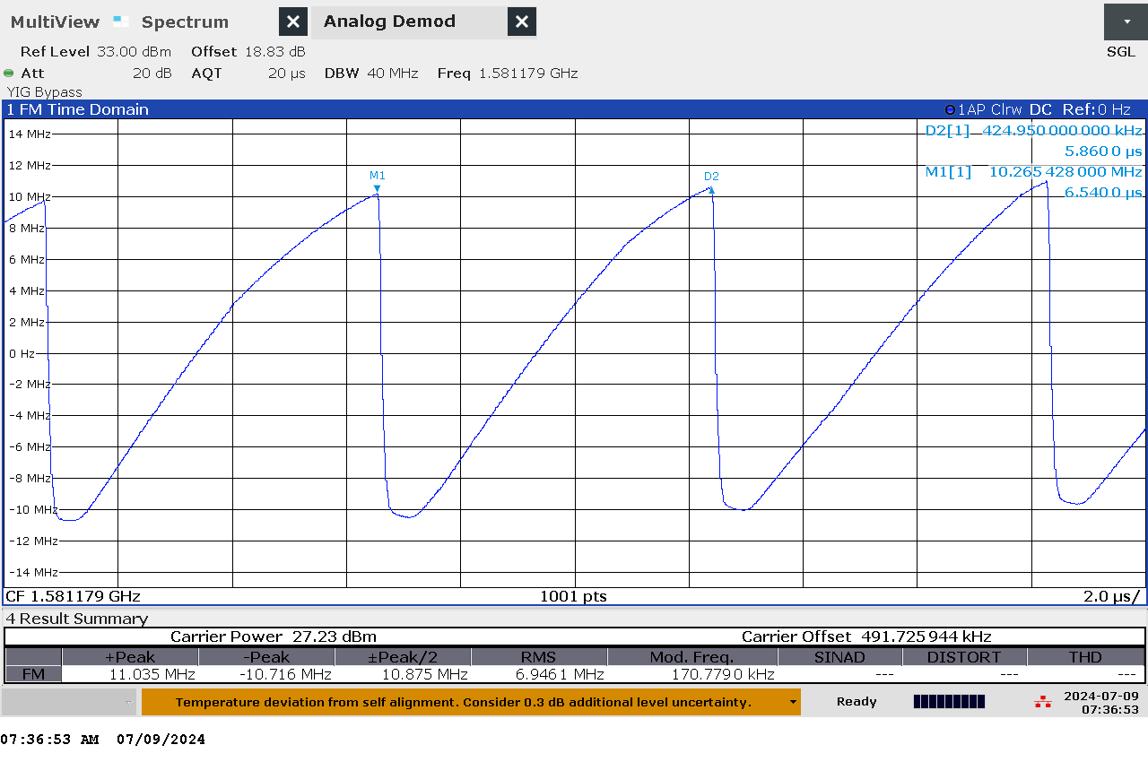

G 104: Time domain (analog demod) measurement of jammer H6.1 on antenna “6” (L1)

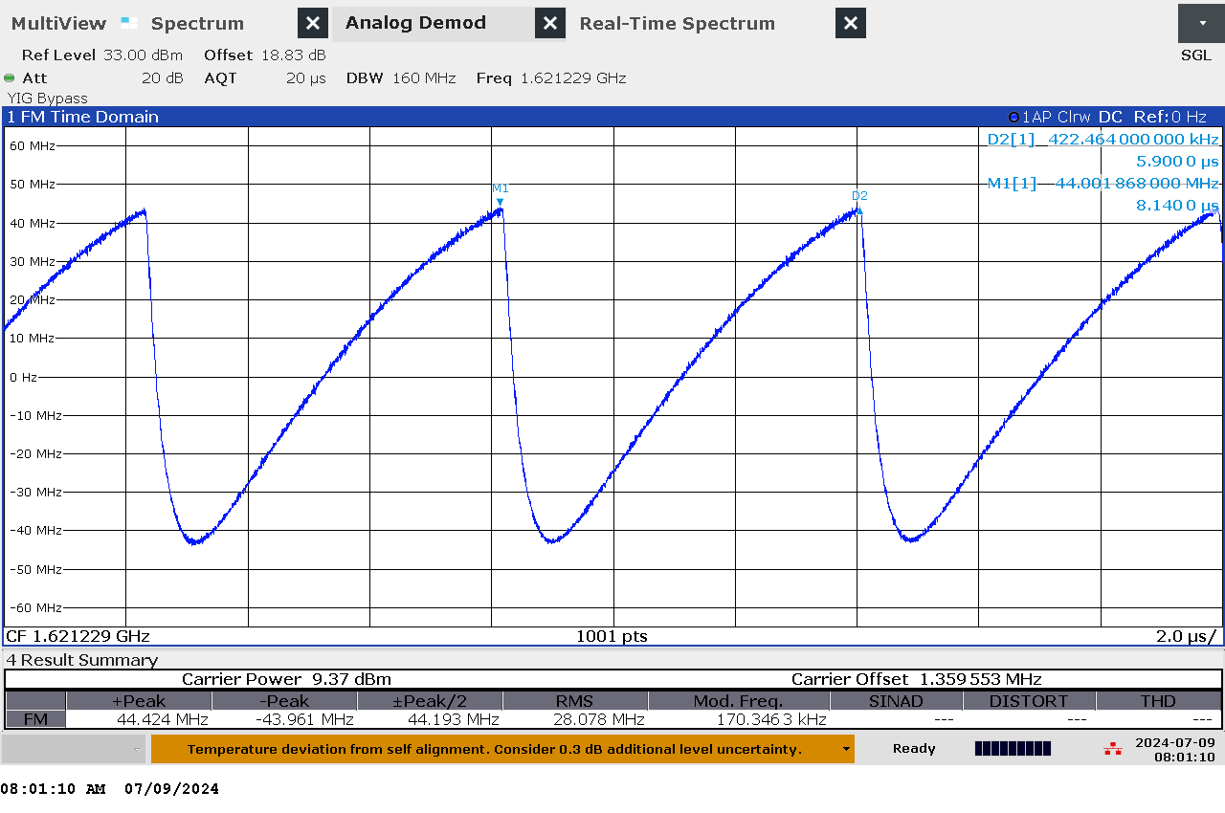

G 105: Time domain (analog demod) measurement of jammer H6.1 on antenna “4”

### Et bilde som inneholder innendørs Automatisk generert beskrivelseTechnical details on low-power jammer “H6.2”

The jammer H6.2 belongs to the ‘Handheld category’ of jammers. It is a larger but relatively light battery driven jammer with a relatively easy operation, just an on/off-button with a LED-light to indicate activation and DIP switches to change between channels.

H6.2 is a six-antenna, so-called “multi-frequency”, jammer. It jams six different bands, but only three channels are relevant for GNSS bands (“L1+L2+L5”), thus disrupting the upper and lower L-band.

The relevant antennas are marked with numbers: “4” (L1), “5” (L5) and “6” (L2).

The jammer has additional noise in several other (non GNSS) frequency bands, but with significant lower power.

Technical characteristics of H6.2 (2024 measurements)

|  |  |  |  |  |  |  |  |
| --- | --- | --- | --- | --- | --- | --- | --- |
| Antenna | Centre frequency [MHz] | Bandwidth [MHz] | PSD [dBm/MHz] | TX total [dBm] | CF max [dBm] | Sweep rate [µs] | Modulation |
| “4” (L1) | 1581,51 | 30,00 | 26,50 | 41,27 | 25,99 | 7,0 / 28,2 | Sawtooth modulated unto sinus |
| “5” (L5) | 1154,62 | 110,77 | 19,98 | 40,42 | 24,57 | 7,14 | Sawtooth |
| “6” (L2) | 1247,94 | 113,14 | 21,85 | 42,39 | 26,78 | 7,1 | Sawtooth |

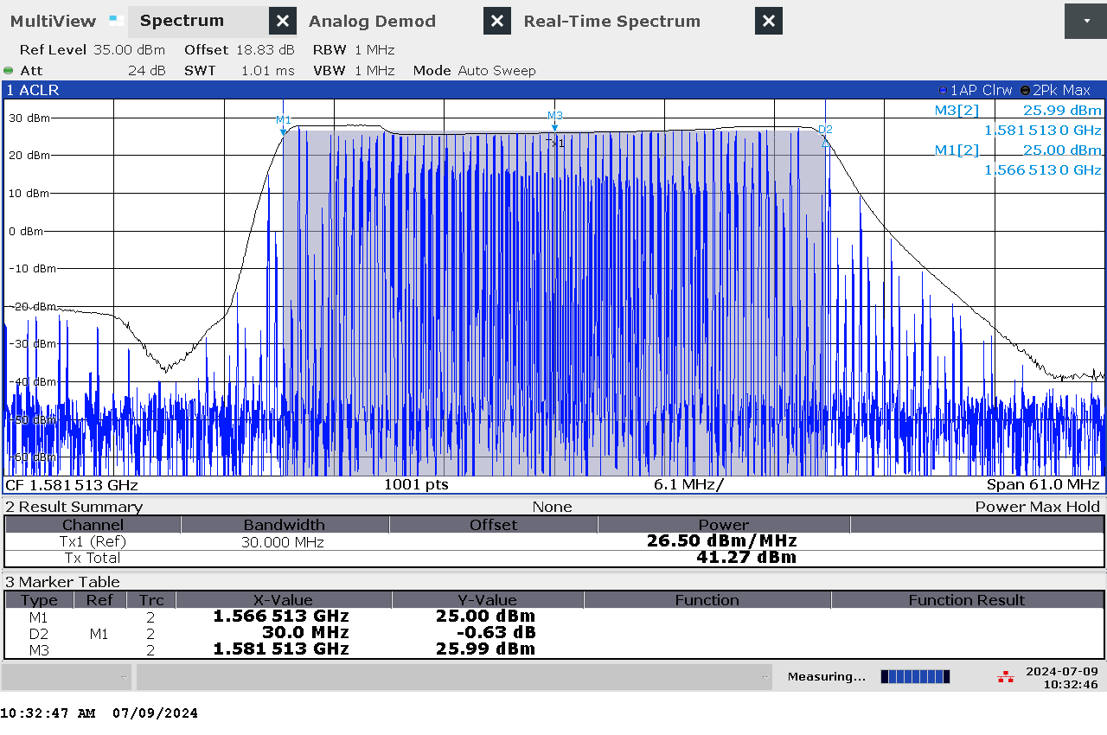

G 106: Frequency and power measurement of jammer H6.2 on antenna “4” (L1)

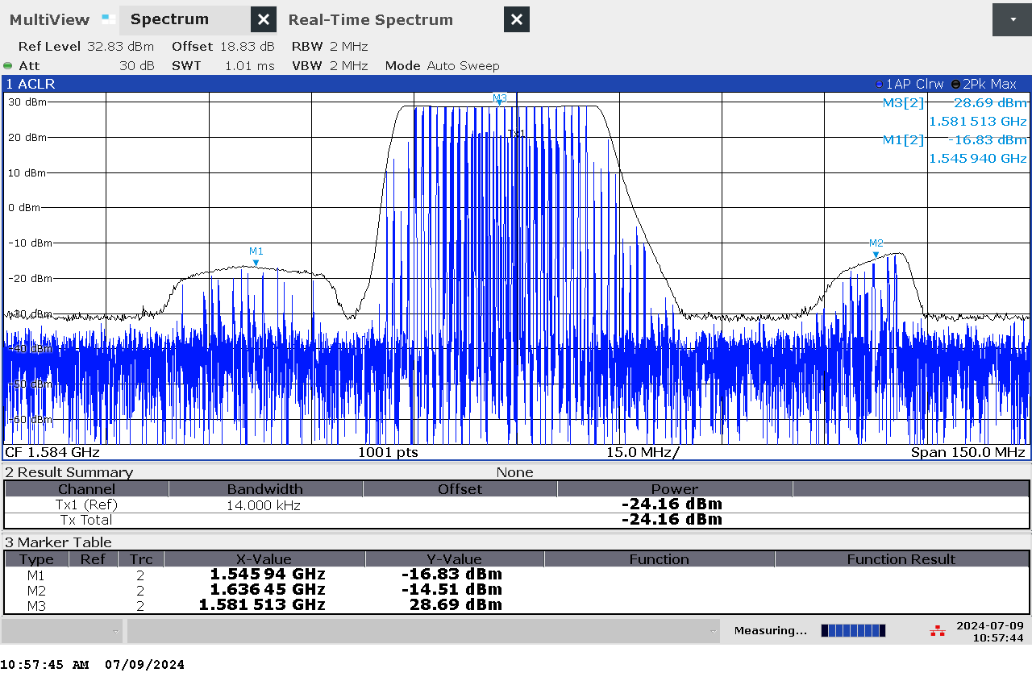

G 107: Frequency and power measurement with wider band of jammer H6.2 on antenna “4” (L1)

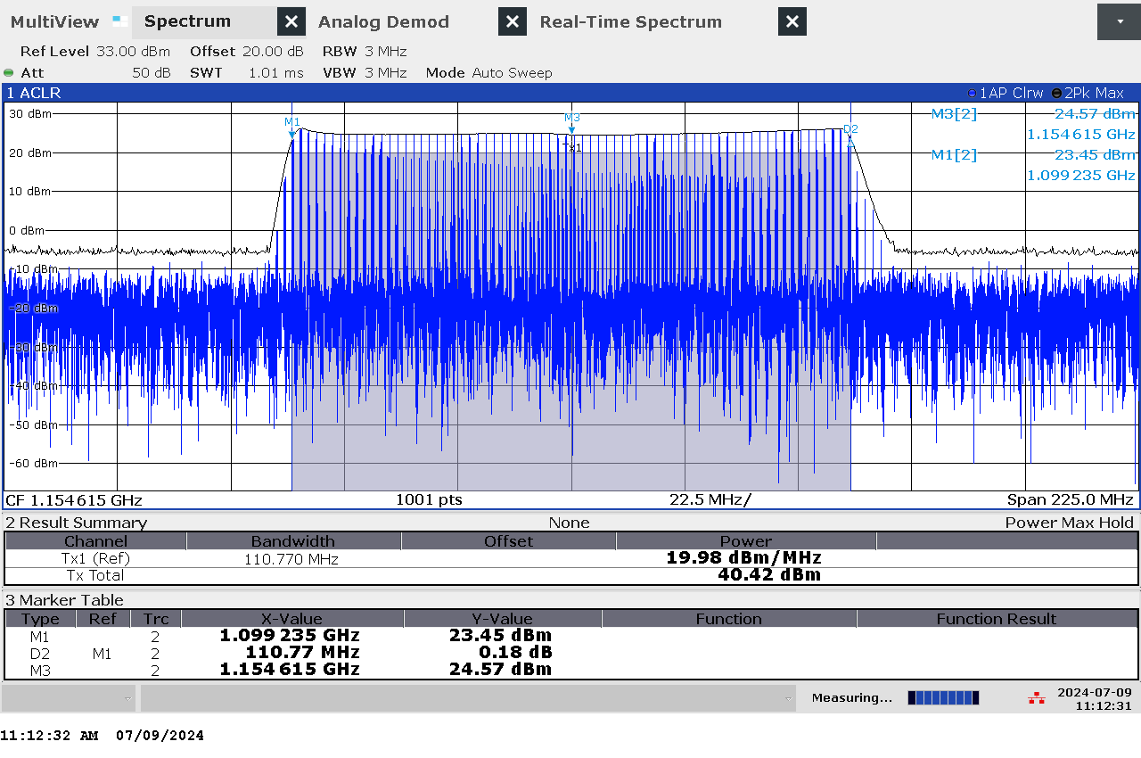

G 108: Frequency and power measurement of jammer H6.2 on antenna “5” (L5)

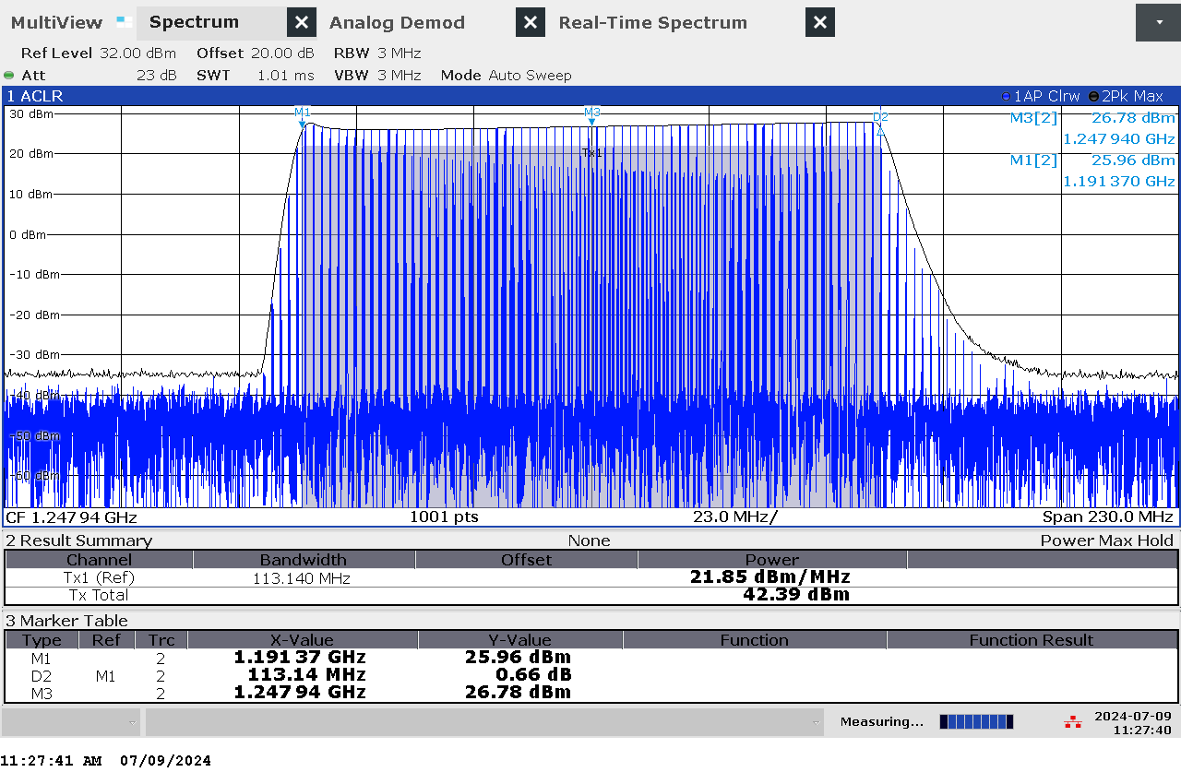

G 109: Frequency and power measurement of jammer H6.2 on antenna “6” (L2)

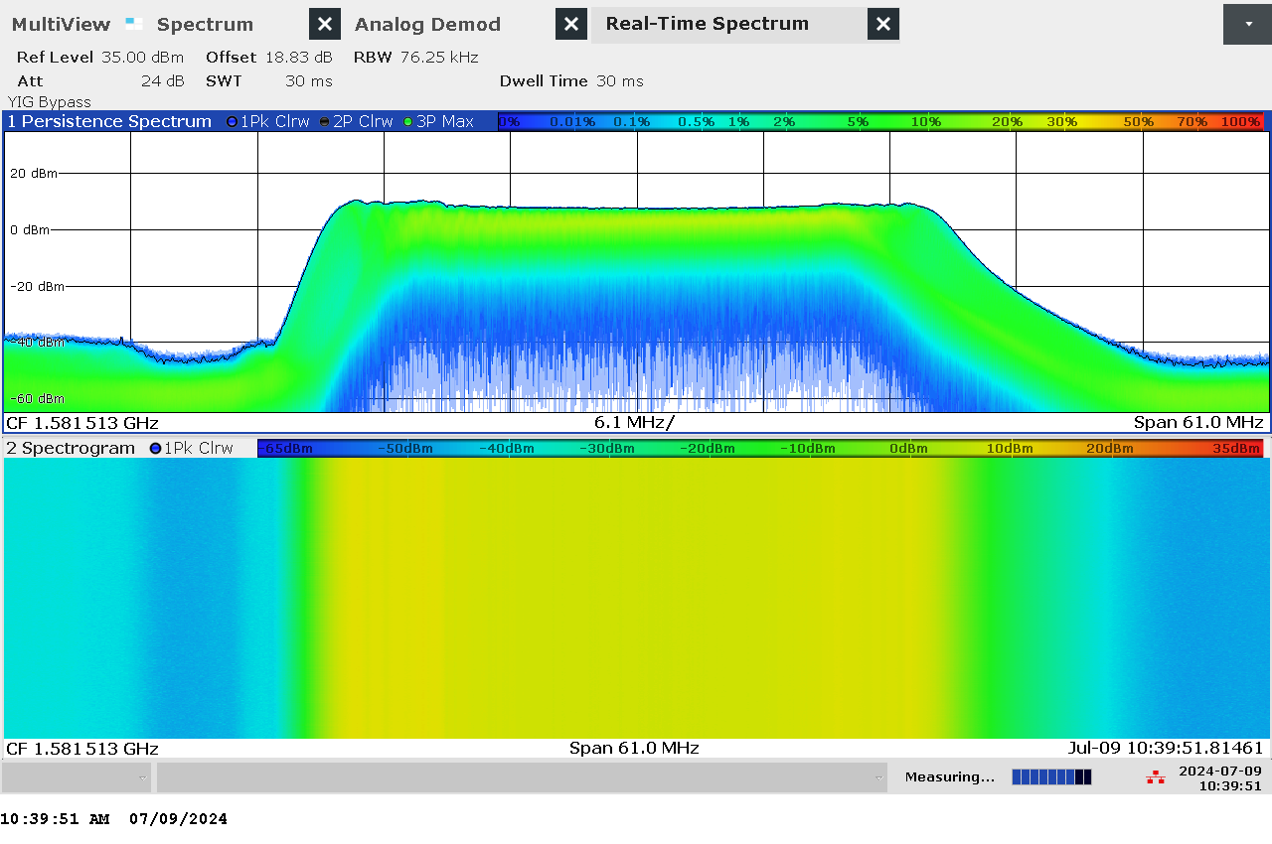

G 110: Real-time persistence and spectrogram measurement of jammer H6.2 on antenna “4” (L1)

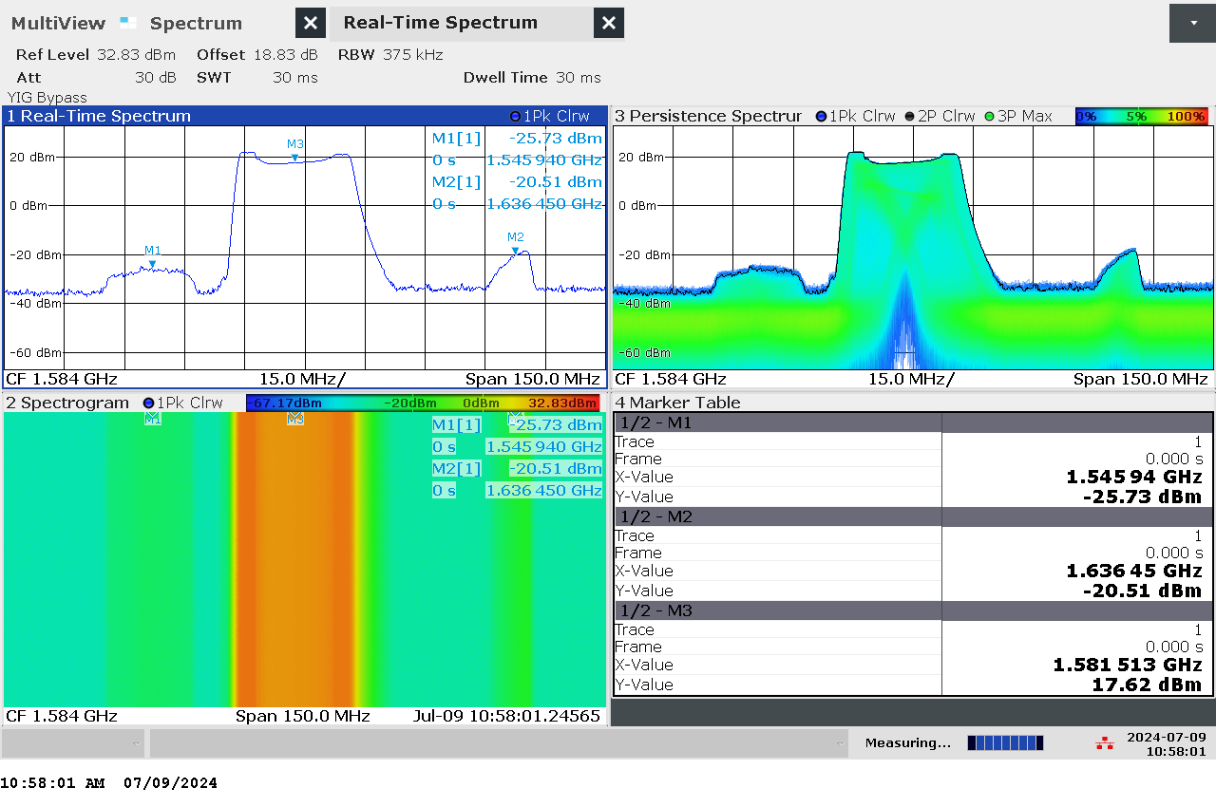

G 111: Real-time persistence and spectrogram measurement with wider span of jammer H6.2 on antenna “4” (L1)

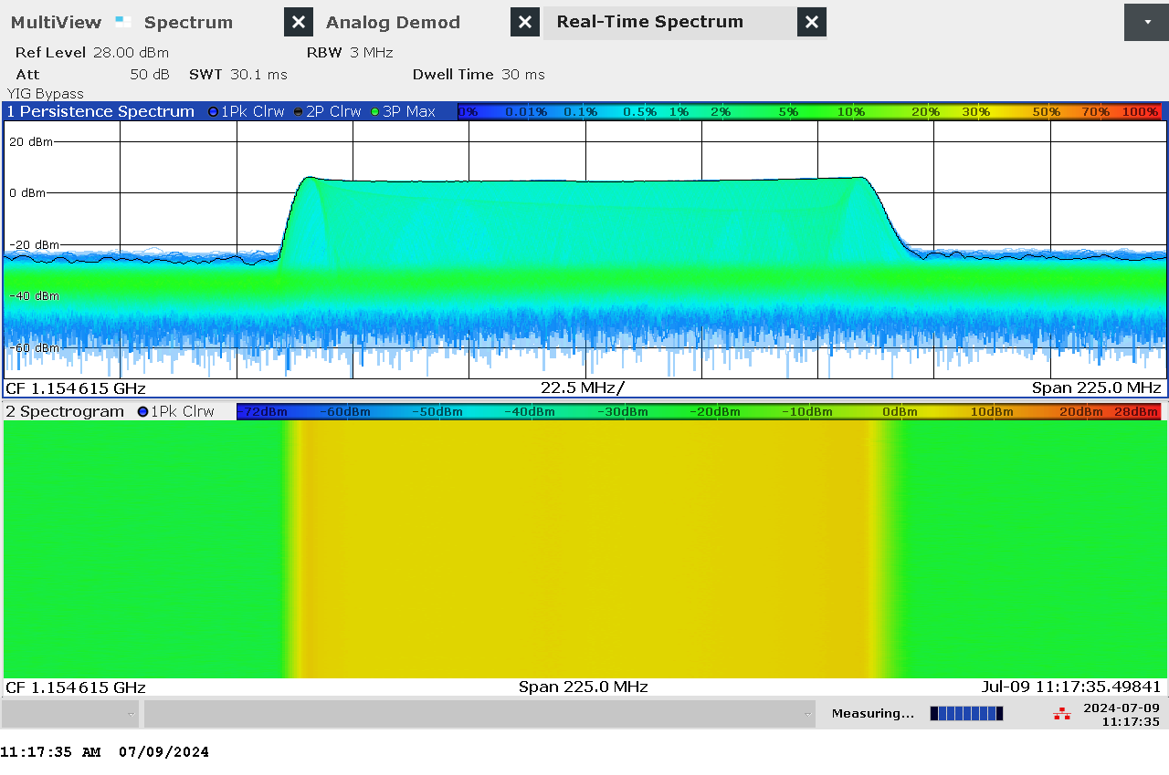

G 112: Real-time persistence and spectrogram measurement of jammer H6.2 on antenna “5” (L5)

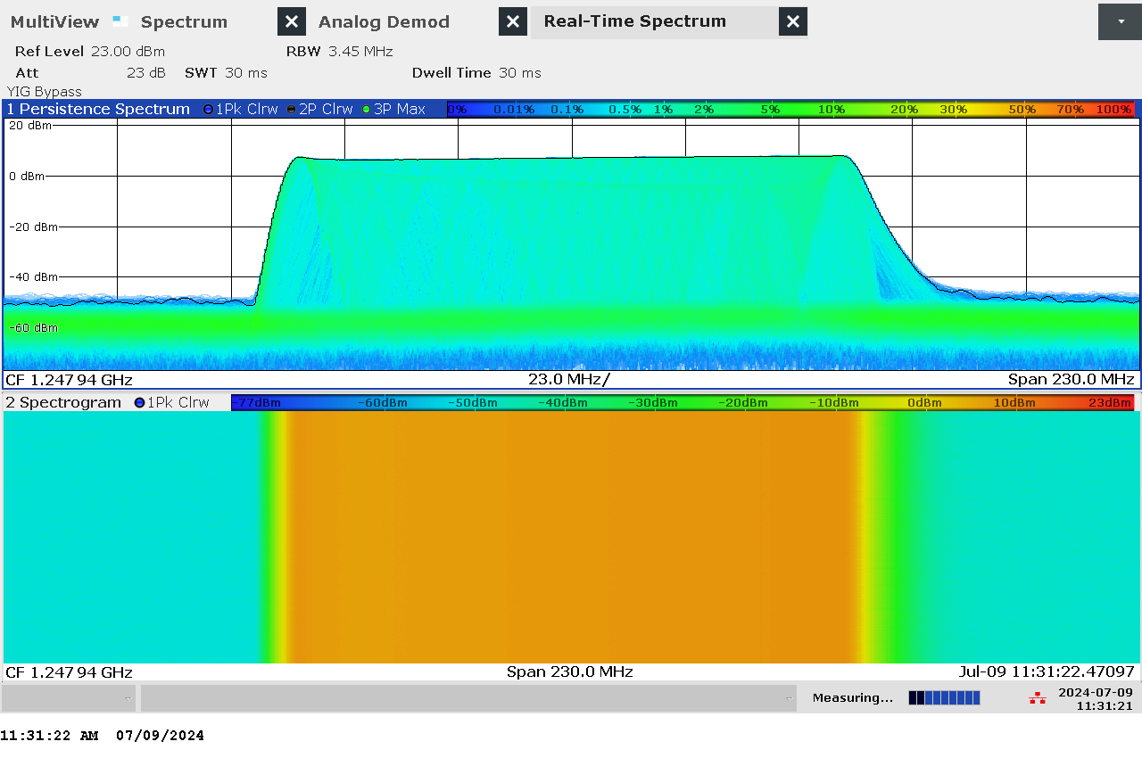

G 113: Real-time persistence and spectrogram measurement of jammer H6.2 on antenna “6” (L2)

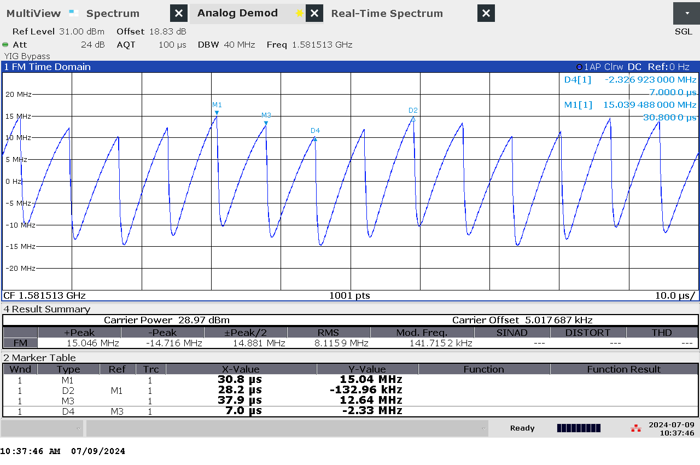

G 114: Time domain (analog demod) measurement with wider sweep of jammer H6.2 on antenna “4” (L1)

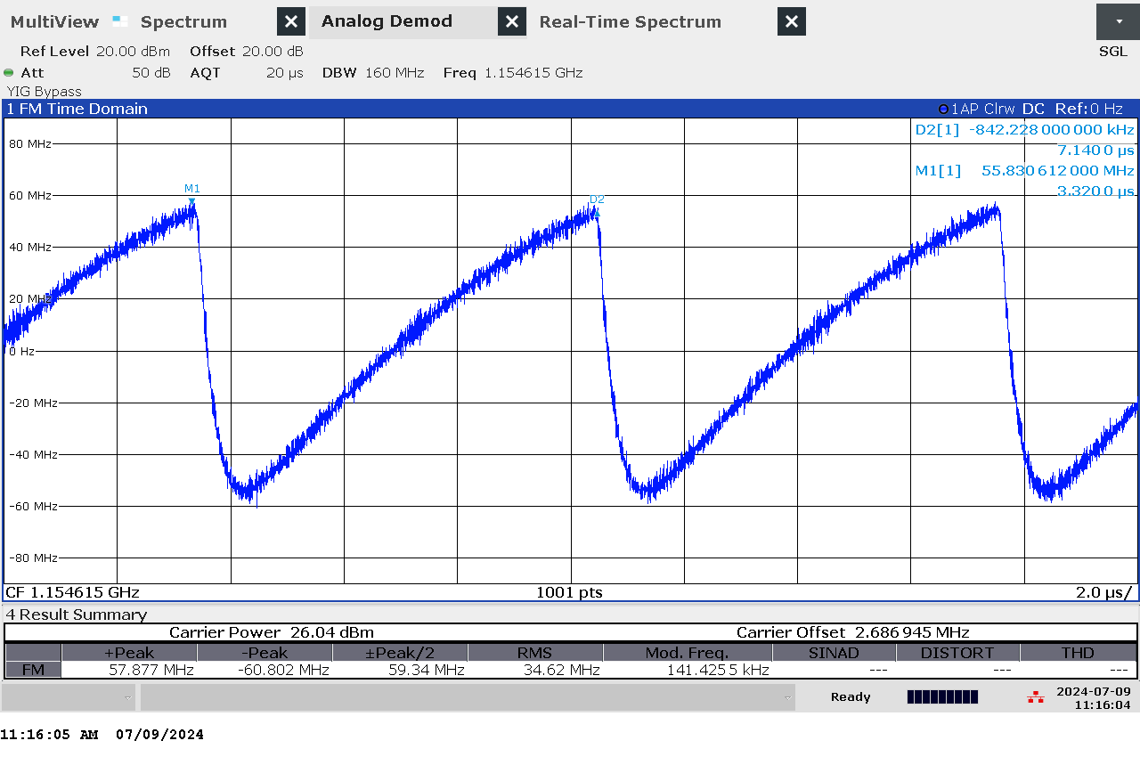

G 115: Time domain (analog demod) measurement of jammer H6.2 on antenna “5” (L5)

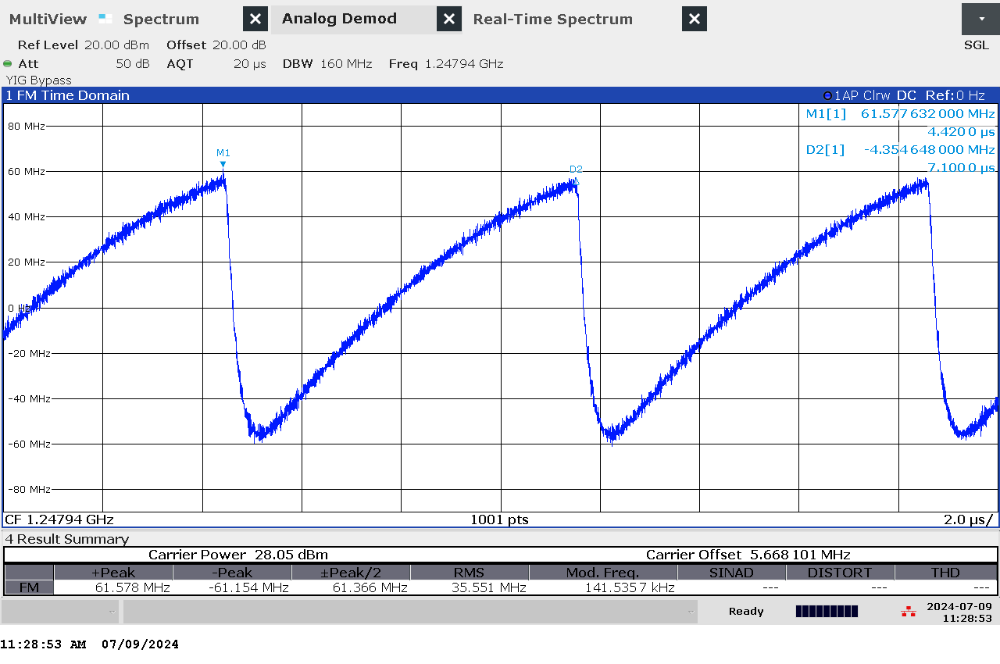

G 116: Time domain (analog demod) measurement of jammer H6.2 on antenna “6” (L2)

### Technical details on low-power jammer “H6.3”

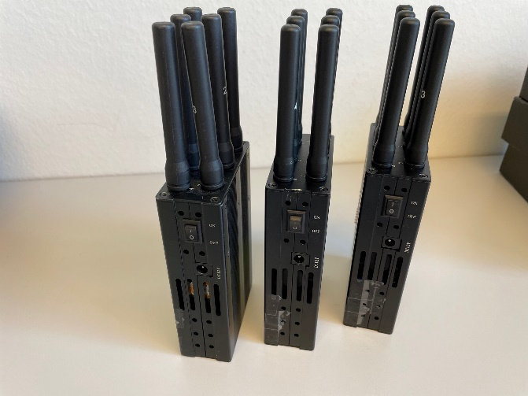The jammer H6.3 belongs to the ‘Handheld category’ of jammers. It is a larger but relatively light battery driven jammer with a relatively easy operation, just an on/off-button with a LED-light to indicate activation and DIP switches to change between channels.

H6.3 is a six-antenna, so-called “multi-frequency”, jammer. It jams six different bands, but only three channels are relevant for GNSS bands (“L1+L2+L5”), thus disrupting the upper and lower L-band.

The relevant antennas are marked with numbers: “4” (L1), “5” (L5) and “6” (L2).

Technical characteristics of H6.3 (2024 measurements)

|  |  |  |  |  |  |  |  |
| --- | --- | --- | --- | --- | --- | --- | --- |
| Antenna | Centre frequency [MHz] | Bandwidth [MHz] | PSD [dBm/MHz] | TX total [dBm] | CF max [dBm] | Sweep rate [µs] | Modulation |
| “4” (L1) | 1581,37 | 26,50 | 25,54 | 39,77 | 25,46 | 7,1 | Sawtooth |
| “5” (L5) | 1152,73 | 112,05 | 19,50 | 39,99 | 24,36 | 7,06 | Sawtooth |
| “6” (L2) | 1248,65 | 111,06 | 21,80 | 42,25 | 26,65 | 7,08 | Sawtooth |

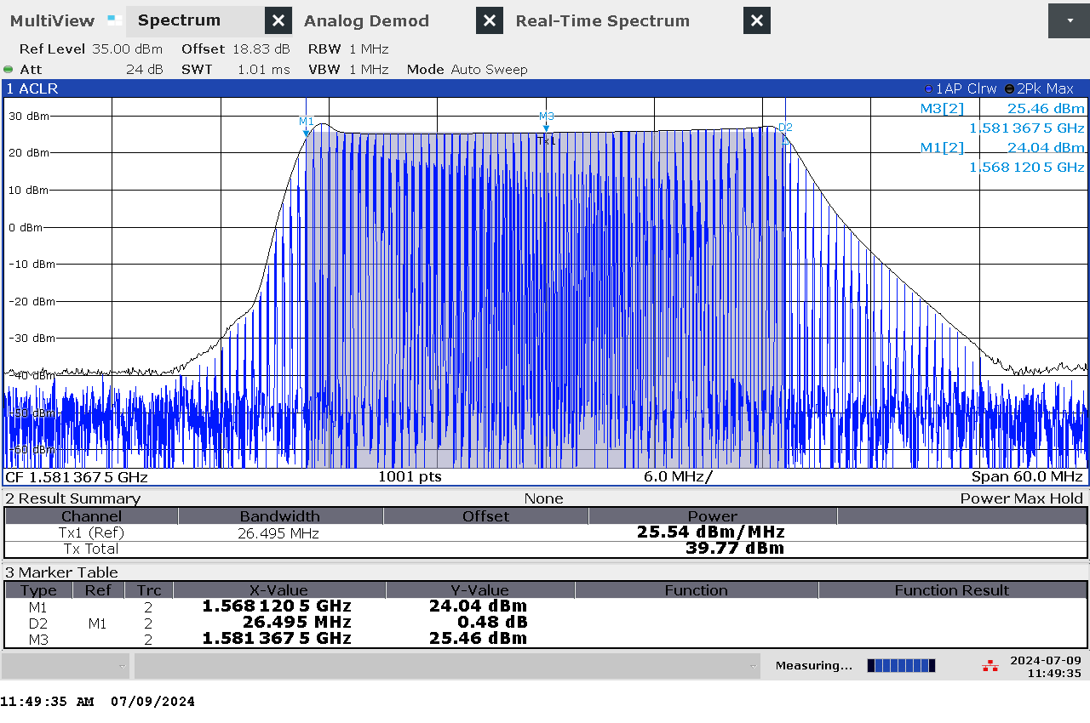

G 117: Frequency and power measurement of jammer H6.3 on antenna “4” (L1)

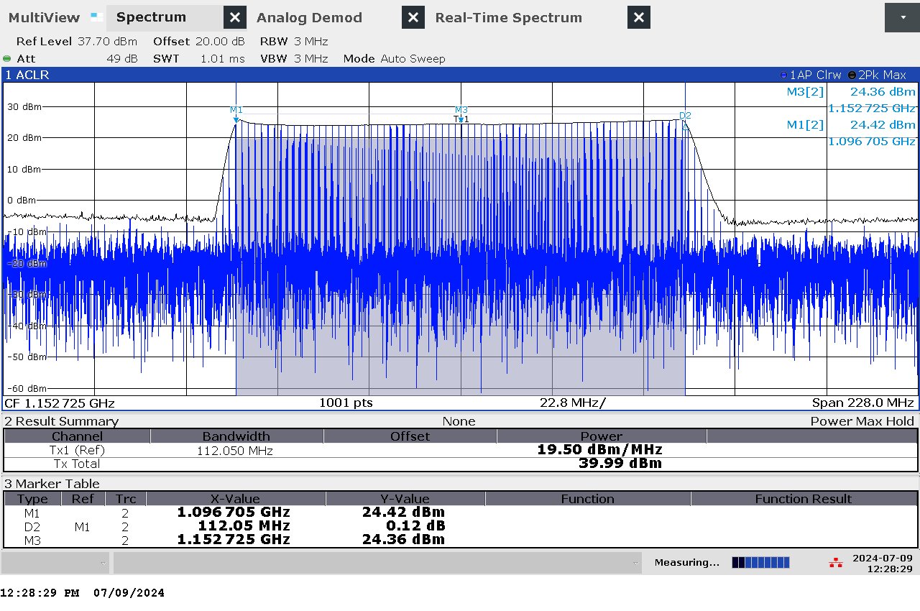

G 118: Frequency and power measurement of jammer H6.3 on antenna “5” (L5)

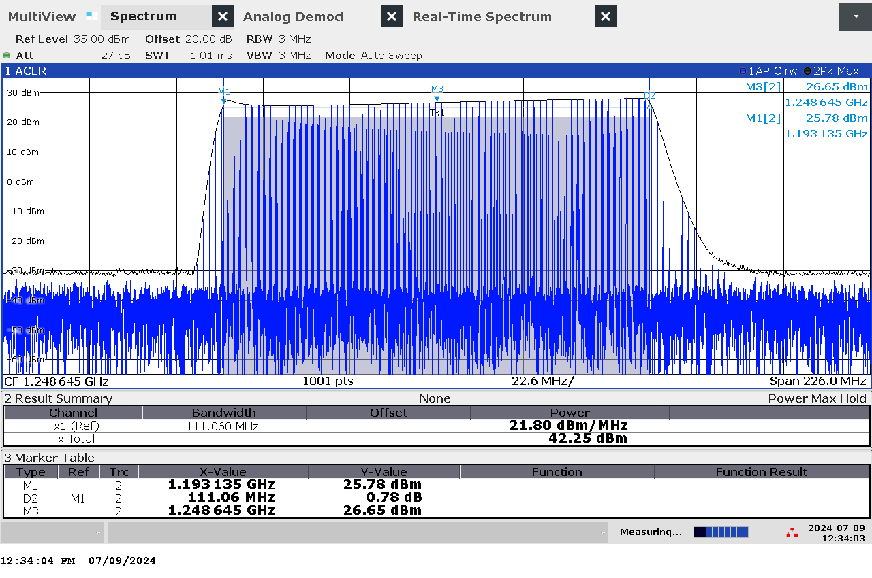

G 119: Frequency and power measurement of jammer H6.3 on antenna “6” (L2)

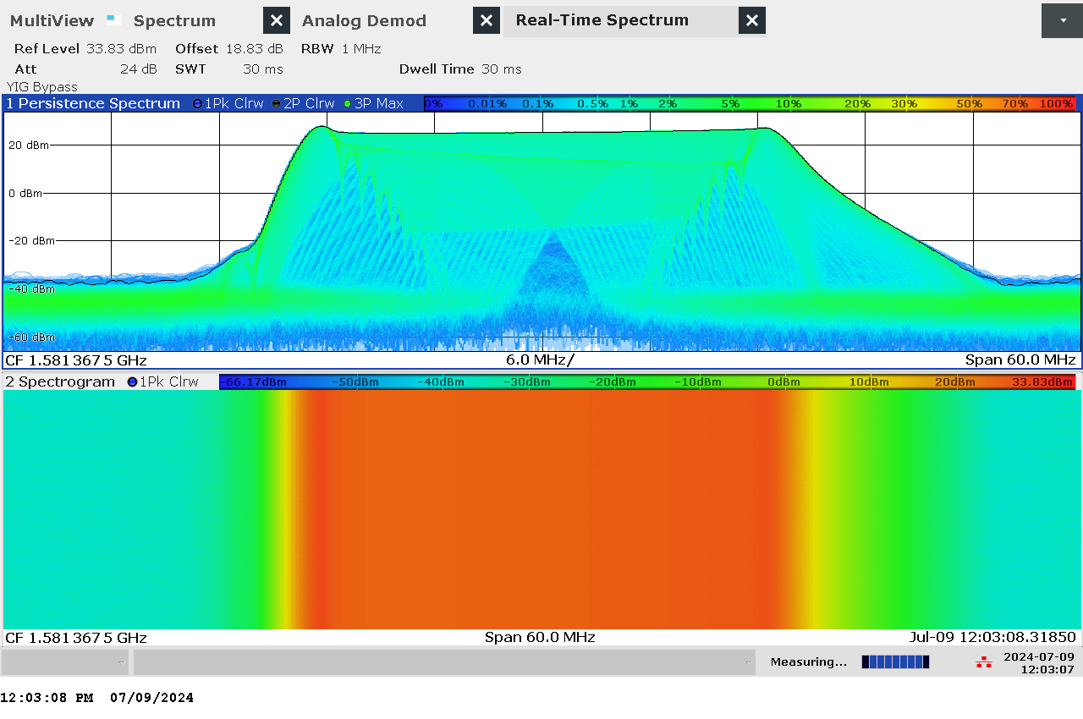

G 120: Real-time persistence and spectrogram measurement of jammer H6.3 on antenna “4” (L1)

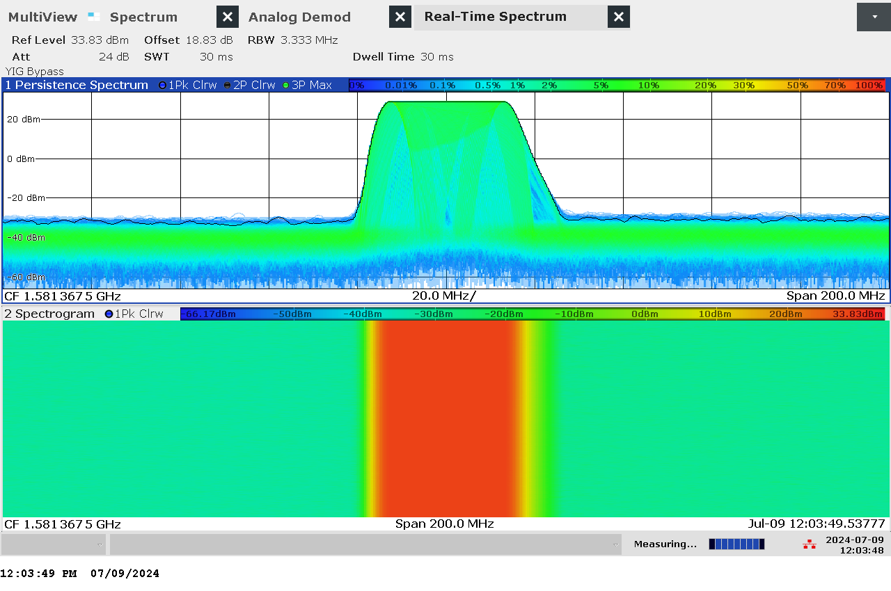

G 121: Real-time persistence and spectrogram measurement with wider span of jammer H6.3 on antenna “4” (L1)

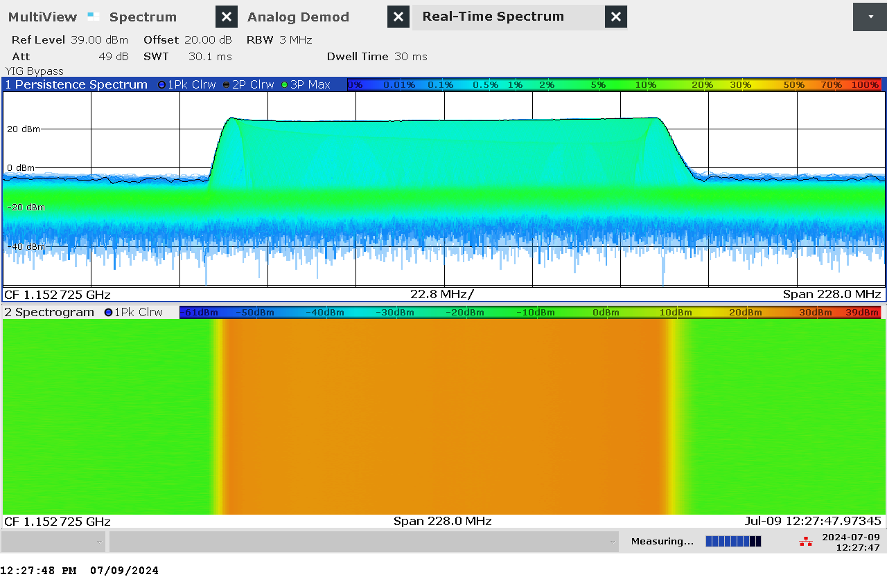

G 122: Real-time persistence and spectrogram measurement of jammer H6.3 on antenna “5” (L5)

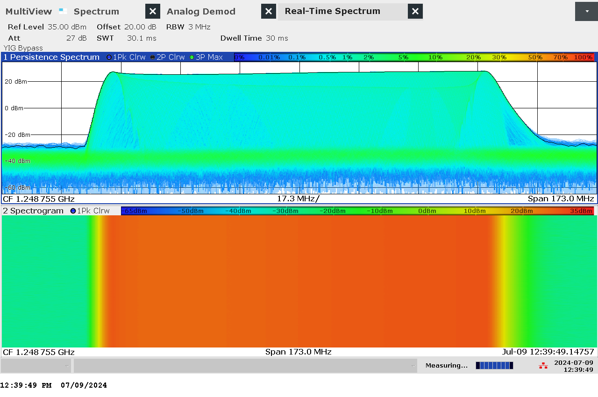

G 123: Real-time persistence and spectrogram measurement of jammer H6.3 on antenna “6” (L2)

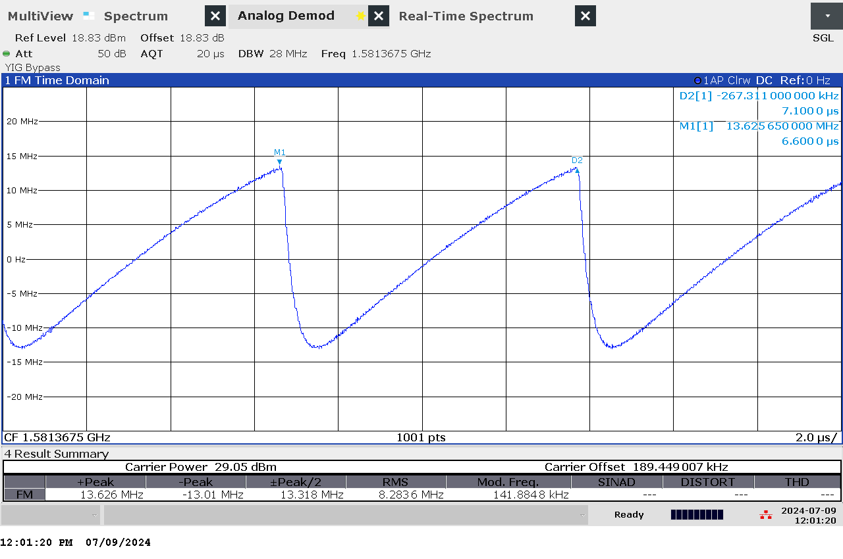

G 124: Time domain (analog demod) measurement of jammer H6.3 on antenna “4” (L1)

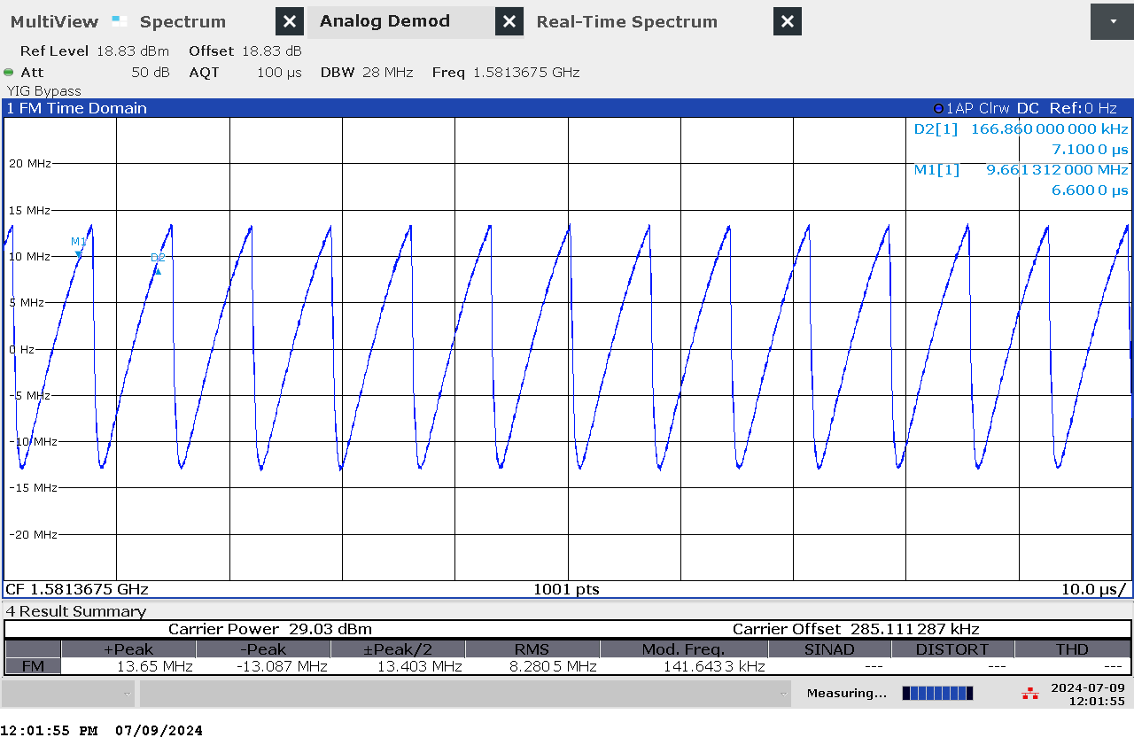

G 125: Time domain (analog demod) measurement with wider sweep of jammer H6.3 on antenna “4” (L1)

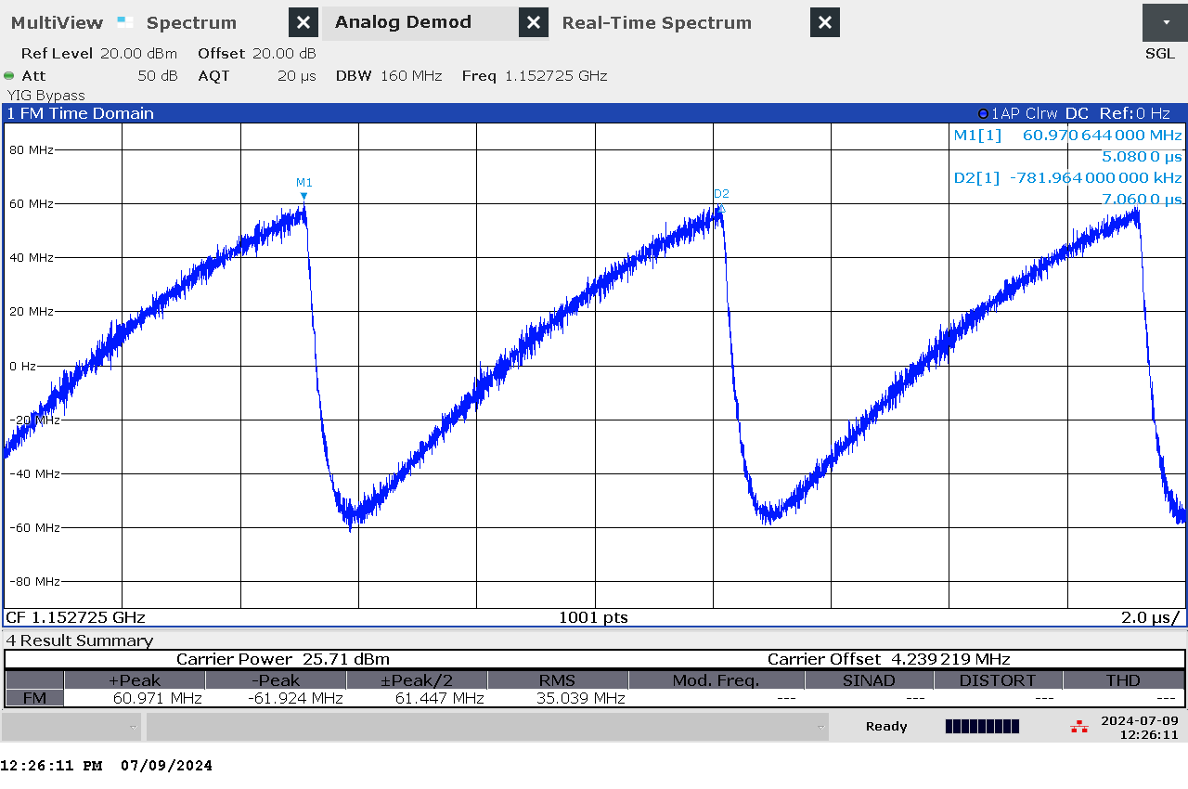

G 126: Time domain (analog demod) measurement of jammer H6.3 on antenna “5” (L5)

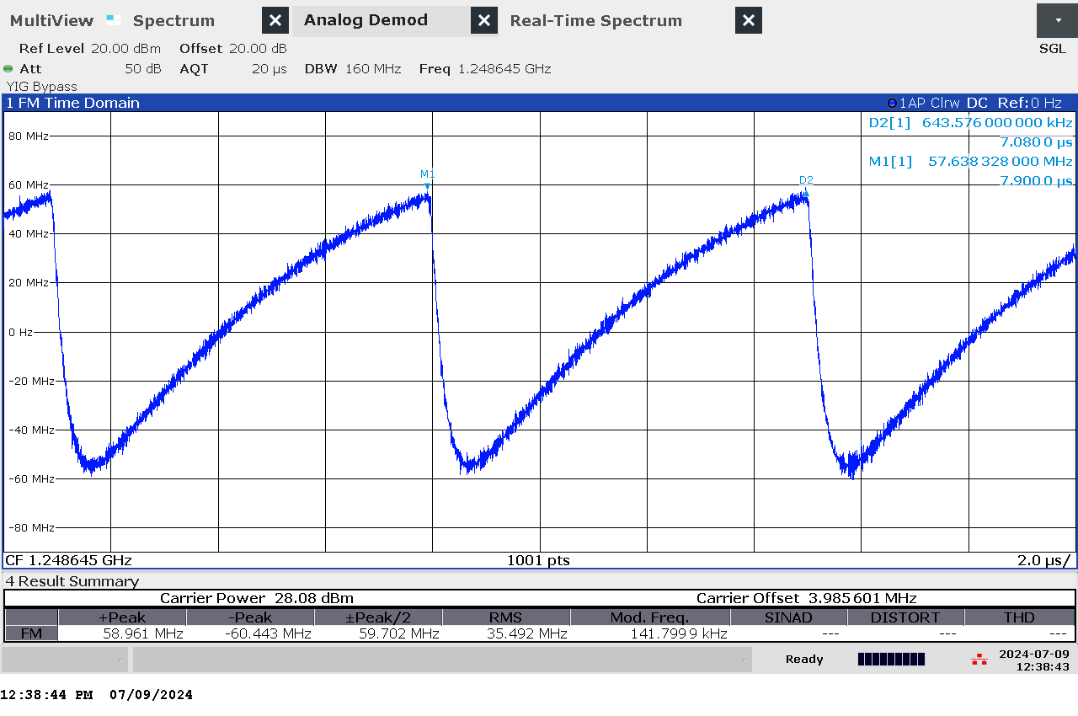

G 127: Time domain (analog demod) measurement of jammer H6.3 on antenna “6” (L2)

### Et bilde som inneholder innendørs, eske, kontorforsyninger, verktøy Automatisk generert beskrivelseTechnical details on low-power jammer “H6.4”

The jammer H6.4 belongs to the ‘Handheld category’ of jammers. It is a larger but relatively light battery driven jammer with a relatively easy operation, just an on/off-button with a LED-light to indicate activation and DIP switches to change between channels.

H6.4 is a six-antenna, so-called “multi-frequency”, jammer. It jams six different bands, but only three channels are relevant for GNSS bands (“L1+L2+L5”), thus disrupting the upper and lower L-band.

The relevant antennas are marked with numbers: “1” (L5), “3” (L2) and “5” (L1)

Technical characteristics of H6.4 (2024 measurements)

|  |  |  |  |  |  |  |  |
| --- | --- | --- | --- | --- | --- | --- | --- |
| Antenna | Centre frequency [MHz] | Bandwidth [MHz] | PSD [dBm/MHz] | TX total [dBm] | CF max [dBm] | Sweep rate [µs] | Modulation |
| “1” (L5) | 1176,66 | 17,23 | 16,54 | 28,91 | 19,30 | 10,62 | Triangle |
| “3” (L2) | 1248,01 | 85,41 | 23,54 | 42,86 | 26,15 | 10,3 | Triangle |
| “5” (L1) | 1593,36 | 81,28 | 22,82 | 41,92 | 25,63 | 11 | Triangle |

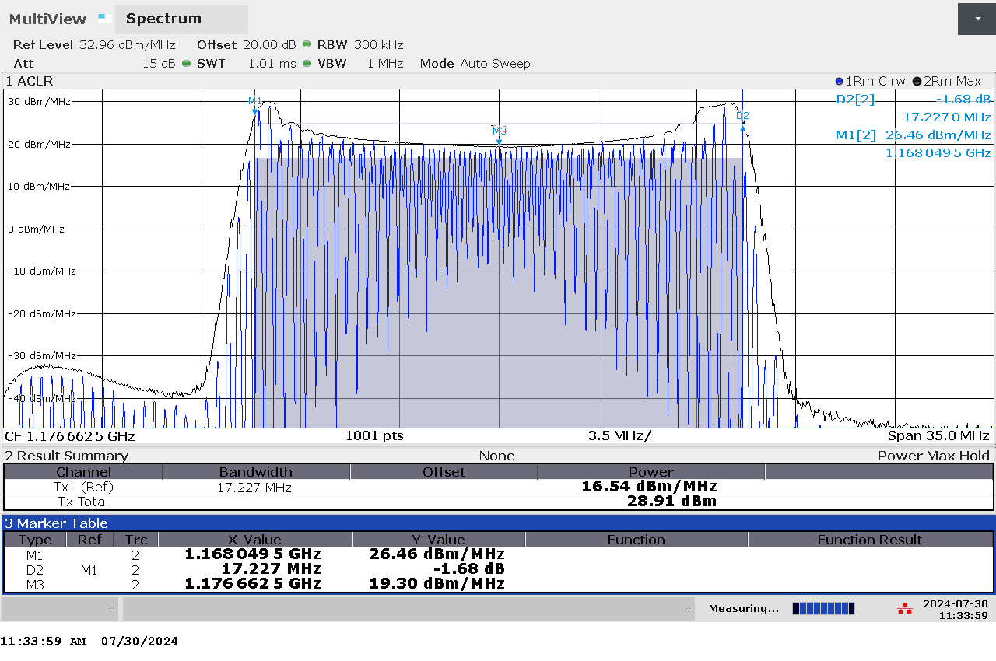

G 128: Frequency and power measurement of jammer H6.4 on antenna “1” (L5)

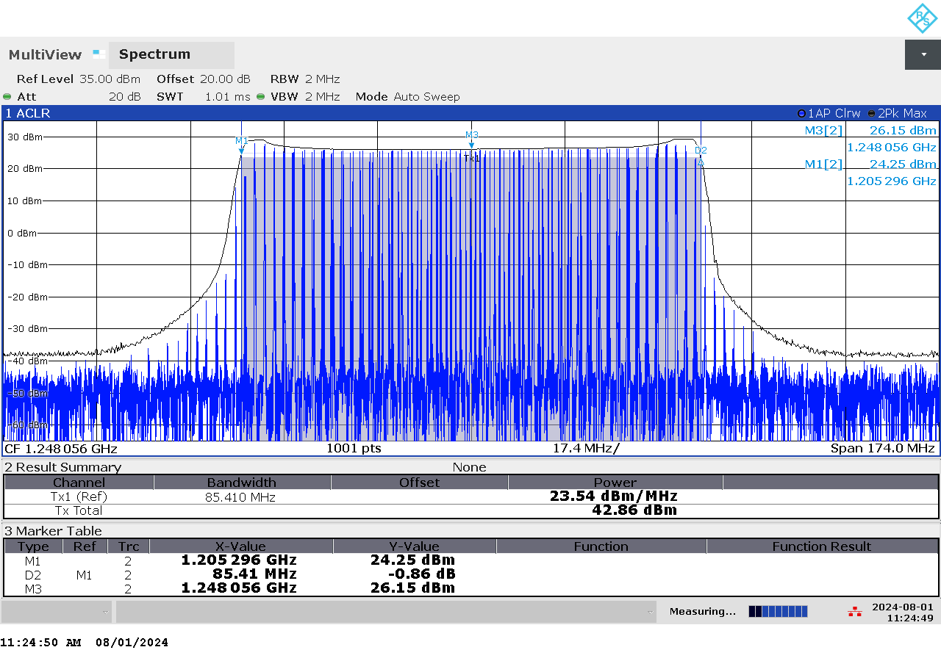

G 129: Frequency and power measurement of jammer H6.4 on antenna “3” (L2)

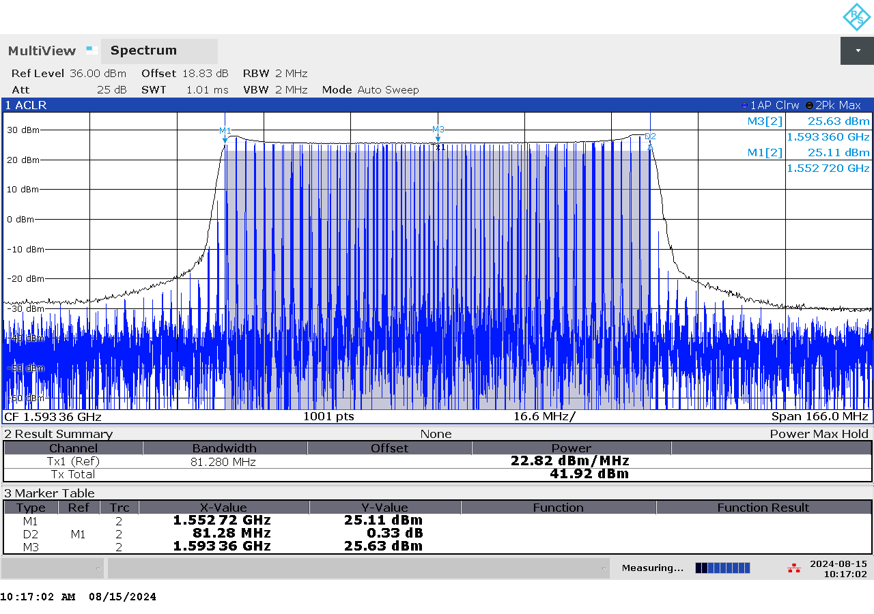

G 130: Frequency and power measurement of jammer H6.4 on antenna “5” (L1)

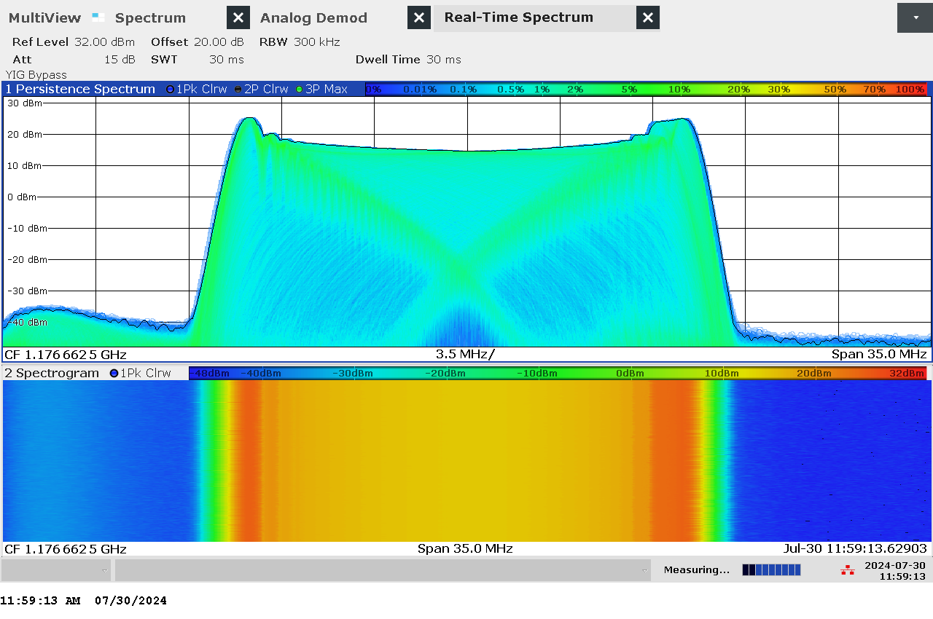

G 131: Real-time persistence and spectrogram measurement of jammer H6.4 on antenna “1” (L5)

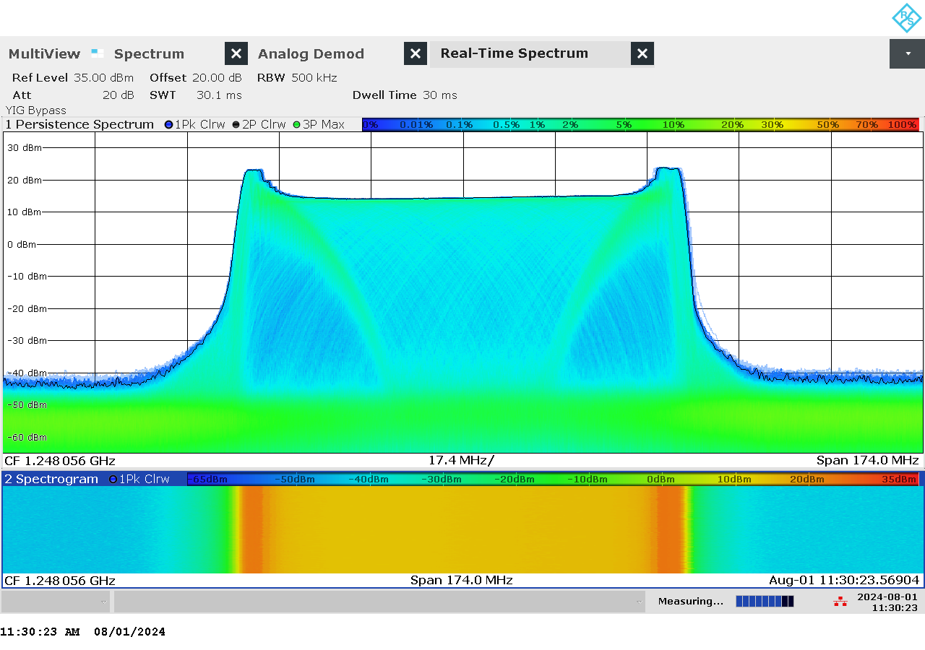

G 132: Real-time persistence and spectrogram measurement of jammer H6.4 on antenna “3” (L2)

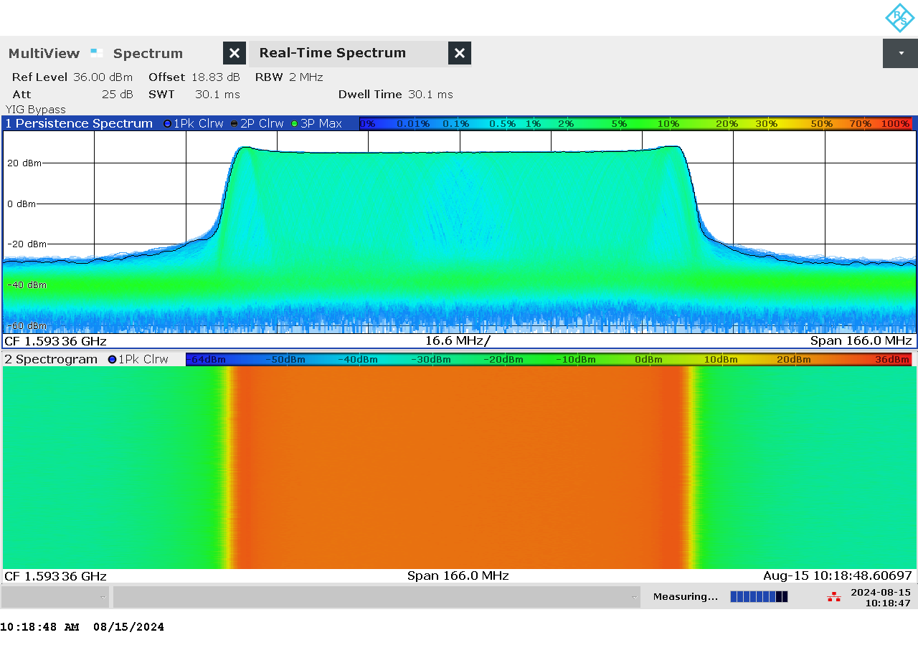

G 133: Real-time persistence and spectrogram measurement of jammer H6.4 on antenna “5” (L1)

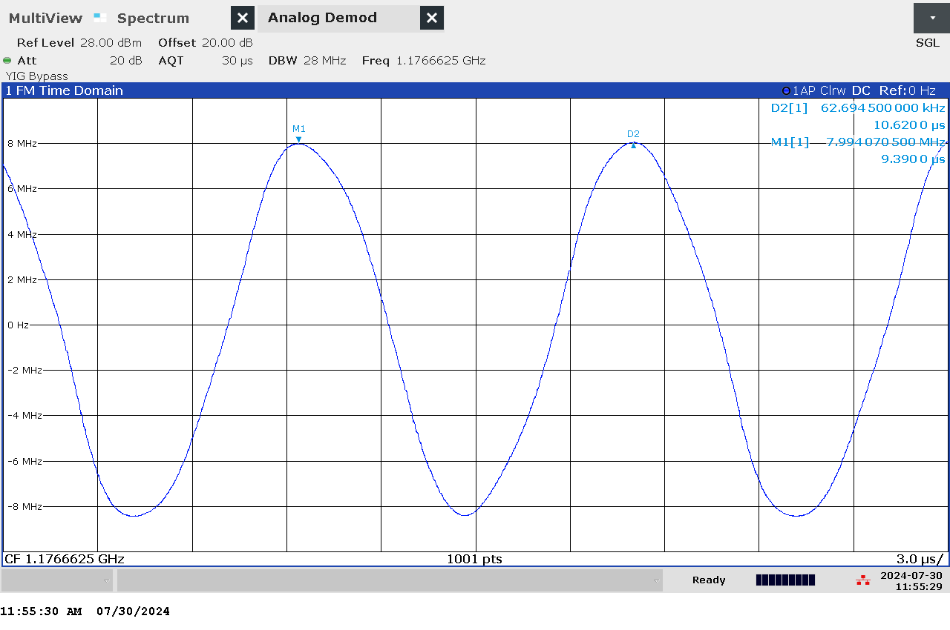

G 134: Time domain (analog demod) measurement of jammer H6.4 on antenna “1” (L5)

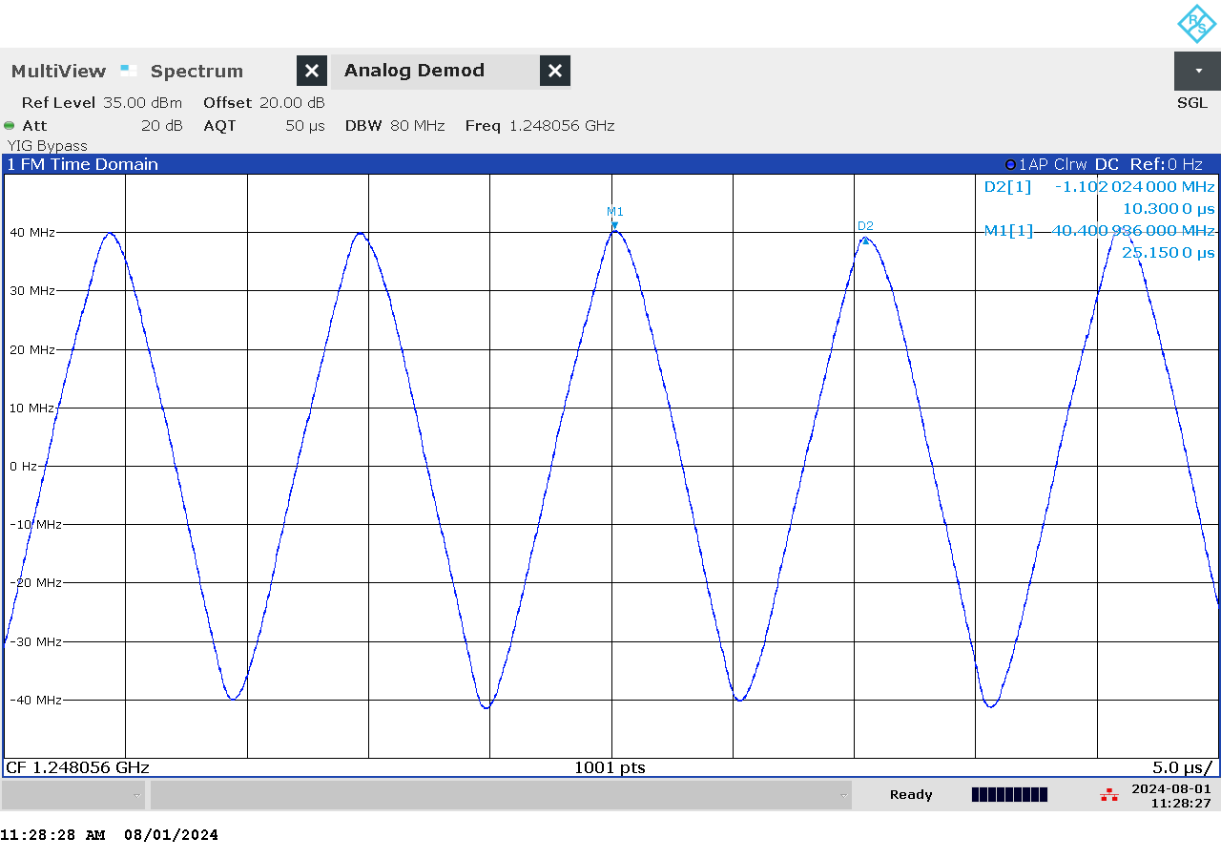

G 135: Time domain (analog demod) measurement of jammer H6.4 on antenna “3” (L2)

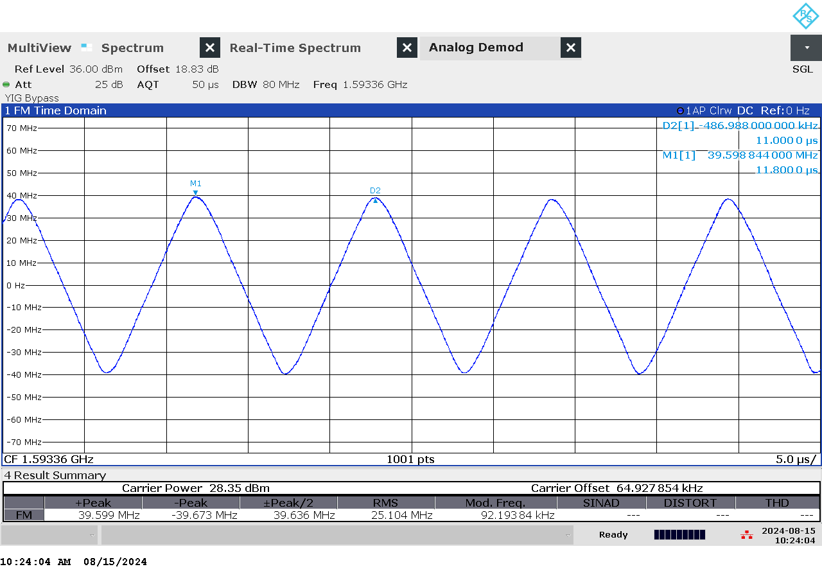

G 136: Time domain (analog demod) measurement of jammer H6.4 on antenna “5” (L1)

### Et bilde som inneholder innendørs, eske, kontorforsyninger, verktøy Automatisk generert beskrivelseTechnical details on low-power jammer “H6.5”

The jammer H6.5 belongs to the ‘Handheld category’ of jammers. It is a larger but relatively light battery driven jammer with a relatively easy operation, just an on/off-button with a LED-light to indicate activation and DIP switches to change between channels.

H6.5 is a six-antenna, so-called “multi-frequency”, jammer. It jams six different bands, but only three channels are relevant for GNSS bands (“L1+L2+L5”), thus disrupting the upper and lower L-band.

The relevant antennas are marked with numbers: “1” (L5), “3” (L2) and “5” (L1)

Technical characteristics of H6.5 (2024 measurements)

|  |  |  |  |  |  |  |  |
| --- | --- | --- | --- | --- | --- | --- | --- |
| Antenna | Centre frequency [MHz] | Bandwidth [MHz] | PSD [dBm/MHz] | TX total [dBm] | CF max [dBm] | Sweep rate [µs] | Modulation |
| “1” (L5) | 1180,33 | 24,28 | 24,73 | 38,58 | 27,66 | 10,26 | Triangle |
| “3” (L2) | 1247,05 | 82,22 | 23,22 | 42,37 | 25,77 | 10,32 | Triangle |
| “5” (L1) | 1595,6 | 80,12 | 22,62 | 41,65 | 25,41 | 10,3 | Triangle |

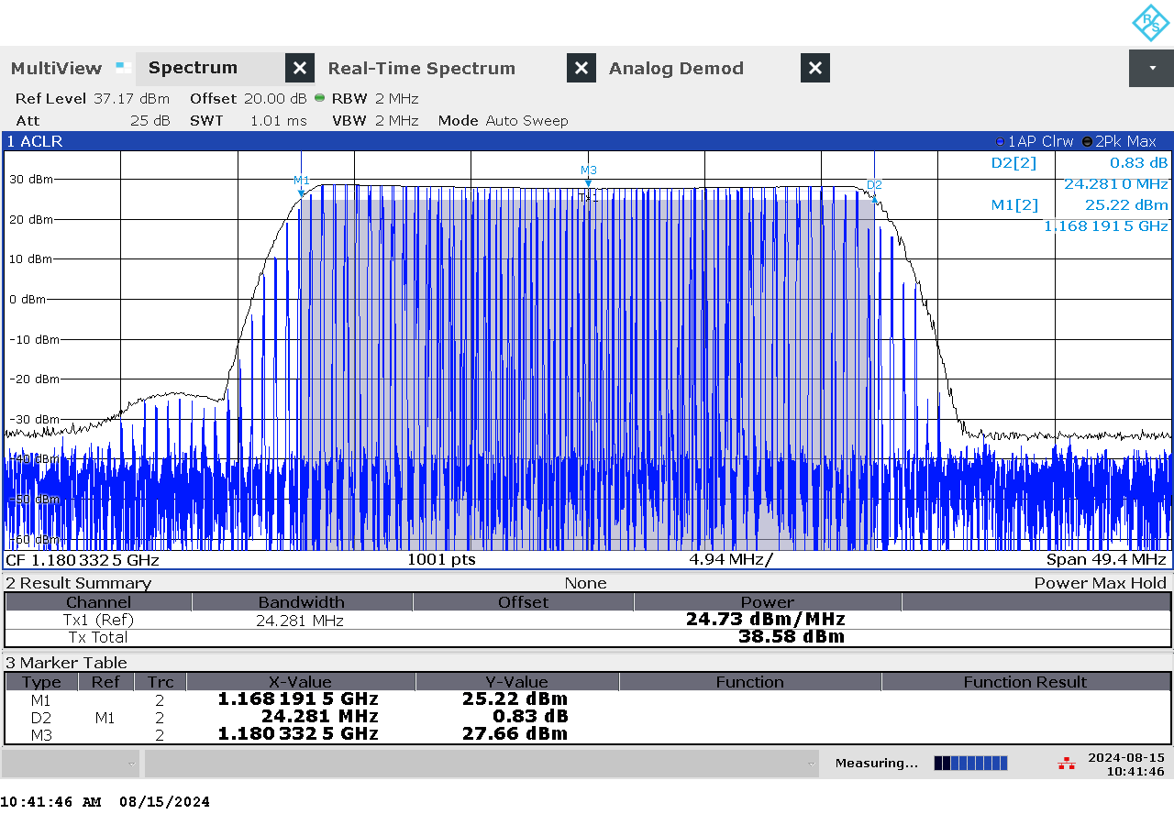

G 137: Frequency and power measurement of jammer H6.5 on antenna “1” (L5)

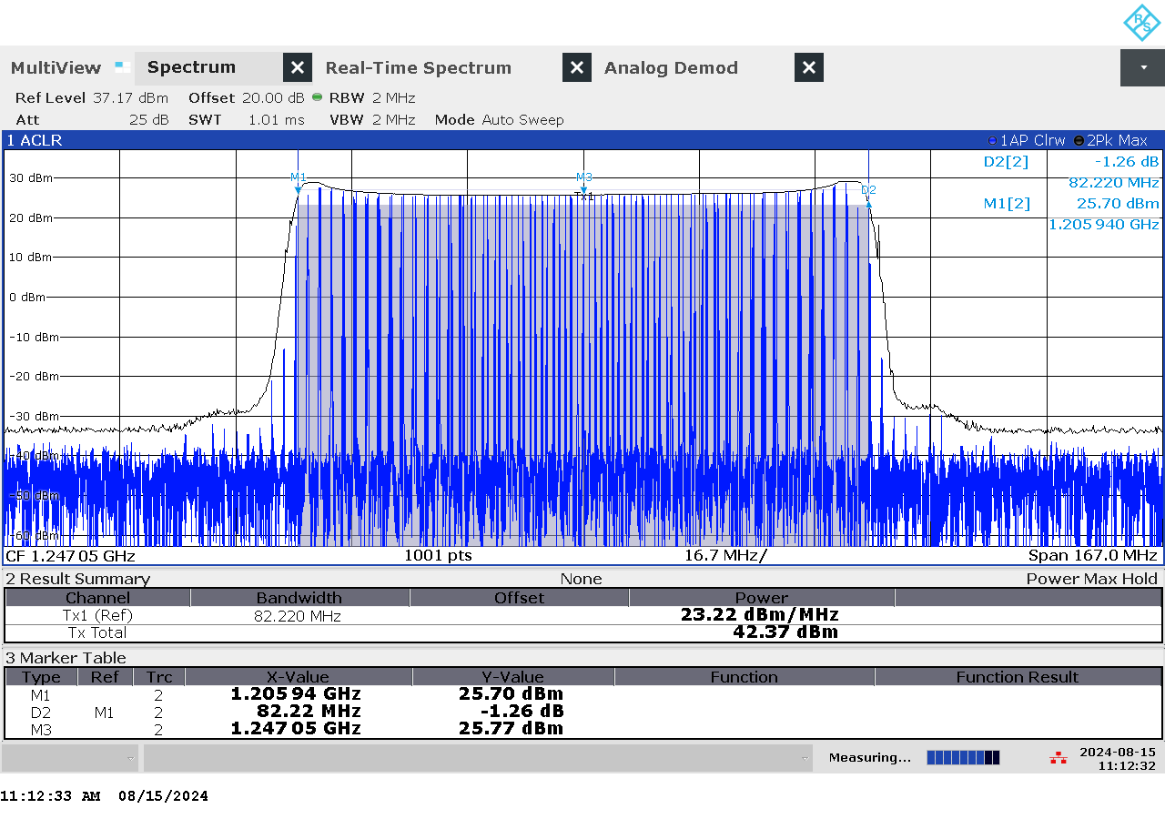

G 138: Frequency and power measurement of jammer H6.5 on antenna “3” (L2)

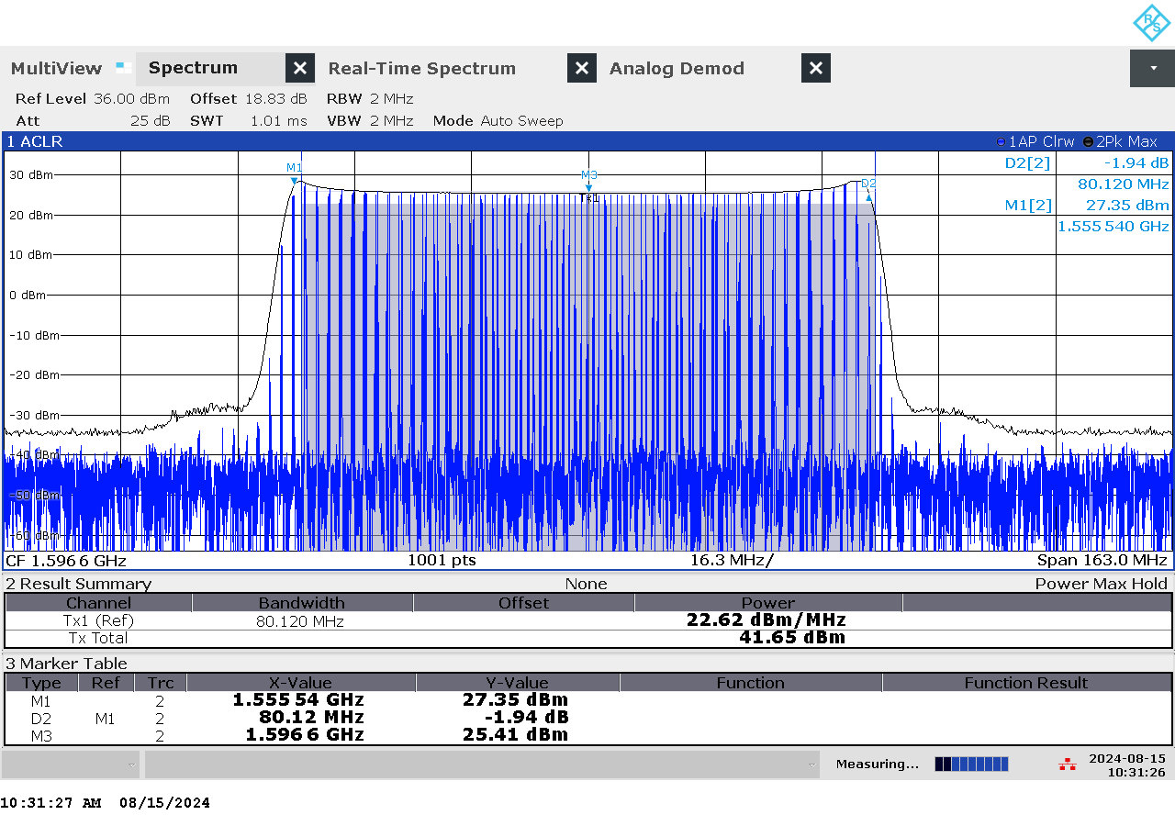

G 139: Frequency and power measurement of jammer H6.5 on antenna “5” (L1)

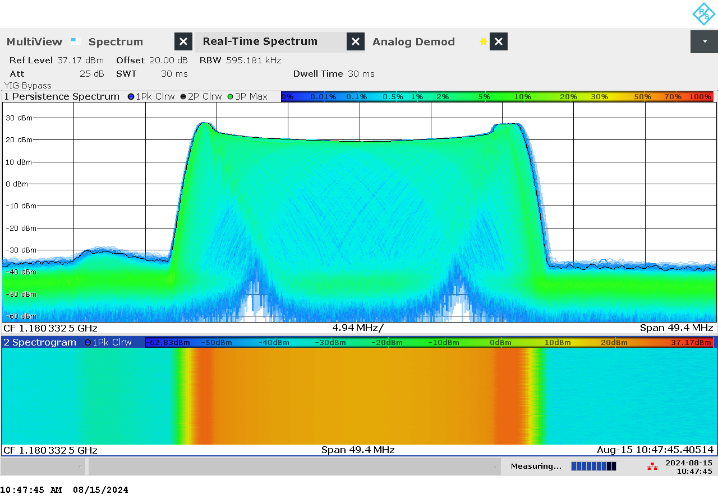

G 140: Real-time persistence and spectrogram measurement of jammer H6.5 on antenna “1” (L5)

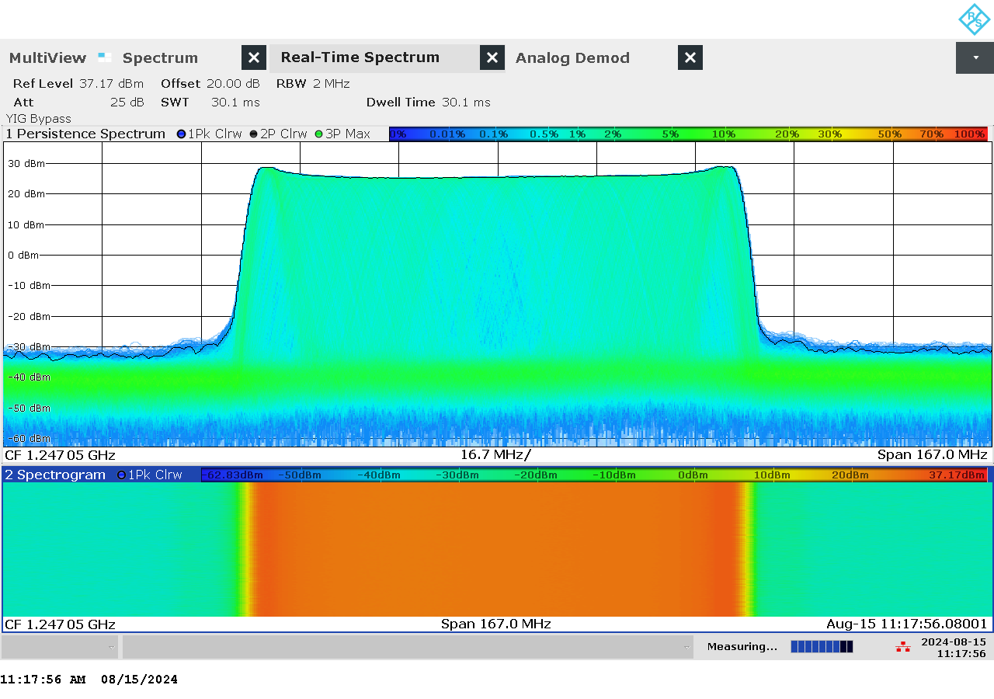

G 141: Real-time persistence and spectrogram measurement of jammer H6.5 on antenna “3” (L2)

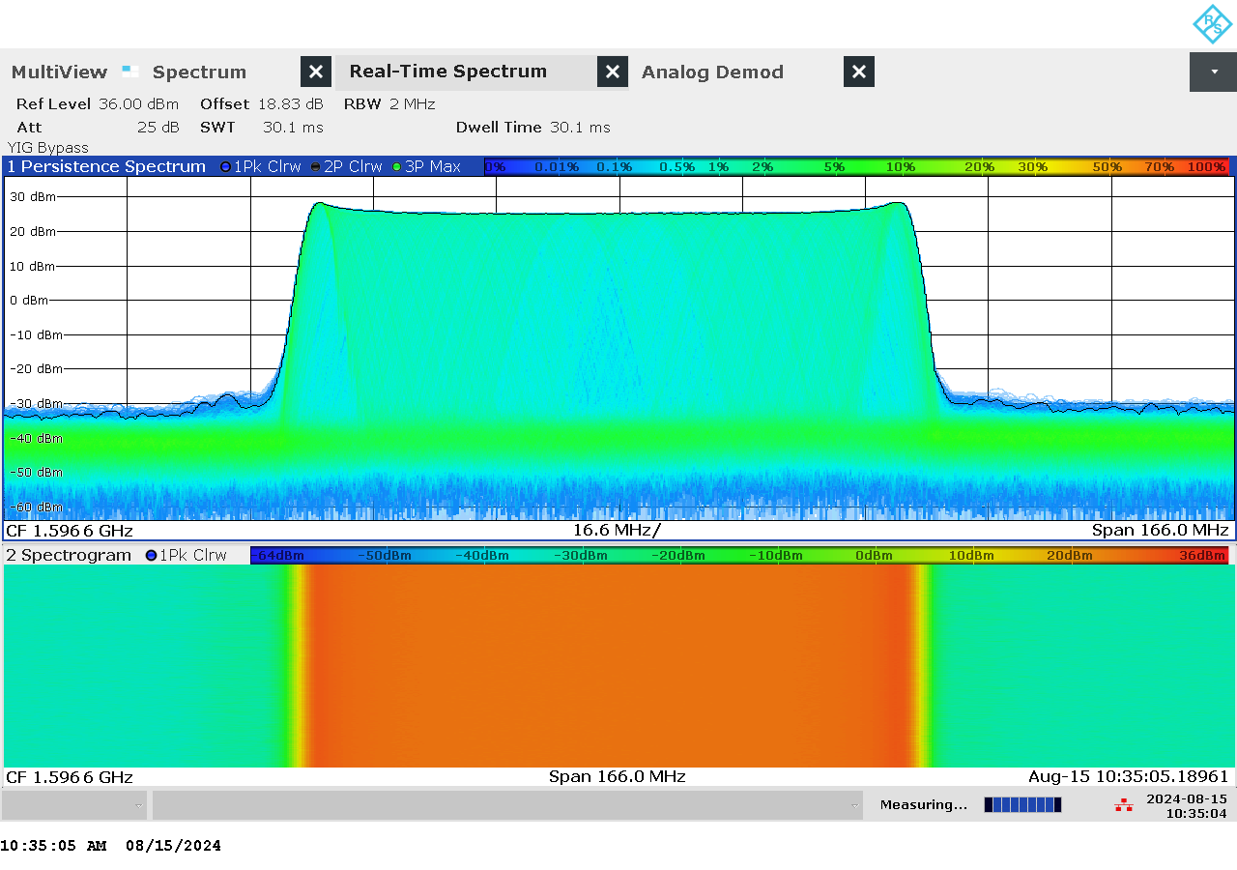

G 142: Real-time persistence and spectrogram measurement of jammer H6.5 on antenna “5” (L1)

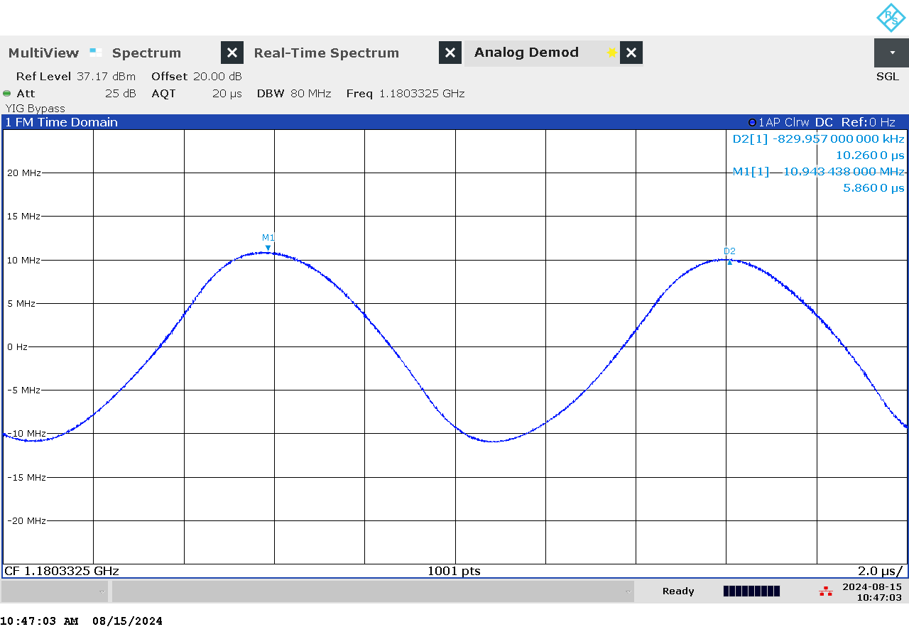

G 143: Time domain (analog demod) measurement of jammer H6.5 on antenna “1” (L5)

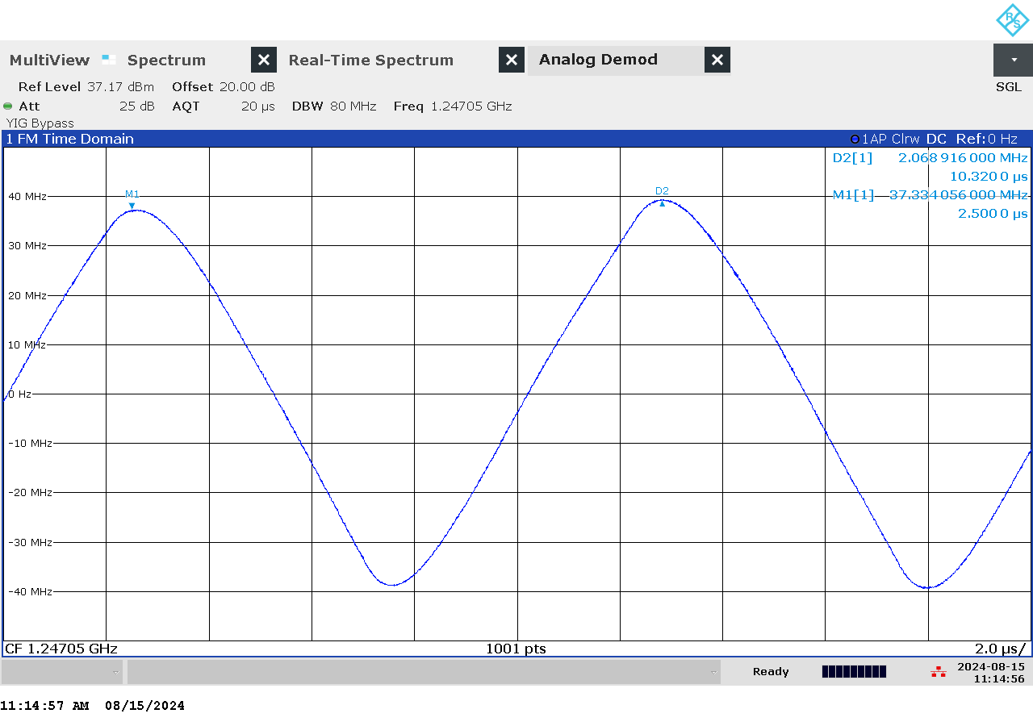

G 144: Time domain (analog demod) measurement of jammer H6.5 on antenna “3” (L2)

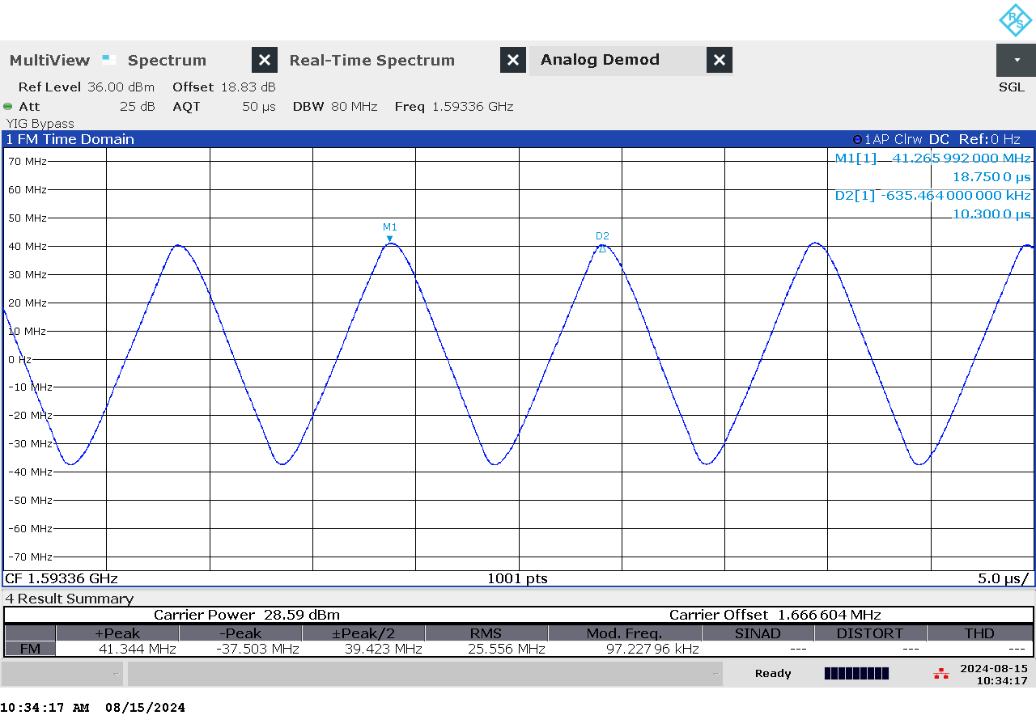

G 145: Time domain (analog demod) measurement of jammer H6.5 on antenna “5” (L1)

### Et bilde som inneholder innendørs, eske, kontorforsyninger, verktøy Automatisk generert beskrivelseTechnical details on low-power jammer “H6.6”

The jammer H6.6 belongs to the ‘Handheld category’ of jammers. It is a larger but relatively light battery driven jammer with a relatively easy operation, just an on/off-button with a LED-light to indicate activation and DIP switches to change between channels.

H6.6 is a six-antenna, so-called “multi-frequency”, jammer. It jams six different bands, but only three channels are relevant for GNSS bands (“L1+L2+L5”), thus disrupting the upper and lower L-band.

The relevant antennas are marked with numbers: “1” (L5), “3” (L2) and “5” (L1)

Technical characteristics of H6.6 (2024 measurements)

|  |  |  |  |  |  |  |  |
| --- | --- | --- | --- | --- | --- | --- | --- |
| Antenna | Centre frequency [MHz] | Bandwidth [MHz] | PSD [dBm/MHz] | TX total [dBm] | CF max [dBm] | Sweep rate [µs] | Modulation |
| “1” (L5) | 1178,53 | 21,01 | 24,93 | 38,15 | 27,94 | 10,00 | Triangle |
| “3” (L2) | 1247,30 | 88,06 | 23,65 | 43,10 | 26,28 | 9,92 | Triangle |
| “5” (L1) | 1592,48 | 73,60 | 22,84 | 41,51 | 25,60 | 10,46 | Triangle |

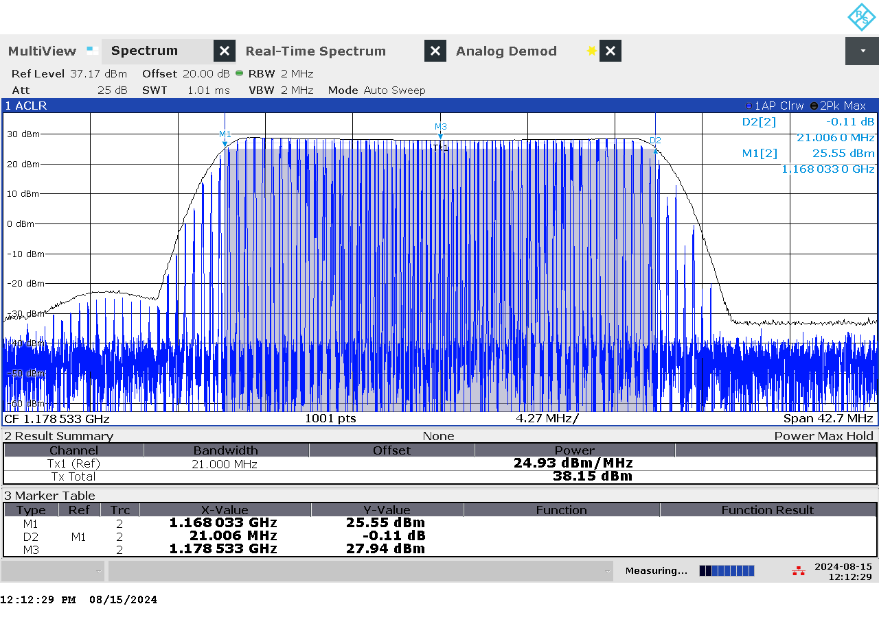

G 146: Frequency and power measurement of jammer H6.6 on antenna “1” (L5)

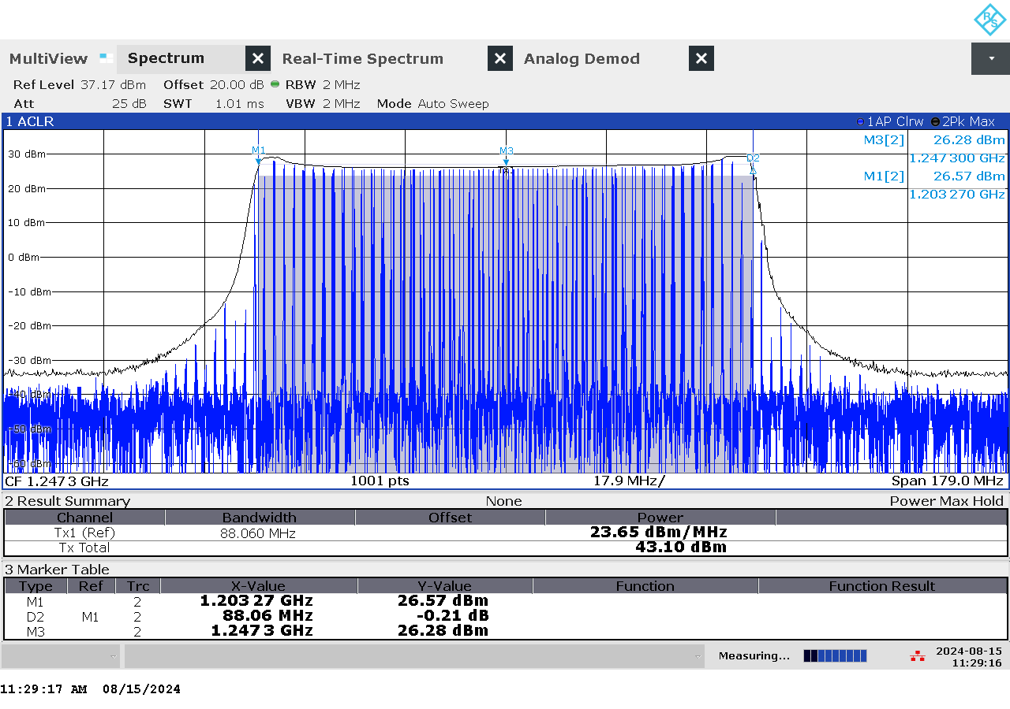

G 147: Frequency and power measurement of jammer H6.6 on antenna “3” (L2)

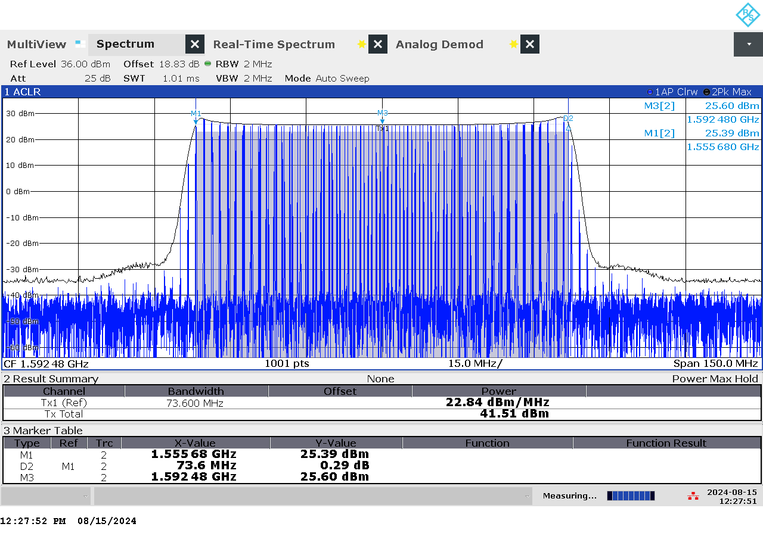

G 148: Frequency and power measurement of jammer H6.6 on antenna “5” (L1)

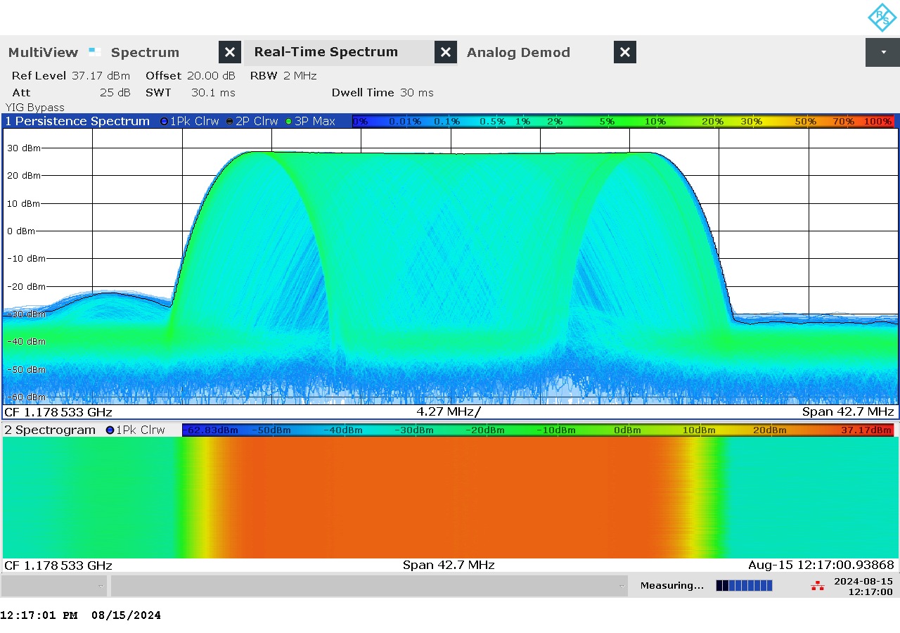

G 149: Real-time persistence and spectrogram measurement of jammer H6.6 on antenna “1” (L5)

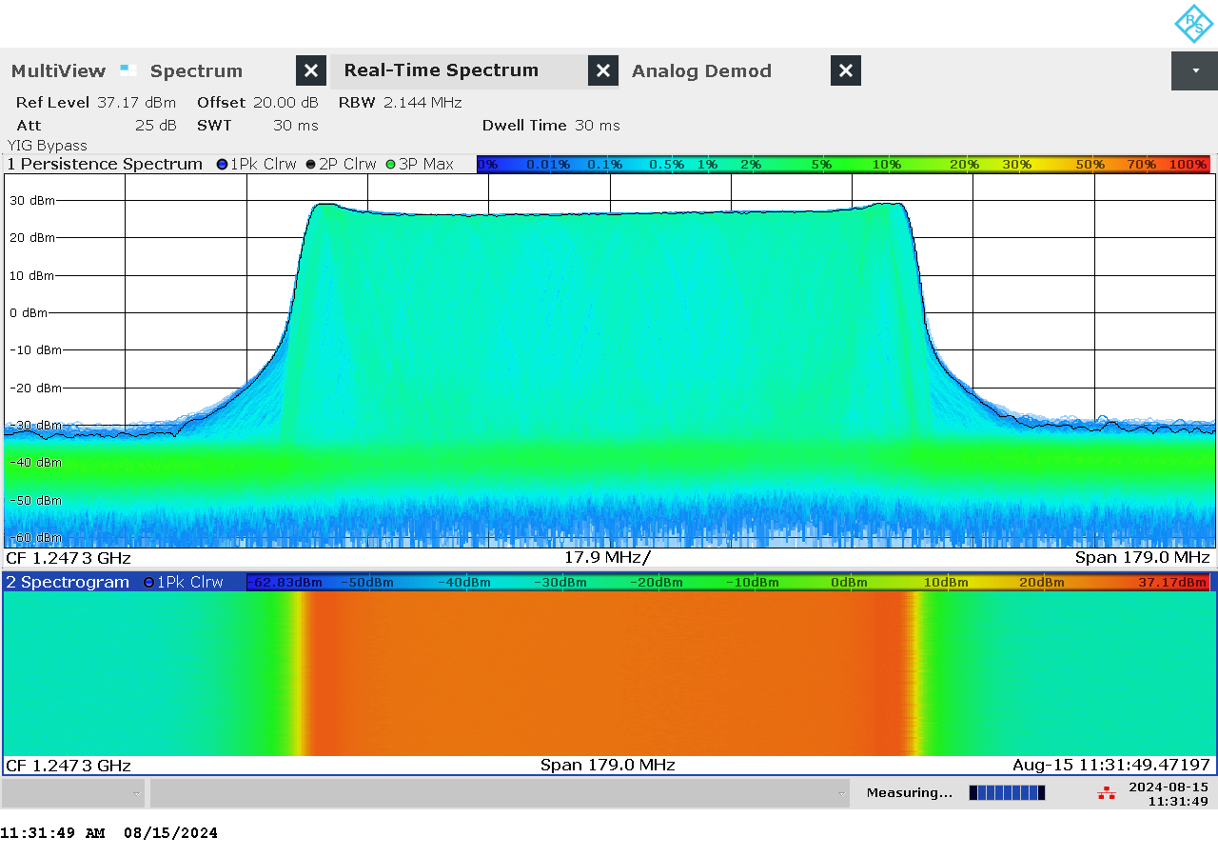

G 150: Real-time persistence and spectrogram measurement of jammer H6.6 on antenna “3” (L2)

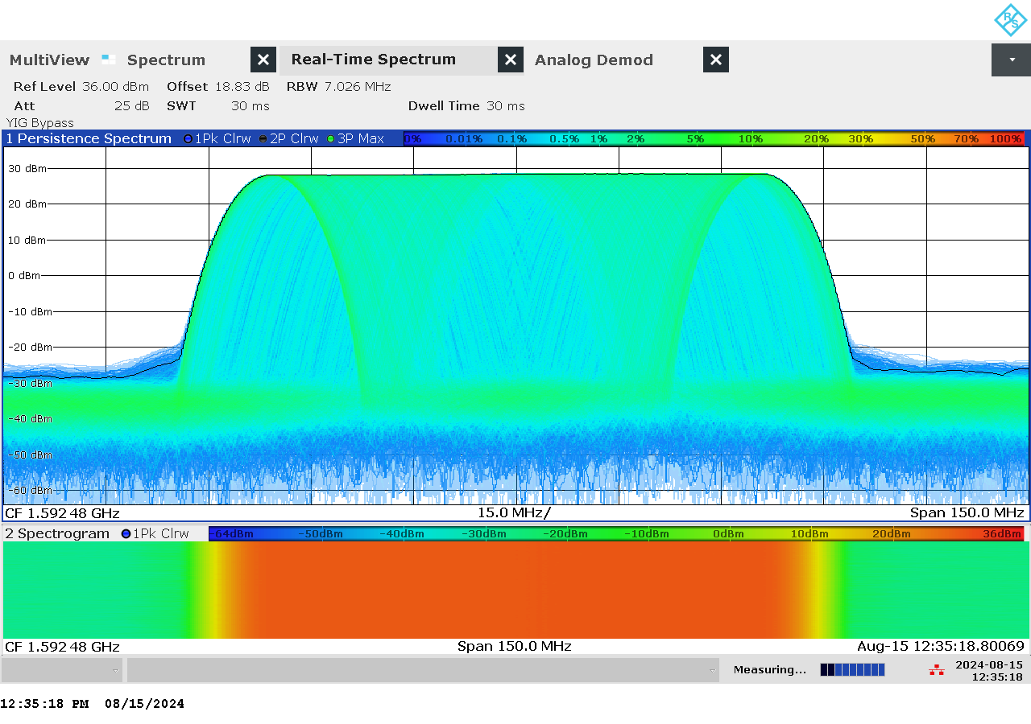

G 151: Real-time persistence and spectrogram measurement of jammer H6.6 on antenna “5” (L1)

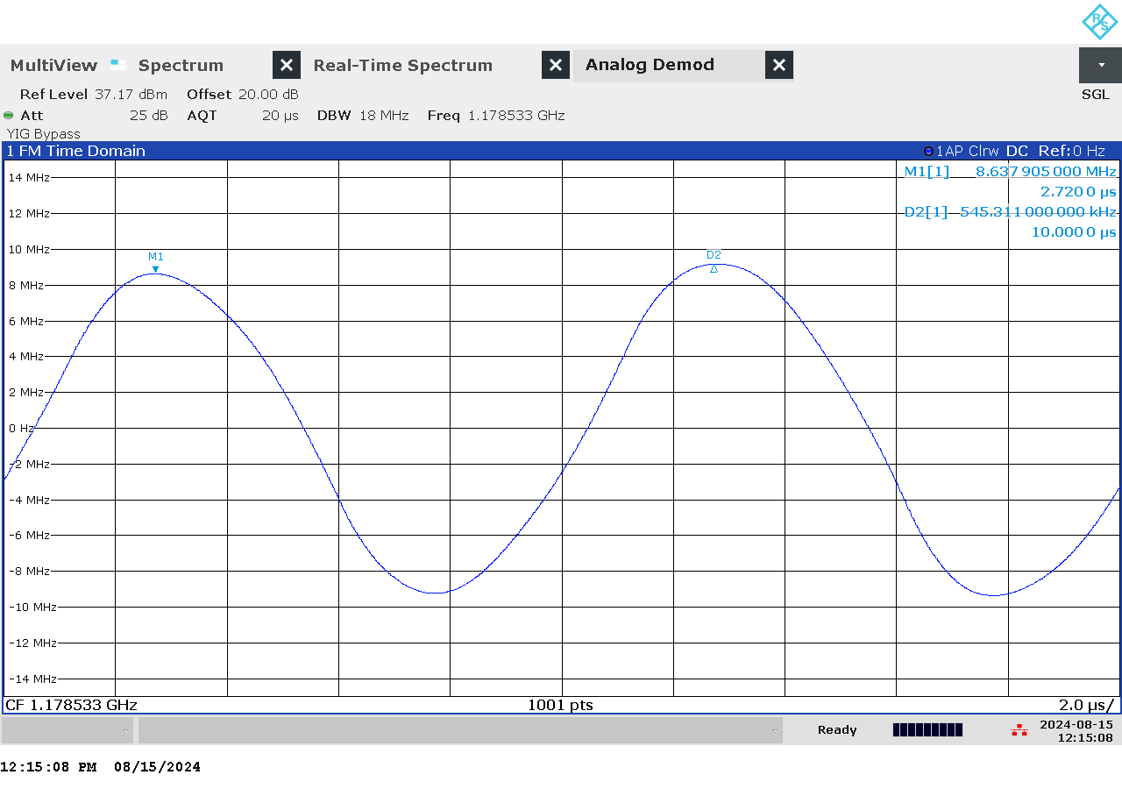

G 152: Time domain (analog demod) measurement of jammer H6.6 on antenna “1” (L5)

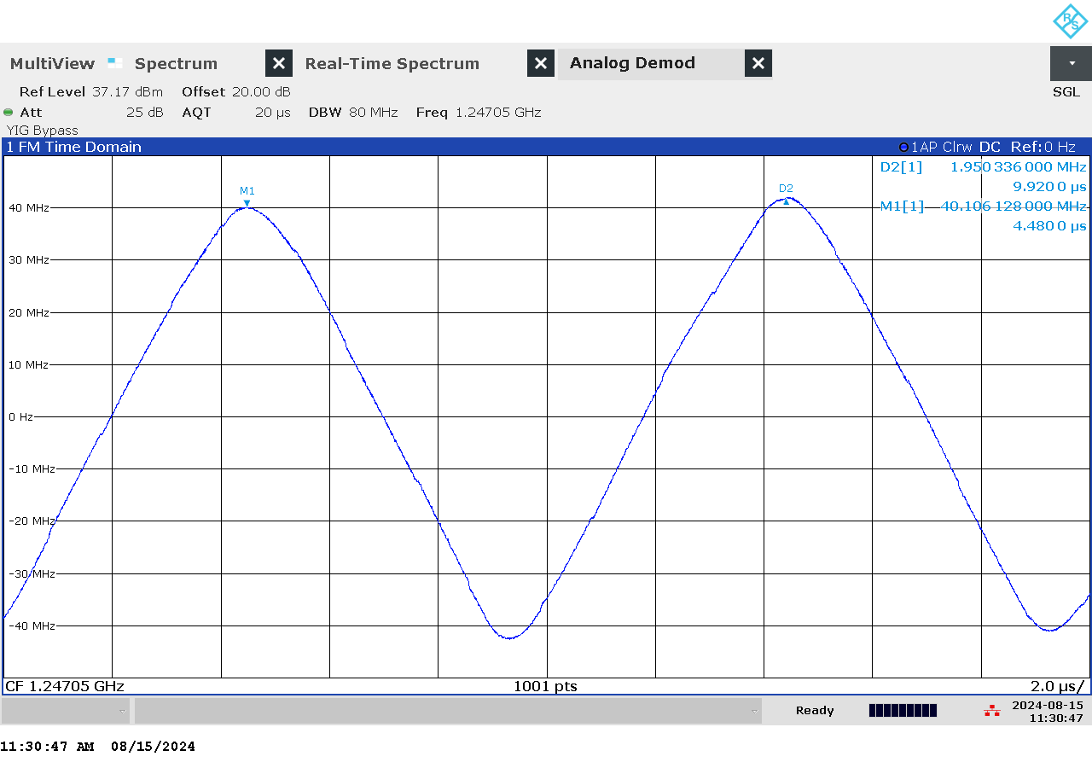

G 153: Time domain (analog demod) measurement of jammer H6.6 on antenna “3” (L2)

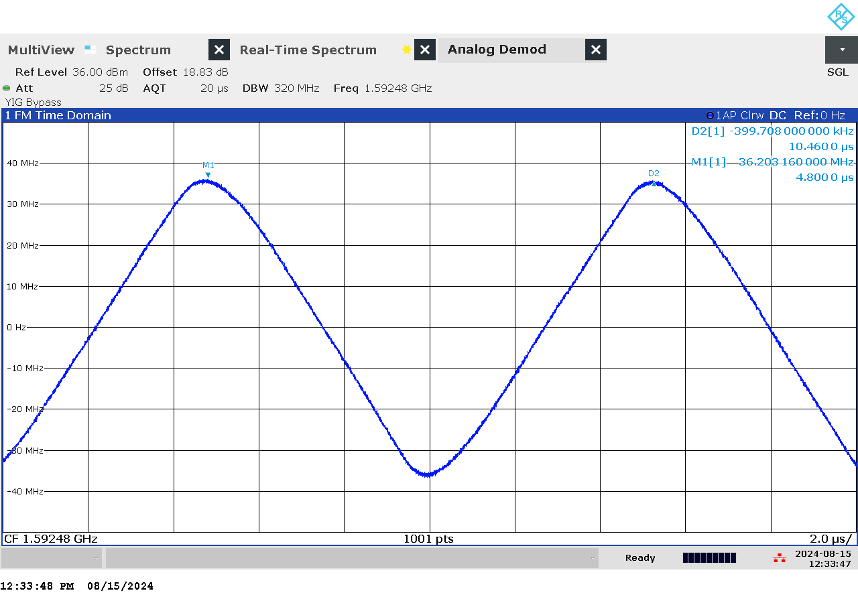

G 154: Time domain (analog demod) measurement of jammer H6.6 on antenna “5” (L1)

### Et bilde som inneholder vegg, kunst, innendørs Automatisk generert beskrivelseTechnical details on low-power jammer “F6.1”

The jammer F6.1 belongs to the ‘Permanently installed (Fixed)’ of jammers. It is a large and heavy tabletop type of jammer, in need of constant power supply with a relatively easy operation, just an on/off-button with a LED-light to indicate activation and DIP switches to change between channels.

F6.1 is a six-antenna, so-called “multi-frequency”, jammer. It jams six different bands, but only four channels are relevant for GNSS bands (“L1+L2+L5”), thus disrupting the upper and lower L-band.

The relevant antennas are marked with letters and numbers: “F2” (L1), “F3” (L1), “F4” (L2) and “F6” (L5)

This jammer has the possibility to adjust the output power, with a power control knob for each antenna. The measurements below are all done at maximum power.

Technical characteristics of F6.1 (2024 measurements)

|  |  |  |  |  |  |  |  |
| --- | --- | --- | --- | --- | --- | --- | --- |
| Antenna | Centre frequency [MHz] | Bandwidth [MHz] | PSD [dBm/MHz] | TX total [dBm] | CF max [dBm] | Sweep rate [µs] | Modulation |
| “F2” (L1) | 1592,59 | 66,55 | 31,49 | 49,72 | 34,85 | 6,46 / 98,50 | sinus / FM-modulert |
| “F3” (L1) | 1589,40 | 73,75 | 27,45 | 46,13 | 29,14 | 6,24 | sinus |
| “F4” (L2) | 1243,65 | 76,22 | 25,42 | 44,24 | 26,94 | 6,20 / 155,00 | sinus / FM-modulert |
| “F6” (L5) | 1177,93 | 16,58 | 24,93 | 37,13 | 18,51 | 5,96 | sinus |

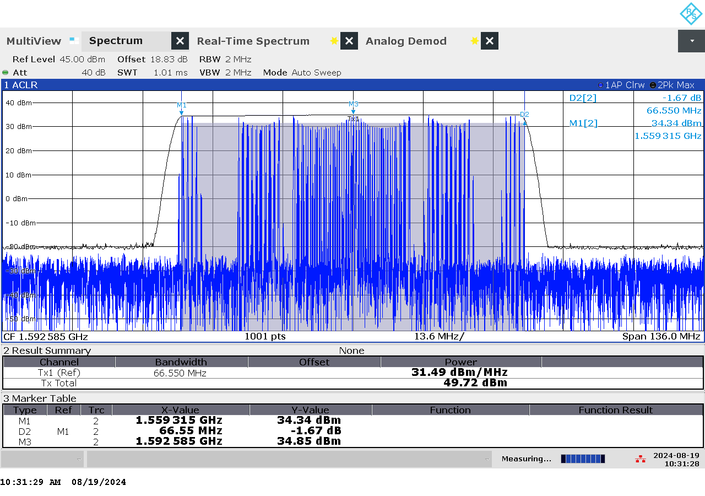

G 155: Frequency and power measurement of jammer F6.1 on antenna “F2” (L1)

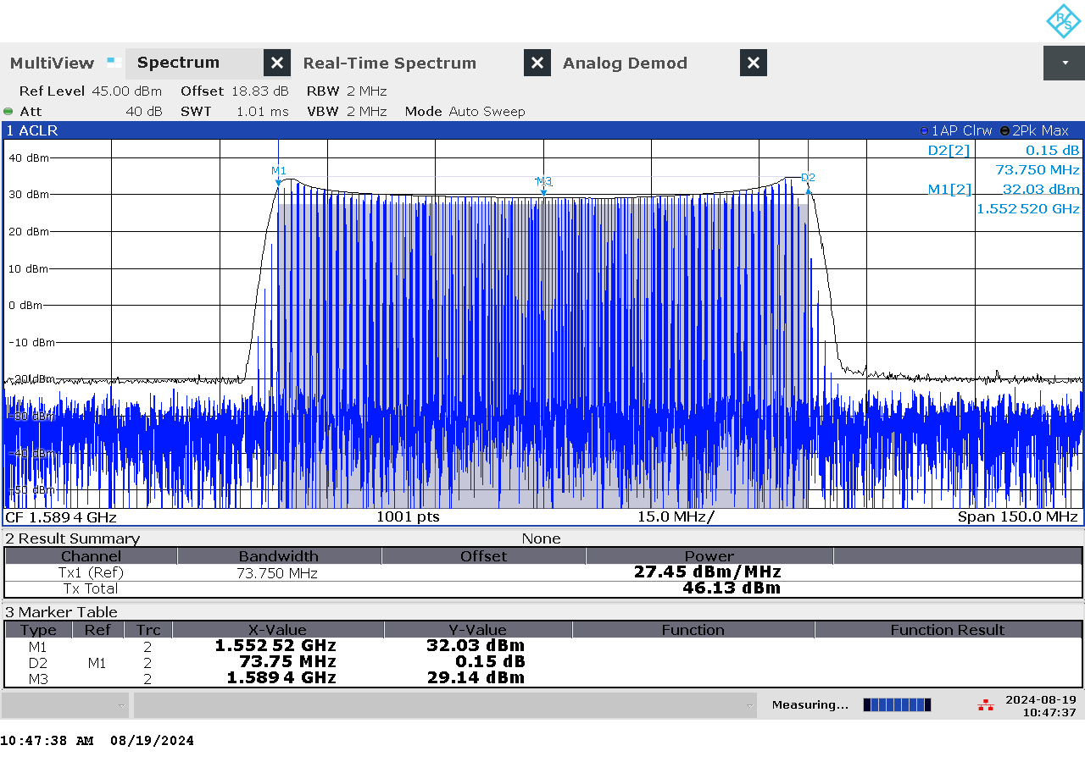

G 156: Frequency and power measurement of jammer F6.1 on antenna “F3” (L1)

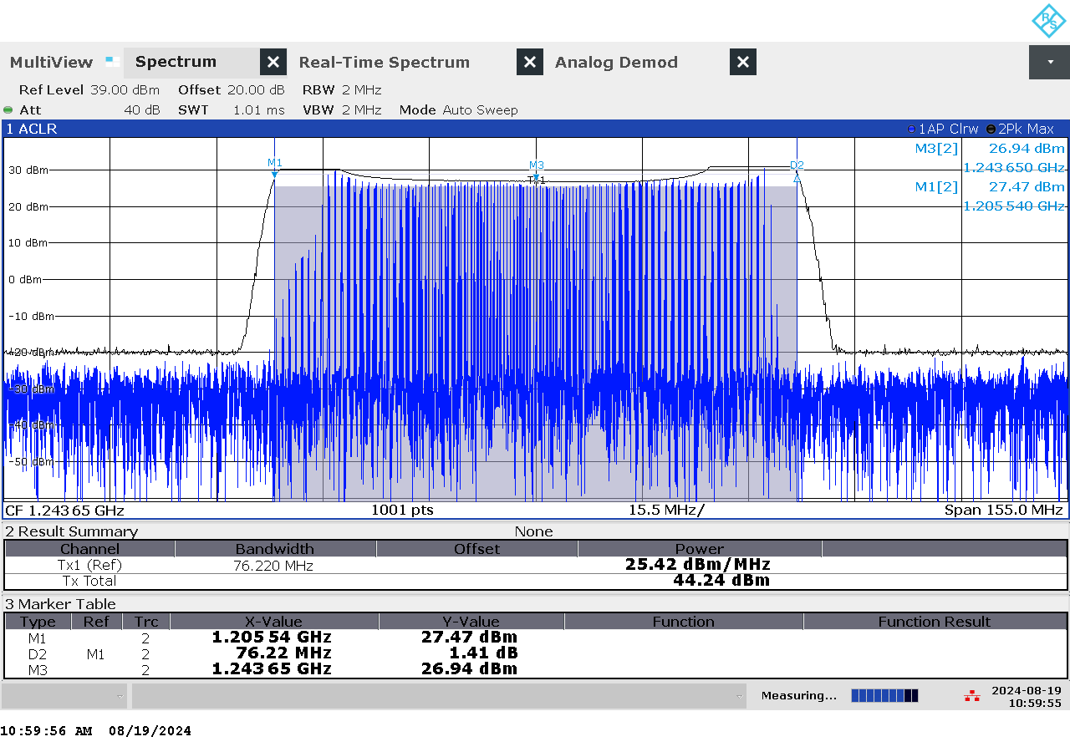

G 157: Frequency and power measurement of jammer F6.1 on antenna “F4” (L2)

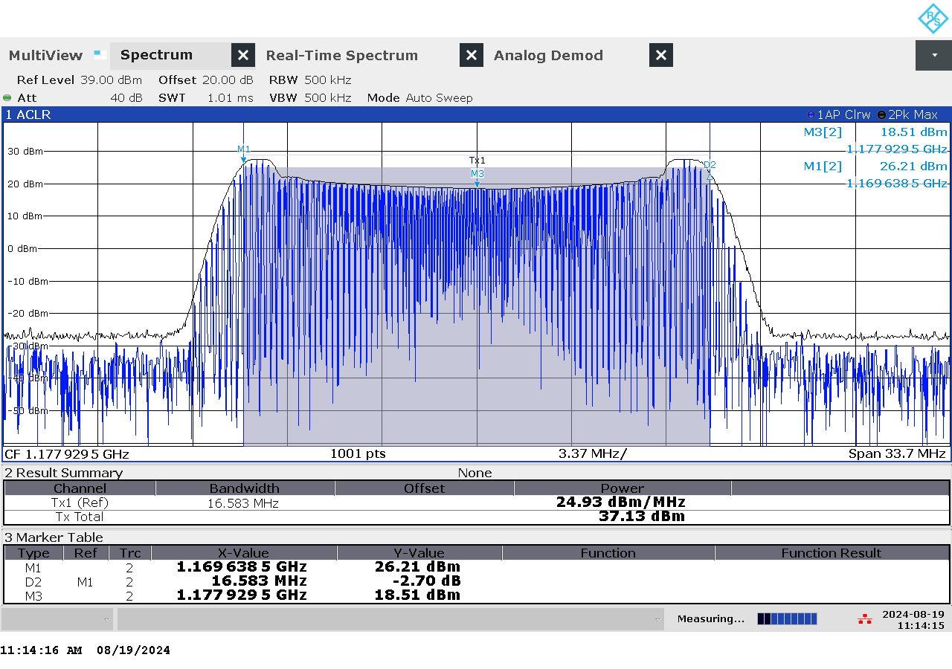

G 158: Frequency and power measurement of jammer F6.1 on antenna “F6” (L5)

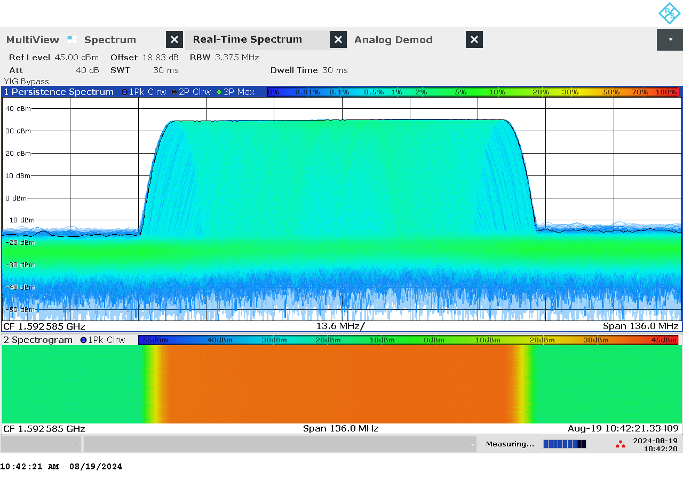

G 159: Real-time persistence and spectrogram measurement of jammer F6.1 on antenna “F2” (L1)

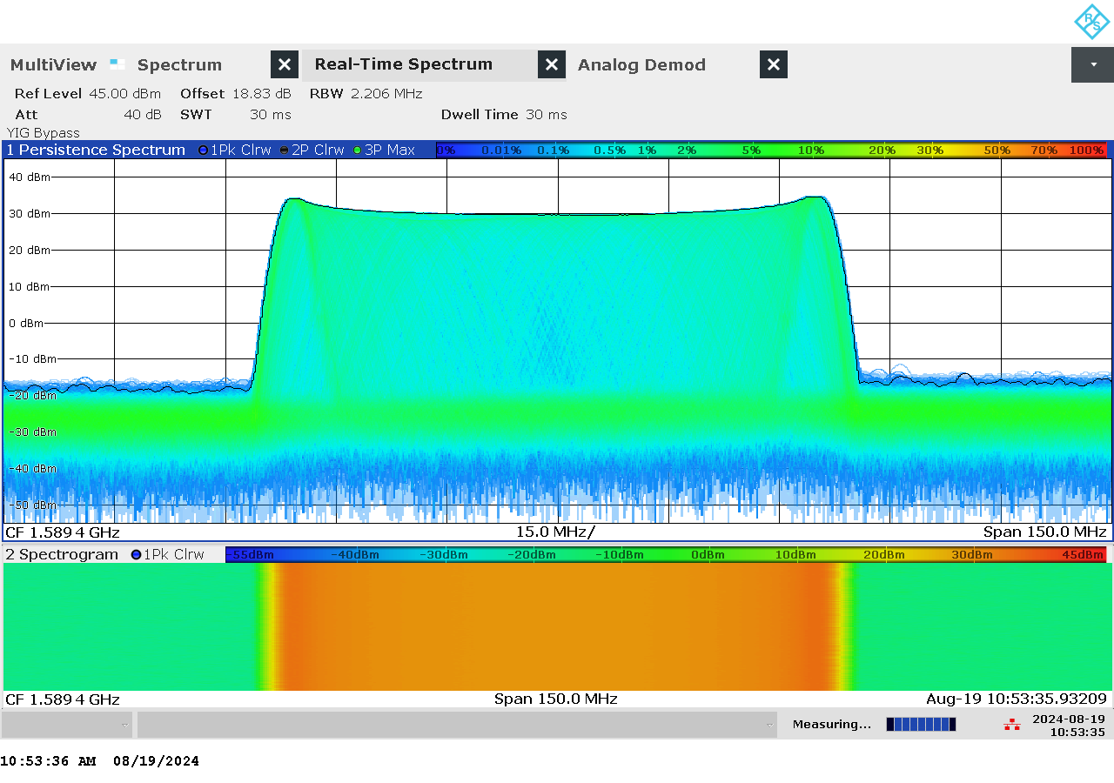

G 160: Real-time persistence and spectrogram measurement of jammer F6.1 on antenna “F3” (L1)

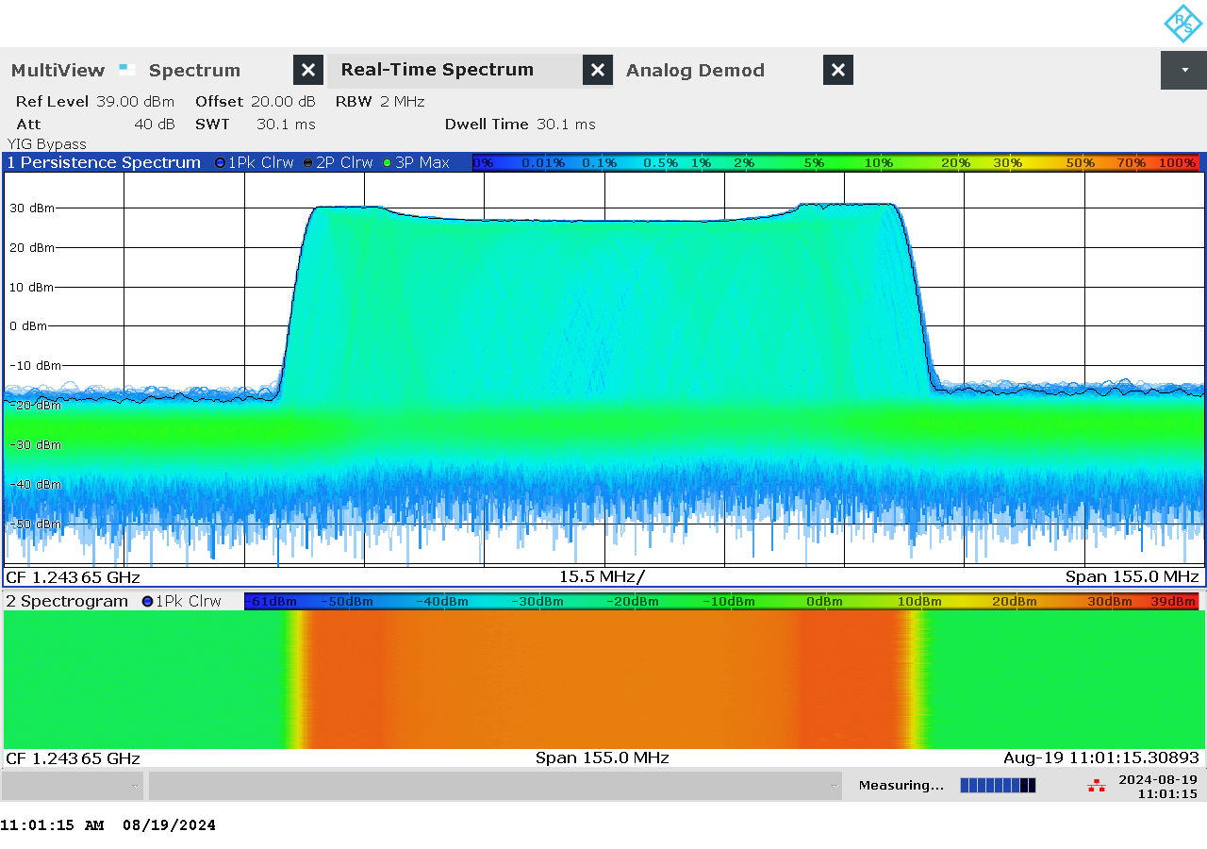

G 161: Real-time persistence and spectrogram measurement of jammer F6.1 on antenna “F4” (L2)

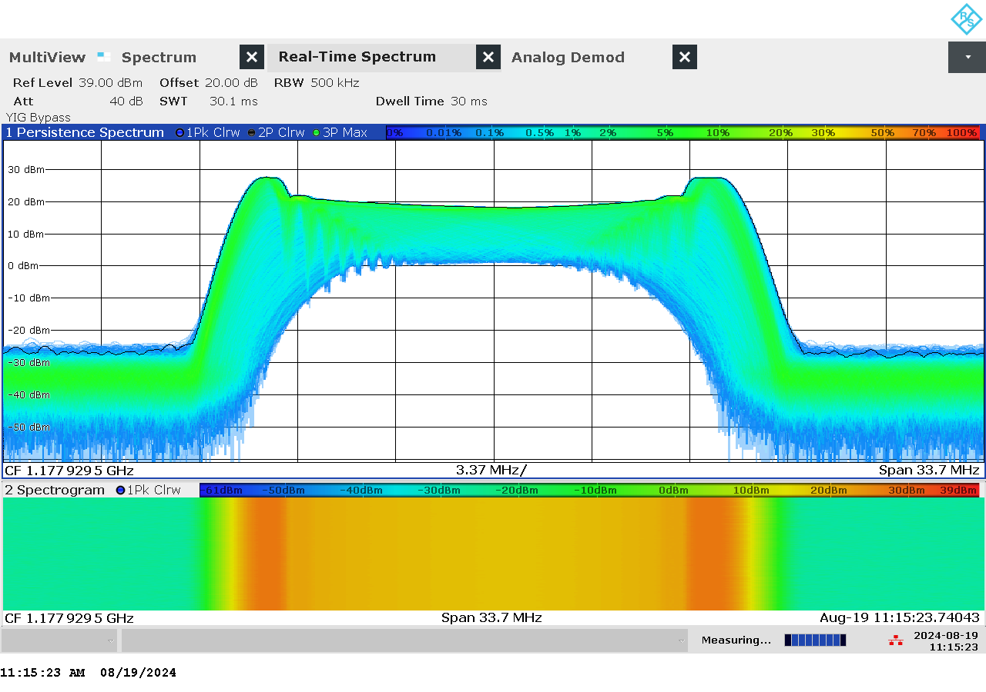

G 162: Real-time persistence and spectrogram measurement of jammer F6.1 on antenna “F6” (L5)

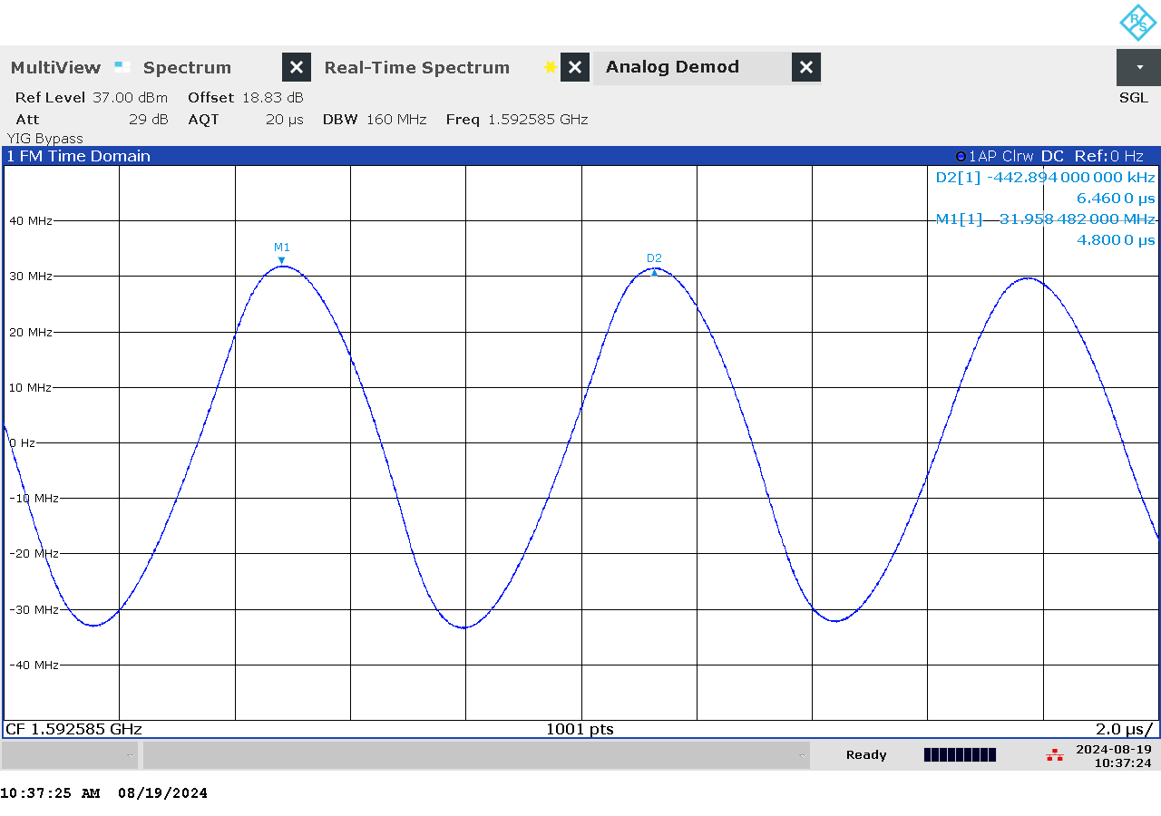

G 163: Time domain (analog demod) measurement of jammer F6.1 on antenna “F2” (L1)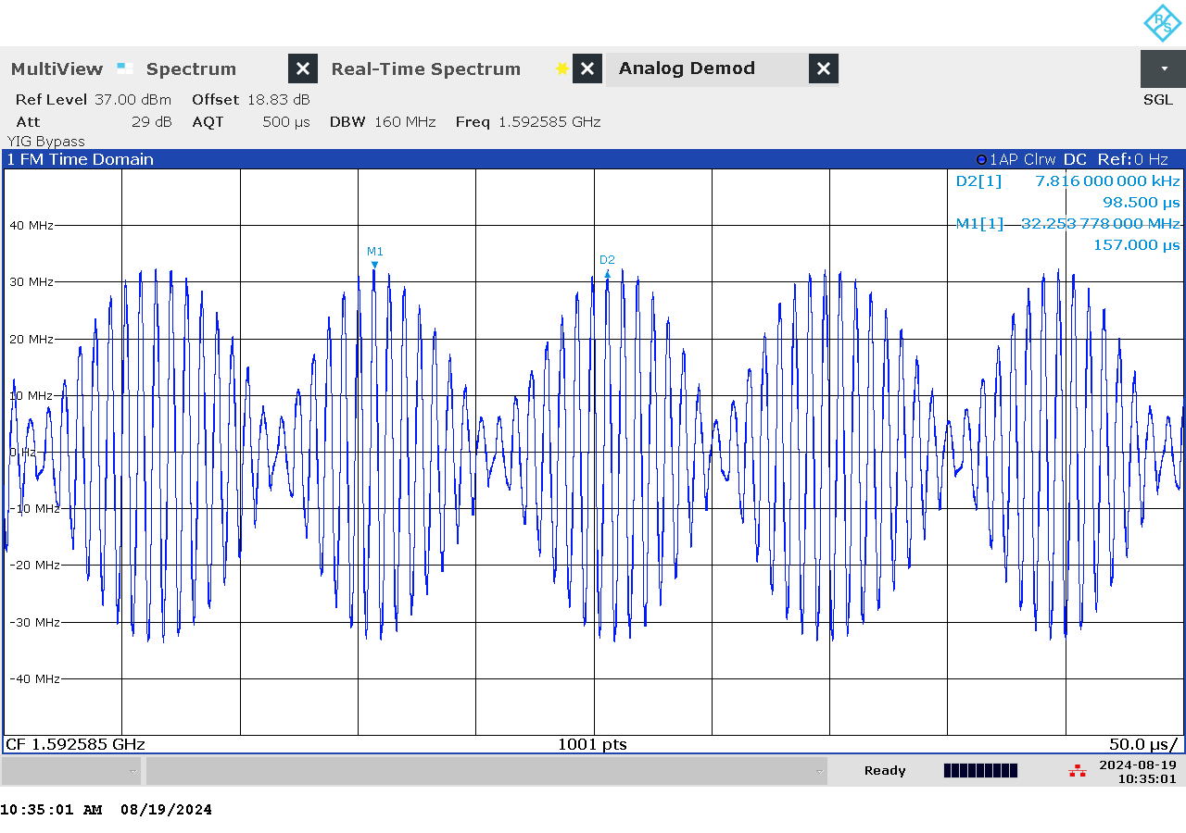

G 164: Time domain (analog demod) measurement with wider span of jammer F6.1 on antenna “F2” (L1)

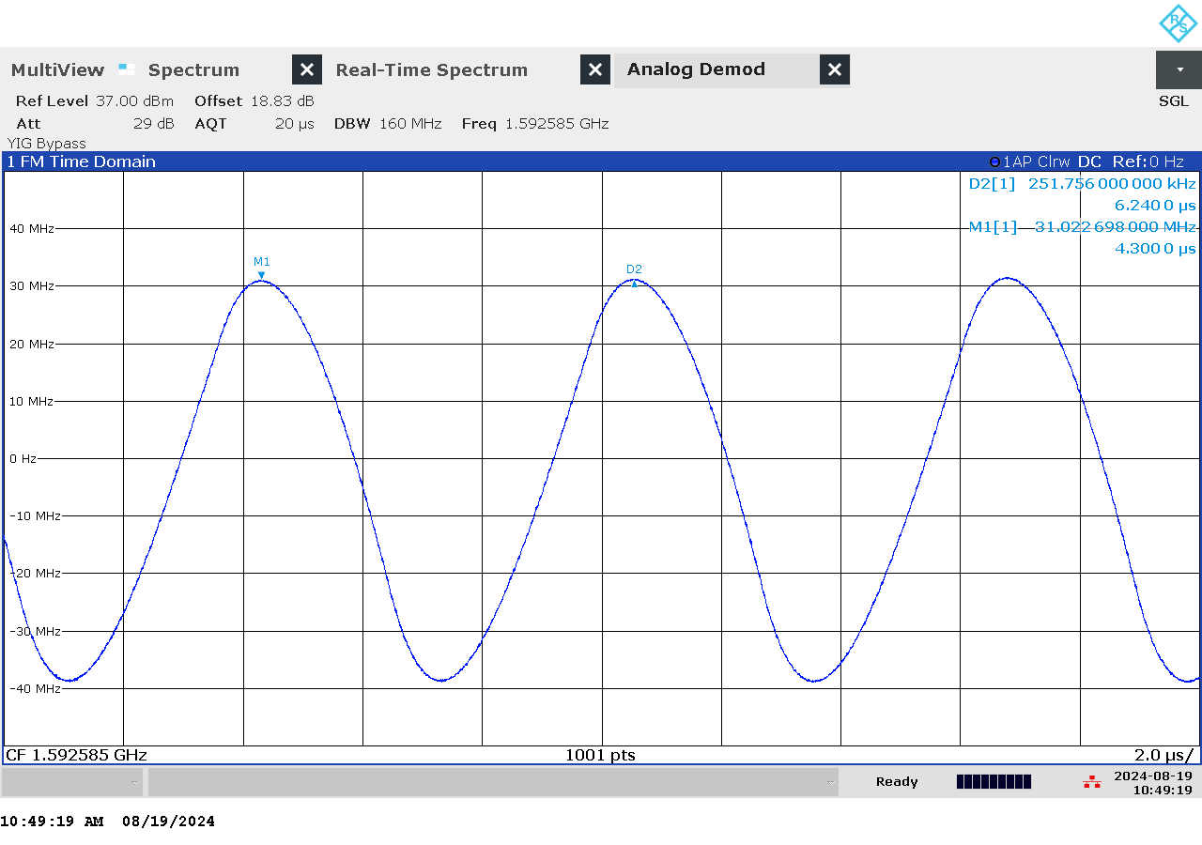

G 165: Time domain (analog demod) measurement of jammer F6.1 on antenna “F3” (L1)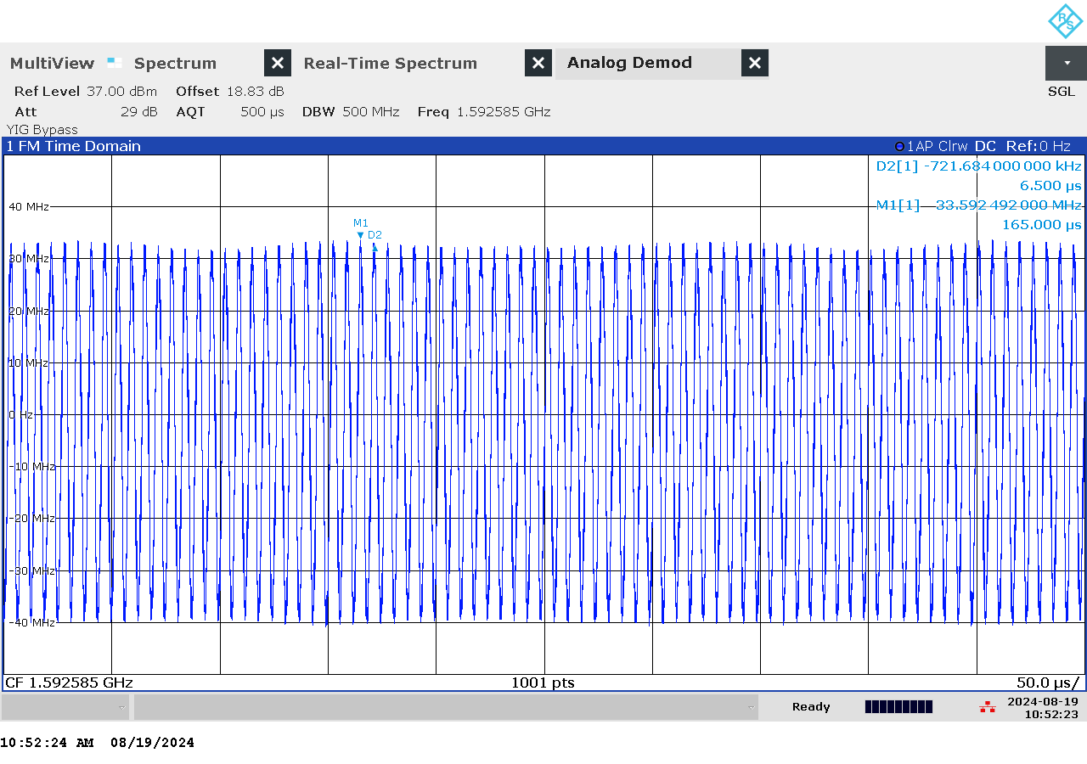

G 166: Time domain (analog demod) measurement with wider span of jammer F6.1 on antenna “F3” (L1)

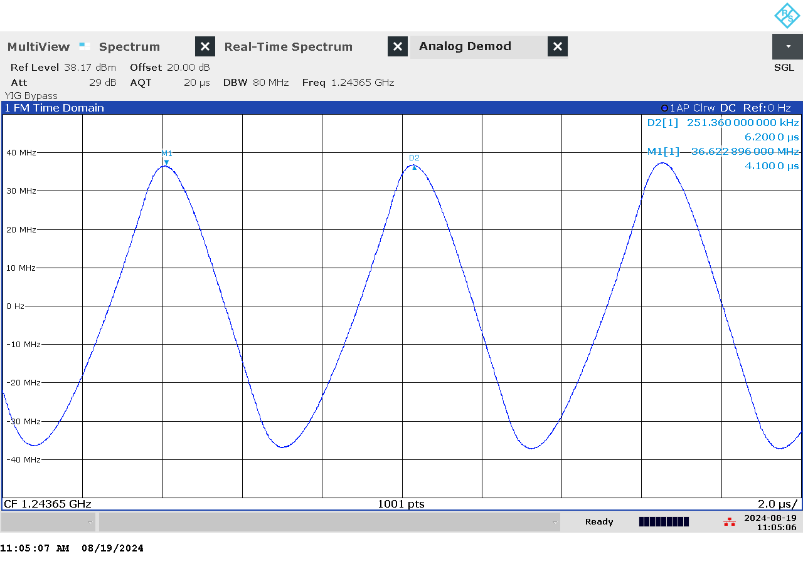

G 167: Time domain (analog demod) measurement of jammer F6.1 on antenna “F4” (L2)

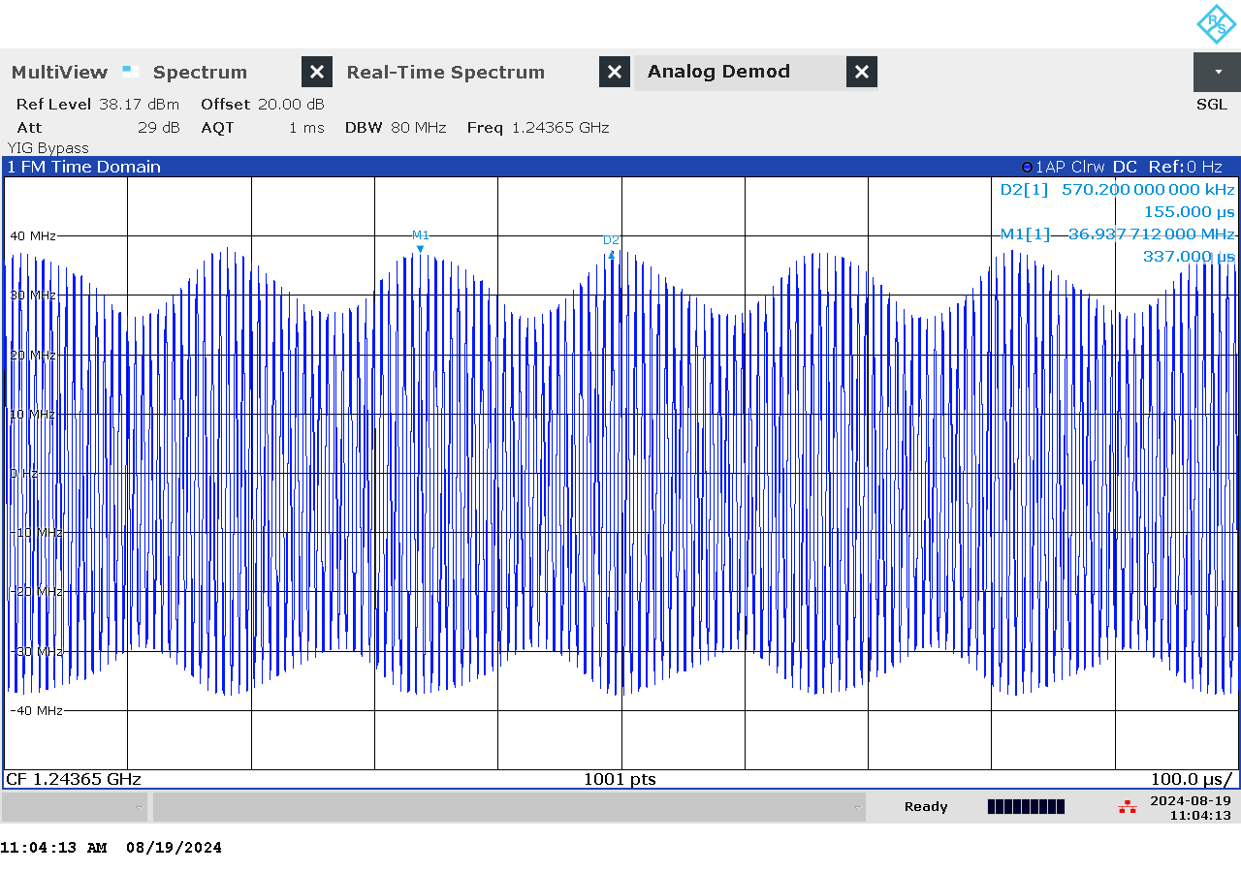

G 168: Time domain (analog demod) measurement with wider span of jammer F6.1 on antenna “F4” (L2)

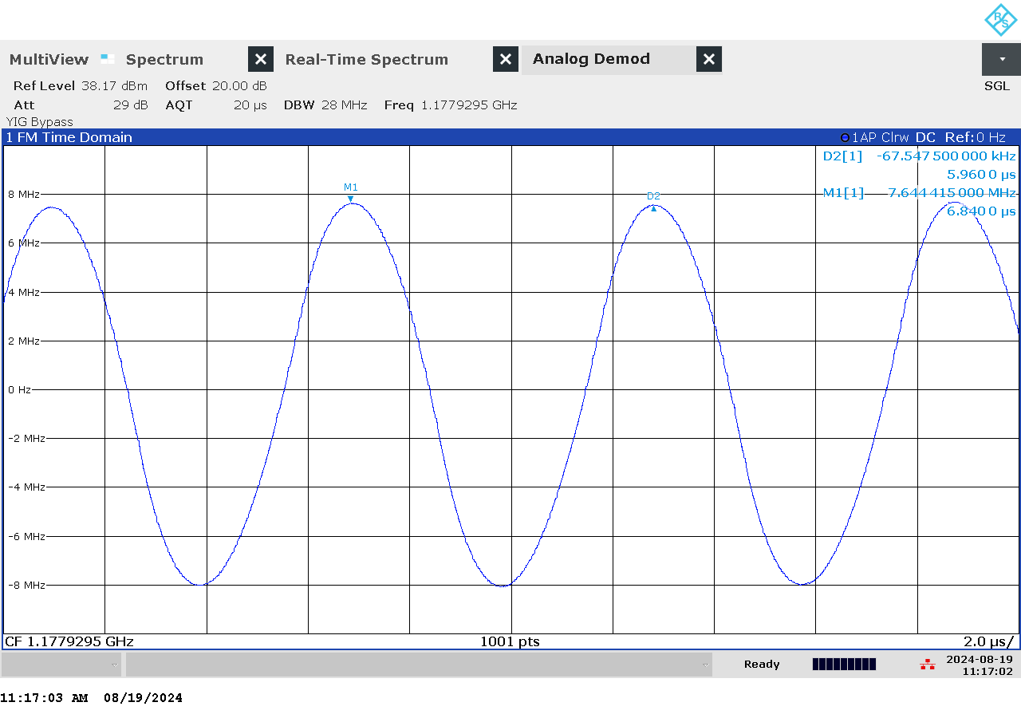

G 169: Time domain (analog demod) measurement of jammer F6.1 on antenna “F6” (L5)

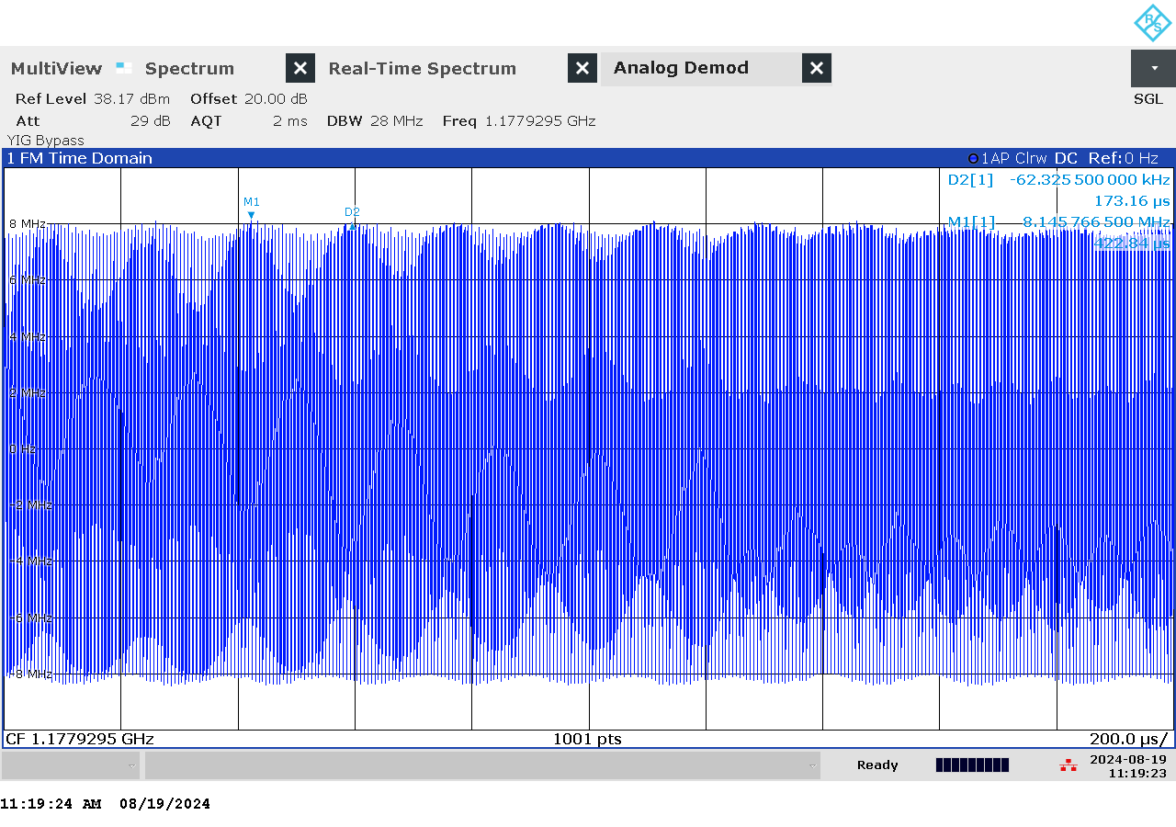

G 170: Time domain (analog demod) measurement with wider span of jammer F6.1 on antenna “F6” (L5)

### Et bilde som inneholder tekst, batteri Automatisk generert beskrivelseTechnical details on low-power jammer H8.1

The jammer H8.1 belongs to the ‘Handheld category’ of jammers. It is a larger but relatively light battery driven jammer with a relatively easy operation, just an on/off-button with a LED-light to indicate activation and DIP switches to change between channels.

H8.1 is a eight-antenna, so-called “multi-frequency”, jammer, but not a “multi-GNSS-jammer”. It jams eight different bands, but only one GNSS-band (“L1-only”), so disrupting only the upper L-band.

Relevant GNSS antenna is marked: “6”

Technical characteristics of H8.1 (2024 measurements)

|  |  |  |  |  |  |  |  |
| --- | --- | --- | --- | --- | --- | --- | --- |
| Antenna | Centre frequency [MHz] | Bandwidth [MHz] | PSD [dBm/MHz] | TX total [dBm] | CF max [dBm] | Sweep rate [µs] | Modulation |
| “6” | 1593,30 | 77,14 | 23,48 | 42,35 | 26,59 | 10,47 | Triangle |

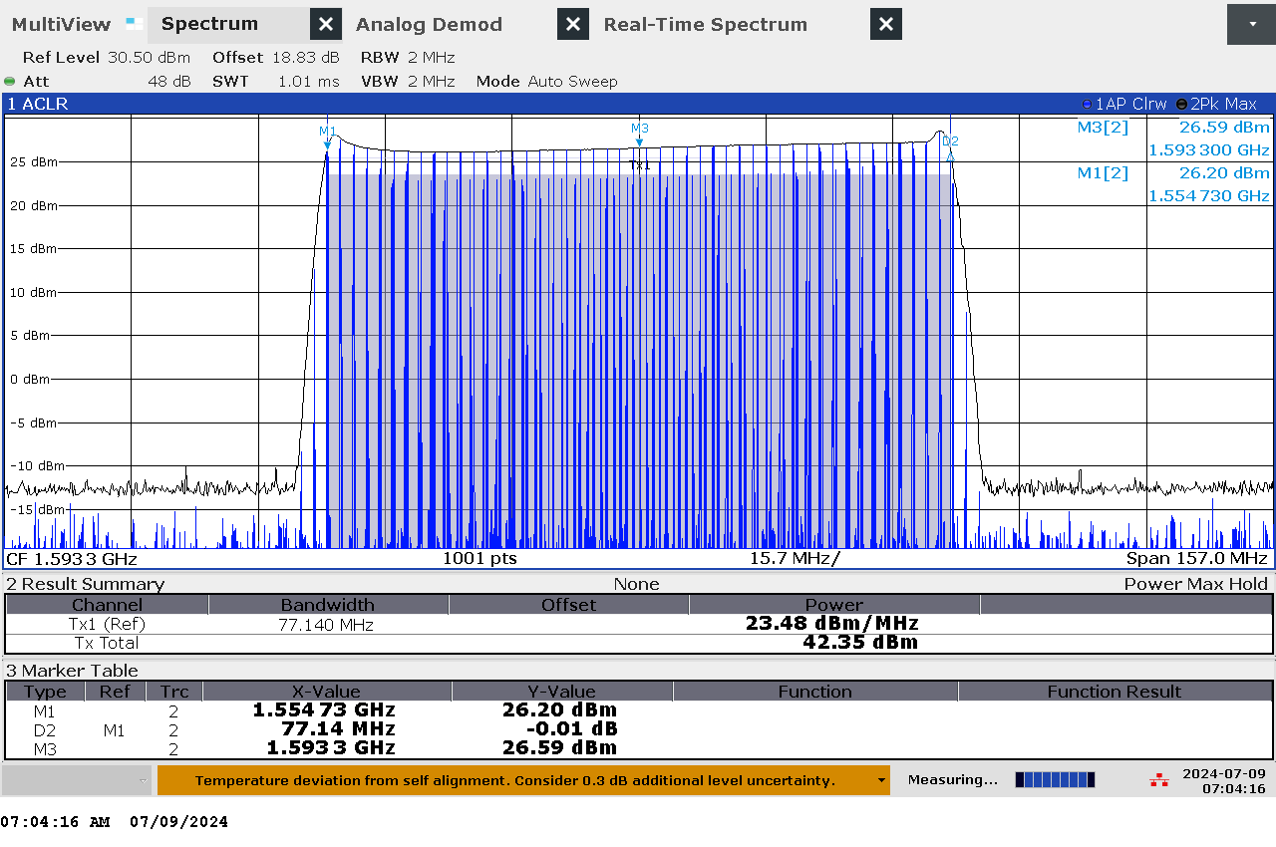

G 171: Frequency and power measurement of jammer H8.1 on antenna “6”

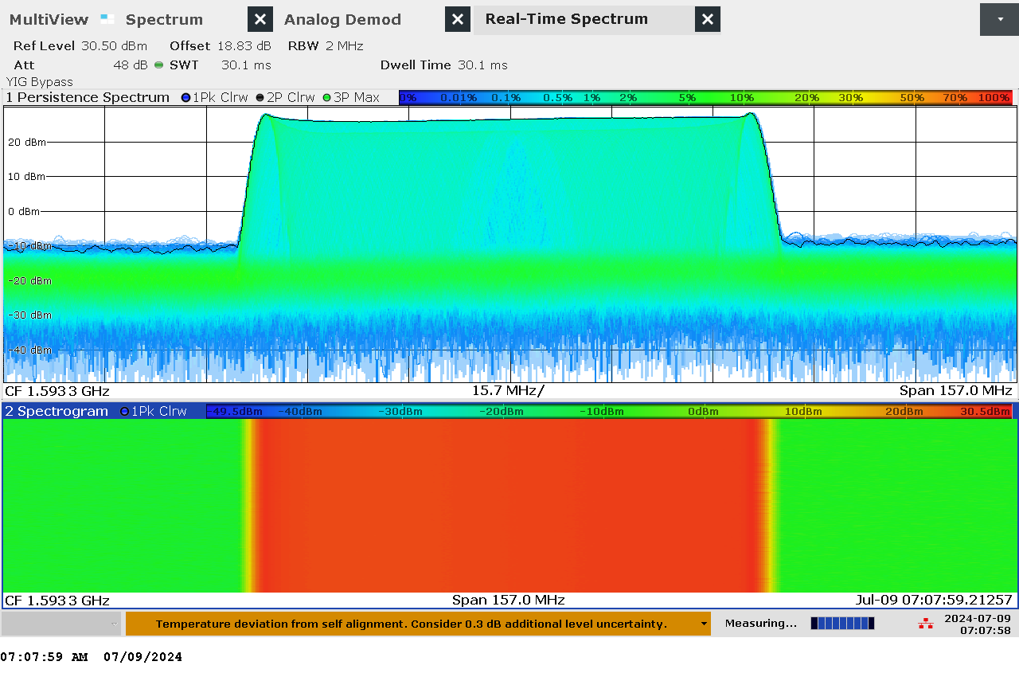

G 172: Real-time persistence and spectrogram measurement of jammer H8.1 on antenna “6”

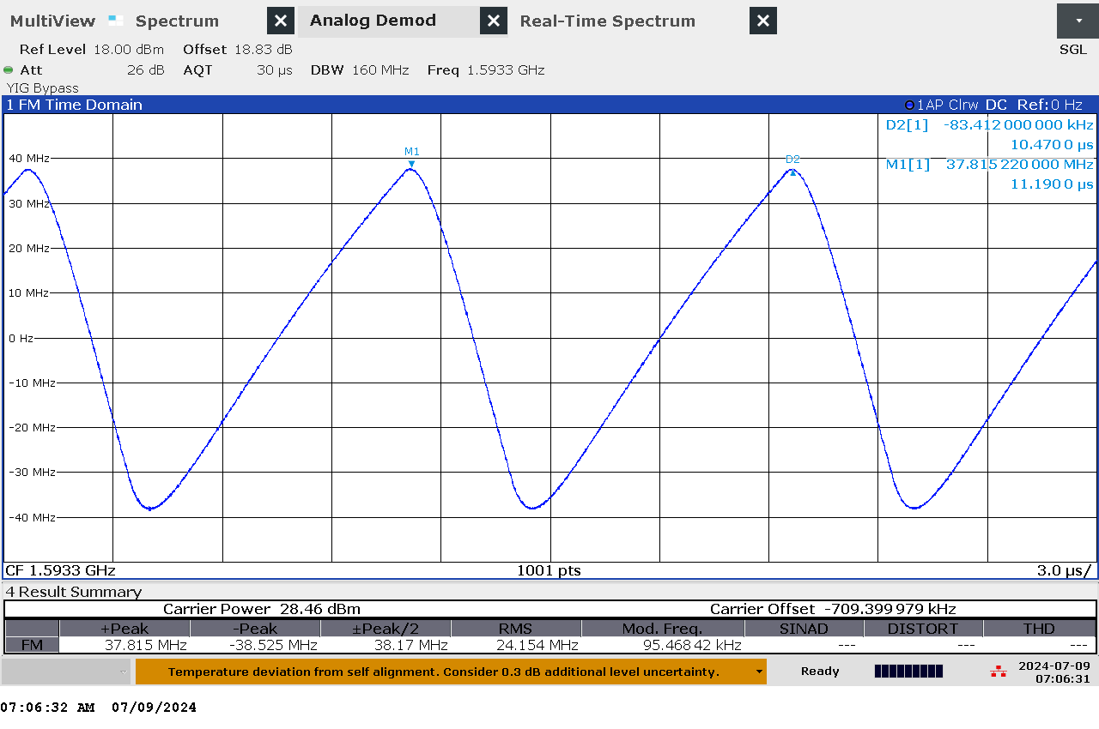

G 173: Time domain (analog demod) measurement of jammer H8.1 on antenna “6”

### Technical details on the meaconing setup “Porcellum” / “F1.1”

The meaconing setup consists of two GNSS antennas “E1” and “E2” at two respective locations some distance from the transmitting antenna. Real live sky signals from the receivers are (after travelling through long cables) retransmitted with a directional antenna “E3” pointing towards the community house in Bleik. The locations of the receiving antennas are outside of the line-of-sight to the transmitter antenna to avoid a feedback loop. The setup allows for switching between the two receiving antennas, ramping power and simultaneous transmission of both signals.

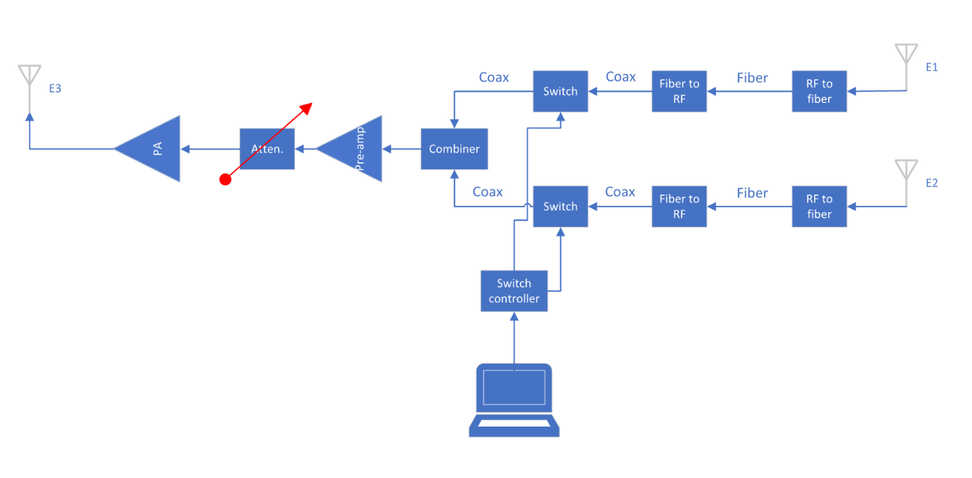

G 174: Diagram of the meaconing setup

### Technical details on the high-power jammer “Porcus Major”/ “F8.1”

The high-power jammer provides jamming signals with up to 50 W EIRP simultaneously on eight GNSS bands, where the maximum available power depends on the signal modulations. Figure G 176 is a block diagram of the high-power jammer that shows how it works in pniciple. The jammer uses two USRP X410 SDR from Ettus Research as exciters. Each SDR have four output channels covering the frequency range of 1 MHz to 7.2 GHz, with maximum 400 MHz instantaneous bandwidth. The SDRs have an internal gain range of 60 dB in 1 dB steps. Each of the exciter output signals are fed to the corresponding channel of the programmable step-attenuator. The jammer can also utilize other signal generators. The attenuator has an attenuation range of 95 dB in 0.25 dB steps. The output signal from the attenuators is then fed to the power amplifiers. The amplifiers connect to eight individual antennas via a 10 m coax. The antennas are directional helical antennas with right hand circular polarization (RHCP) and 10 dB gain.

An overview of the jammer signal modulations is given in G 175.

|  |  |  |  |  |  |  |
| --- | --- | --- | --- | --- | --- | --- |
| **Frequency band name** | **CW** | **PRN** | | **Frequency sweep** | | |
| **Frequency (MHz)** | **Center frequency (MHz)** | **BPSK chiprate (MHz)** | **Center frequency (MHz)** | **Sweep rates (kHz)** | **Frequency bandwidth (MHz)** |
| **L1** | 1575.42 | 1575.42 | 10 | 1575.42 | 1-100 | TBA |
| **L2** | 1227.6 | 1227.6 | 10 | 1227.6 | 1-100 | TBA |
| **L5** | 1176.45 | 1176.45 | 10 | 1176.45 | 1-100 | TBA |
| **G1** | 1602 | 1602 | 5* | 1602 | 1-100 | TBA |
| **G2** | 1246 | 1246 | 3 | 1246 | 1-100 | TBA |
| **E5b** | 1207.14 | 1207.14 | 10 | 1207.14 | 1-100 | TBA |
| **E6** | 1278.75 | 1278.75 | 10 | 1278.75 | 1-100 | TBA |
| **B1I** | 1561.098 | 1561.098 | 3 | 1561.098 | 1-100 | TBA |

G 175: Overview of the signal modulations employed by ‘Porcus Major’ (*3MHz may be used in pyramid jamming)

A PC controls the high-power jammer, that is both exciters and the step-attenuators. Software allows for the jammer to automatically execute individual tests described for the high-power jammer and supports all jamming signals described therein.

The high-power jammer is connected to Internet and time synchronized using Network Time Protocol (NTP). After a jamming activity, it can upload the activity log to the central server.

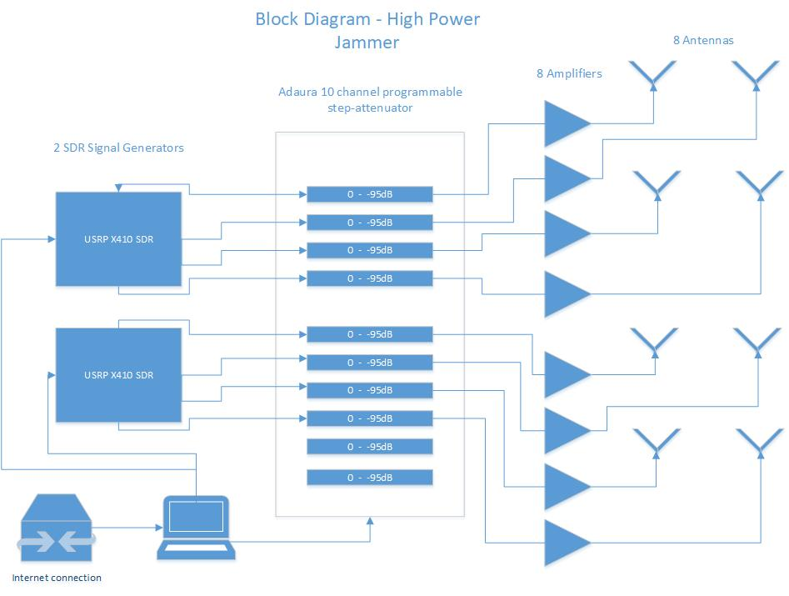

G 176: Diagram of the high-power jammer

### Technical details on software defined radio mobile SDR spoofer “F1.2”

A software defined radio (SDR) of type BladeRF x115 from Nuand is used for the mobile spoofing tests. The output signal is amplified 45 dB through an AA MCS 800 – 2200MHz amplifier, so that the maximum total EIRP is about 10 dBm. This signal is transmitted by a dipole antenna on the top of the vehicle, see [ds1036-080410.pdf (european-antennas.co.uk).](https://www.european-antennas.co.uk/media/1900/ds1036-080410.pdf)

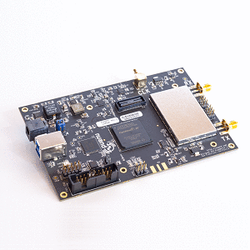

G 177: Picture of the SDR without casing

The spoofed signals are GPS C/A only and may be combined with Glonass jamming (G1).